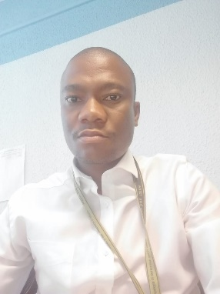

Mr. Solomon Moitswadi Makate is the Director of Drinking Water Regulation at the Department of Water & Sanitation, a position he has held since September 2022. In this role, he oversees the regulation of water services in line with legislated norms and ensures the implementation of the National Water Services Act. He also manages the National Drinking Water Quality Consultative Audits and Blue Drop Certification programmes, and optimises the Integrated Regulatory Information System (IRIS) for over 1,000 water supply systems.
Previously, Mr. Makate served as Director: Wastewater Services Regulation from 2015 to 2019, where he successfully managed the Green Drop Certification programme. He also led the revision of Regulation 2834, which became Regulation 3630 under the Water Services Act. His international experience includes representing South Africa at the Japan International Cooperation Agency and participating in the BRICS Water Sector technical task team in Russia.
In addition to his professional achievements, Mr. Makate has contributed to critical water-related crisis investigations, such as the Delmas and Blemhof cholera outbreaks. He has also played a key role in the Aqua Enduro programme, which has awarded over 150 bursaries to learners pursuing studies in water-related engineering and science. Mr. Makate is a member of the Engineering Council of South Africa and the Water Institute of Southern Africa.

