IST652 Scripting for Data Analysis

Fall 2020

12/4/2020

**School of Information Studies  
SYRACUSE UNIVERSITY**

**IST 652 Final Project Report**

**Submitted by:**

**Xiwei Shen | Sihan Yang**

**Introduction**

The dataset we are using for this final project is called the “MCG Personnel Management Review (PMR)” dataset, which contains a summary of the County Government and composition by generational category, age, race, ethnicity, gender, years of service, and job class. The dataset contains nine variables and 9244 entries in total. The source of our dataset is: <https://catalog.data.gov/dataset/mcg-personnel-management-review-pmr>. The secondary dataset we are using is called "Average Salary by Job Classification", which can be found at: <https://catalog.data.gov/dataset/average-salary-by-job-classification>. This dataset contains five variables, which are position title, position class code, grade, average of base salary, and the number of employees. The supplement dataset contains the average salary by position title and grade for full-time regular employees. It is like a summary of our original dataset. For this project, we are planning to first use the descriptive analysis to summarize our data and find interesting patterns. For categorical variables, we want to regroup the data in a different unit of analysis than is present in the original dataset. For this step, we can use pivot tables and plots to interpret our analysis results. At last, we want to try to conduct a regression analysis to analyze the relationship between each variable and the salary level.

**Data Information and Preprocessing**

Our dataset contains nine columns in total, which are "Generation", "Age", "Ethnic Origin", "Gender", "Length Of Service", "Job Class", "Grade", "Assignment Category" and "Salary Range". The "Generation" column contains the generational category of an employee and there are five unique values in total, which are "Generation X", "Baby Boomers", "Millennial Generation", "Traditionalist/Silent Generation" and "Post Millennials". The "Ethnic Origin" column contains the race of an employee and there are eight unique values in total, which are "White", "Hispanic or Latino", "Black or African American", "Asian", "Unreported", "Two or More Races", "American Indian or Alaska Native" and "Native Hawaiian/Other Pacific Islander". The "Salary Range" column splits the annual salary of an employee into 16 different groups. The lowest annual salary is less than 20K, and the highest annual salary is greater than 150K. For the data preprocessing steps, we first checked the missing values in our dataset. We found that there are no missing values in our dataset. Next, we add a dummy column in our dataset which contains all values 1. This column is very useful when using pivot tables to perform our analysis of different categories of data. We can use this column in the pivot table to count the number of categorical variables.

**Data Analysis**

For this project, we first conduct our analysis based on the salary range column of our dataset. We first plot the number of people in each salary range. Based on the plot (Figure 1), we can see that the majority of people have a salary of 50K-80K. There are only around 200 people who have a salary greater than 150K, and there are only around 100 people who have a salary less than 20K.

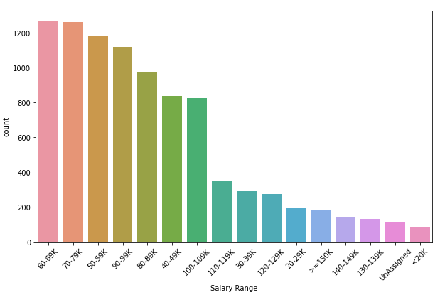

Figure. 1

Next, we focused on the Ethnic Origin variable of our dataset. We check the distribution of the Ethnic Origin variable through a bar plot. 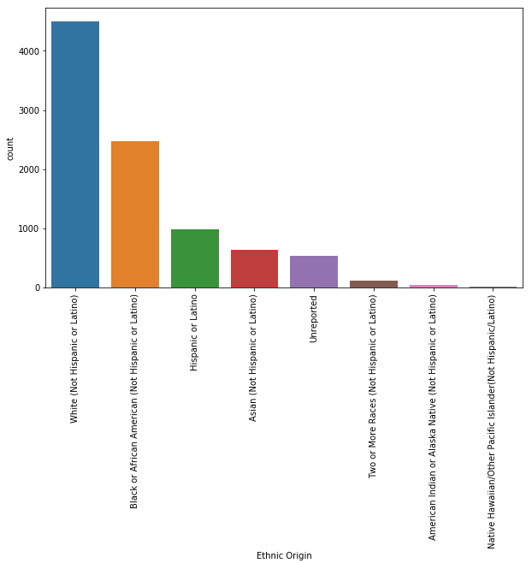

Figure. 2

Based on the plot (Figure 2), we can see that the majority of the employees are white origin and black origin. Other groups of people, like Asian, only take a small proportion of the total employee.

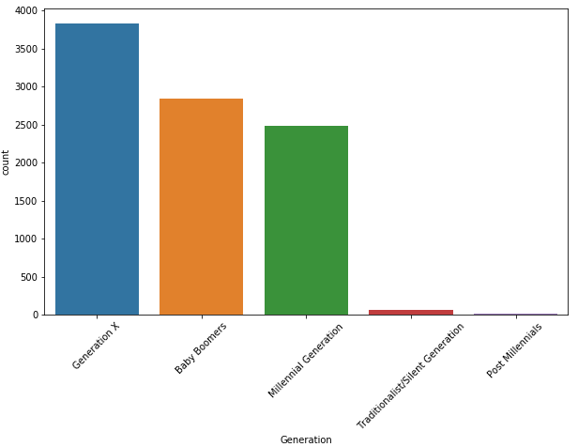

Figure. 3

Next, we plot the number of employees in each generational category (Figure 3). We found that the majority of employees were born during Generation X, which is from 1965 to1980, and Baby Boomers, which is from 1946 to 1964, and Millennials, which is from 1981 to 1996.

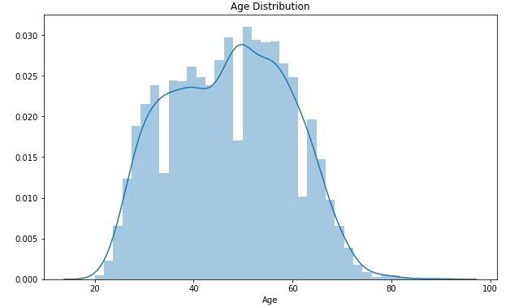

Figure. 4

The field we analyzed next is age. We draw a density plot to check the age distribution of employees (Figure 4). We can see that the age distribution of our dataset roughly follows a normal distribution. Most employees were included in the age range from 20 to 80. Age range from 50 to 60 seems to contain the largest number of employees.

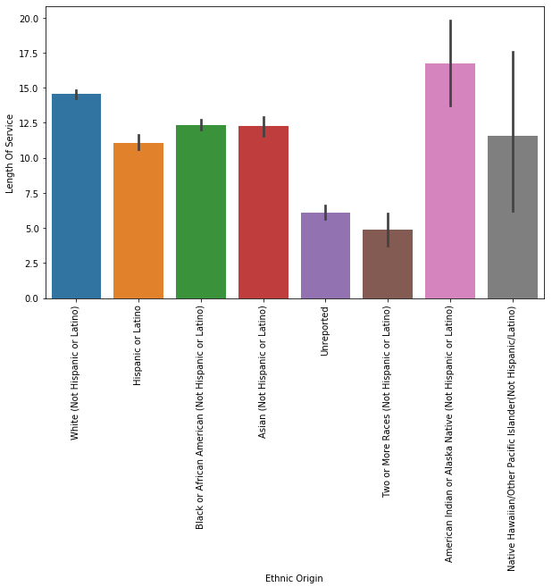

Figure. 5

The next fields we analyzed are ethnic origin and length of service (Figure 5). Since the length of service is a numerical attribute, we computed its average value for each ethnic group. We can see that the employees of American Indian or Alaska Native have the longest average length of services then followed by employees of White origin, while employees of Two or More Races have the shortest average length of services. For other ethnic origins, the average length of services is similar.

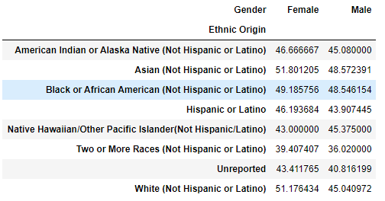

Figure. 6

Next, we use the pivot table to conduct our analysis of fields age, gender, and ethnic origin (Figure 6). For each ethnic origin, we compute the average age of female employees and male employees. Basically, for every ethnic origin, the average age of female employees is greater than the average age of male employees, except for Native Hawaiian/Other Pacific Islander. Asian employees are the oldest one, while employees of Two or More Races are the youngest group.

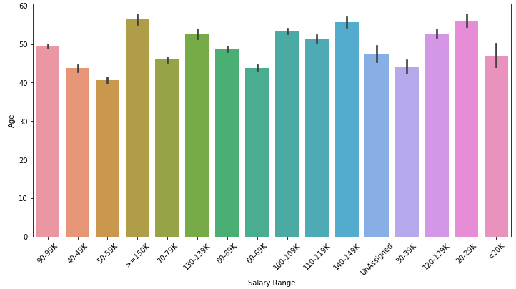

Figure. 7

Next, we use the bar plot to conduct our analysis of fields age, and salary range. We plot the average age for each salary range (Figure 7). We were expecting that older people have a higher salary, but surprisingly, the difference in average age among each salary range is not significant. It is true that the average age of people who have a salary greater than 150K is nearly 60. But if we look at the people who have a salary less than 20K, and within 20-29K, their average age is also very high.

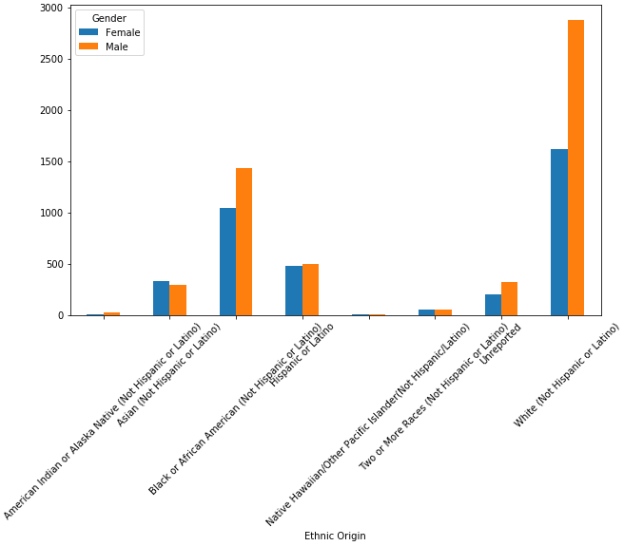

Figure. 8

The next analysis we did is based on gender and ethnic origin fields. We use the pivot table to get the distribution of gender for each ethnic group, store the result into a data frame, and then display the output (Figure 8). We can see that for two major ethnic origins, White and Black or African American, there are more male employees than female employees. For Asian and Hispanic or Latino, the number of male employees and female employees is overall balanced.

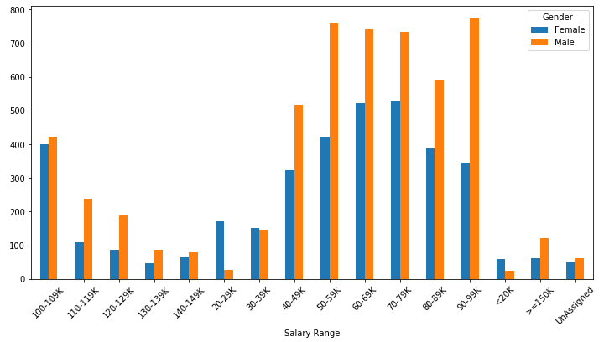

Figure. 9

Next, we follow the same approach to analyze the gender and salary range fields (Figure 9). We can see that for the majority of the salary range, the number of male employees is greater than the number of female employees. But for the salary range of 30-39K, 100-109K and 140-149K, the number of male and female employees are relatively balanced. For the salary range of 20-29K, the number of female employees is much greater than the number of male employees.

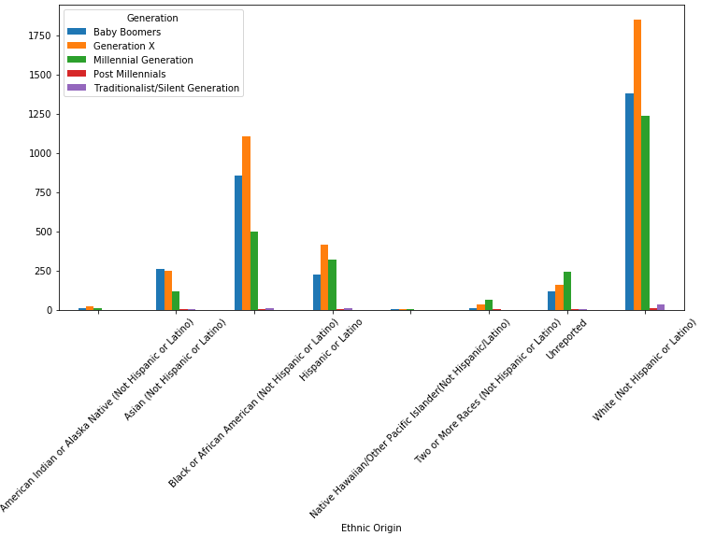

Figure. 10

We then use the pivot table to analyze the generation and ethnic origin fields and then plot the result data frame (Figure 10). For two major ethnic origins, White and Black or African American, most of the employees were born during Generation X, then followed by Baby Boomers. For Hispanic or Latino, most of the employees were born during Generation X, then followed by Millennials. For Asians, the number of employees that were born during Baby Boomers and Generation X is almost the same.

In addition, we want to separate our data into different categories and provide summary statistics on those categories. Therefore, we defined a function to separate all data into different categories based on the salary range field of the dataset. If an employee has a salary lower than 60K, the person will be classified as a "Low Salary" employee. If an employee has a salary between 60K and 110K, the person will be classified as a "Medium Salary" employee. Employees with a salary greater than 110K will be classified as "High Salary" employees. We then added a new column to the data frame for this income category field.

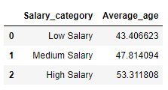

Figure. 11

The first analysis we did is to check the average age of employees in each salary category (Figure 11). Here the trend is clearer and more reasonable. Older employees tend to have a higher salary.

Next, we focused on the ethnic origin attribute. For each salary category, we would like to find out the most frequent ethnic origin of that category (Figure 12). Since we already have three sub data frames for three salary categories, simply counting the number of ethnic origin variables will provide us the desired output.

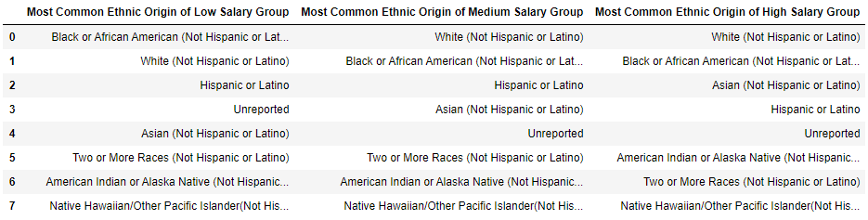

Figure. 12

We can see that there are some differences between different income categories. Black and African American employees are the most common one in the low salary group, while White employees are the most common one in the medium and high salary group. Employees of these two ethnic origins are the most common two in all salary groups due to the large amount of data points. The number of Asian employees rises up from low salary group to high salary group.

Based on the same logic, we then focused on the generation attribute. We want to find out the most frequent generational category of each income category (Figure 13).

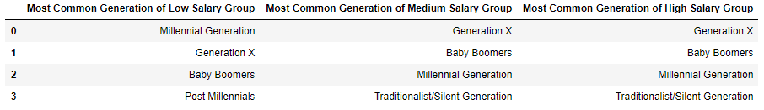

Figure. 13

The most common generational category for the low salary group is Millennials. For the medium and high salary group, the most common generational category is Generation X, and the Baby Boomers category is more common than the low salary group.

**Analysis of Second Dataset**

Next, we conducted some analysis on our supplement dataset. We were trying to combine these two datasets together since the datasets that we used are from the same source. But since the second dataset only contains general information of our original dataset and there is no specific information of the employee, such as gender and age. Therefore, we are not able to merge two datasets together. Instead, we just performed some analysis on these two datasets separately. Our secondary dataset contains position title, position class code, job grade, average of base salary for each position, and number of employees for each position.

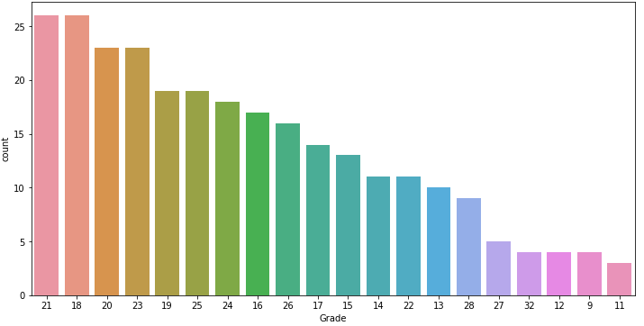

Figure. 14

We first checked the distribution of the job grade variable by using a plot (Figure 14). Based on our research, the higher the job grade value, the higher the position level. Based on the plot, we can see that the majority of the positions are in the medium level. The high level and low level positions only take a small proportion of the total position.

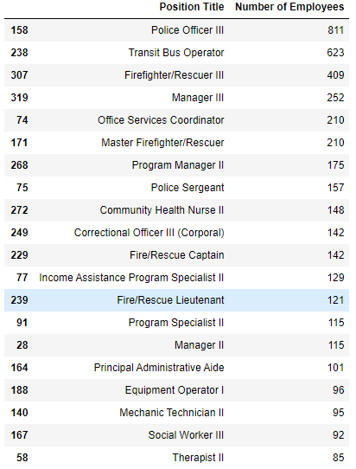

Figure. 15

Next, we want to find out the top 20 positions that have the largest number of employees. We just select the position title and number of employee columns from the dataframe and sort the data by number of employees (Figure 15). We can see that the police officer, bus operator and firefighter are the positions that have the largest number of employees. Some other positions, such as nurse and program manager, also have a large number of employees.

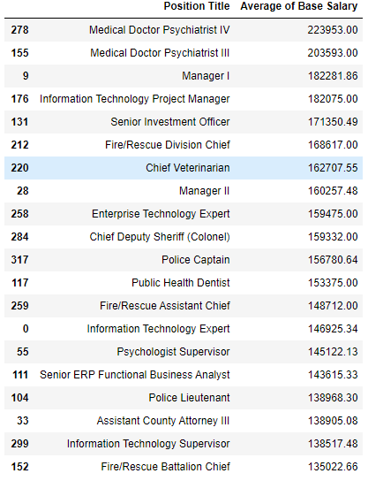

Figure. 16

Then, we want to find out the top 20 positions that have the highest average base salary. We just select the position title and average base salary columns from the dataframe and sort the data by average base salary (Figure 16). Without surprise, medical doctors and various managers have the highest average base salary. Some other positions like the senior investment officer, fire division chief, and chief veterinarian also have a high enough average base salary.

**Linear Regression**

In this part, we want to understand the relationship between each column in this data set through linear regression analysis, understand the characteristics of all employees by analyzing their personal information, and then understand all the factors affecting the salary level of employees through linear regression.

In order to achieve this goal, we will carry out the following steps: first, introduce the data, convert it into a format capable of data analysis, then classify each column, and finally introduce the regression equation to understand its correlation.

1. Import data:

We decided to use the json format of data, from the website https://data.montgomerycountymd.gov/api/views/bedm-7sqa/rows.json? AccessType=DOWNLOAD

imports JSON-formatted data to Jupyter and then decodes JSON-formatted data to Jupyter through Python JSON packages.

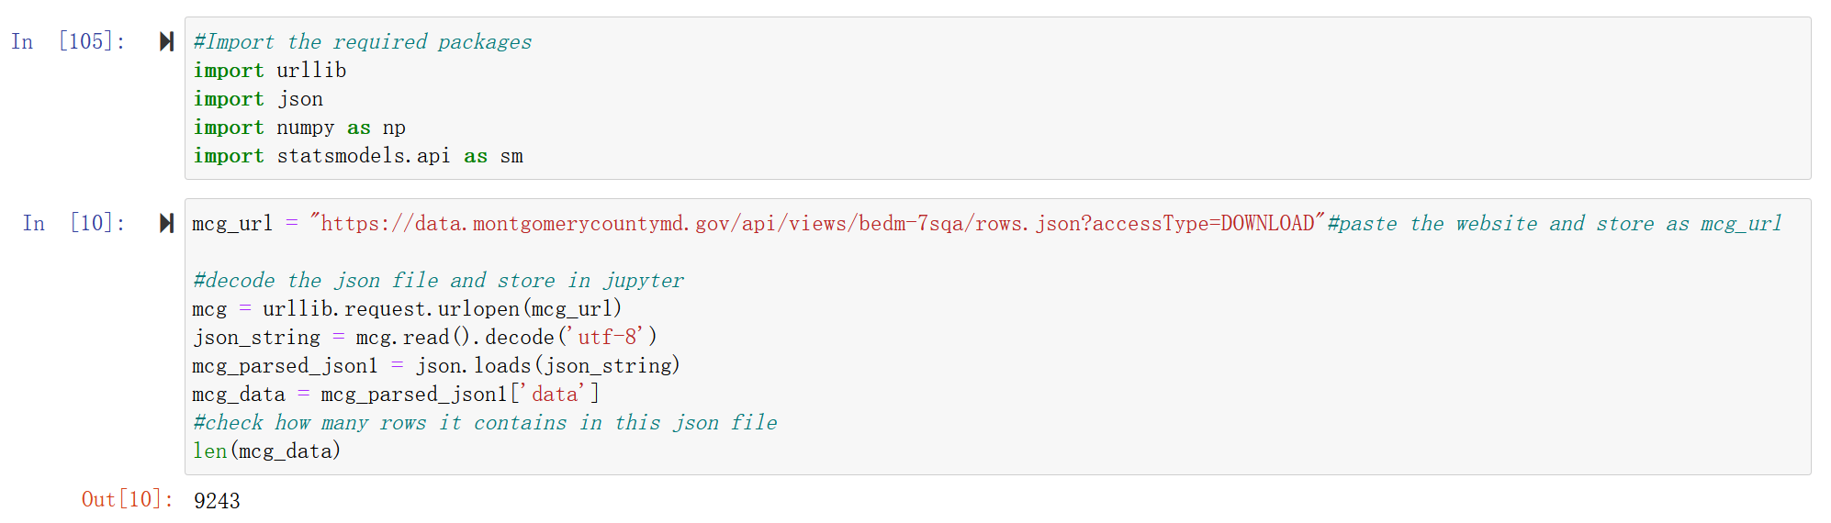

1. Transform data:

For the next step, we use the panda package to select nine useful columns from the JS-formatted data and convert them to panda Dataframe.

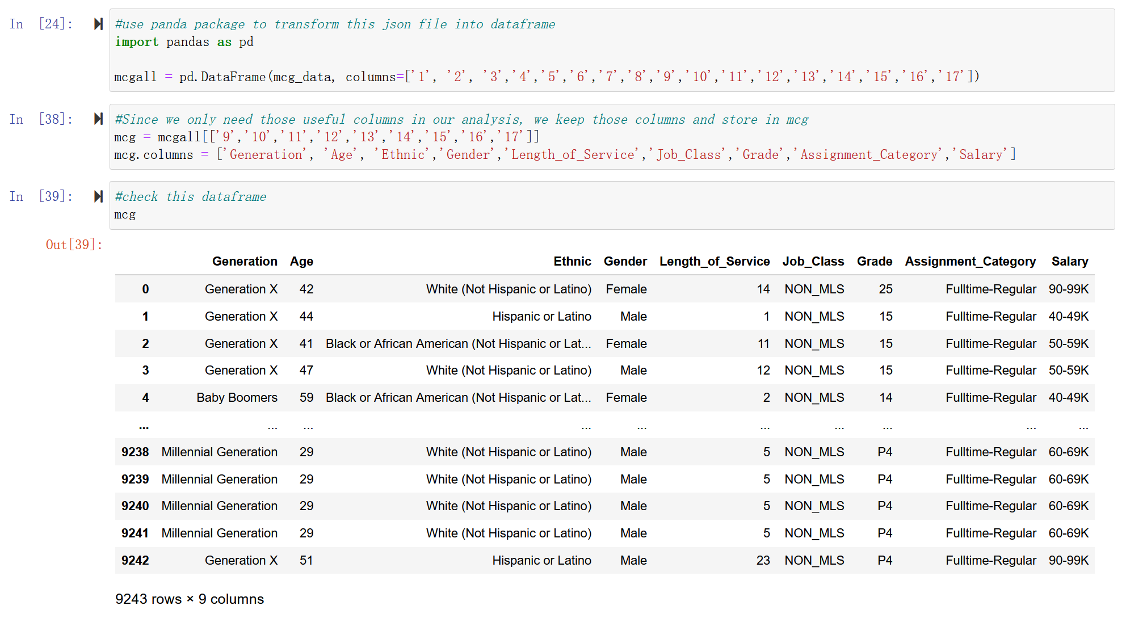

1. Create dummy variables:

In this dataset, we can easily notice that there are many columns that contains categorical variables, like ethnic and gender, in order to do the linear regression, we need to create dummy variables for those categorical variables:

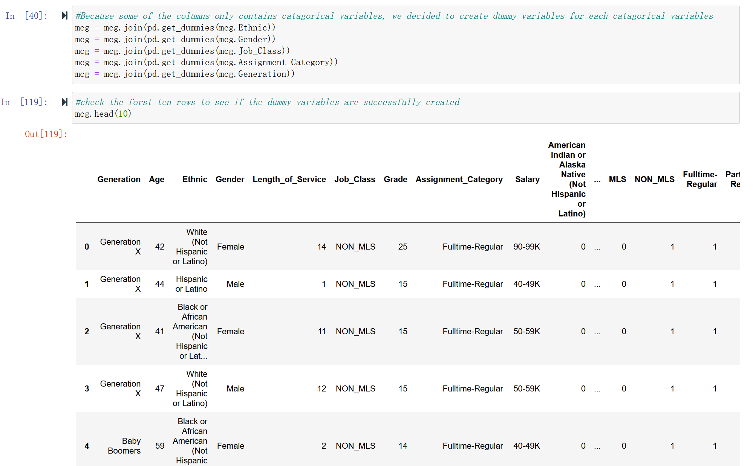

At the same time, when we check the column Grade, we can notice that this column has many variables that contain non-numeric variables, so we delete those variables and only use numerical variables.



1. Create dependent and independent variable:

For this step, we use the average salary instead of salary range, assign average salary for each range, then. We use all numeric variables columns and dummy variables as independent variables, and average salary as dependent variables, creating two new dataframe for further use.

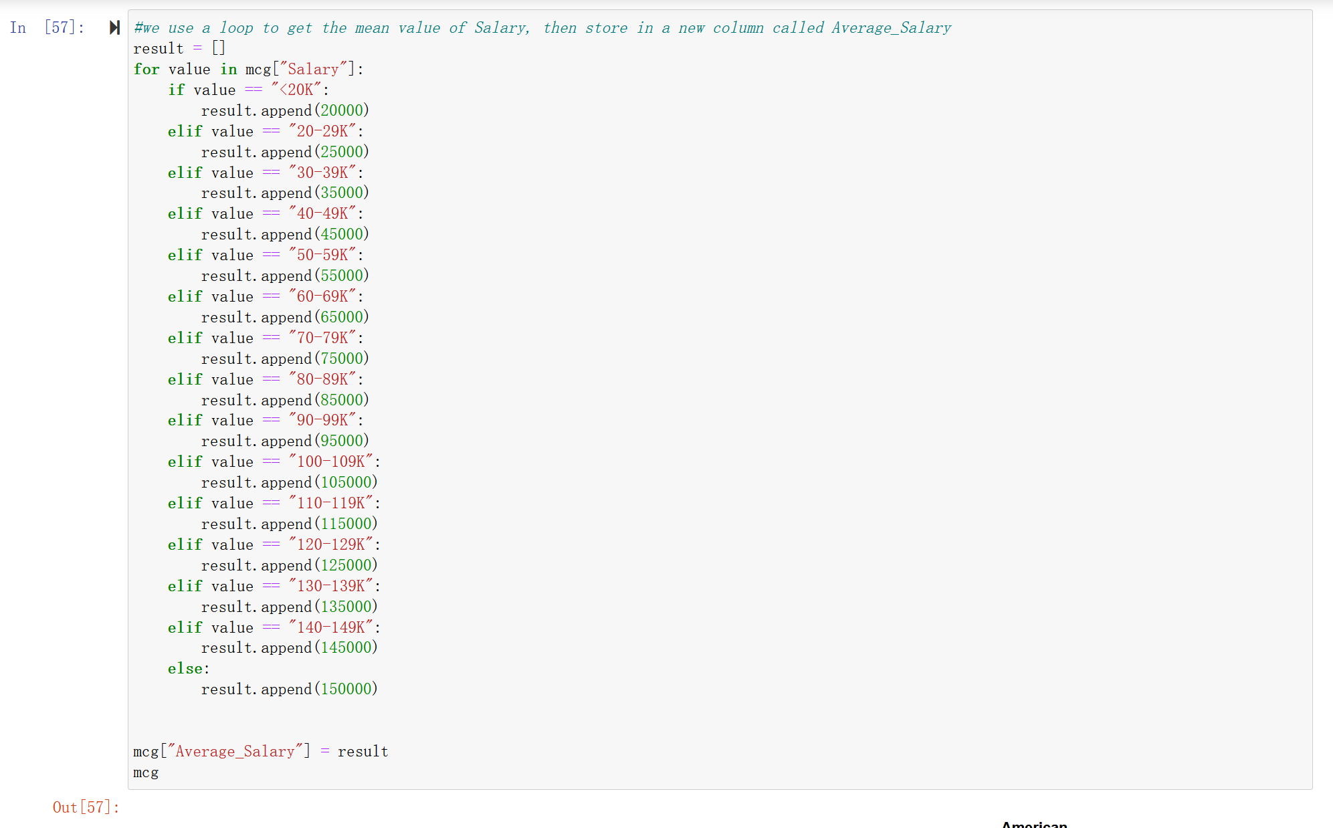

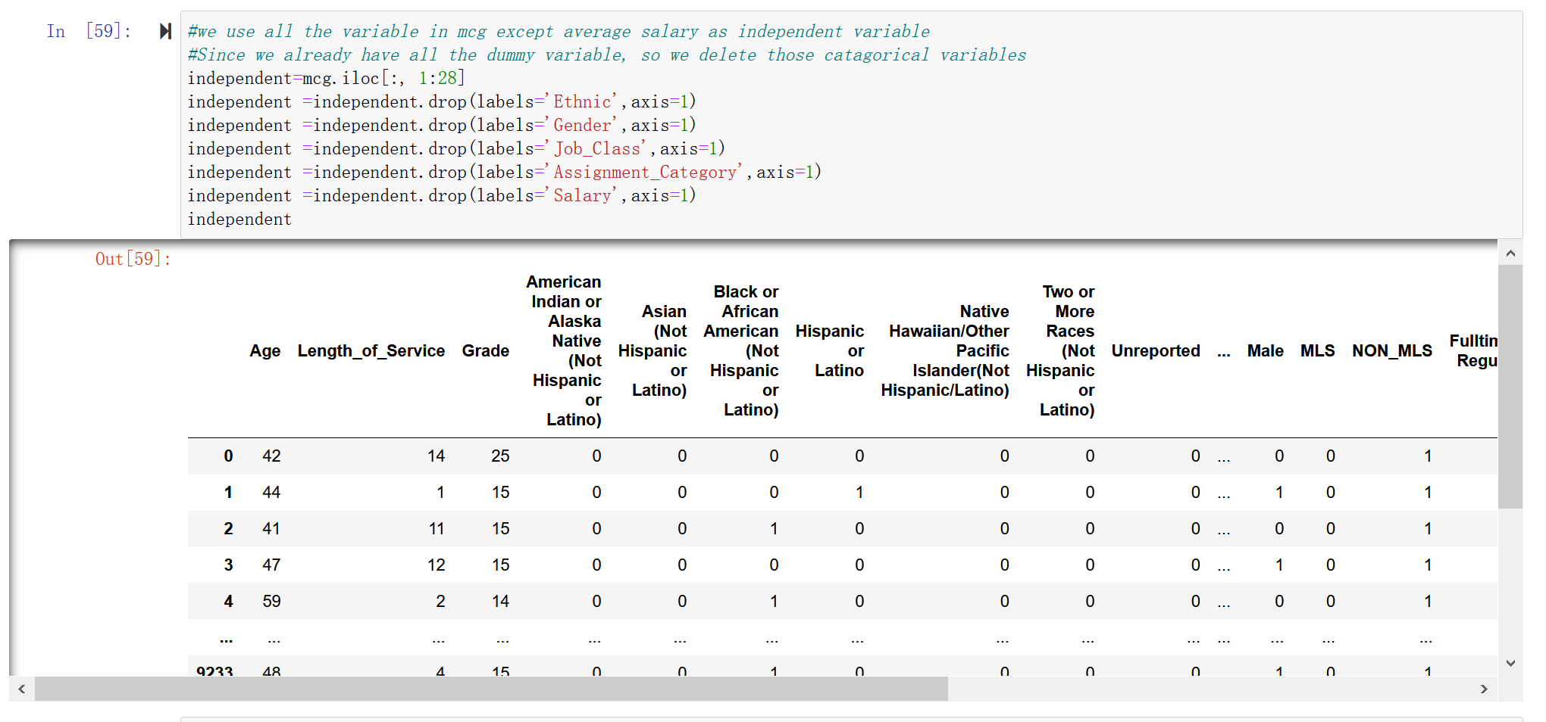

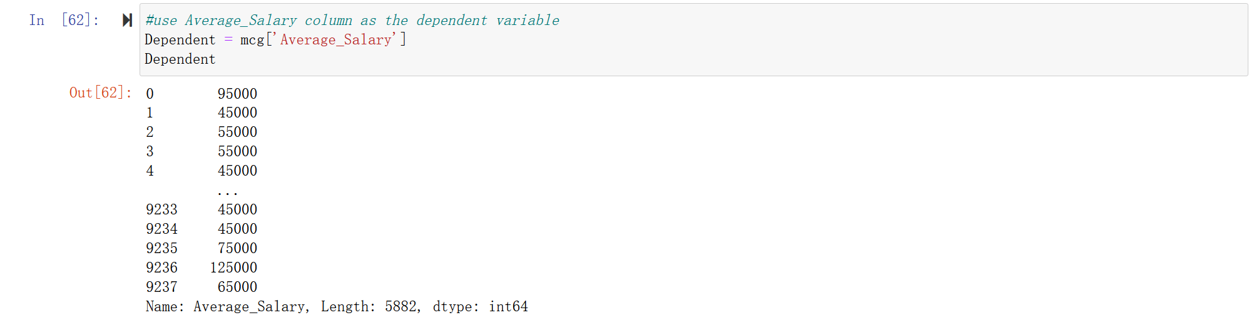

1. Create regression model:

In the last step, we apply those two dataframe into the regression model through sklearn.linear_model package, use all the numeric variables and dummy variables as independent variables, and average salary as dependent variables.

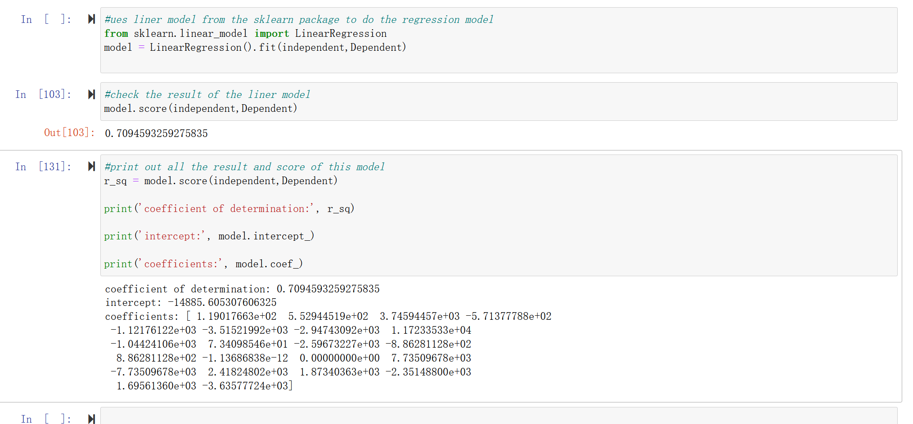

Through the linear regression analysis, we obtained a regression equation, and through the analysis of this equation, we obtained a score, namely 0.7094, which is relatively not very high, so this data set is actually not very suitable for the prediction by regression equation.

**Conclusion**

The goal and questions that we listed in our project proposal were all properly solved by our analysis work. We do get some insights of our dataset based on our analysis results. We also conducted the linear regression analysis on our dataset, but since the dataset contains many categorical variables, linear regression might not be an optimal choice. We finished this project by a group of two. About the work distribution, Sihan Yang did the works that related to the regression analysis and I did all the rest of the works, and we finished the report together. Our team collaborated well on this project.