# Stream

## 介绍

上回写到ReadableStreamDefaultController.内容[代码案例](API学习目录.docx)

## 接口目录

|  |  |
| --- | --- |
| 接口名称 | 目录链接 |
| ReadableStream | [文档](ReadableStream/index.docx) |
| ReadableStreamDefaultReader | 文档 |
| ReadableStreamDefaultController | 文档 |
| WritableStream | [文档](writableStream/index.docx) |
| WritableStreamDefaultWriter | [文档](writableStreamDefaultwriter/index.docx) |
| WritableStreamDefaultController | [文档](writableStreamDefaultController/index.docx) |
| TransformStream | [文档](TransformStream/index.docx) |
| TransformStreamDefaultController | [文档](TransformStreamDefaultController/index.docx) |
| ByteLengthQueuingStrategy | [文档](ByteLengthQueuingStrategy/index.docx) |
| CountQeuingStrategy | [文档](CountQueuingStrategy/index.docx) |
| ReadableStreamBYOBReader | [文档](ReadableStreamBYOBReader/index.docx) |
| ReadableByteStreamController | [文档](ReadableByteStreamController/index.docx) |
| ReadableStreamBYOBRequest | [文档](ReadableStreamBYOBRequest/index.docx) |

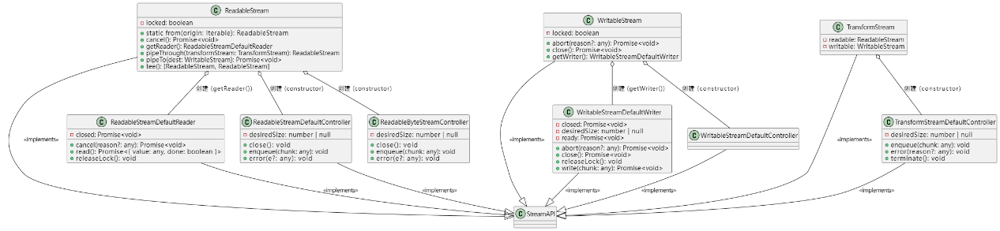

## 特殊用法

|  |  |
| --- | --- |
| 用法名称 | 目录链接 |
| ReadableStream特殊用法 | [链接](1%20异步迭代ReadableStream/index.docx) |
| request中流的用法 | [链接](0%20request中流的用法/index.docx) |
| ReadableStream解码 | [链接](2%20ReadableStream解码/index.docx) |
| 利用ReadableStreamDefaultReader读取字节流 | [链接](3%20利用ReadableStreamDefaultReader读取字节流/index.docx) |

## 注意事项

见诸多其他文件记录