**SOFTWARE QUALITY**

We defined software quality in our application as follows:

1. Maintainability

Our application is strongly object oriented. We separated GUI, action handler and background processing into different classes. It makes our application easy to maintain.

1. Extendibility

As a result of object oriented programming, our application is also extendable. Every programmer that wants to contribute in the GUI for example, can simply make use of the getter methods provided or request a new function from our ‘backend’ programmer.

1. Usability

Our application works very intuitively and easy to use.

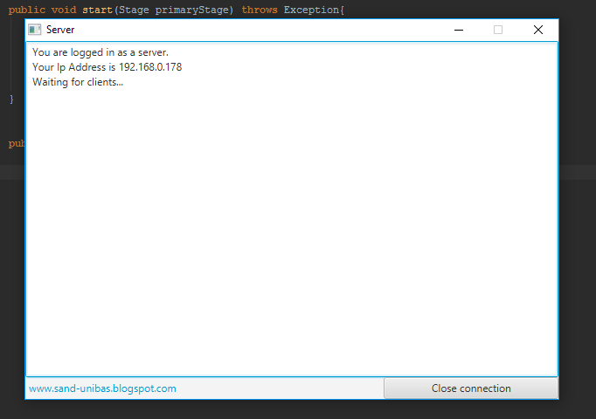

**QUALITY MANAGEMENT**

To ensure the quality standard of our application, we are using variety of tools that shipped with the Java programming language.

We wrapped any critical processes in try catch block and we provide them with suitable message using comments and System.out.println method.

In the future, we are going to integrate an open source logging tools from [www.slf4j.org](http://www.slf4j.org) to provide our application with better logging system to reach higher rate of maintainability.

We are also using external library such as JUnit to run some unit testing for functions considered critical.