Uebung 7, Aufgabe 5

*%Hauptprogramm Uebung 07 Aufgabe 5*

*[x, N] = adaptDivDiff(@(x) 1./(25\*x.^2+1), -1, 1, 127);*

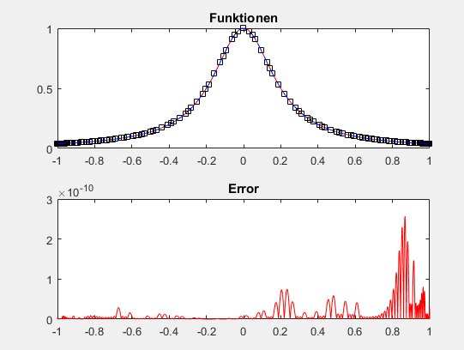

*--------------------------------------------------------------*

*function [x, N] = adaptDivDiff(f, a, b, n)*

*xp = linspace(a, b, 4097);*

*x = [a; b];*

*N = divDiff(x, f(x));*

*xi = 0.5\*(a+b);*

*fxi = f(xi);*

*pxi = hornerNewton(N, x, xi);*

*subplot(2, 1, 1)*

*plot(xp, f(xp), 'r-', x, f(x), 'ks', xp, hornerNewton(N, x, xp), 'b--');*

*title('Funktionen')*

*subplot(2, 1, 2)*

*plot(xp, abs(f(xp)-hornerNewton(N, x, xp)), 'r-');*

*title('Error')*

*pause(1);*

*for ii=2:n*

*[~, jj] = max(abs(fxi-pxi));*

*h = (xi(jj) - x(jj))/2;*

*[x, N] = addDivDiff(x, N, xi(jj), fxi(jj));*

*xi = [xi(jj)+h; xi(1:jj-1); xi(jj)-h; xi(jj+1:end)];*

*fxi = [f(xi(1)); fxi(1:jj-1); f(xi(jj+1)); fxi(jj+1:end)];*

*pxi = hornerNewton(N, x, xi);*

*subplot(2, 1, 1)*

*plot(xp, f(xp), 'r-', x, f(x), 'ks', xp, hornerNewton(N, x, xp), 'b--');*

*title('Funktionen')*

*subplot(2, 1, 2)*

*plot(xp, abs(f(xp)-hornerNewton(N, x, xp)), 'r-');*

*title('Error')*

*pause(0.1);*

*end*

*end*

*--------------------------------------------------------------*

*function[xe, Ne] = addDivDiff(x, N, xi, yi)*

*n = length(N);*

*Ne = zeros(n+1,1);*

*Ne(1) = yi;*

*xe = [xi;x];*

*for i = 1:n*

*Ne(i+1) = (N(i) - Ne(i)) ./ (x(i) - xi);*

*end*

*end*

--------------------------------------------------------------

function N = divDiff(x, y)

n = size(x,1);

N = y;

for i = 1:n-1

N(i+1:n) = (N(i+1:n)-N(i:n-1))./(x(i+1:n) - x(1:n-i));

end

end

*--------------------------------------------------------------*

*function p = hornerNewton(N, x, xi)*

*n = size(x,1);*

*p = N(n)\*ones(size(xi));*

*for i = n-1:-1:1*

*p = p.\*(xi-x(i))+ N(i);*

*end*

*end*