Nama : Syavira Rizki Ariani Cohort: BDSE-UIF-1222

You have been approached by a Car Dealership company XYZ Cars. As part of their new initiative, you are asked to set up a basic Angular application to which Angular components will be added. You are supposed to setup a Angular environment.

1. Setup NodeJs
2. Setup an Angular Project using Angular CLI
3. Run the Angular Project using ng serve –open
4. Provide the script to generate an Angular Component using Angular CLI
5. Generate an Angular Component called WelcomeComponent
6. Include the text “Welcome to XYZ Cars…” in the Component
7. Include the Component created as part of AppComponent
8. Create 2 Components
   1. One for displaying Cars On Sale
   2. Detail of a Car which is being clicked
9. Configure 2 Routes
10. Create a Custom Service to provide test Car Data with 3 fields, Make, Model, Year, Description & Car Photo & subscribe to the service
11. Include the 2 Components in the AppComponent
12. The final project should have a Welcome Screen, List of Cars Screen and Car Detail Screen

Provide screen capture & Sources

1. Setup NodeJs

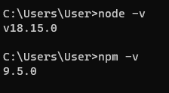

1. Setup an Angular Project using Angular CLI

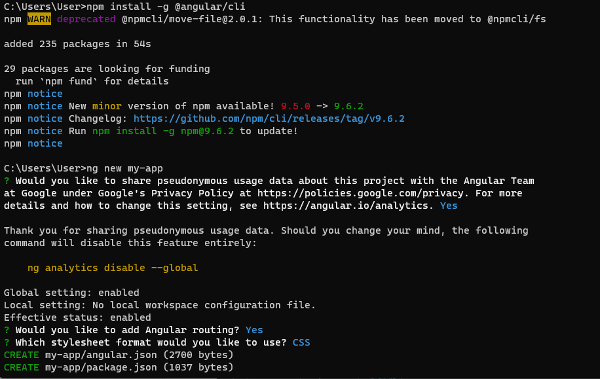

1. Run the Angular Project using ng serve –open

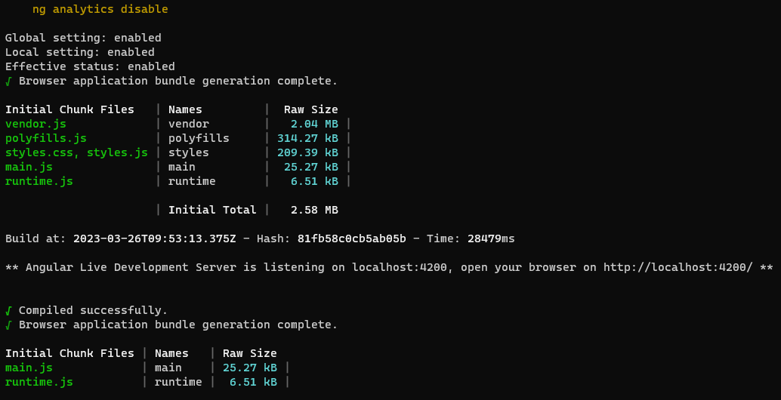

1. Provide the script to generate an Angular Component using Angular CLI

“ ng generate component nama-komponen --inline-style”

1. Generate an Angular Component called WelcomeComponent

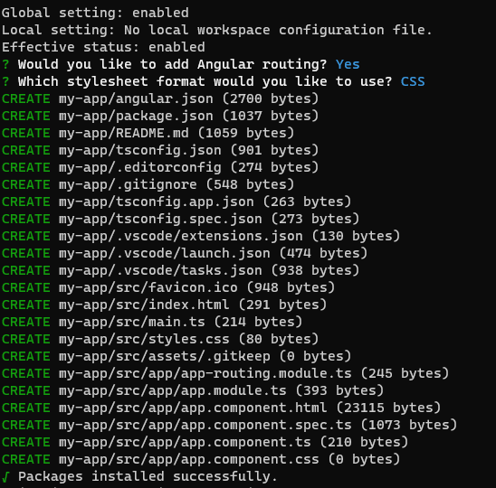

1. Include the text “Welcome to XYZ Cars…” in the Component

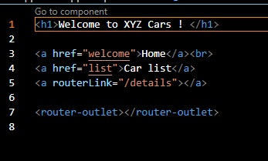

1. Include the Component created as part of AppComponent

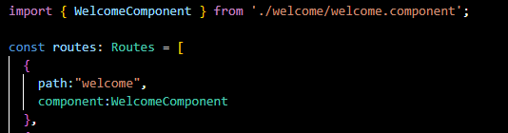

1. Create 2 Components
   1. One for displaying Cars On Sale

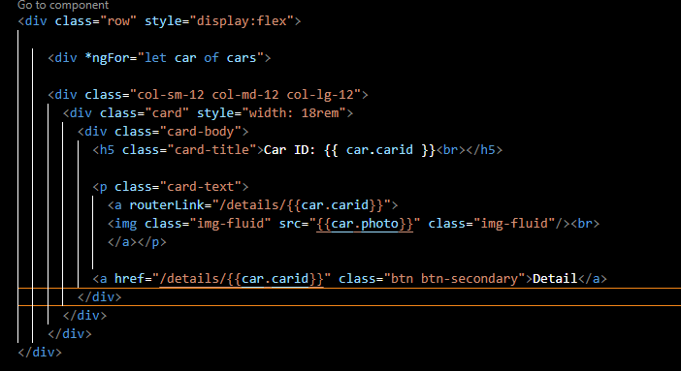

* 1. Detail of a Car which is being clicked

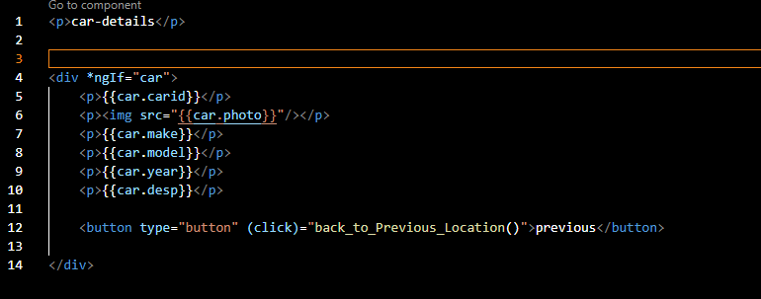

1. Configure 2 Routes

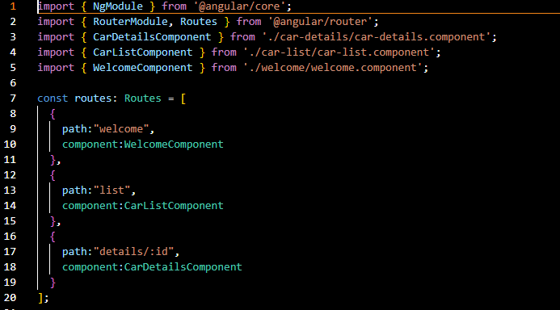

1. Create a Custom Service to provide test Car Data with 3 fields, Make, Model, Year, Description & Car Photo & subscribe to the service

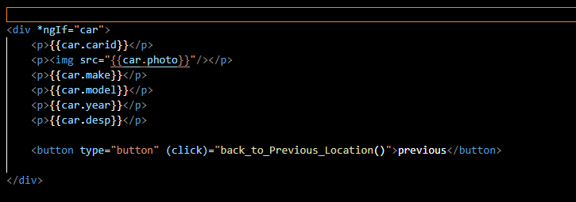

1. Include the 2 Components in the AppComponent

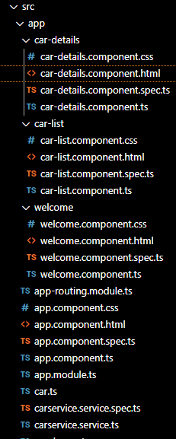

1. The final project should have a Welcome Screen, List of Cars Screen and Car Detail Screen

