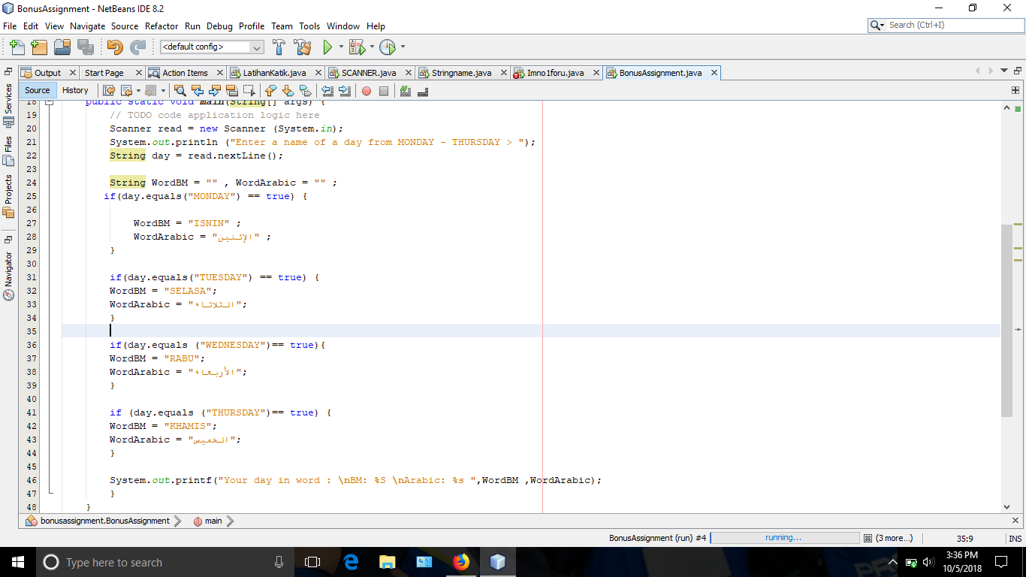

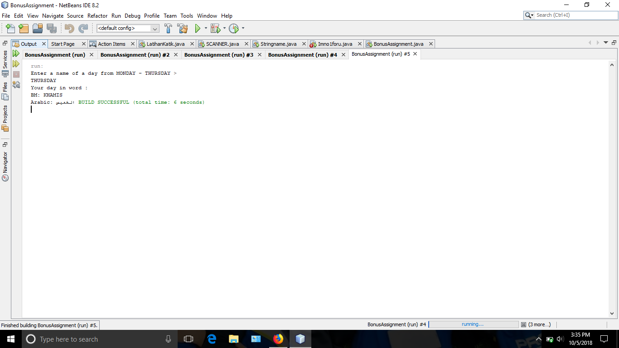

NAME : NURFARAHIN BINTI MOHAMAD ZAFIR (261361)

NAME: SYAZATUL NATRAH BINTI ABDUL RAHMAN (261318)