AGRO-932 HW1
Santos Barrera Lemus
02-20-2020

1. Establish a version-controlled directory system to host the project.
https://github.com/Sybalemus1/Agro932Hw1.git

2. Describe your simulation strategy and the hypothesis to test (positive, negative, or neutral selection).
Simulation strategy
I used the wgsim program to generate the NGS simulated data of two populations with ten individuals each one (I ran the program twice to generate the 20 individual). Then I download the reference genome (Zea_mays) using the wget program. The genome used was small with about 500k, 20x coverage, 100bp pair ends reads, only SNP no Indel, and a low mutation rate.

Hypothesis
To determine how different both simulated populations are is necessary to decide on the Fst values. Two scenarios, 1). If the Fst value is = 0, it indicated that there is not population differentiation, which means no evolution forces involved. 2) If the Fst value is = 1, it means completely differentiation (completely homozygous). If there are evolutionary forces involved in the population differentiation, we assume that for a negative selection, the Fst value is lower than balancing selection. If there is an increase of allele frequency over advantage alleles, which leads to the reduction of the variance, the Fst value will be more significant.
3. Use ANGSD to calculate thetas for each population and Fst between the two populations.
Distribution of site frequency spectrum of alleles (SFS)

Distribution of different theta values (pairwise, Waterson, singleton, H)

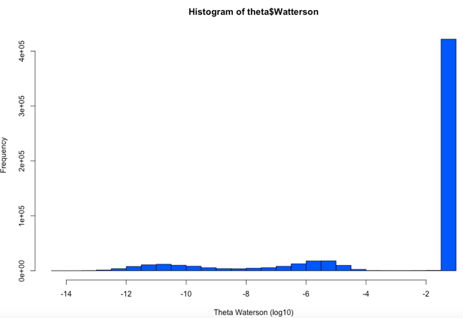
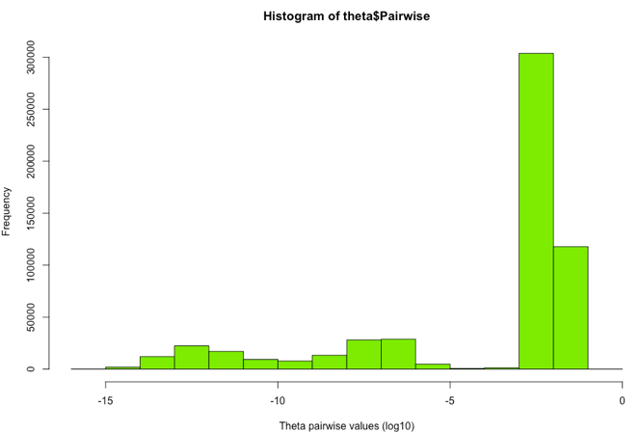

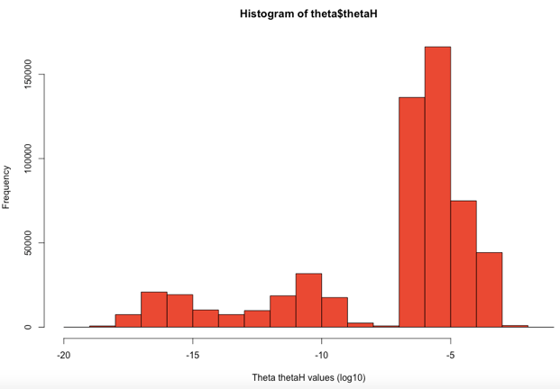
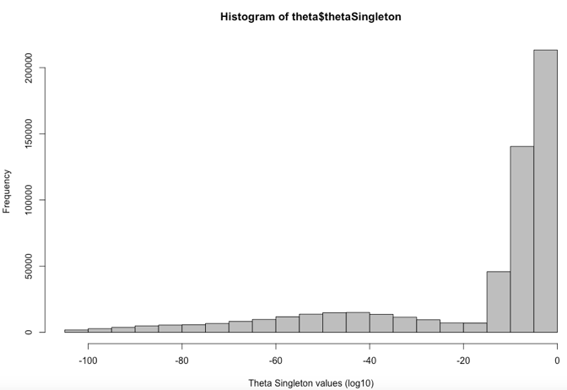

Scatter plot of the Fst values:
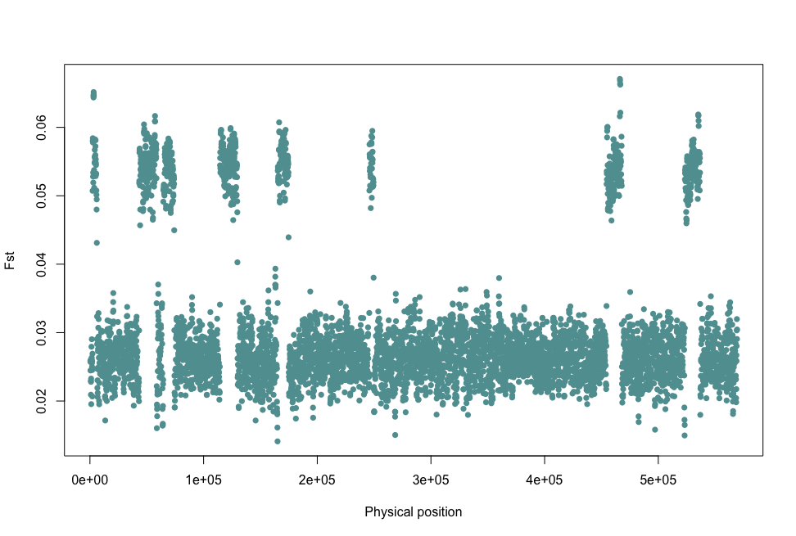

Fst values are too low (between 0.02 and 0.006) indicating that there is no population differentiation

4. Breakdown the theta ratios and Fst values into different genomic features (i.e., genic and intergenic regions) according to the general feature format (GFF) file for the reference genome of your choice.

FstRplot

FstRplot FstRplot

Even though the Fst values are too low (between 0.02 and 0.006) indicating that there is no population differentiation, we can see a slightly Fst difference in the genic region indicating a positive selection.

hw1
Santos Barrera
2/26/2020

NGS data simulation using wgsim

Type in the following command:
wgsim lambda.fa -e 0 -d 500 -N 5000 -1 100 -2 100 -r 0.01 -R 0 -X 0 -S 1234567 -h l1.read1.fq l1.read2.fq

Download Reference from EnsemblPlants
Maize reference genome

Change to largedata\lab4 folder:
cd largedata
mkdir Thetas_Fst
cd Thetas_Fst

Then use wget to download the reference genome:
wget ftp://ftp.ensemblgenomes.org/pub/plants/release-46/fasta/zea_mays/dna/Zea_mays.B73_RefGen_v4.dna.chromosome.Mt.fa.gz
### then unzip it
gunzip Zea_mays.B73_RefGen_v4.dna.chromosome.Mt.fa.gz

NGS data simulation using wgsim

Type in the following command:
wgsim Zea_mays.B73_RefGen_v4.dna.chromosome.Mt.fa \
-e 0 -d 500 -N 5000 -1 100 -2 100 -r 0.01 \
-R 0 -X 0 -S 1234567 l1.read1.fq l1.read2.fq
- Reference (about 500k)
  - Zea_mays.B73_RefGen_v4.dna.chromosome.Mt.fa
- 20x coverage
  - N 5000
- PE 100bp
  - -1 100 -2 100
- Only SNP no Indel
  - -R 0 -X 0
- Mutation rate is low
  - -r 0.01

NGS data simulation using wgsim

simulate 10 individals population 1
for i in {1..10}; do wgsim Zea_mays.B73_RefGen_v4.dna.chromosome.Mt.fa -e 0 -d 500 -N 50000 -1 100 -2 100 -r 0.1 -R 0 -X 0 p1l$i.read1.fq l$i.read2.fq; done
mv l1.read1.fq p1l1.read1.fq #(Change name pop 1. all 10 idividuals)

simulate 10 individals population 2
–
for i in {1..10}; do wgsim Zea_mays.B73_RefGen_v4.dna.chromosome.Mt.fa -e 0 -d 500 -N 50000 -1 100 -2 100 -r 0.1 -R 0 -X 0 l$i.read1.fq l$i.read2.fq; done
mv l1.read1.fq p2l1.read1.fq #(Change name pop 2. all 10 idividuals)
#### check how many reads
bash wc -l p1l1.read1.fq wc -l p2l1.read1.fq # suppose to be 200,000 lines = 50,000 reads

A procedure to calculate $θ$ and $F_{ST}$ values

1. Align the NGS reads to the reference genome
- bwa
- samtools

2. Calculate SFS
- ANGSD

3. Calculate the thetas and Fst for each site
- ANGSD

Submit a Slurm job (I couldn’t do it)
- We wrap our jobs in little batch scripts, which is nice because these also help make steps reproducible.
- To keep your directory organized, I usually keep a scripts directory (i.e., slurm-script/ ) and log dir (i.e., slurm-log ) for Slurm’s logs.
  - Tip: use these logs, as these are very helpful in debugging. I separate them from my project because they fill up directories rather quickly.
- D sets your project directory.
- o sets where standard output (of your batch script) goes.
- e sets where standard error (of your batch script) goes.
- J sets the job name.
- t sets the time limit for the job, 24:00:00 indicates 24 hours.
- --mail: will email you if the job is “END” or “FAIL”
–
vi my_theta.sh
#!/bin/bash -l
#SBATCH -D /home/agro932/sybarreral/Agro932hw
#SBATCH -o /home/agro932/sybarreral/Agro932hw/slurm-log/stdout-%j.txt
#SBATCH -e /home/agro932/sybarreral/Agro932hw/slurm-log/stderr-%j.txt
#SBATCH -J theta
#SBATCH -t 1:00:00
#SBATCH --mail-user=sybarreral@huskers.unl.edu
#SBATCH --mail-type=END #email if ends
#SBATCH --mail-type=FAIL #email if fails
set -e
set -u
# insert your script here
module load bwa samtools
# alignment pop.1
cd largedata/Thetas_Fst/bam_files
for i in {1..10}; do bwa mem Zea_mays.B73_RefGen_v4.dna.chromosome.Mt.fa p1l$i.read1.fq p1l$i.read2.fq | samtools view -bSh - > p1l$i.bam; done
# alignment pop.2
for i in {1..10}; do bwa mem Zea_mays.B73_RefGen_v4.dna.chromosome.Mt.fa p2l$i.read1.fq p2l$i.read2.fq | samtools view -bSh - > p2l$i.bam; done
# sort
for i in *.bam; do samtools sort $i -o sorted_$i; done
# index them
for i in sorted*.bam; do samtools index $i; done

A procedure to calculate $θ$ values

2. Calculate SFS using ANGSD

Install ANGSD first
cd ~/bin/ # if you don't have one, do `mkdir bin`
git clone https://github.com/samtools/htslib.git
git clone https://github.com/ANGSD/angsd.git
cd htslib; make;
cd ../angsd;
make HTSSRC=../htslib

run angsd
#write the bam files to a txt file
mkdir bam_files
mv sorted*.bam bam_files
cd bam_files/
ls sorted_p1*.bam > bam.txt
#see file 1
cat bam_p1.txt
ls sorted_p2*.bam > bam.txt
#see file 2
cat bam_p2.txt

A procedure to calculate $θ$ values
#calculate Sfs
../../../../angsd/angsd -bam bam.txt -doSaf 1 -anc ../Zea_mays.B73_RefGen_v4.dna.chromosome.Mt.fa -GL 1 -out out
# use realSFS to calculate sfs
../../../../angsd/misc/realSFS out.saf.idx > out.sfs

Copy the result to cache/ folder
## cp sfs to the cache/ folder
cp out.sfs ../../../cache/

3. Calculate the thetas for each site
The output from the above command are two files out.thetas.gz and out.thetas.idx. A formal description of these files can be found in the doc/formats.pdf in the angsd package. It is possible to extract the logscale persite thetas using the ./thetaStat print program.
../../../../angsd/angsd -bam bam.txt -out out -doThetas 1 -doSaf 1 -pest out.sfs -anc ../Zea_mays.B73_RefGen_v4.dna.chromosome.Mt.fa -GL 1
../../../../angsd/misc/thetaStat print out.thetas.idx > theta.txt
## cp theta to the cache/ folder
cp theta.txt ../../../cache/

A procedure to calculate $F_{ST}$

Create two list bam files
cp bam_p1.txt pop1.txt
cp bam_p2.txt pop2.txt

Two population Fst
# first calculate per pop saf for each populatoin
../../../../angsd/angsd -b pop1.txt -anc ../Zea_mays.B73_RefGen_v4.dna.chromosome.Mt.fa -out pop1 -dosaf 1 -gl 1
../../../../angsd/angsd -b pop2.txt -anc ../Zea_mays.B73_RefGen_v4.dna.chromosome.Mt.fa -out pop2 -dosaf 1 -gl 1
# calculate the 2dsfs prior
../../../../angsd/misc/realSFS pop1.saf.idx pop2.saf.idx > pop1.pop2.ml
# prepare the fst for easy window analysis etc
../../../../angsd/misc/realSFS fst index pop1.saf.idx pop2.saf.idx -sfs pop1.pop2.ml -fstout out
# get the global estimate
../../../../angsd/misc/realSFS fst stats out.fst.idx
# below is not tested that much, but seems to work
../../../../angsd/misc/realSFS fst stats2 out.fst.idx -win 500 -step 100 > fst_win.txt

Copy the result to cache/ folder
## cp sfs to the cache/ folder
cp fst_win.txt ../../../cache/

Visualize the results
In local computer, using R:

Barplot for SFS
#Barplot for SFS
sfs <- scan('cache/out.sfs')
sfs <- sfs[-c(1,length(sfs))]
sfs <- sfs/sum(sfs)
barplot(sfs,names=1:length(sfs), main='SFS')
barplot(sfs, col="#cdc0b0", xlab="No. of segregating sites",
ylab="Minor allele frequency",
names=1:length(sfs))

Histgram distribution of the theta values
library("data.table")
#Histgram distribution of the theta values
#theta <- read.table("cache/theta.txt", header=TRUE)
theta <- fread("cache/theta.txt", data.table =FALSE)
hist(theta$Pairwise)
hist(theta$Pairwise, col="green", xlab="Theta pairwise values (log10)") hist(theta$Waterson, col="blue", xlab="Theta Waterson values (log10)")
hist(theta$thetaSingleton, col="grey", xlab="Theta thetaSingleton values (log10)")
hist(theta$thetaH, col="red", xlab="Theta thetaH values (log10)")

Scatter plot of the Fst values
#Scatter plot of the Fst values
fst <- read.table("cache/fst_win.txt", skip=1, header=FALSE)
names(fst)[c(3,5)] <- c("midp", "fst")
plot(fst$midp, fst$fst, xlab="Physical position", ylab="Fst", col="#5f9ea0", pch=16)

General feature format (GFF) from EnsemblPlants
Maize reference genome
change to largedata\lab4 folder:
wget ftp://ftp.ensemblgenomes.org/pub/plants/release-46/fasta/zea_mays/dna/Zea_mays.B73_RefGen_v4.dna.chromosome.Mt.fa.gz
### then unzip it
gunzip Zea_mays.B73_RefGen_v4.dna.chromosome.Mt.fa.gz
Similarly, we will download and unzip the Mt GFF3 file
–

Use R to process the GFF3 file
# install.package("data.table")
library("data.table")
## simply read in wouldn't work
gff <- fread("largedata/Zea_mays.B73_RefGen_v4.46.chromosome.Mt.gff3", skip="#", header=FALSE, data.table=FALSE)
## grep -v means select lines that not matching any of the specified patterns
gff <- fread(cmd='grep -v "#" largedata/Zea_mays.B73_RefGen_v4.46.chromosome.Mt.gff3', header=FALSE, data.table=FALSE)

General feature format (GFF) version 3
V1 V2 V3 V4 V5 V6 V7 V8
1 Mt Gramene chromosome 1 569630 . . .
2 Mt ensembl gene 6391 6738 . + .
3 Mt NCBI mRNA 6391 6738 . + .
4 Mt NCBI exon 6391 6738 . + .
5 Mt NCBI CDS 6391 6738 . + 0
6 Mt ensembl gene 6951 8285 . + .
V9
1 ID=chromosome:Mt;Alias=AY506529.1,NC_007982.1;Is_circular=true
2 ID=gene:ZeamMp002;biotype=protein_coding;description=orf115-a1;
3 ID=transcript:ZeamMp002;Parent=gene:ZeamMp002;
4 Parent=transcript:ZeamMp002;Name=ZeamMp002.exon1;constitutive=1;ensembl_end_phase=0;
5 ID=CDS:ZeamMp002;Parent=transcript:ZeamMp002;
6 ID=gene:ZeamMp003;biotype=protein_coding;description=orf444

Work with GFF
names(gff) <- c("seq", "source", "feature", "start", "end", "score", "strand", "phase", "att")
table(gff$feature)

Get genes and upstream and downstream 5kb regions
g <- subset(gff, feature %in% "gene")
g$geneid <- gsub(".*gene:|;biotype.*", "", g$att)
### + strand
gp <- subset(g, strand %in% "+")
# nrow(gp) 75
### get the 5k upstream of the + strand gene model
gp_up <- gp
gp_up$end <- gp_up$start - 1
gp_up$start <- gp_up$end - 5000
### get the 5k downstream of the + strand gene model
gp_down <- gp
gp_down$start <- gp_down$end + 1
gp_down$end <- gp_down$start + 5000

Get genes and upstream and downstream 5kb regions
### - strand
gm <- subset(g, strand %in% "-")
dim(gm) # 82
fwrite(g, "cache/mt_gene.txt", sep="\t", row.names = FALSE, quote=FALSE)

Intepret the theta results
library("data.table")
library("GenomicRanges")
library("plyr")
theta <- fread("cache/theta.txt", data.table=FALSE)
names(theta)[1] <- "seq"
up5k <- read.table("cache/mt_gene_up5k.txt", header=TRUE)
### define the subject file for theta values
grc <- with(theta, GRanges(seqnames=seq, IRanges(start=Pos, end=Pos)))
### define the query file for genomic feature
grf <- with(up5k, GRanges(seqnames=seq, IRanges(start=start, end=end), geneid=geneid))
### find overlaps between the two
tb <- findOverlaps(query=grf, subject=grc)
tb <- as.matrix(tb)
out1 <- as.data.frame(grf[tb[,1]])
out2 <- as.data.frame(grc[tb[,2]])
### for each genomic feature, find the sites with non-missing data
out <- cbind(out1, out2[, "start"])
names(out)[ncol(out)] <- "pos"

Intepret the theta results
#define unique identifier and merge with the thetas
out$uid <- paste(out$seqnames, out$pos, sep="_")
theta$uid <- paste(theta$seq, theta$Pos, sep="_")
df <- merge(out, theta[, c(-1, -2)], by="uid")
# for each upstream 5k region, how many theta values
mx <- ddply(df, .(geneid), summarise,
Pairwise = mean(Pairwise, na.rm=TRUE),
thetaH = mean(thetaH, na.rm=TRUE),
nsites = length(uid))

Intepret the theta results
Copy and paste everything above, and pack it into an R function:
get_mean_theta <- function(gf_file="cache/mt_gene_up5k.txt"){
# gf_file: gene feature file [chr, ="cache/mt_gene_up5k.txt"]
theta <- fread("cache/theta.txt", data.table=FALSE)
names(theta)[1] <- "seq"
up5k <- read.table(gf_file, header=TRUE)
### define the subject file for theta values
grc <- with(theta, GRanges(seqnames=seq, IRanges(start=Pos, end=Pos)))
### define the query file for genomic feature
grf <- with(up5k, GRanges(seqnames=seq, IRanges(start=start, end=end), geneid=geneid))
### find overlaps between the two
tb <- findOverlaps(query=grf, subject=grc)
tb <- as.matrix(tb)
out1 <- as.data.frame(grf[tb[,1]])
out2 <- as.data.frame(grc[tb[,2]])
### for each genomic feature, find the sites with non-missing data
out <- cbind(out1, out2[, "start"])
names(out)[ncol(out)] <- "pos"
#define unique identifier and merge with the thetas
out$uid <- paste(out$seqnames, out$pos, sep="_")
theta$uid <- paste(theta$seq, theta$Pos, sep="_")
df <- merge(out, theta[, c(-1, -2)], by="uid")
# for each upstream 5k region, how many theta values
mx <- ddply(df, .(geneid), summarise,
Pairwise = mean(Pairwise, na.rm=TRUE),
thetaH = mean(thetaH, na.rm=TRUE),
nsites = length(uid))
return(mx)
}

Plot the results
Run the customized R function
### apply the function
up5k <- get_mean_theta(gf_file="cache/mt_gene_up5k.txt")
down5k <- get_mean_theta(gf_file="cache/mt_gene_down5k.txt")
gene <- get_mean_theta(gf_file="cache/mt_gene.txt")
And then plot the results:
library("ggplot2")
up5k$feature <- "up 5k"
down5k$feature <- "down 5k"
gene$feature <- "genic"
res <- rbind(up5k, down5k)
res_nongenic <- res
res_nongenic$feature <- "intergenic"
res_t <- rbind(res, gene, res_nongenic)
ggplot(res_t, aes(x=feature, y=Pairwise, fill=feature)) +
geom_violin(trim=FALSE)+
labs(title="Theta value", x="", y = "Log10 (theta)")+
geom_boxplot(width=0.1, fill="white")+
scale_fill_brewer(palette="Blues") +
theme_classic()

Intepret the Fst results
get_mean_Fst <- function(gf_file="cache/mt_gene_up5k.txt"){
# gf_file: gene feature file [chr, ="cache/mt_gene_up5k.txt"]
fst <- fread("cache/fst_win.txt", data.table=FALSE)
names(fst)[2] <- "seq"
up5k <- read.table(gf_file, header=TRUE)
### define the subject file for Fst values
grc_f <- with(fst, GRanges(seqnames=seq, IRanges(start=chr, end=chr)))
### define the query file for genomic feature
grf <- with(up5k, GRanges(seqnames=seq, IRanges(start=start, end=end), geneid=geneid))
### find overlaps between the two
tb_f <- findOverlaps(query=grf, subject=grc_f)
tb_f <- as.matrix(tb_f)
out1_f <- as.data.frame(grf[tb_f[,1]])
out2_f <- as.data.frame(grc[tb_f[,2]])
### for each genomic feature, find the sites with non-missing data
out_f <- cbind(out1_f, out2_f[, "start"])
names(out_f)[ncol(out_f)] <- "pos"
#define unique identifier and merge with the Fst
out_f$uid <- paste(out_f$seqnames, out_f$pos, sep="_")
fst$uid <- paste(fst$seq, fst$chr, sep="_")
df_f <- merge(out_f, fst[, c(-1, -2, -3, -4)], by="uid")
# for each upstream 5k region, how many Fst values
names(df_f)[ncol(df_f)] <- "fst"
mx_f <- ddply(df_f, .(geneid), summarise,
Fst = mean(fst, na.rm=TRUE),
nsites = length(uid))
return(mx_f)
}

Plot the results
Run the customized R function
### apply the function
up5k_f <- get_mean_Fst(gf_file="cache/mt_gene_up5k.txt")
down5k_f <- get_mean_Fst(gf_file="cache/mt_gene_down5k.txt")
gene_f <- get_mean_Fst(gf_file="cache/mt_gene.txt")
And then plot the results:
library("ggplot2")
up5k_f$feature <- "up 5k"
down5k_f$feature <- "down 5k"
gene_f$feature <- "genic"
res_f <- rbind(up5k_f, down5k_f)
res_nongenic_f <- res_f
res_nongenic_f$feature <- "intergenic"
res_t_f <- rbind(res_f, gene_f, res_nongenic_f)
ggplot(res_t_f, aes(x=feature, y=Fst, fill=feature)) +
geom_violin(trim=FALSE)+
labs(title="Fst distribution", x="", y = "Fst")+
geom_boxplot(width=0.1, fill="white")+
scale_fill_brewer(palette="greens") +
theme_classic()

