**Internet Client Engineering CSE2ICE**

**Subject Lecturer: Luiz Oliveira**

**Subject Coordinator: Dr. Scott Mann**

**Assignment:**

**Design & Planning Report**

**Week 6 & Week 12 Time: Week 6 to Week 12**

**2part Web Development Assignment**

**Group member:**

**Student Name: (Xiaopeng Li)(Ruolin Xie)(Yu Bai)**

**Student Number:(18386537)(18827929)( 19191221)**

**Development purpose for:**

We are developed a football website named as “football website”, the main purpose is to proving competition information for football fans to visitor and look current league tables of their favorite team, performances, results.

|  |  |
| --- | --- |
| **User Story** | **Mandatory** |
| **As a fan, I want to check out the current league table** | **Mandatory** |
| **As a fan, I want to see the result of the last game my team played** | **Mandatory** |
| **As a fan, I want to see the performance of my team over the last 5 games** | **Mandatory** |
| **As a fan, I want to see all the games and results so far this season for my team** | **Mandatory** |
| **As a fan, I want to see the head-to-head results between my team and my team’s rival this season** | **Mandatory** |
| **As a fan I want to see my team score** | **Option** |
| **As a fan I want to see my team matches** | **Option** |
| **As a fan I want to see my team competitor** | **Option** |

**Main User Stories:**

**Optional User Stories:**

|  |  |
| --- | --- |
| **User Story** | **Additional** |
| **See today's matches of my subscribed competitions** | **Optional** |
| **See today's matches of my subscribed competitions** | **Optional** |
| **See all upcoming matches for Real Madrid** | **Optional** |

**Competitor website analysis:**

During this report, our group review two football websites, they are One football: it covers over 100 international football leagues and competitions live and in incomparable detail, and ESPN: the Real-time Soccer Game scores.

This report will include critical analysis of their interface with the positive and negative design and function of those two websites.

**The purposes of sites:**

Both of the website gives a clear view for the visitor visiting their website to view the information about football or another sports leagues information. The website also provides every sports team and player information at all leagues.

**Navigation:**

First at all, both of the website has a clear navigation in homepage. It includes the main menu, secondary menu, secondary menu and footer menu. They both set up the inline link for every match of the league in a day. It will also show more details information of the match and related link for the user.

**similarity grouping:**

In this section, both of them had a very similar design such as both websites put their match information in the middle of the webpage where users could see the score immediately and display those scores clearly as the form of a list.

**Symmetry:**

The layout of espn.com can clearly display the various parts and divide the different parts into different modules. There are 10 sections in the main menu, each of which has a different purpose, allowing users to quickly find the information they want in different ways. The symmetry of espn.com is better than data-ui.football-data.org. The latter's main menu is relatively simple, and it is more difficult to find the information users want.

**Economy of styles:**

In terms of economic style, espn.com does a great job in simple web layouts and a variety of different display sections, making it easy for users to use the site. In addition, this site covers mainstream sports events such as NBA, MLB and Golf. Each event has a separate web page where people can query sports messages according to their preferences. This makes the site attractive to more sports audiences.

**Proportion**

Both sites have a good ratio and clearly show important information. The main information accounts for a large proportion and can attract the attention of users. Espn.com displays the main information in the middle and displays other news and different teams on both sides, which allows users to access different aspects of the information while reading. Data-ui.football-data.org also puts the main information in the middle, but there is no other information on either side, which allows more space in the middle to make the main information more detailed.

**Home Screen:**

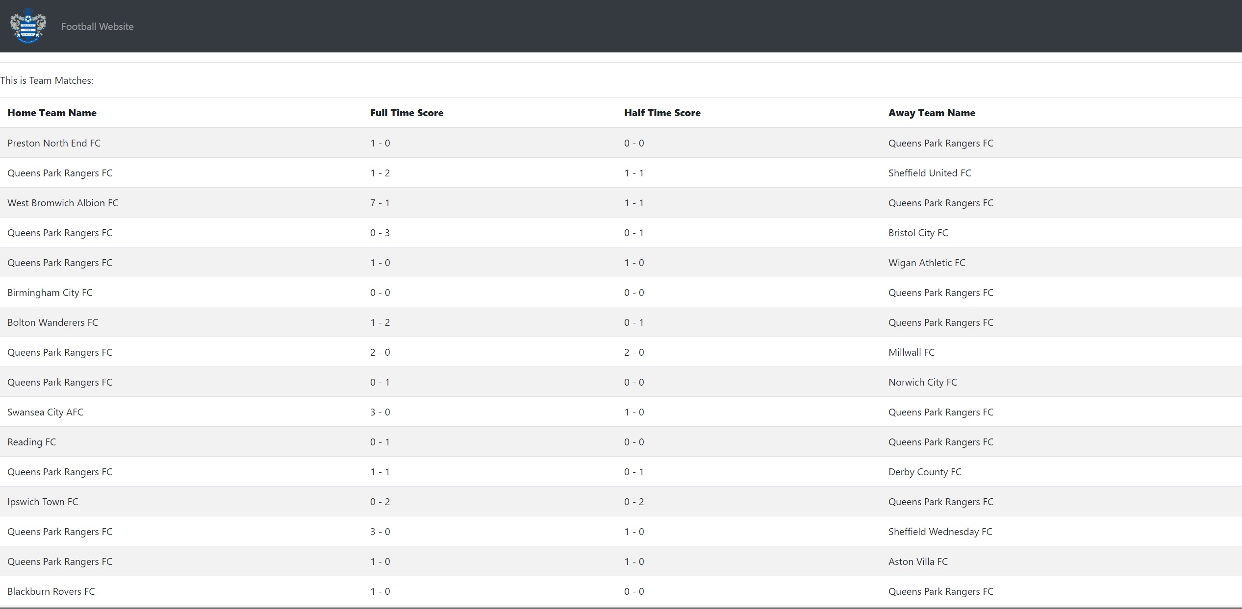

Overall League Screen(Competition Score Screen)

The main of the league screen contains the league table.

**Team Score and match Screen:**

The team Screen will show specific team details (Newest matches and score)

**UI Wireframe:**

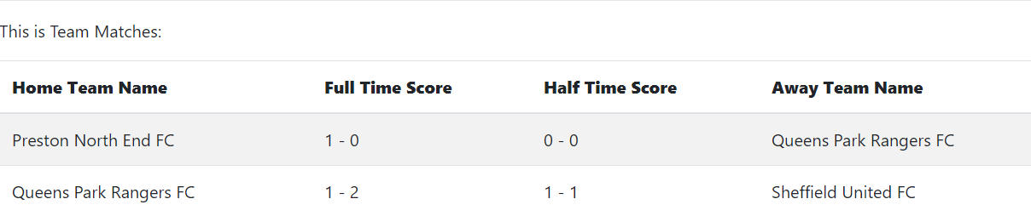

**API Usage Example:**

**First in the service Type Script file, create a http request header with the API authentication token provided by football- data.org:**

**This report includes all the URL necessary for each user story.**

**User story API:**

**1. “As a fan, I want to check out the current league table”**

**Competition’s ID: http://api.football-data.org/v2/competitions/{areaID}/standings**

**In order to complete user stories, we use this API to fetch data from football -data.org.**

**2. “As a fan, I want to see the result of the last game my team played”**

**http://api.football-data.org/v2/teams/{teamID}/matches**

**In order to complete user stories, we use this API to fetch data from football -data.org.**

**3. “As a fan, I want to see the performance of my team over the last 5 games”**

**http://api.football-data.org/v2/teams/{teamID}/matches**

**In order to complete user stories, we use this API to fetch data from football -data.org.**

**4. “As a fan, I want to see all the games and results so far this season for my team”**

**Provided team’ ID: http://api.football-data.org/v2/teams/{teamID}/matches**

**In order to complete user stories, we use this API to fetch data from football -data.org matches.**

**5. “As a fan, I want to see the head-to-head results between my team and my team’s rival this season” Challenge ID: http://api.football-data.org/v2/competitions/{areaID}/matches**

**In order to complete user stories, we use this API to fetch data from football -data.org.**

1. <http://www.espn.com/soccer/>

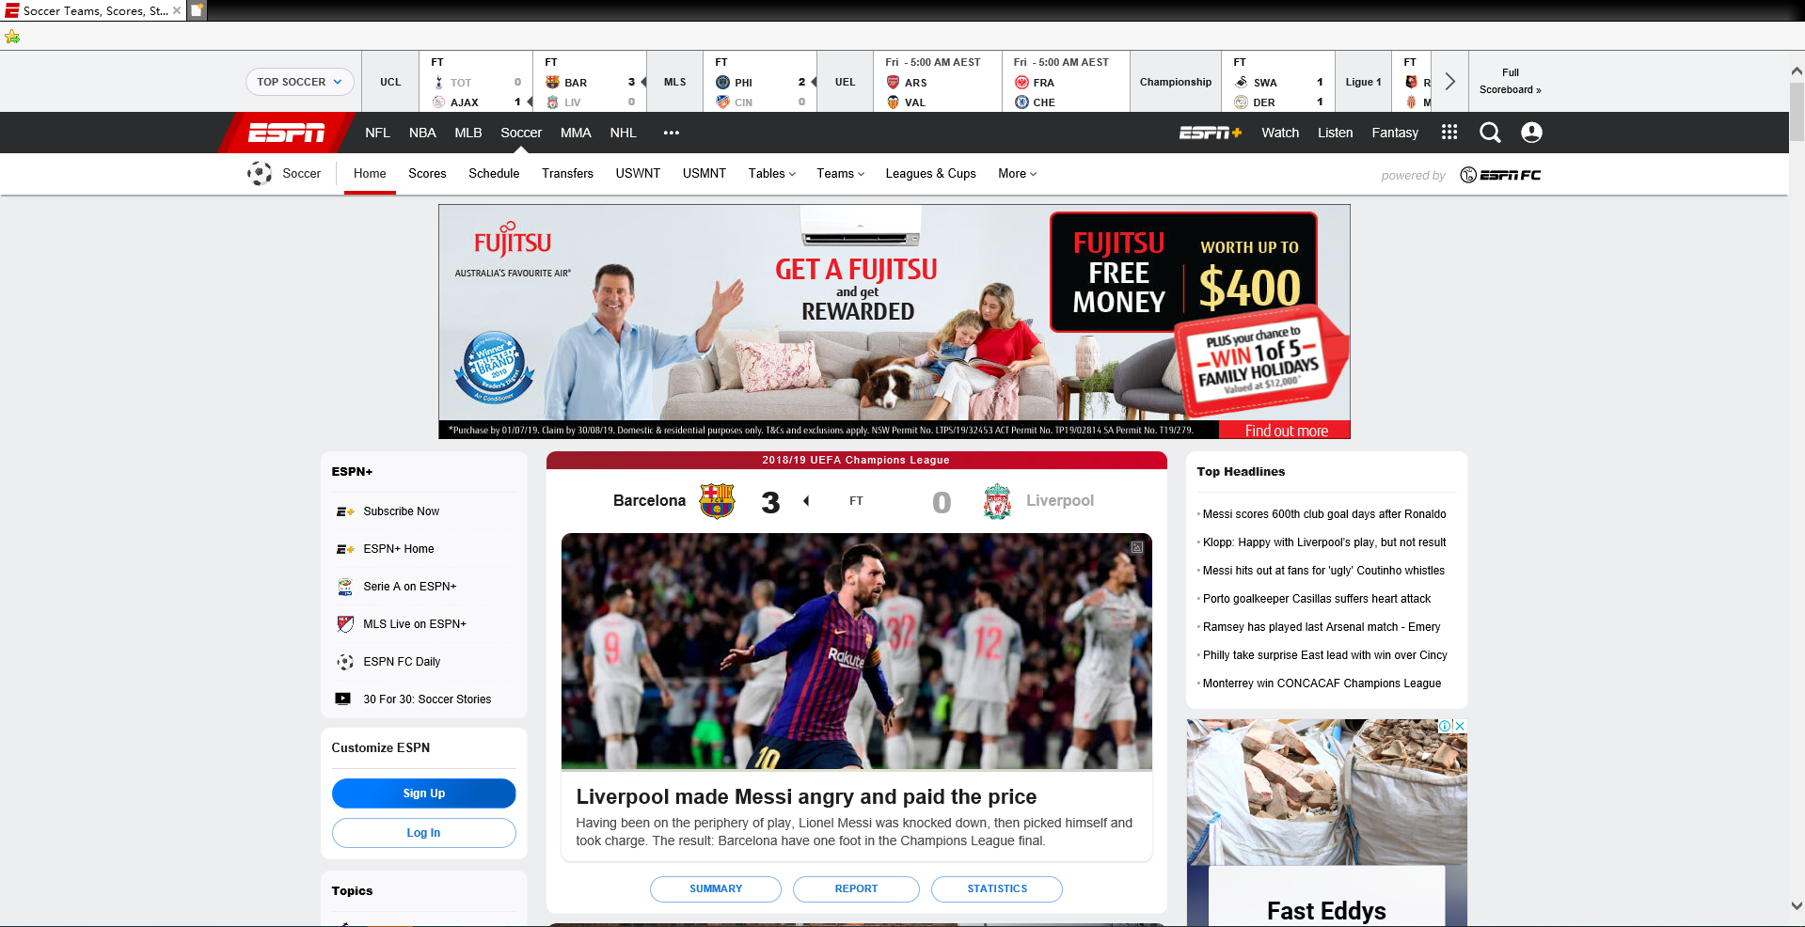

**Positive:**

1. There are vary board information, basically covering the global mainstream of football and other sport event.

2. Information about the key event can be seen directly.

3.Users could log in with their social account such as Facebook

**Negative:**

1. The information and layout are very messy.

2. The advertisement is very eye-catching, and it takes a lot of rooms. And most advertising is not about soccer.

3. The layout of the website is not pretty.

2. <https://data-ui.football-data.org/live>

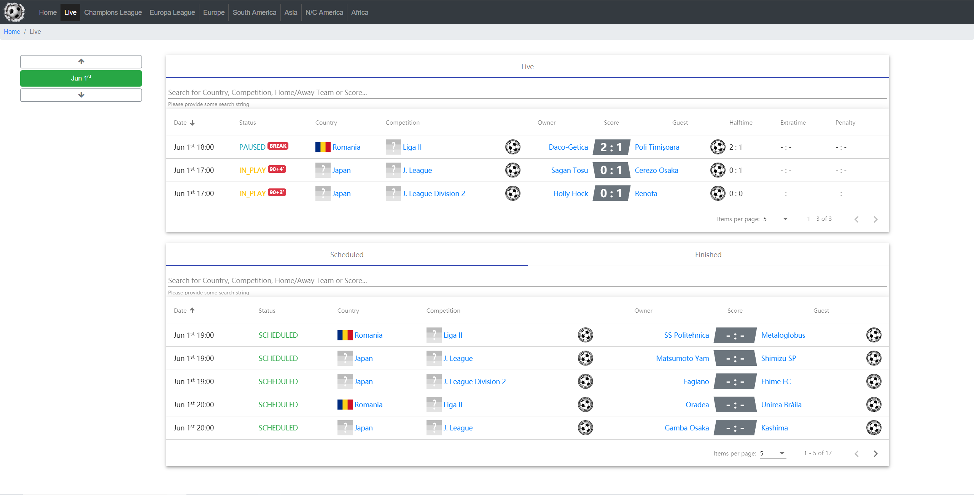

**Positive:**

1. The layout is clean and tidy, and the information is easy to find.
2. Information search is very convenient; users can look up the specific date of the event.

**Negative:**

1. Lack of the event analysis

**Tech stack:**

1. **For Front- end: also call as client – side development, it’s the practice of producing HTML and CSS and JavaScript for a website or web application so the user can see and interact with their directly. When we building for a web, the software below is for front- end tech stack:**

* **HTML (Markup Language)**
* **CSS (Style Sheet Language)**
* **JavaScript (Scripting Language)**

**Optional and recommended for front – end frameworks:**

**Recommended: AngularJS, Backbone.js, ReactJS for JavaScript frameworks.**

**Recommended: Bootstrap for presentation frameworks.**

**The most common solutions for WebView development are:**

1. **NW.js (typically used for desktop apps)**
2. **Cordova (typically for native phone/tablet apps)**
3. **Electron (typically used for desktop apps)**

**Wireframe UI ：**

