**AI-assisted Segmentation Workflow with AnyLabeling**

**Software Description:**

[Anylabeling](https://anylabeling.nrl.ai/) is an open-source software for interactive AI assisted segmentation of image stacks using Segment Anything Model (SAM) or YOLO models.

Advantages:

* ONE-point and click polygon segment generation using auto segmentation.
* Open-source and free, also available as binary installers
* Image annotation for polygon, rectangle, circle, line, and point.
* Export polygon labels in standard json format.

**Workflow:**

* install anylabeling (binary available for Mac, Windows, Linux with and w/o GPU): <https://github.com/vietanhdev/anylabeling/releases>
* align and convert images to png or jpg if necessary.
* split images in tiles depending on size of target organelle; tool: image2tiles.py
* open anylabeling software and load image folder (top left icon).
* select bottom icon on left side (brain icon) for AI-assisted segmentation.
* under auto-models (top panel), select Segment Anything (ViT-H). This will take a while to load for the first time.
* select output Polygon.
* then select +Point or +Rect to select cell organelle of interest. For the first time it will take a while to get results, but then it will be cached and faster.
* click "Finish Object" or press f to add label and add object to list.
* label next object or go to next image in image stack.
* polygons are automatically saved as json files in the same folder as the images.

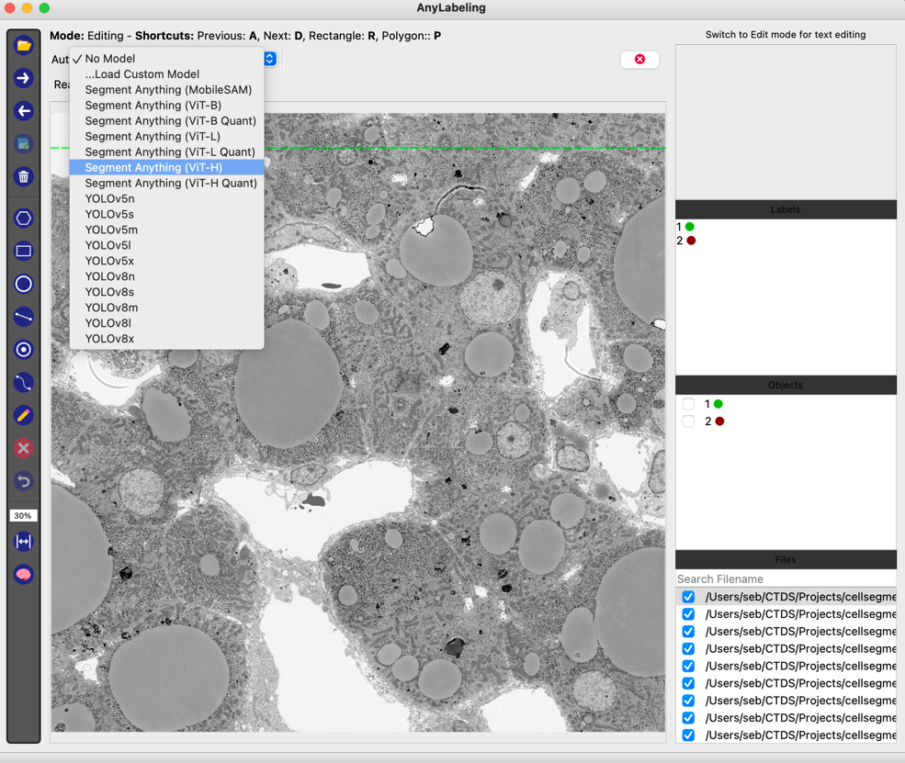

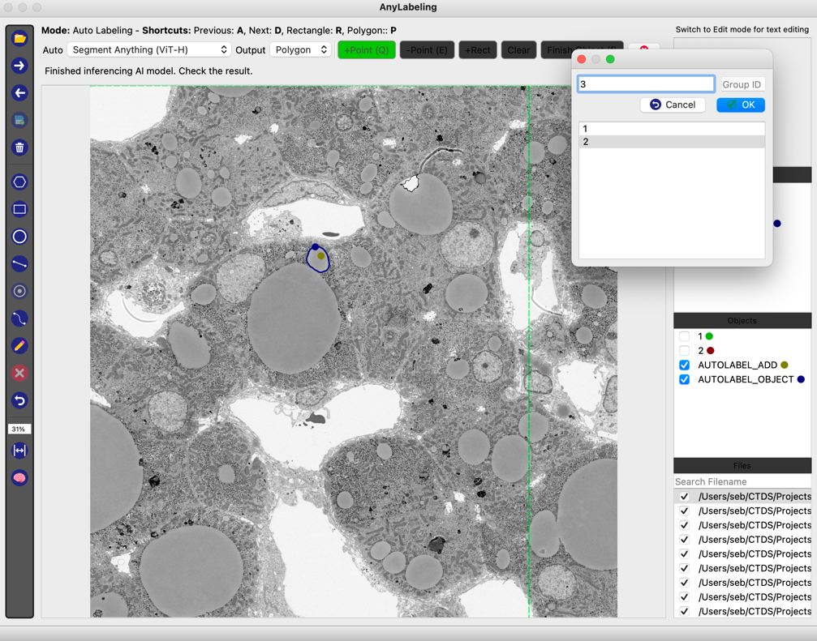

* optional: use anylabeling2tif.py to convert json files to tiff image masks, which then can be used to train Avizo AI segment model.

**Alternative open-source labelling software packages:**

* micro-SAM: <https://github.com/computational-cell-analytics/micro-sam>
* 3D Slicer: <https://www.slicer.org/>
* SAMM: <https://github.com/bingogome/samm>
* Seg3D: <https://www.sci.utah.edu/cibc-software/seg3d.html>

Workflow Overview