Step1: Open file “ui.R” and click Run App.
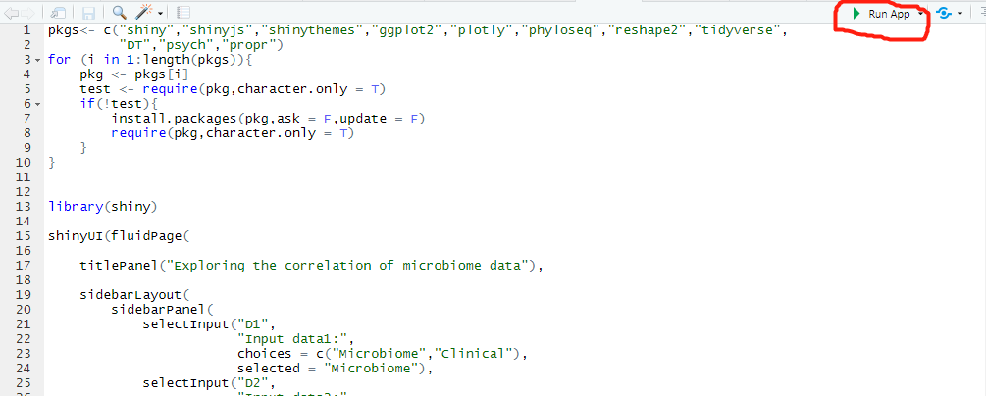
Step2: Set parameters in the left panel:
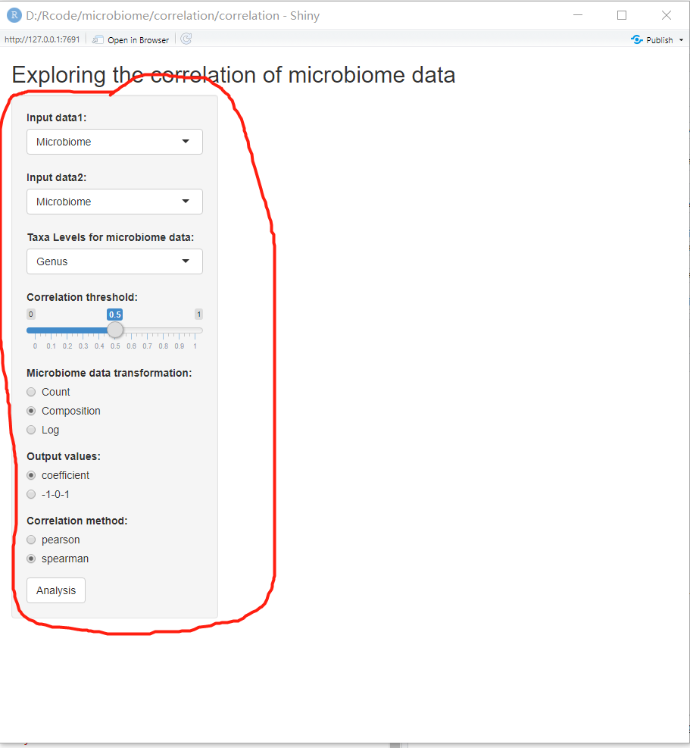
Notes: Output values means that which kind of value you want to see in the output, if coefficient, that means the output heatmap will give a correlation result and -1-0-1 means that it will make any value smaller than -(threshold) be -1 ,larger than threshold be 1 and within 0.
Step3 : click analysis and the result will present.
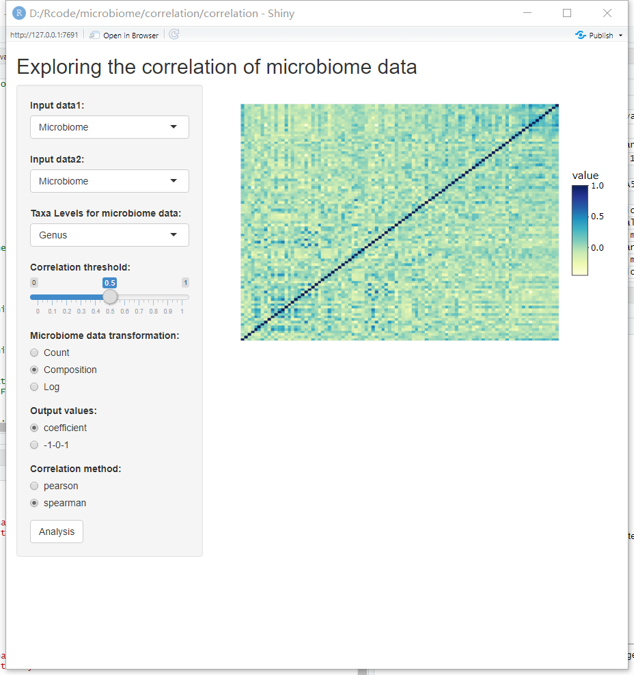
Step4: Click any point in the heatmap will give the scatter plot.
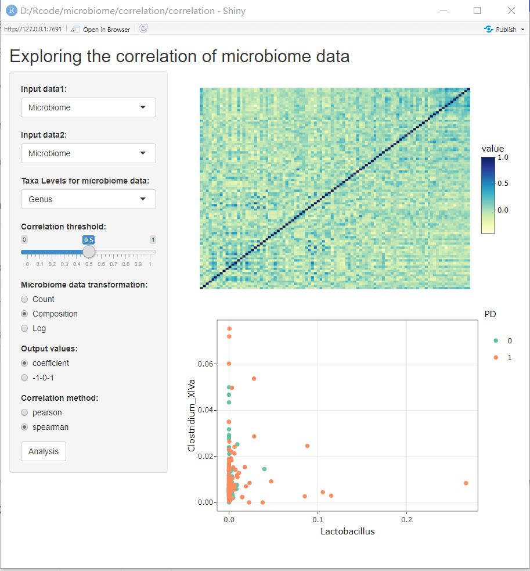
Note1: you can change parameter setting after generating heatmap(esp output values).
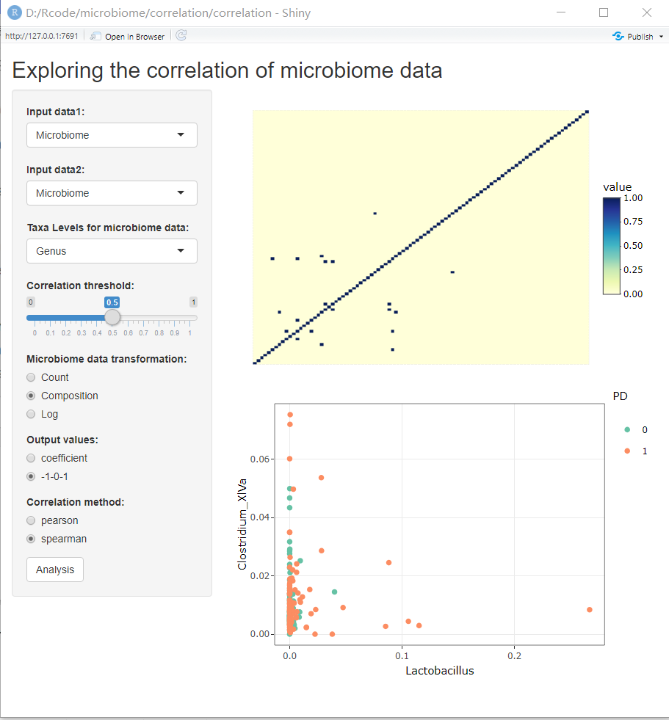
Note2: If you see nothing in the heatmap, just make the threshold a little bit smaller.:)

