first_script.R

sydney

2024-10-11

# my first r script  
x <- 1:50  
plot(x)

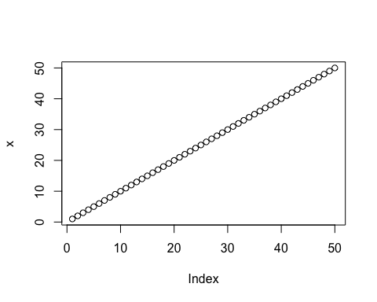

plot(x=x, y=sin(x), type='l', col='blue')

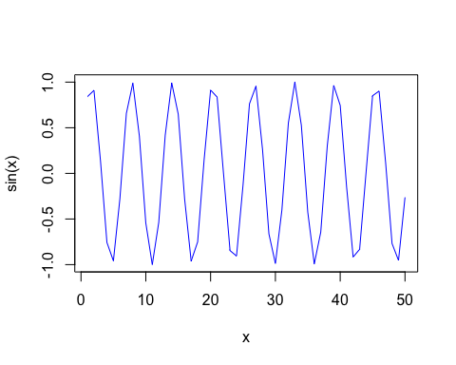

log(10, base=2)

## [1] 3.321928