**National University of Technology**



**Data Structure and Algorithms**

**Instructor Name: Ms Tabinda Nasir**   **Department:** Artificial Intelligence

**Batch: AI** 2022  **Assessment Type:** Lab Task

**Session:** Fall 2023  **Lab Number:** 01

**Name:** Muhammad Sultan Mehmood   **Reg No:** F22607013

# In Lab Task

**Task 1:**

**Code:**

#include <iostream> using namespace std;

class Triangle { int base; int altitude; int hypotenuse; double area;

public:

Triangle(int b, int a, int c) : base(b), altitude(a), hypotenuse(c) { area = (double)(base * altitude) / 2.0;

cout << "Area of the triangle is: " << area << endl;

}

int calculatePerimeter() {

return base + altitude + hypotenuse;

}

}; int main() { int base = 3; int altitude = 4; int hypotenuse = 5;

Triangle t(base, altitude, hypotenuse);

int perimeter = t.calculatePerimeter();

cout << "Perimeter of the triangle is: " << perimeter << endl;

return 0;

}

**Output:**

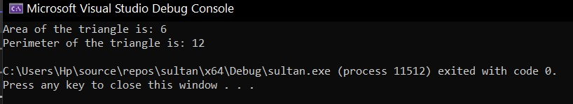

**Task 2:**

**Code:**

#include <iostream> #include <Math.h> using namespace std;

class Rectangle { public:

float l, b;

void setDim(float length, float breadth) {

l = length;

b = breadth;

}

float getArea() {

return (l * b);

}

}; int main() {

float l, b;

cout << "Enter length of the rectangle: " << endl; cin >> l;

cout << "Enter breadth of the rectangle: " << endl;

cin >> b;

Rectangle rect; rect.setDim(l, b);

cout << "Area of the rectangle is : " << rect.getArea();

return 0;

}

**Output:**

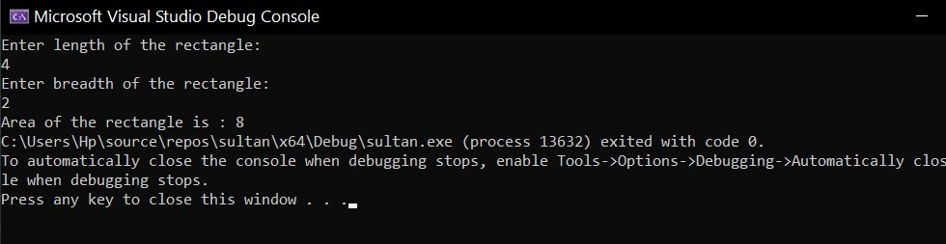

# Post Lab Task

**Code:**

#include<iostream>

using namespace std; int main() {

int no_posit = 0, no_negat = 0, no_zero = 0, no_even = 0, no_odd = 0; int numbers[20]; cout << "Enter 20 Numbers:\n"; for (int i = 0; i < 20; i++) { cin >> numbers[i];

}

for (int i = 0; i < 20; i++) { if (numbers[i] == 0) {

no_zero++;

}

else if (numbers[i] < 0) { no_negat++;

}

else if (numbers[i] > 0) { no_posit++;

}

if (numbers[i] % 2 == 0) { no_even++;

}

else { no_odd++;

}

}

cout << "Number of Positive Numbers: " << no_posit << endl; cout << "Number of Negative Numbers: " << no_negat << endl; cout << "Number of Zero Numbers: " << no_zero << endl; cout << "Number of Even Numbers: " << no_even << endl;

cout << "Number of Odd Numbers: " << no_odd << endl; }

**Output:**

