**ASSIGNMENT#2**

Q17) Two numbers are entered through the keyboard. Write a program to find the value of one number raised to the power of another

A17) int num1,num2, power;

printf("Enter number one: \t");

scanf("%d",&num1);

printf("Enter number two:\t");

scanf("%d",&num2);

power = pow(num1,num2);

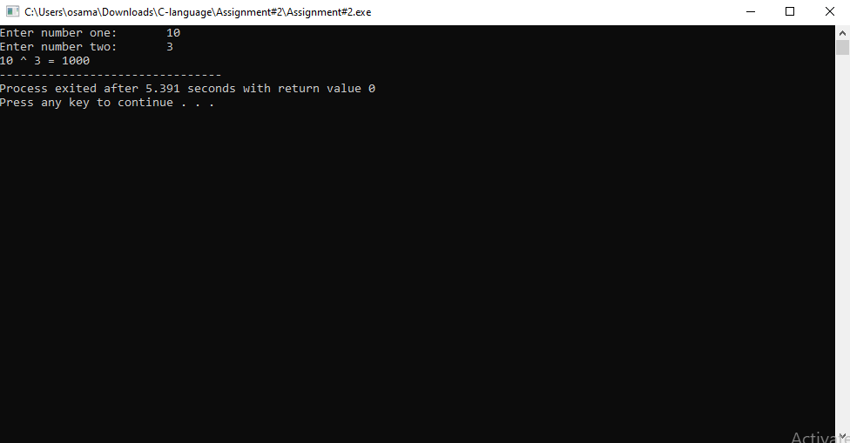 printf("%d ^ %d = %d",num1,num2,power);

Q16) Write a program in C to display the first n terms of Fibonacci series (Take input n from user)

A16) int noOfTerms,a=1,b=1,temp;

printf("Enter number of terms:\n");

scanf("%d",&noOfTerms);

for(int i=0;i<=noOfTerms;i++){

temp = a+b;

printf("%d\t",temp);

a=b;

b=temp;}

Q15) Calculate the sum of digits of a number given by user.

A15) int num,rem,ans=0;

printf("Enter a number:\n");

scanf("%d",&num);

for(int i=0;num>0;i++){

rem=num%10;

ans = ans + rem;

num=num/10;

}

printf("sum of your number is: %d", ans);

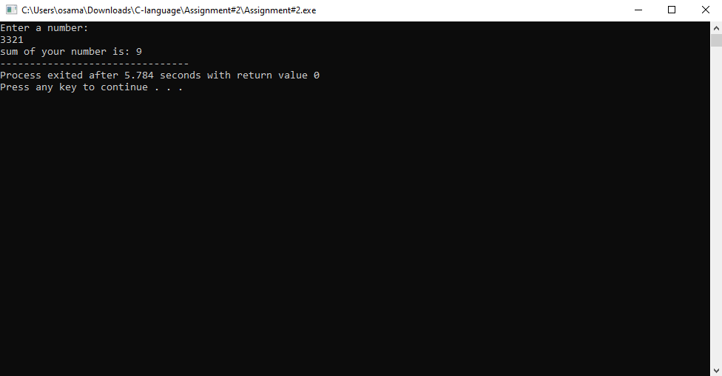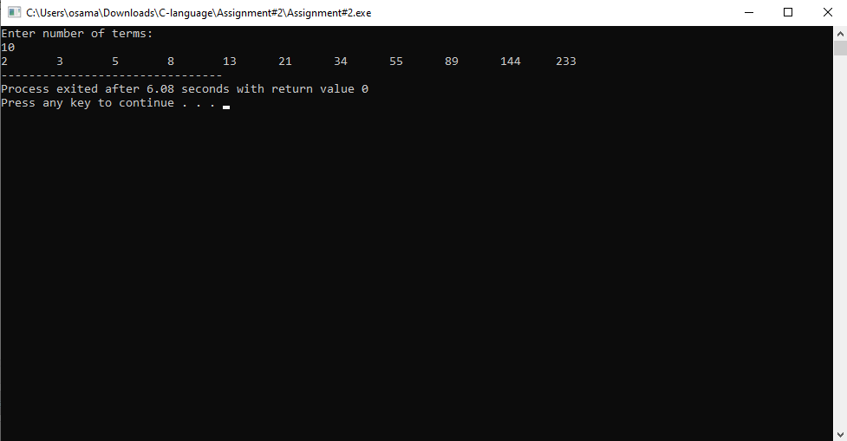

Q14) Write a c program to check whether a number input by the user is a perfect number or not.

A14) int num;

float sq;

printf("Enter a number:\n");

scanf("%d",&num);

sq=sqrt(num);

num=sq;

if(num==sq){

printf("perfect square");

}

else{

printf("not a perfect square");

}

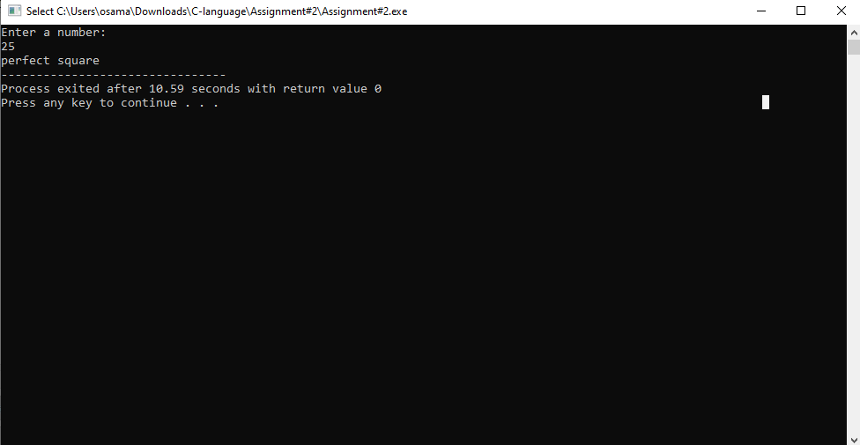

Q13) Write a C program to check number has decimal point or not.

A13) float f;

int i;

printf("Enter a number : ");

scanf("%f",&f);

i=f;

if(i==f){

printf("\nYou have Entered an Intiger number");

}

else{

printf("\nYou have Entered a float number");

}

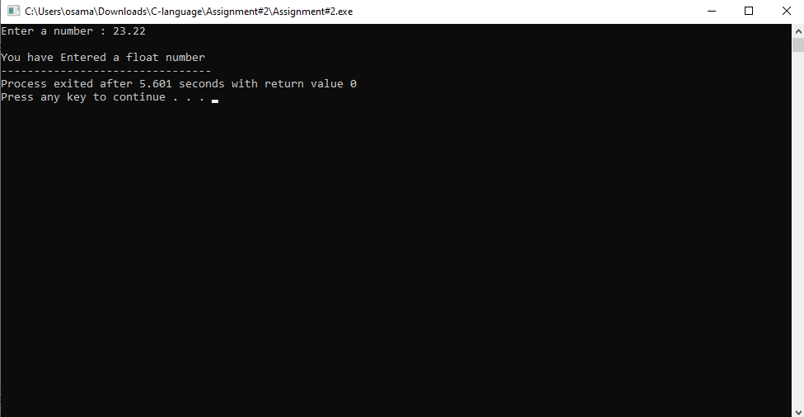

Q12) Write a program in C to display the square of n terms of natural number and their sum.

A12) int num,sq;

printf("Enter number of terms");

scanf("%d",&num);

for(int i=1;i<=num;i++){

sq=i*i;

printf("%d\n",sq);

}

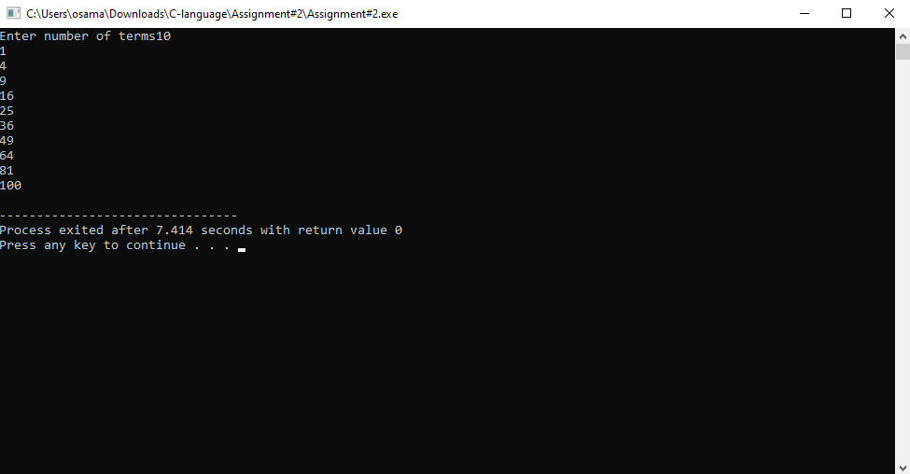

Q11) Find the roots of the following quadratic equation by quadratic formula. (Take the value of coefficient of X^2, the coefficient of X and constant term from user) ________ _______

X = (-b + _/ b^2 - 4ac ) / 2*a X = (-b - _/ b^2 - 4ac ) / 2*a

A11) int a,b, c,p;

float Xp, Xn;

printf("Enter coeffecient of X^2:\t");

scanf("%d",&a);

printf("Enter coeffecient of X\t");

scanf("%d",&b);

printf("Enter constant\t");

scanf("%d",&c);

Xp = (-b + sqrt(b*b-4*a*c) ) / 2*a;

Xn = (-b - sqrt(b*b-4*a*c) ) / 2*a;

printf("Roots are:\t Xp=%f\t Xn=%f",Xp,Xn);

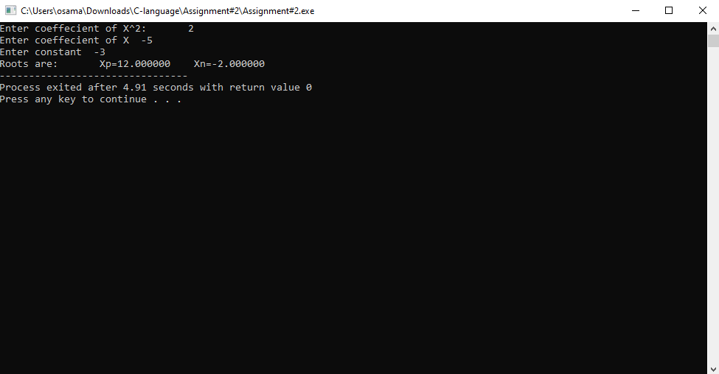

Q10) Write a program to find the factorial of a number input by the user

A10) int num;

printf("Enter a number");

scanf("%d",&num);

int fac=1;

for(int i=num; i>=1;i--){

fac = fac *i;

}

printf("factorial is: %d",fac);

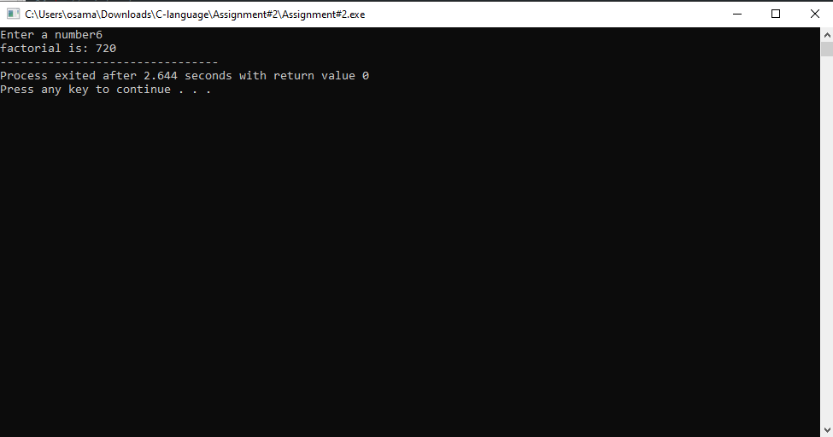

Q9) take binary number input from user and convert it into decimal.

A9) int num,rem,conversion=0;

again:

printf("Enter a number:\n");

scanf("%d",&num);

for(int i=0 ;num>0;i++)

{

rem=num%10;

if(rem==1|| rem==0)

{

conversion = conversion +rem*pow(2,i);

num=num/10;

}

else{

printf("write binary number\n");

goto again;

}

}

printf("%d",conversion);

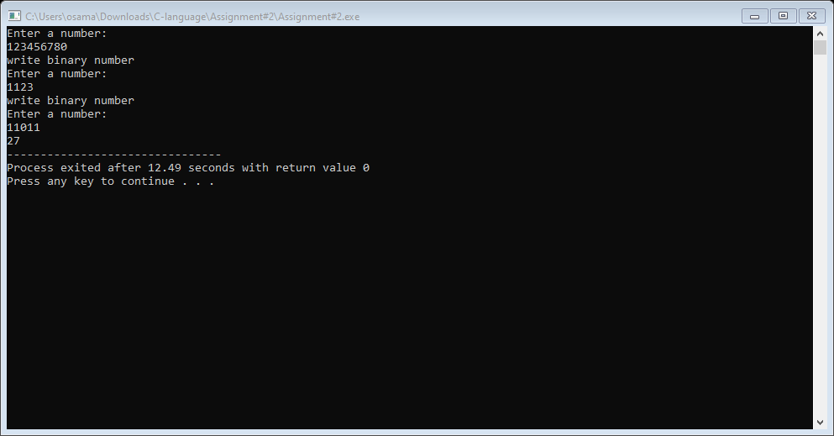

. Q8) take binary number input from user and check if its binary or not.

A8) int num, rem;

again:

printf("Write binary number:\n");

scanf("%d",&num);

for(int i=0;num>0;i++){

rem=num%10;

if(rem == 0 || rem==1){

printf("Binary number: %d",num);

num=num/10;

break;

}

else{

printf("not a binary number\n");

goto again;

}

}

Q7) Write a program in C to display the number in reverse order and display whether its palindrome or not.

A7) int num, rem,rev=0,temp;

printf("Write a number:\n");

scanf("%d",&num);

temp=num;

for(int i=0;num>0;i++){

rem=num%10;

rev = rev*10+rem;

num=num/10;

}

printf("reverse number is: %d", rev);

if(rev==temp){

printf("\nNumber is palindrome");

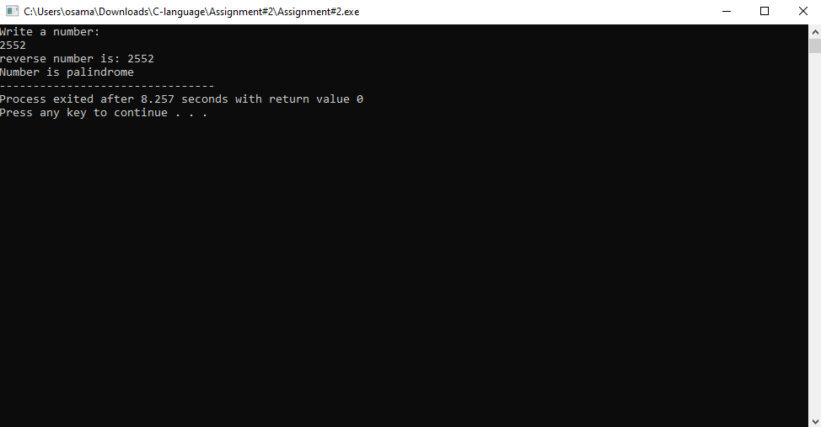}

Q6) Write a program in C to display the natural number (m to n) that are divisible by 7 and 9. Find the number of terms, their sum and their average. Take input m and n from user.

A6) int strt , end, count=0,sum=0;

printf("Enter starting point");

scanf("%d",&strt);

printf("Enter ending point");

scanf("%d",&end);

for(int i=strt;i<=end;i++){

if(i%7==0 && i%9==0){

printf("Numbers divisible by 7 and 9 are: %d\n", i);

count++;

sum=sum+i;

}

}

printf("number of terms between 7 and 9 are: %d \n", count);

printf("sum of terms between 7 and 9 is: %d ", sum);

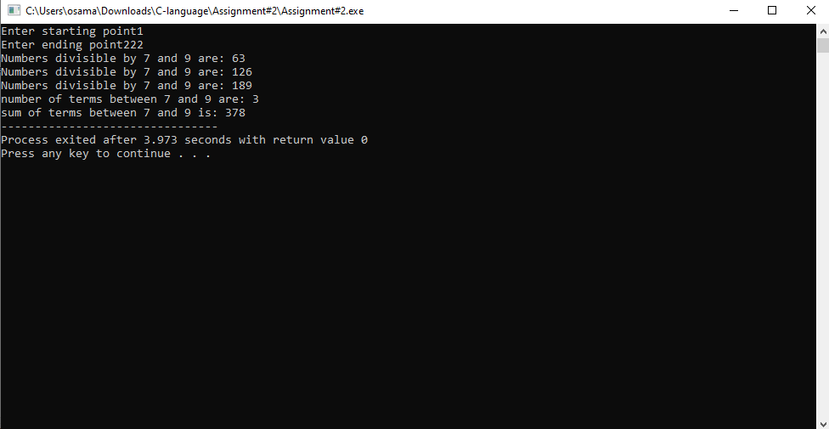

Q5) Write a program in C to display odd numbers b/w (1 to n), their sum and their average. Take input n from user

A5) int num;

printf("upto how many numbers you want to print odd numbers:\n");

scanf("%d",&num);

printf(" odd numbers are:\n");

for(int i=1;i<=num;i++){

if(i%2!=0){

printf("%d\n",i);

}

}

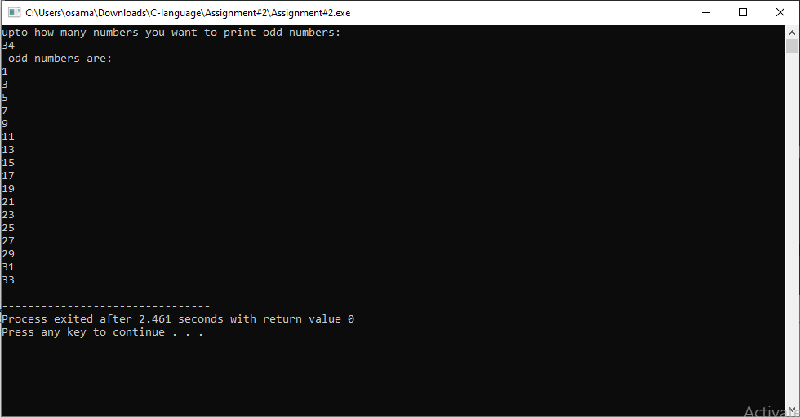

Q4)Write a c program to print an G.P and find out the sum of an G.P. series. (take a,r,n as input from user)

Tn = a* r ^(n-1) Sn = (a* (r^n - 1))/(r-1)

A4) int firstNo,totNo, ratio;

float Tn,Sn;

printf("Enter first no:\n");

scanf("%d",&firstNo);

printf("Enter ratio:\n");

scanf("%d",&ratio);

printf("Enter total no:\n");

scanf("%d",&totNo);

for(int i=1;i<totNo;i++){

Tn = firstNo* pow(ratio,totNo-i);

printf("%f\t",Tn);

Sn = (firstNo* pow(ratio,totNo - i))/(ratio-i);

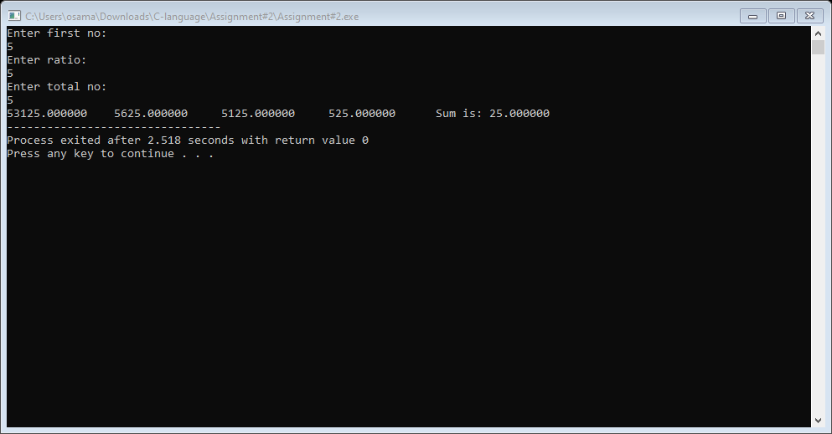 }

Q3)Write a c program to print an A.P and find out the sum of an A.P. series. (take a,d,n as input from user) Tn = a +(n-1)*d Sn = n/2 (2*a+(n-1)*d)

A3) int a,n, d;

float Tn,Sn;

printf("Enter first no:\n");

scanf("%d",&a);

printf("Enter difference:\n");

scanf("%d",&d);

printf("Enter total no:\n");

scanf("%d",&n);

for(int i=1;i<n;i++){

Tn = a +(n-i)*d;

printf("%f\t",Tn);

}

Sn = n/2 *(2*a+(n-1)*d);

printf("Sum is: %f", Sn);

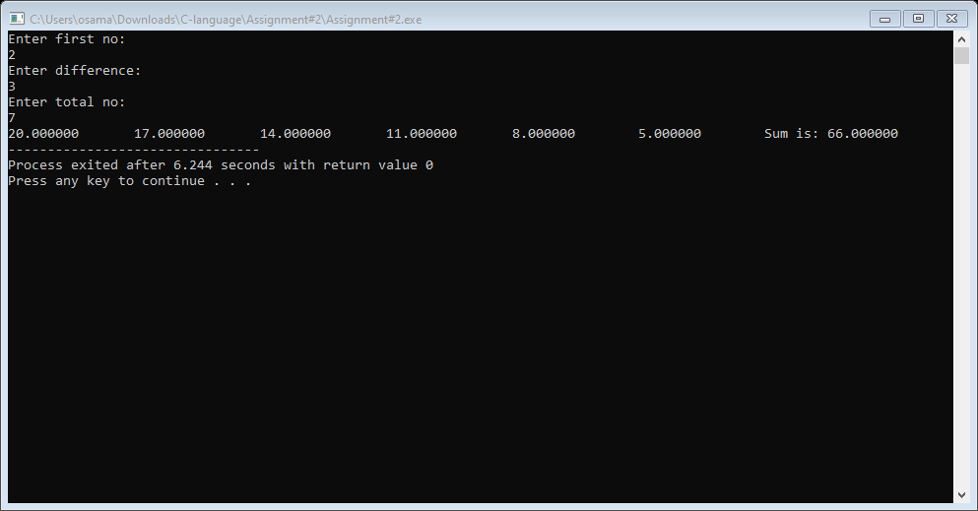

Q2) Write a program in C to display n-terms of natural number (n to 1), their sum and their average. Take input n from user

A2) int n,sum=0,count=0;

float avg;

printf("enter the number:\n");

scanf("%d",&n);

for(int i=n;i>=1;i--){

printf("\n%d\n",i);

sum=sum+i;

count=count+1;

}

printf("\nCount is: %d",count);

printf("\nSum is: %d",sum);

avg = sum/count;

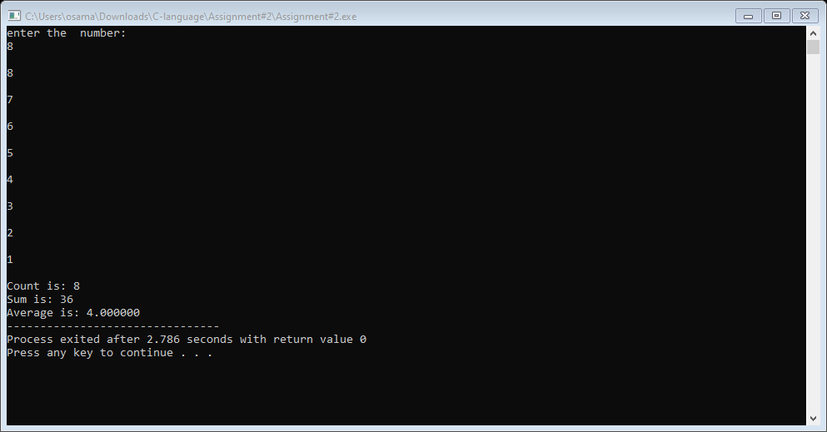 printf("\nAverage is: %f\t",avg);

Q1) Write a program in C to display n-terms of natural number (1 to n), their sum and their average. Take input n from user.

A1) int n,sum=0,count=0;

float avg;

printf("enter the number:\n");

scanf("%d",&n);

for(int i=1;i<=n;i++){

printf("\n%d\n",i);

sum=sum+i;

count=count+1;

}

printf("\nCount is: %d",count);

printf("\nSum is: %d",sum);

avg = sum/count;

printf("\nAverage is: %f\t",avg);

