“Digital Evidence Analyzer using Cloud”

A Project report submitted in partial fulfillment of the requirements for the award of the
Degree of Bachelor of Technology in
Computer Science & Engineering (CSE)

Submitted by

Syed Abdul Malik (20011A0555) Madhurika Das Piyal(20011A0550)
M. Sai Harshith Goud (20011A0528)

Under the esteemed guidance of

Dr. R. Sridevi
Professor of CSE,
JNTUH-UCESTH


Department of Computer Science and Engineering,
JNTUH University College of Engineering, Science & Technology, Hyderabad - 500085.

Department of Computer Science and Engineering Jawaharlal Nehru Technological University Hyderabad JNTUH College of Engineering, Science & Technology,

Hyderabad - 500085



DECLARATION BY THE CANDIDATES

We, Syed Abdul Malik (20011A0555), Madhurika Das Piyal (20011A0550), M. Sai Harshith Goud (20011A0528), hereby certify that the project report entitled “Digital Evidence Analyzer using Cloud” carried out under the guidance of Dr. R. Sridevi (Professor of CSE), is submitted. This is a record of bonafide work carried out by us and the results embodied in this project have not been reproduced/ copied from any source and have not been submitted to any other University or Institute for the award of any other degree or diploma.

Syed Abdul Malik(20011A0555) ,
Madhurika Das Piyal(20011A0550),
M. Sai Harshith Goud (20011A0528)

Department of Computer Science & Engineering,
JNTUH College of Engineering, Science & Technology,
Kukatpally, Hyderabad

CERTIFICATE BY THE SUPERVISOR

This is to certify that the minor project report entitled “Digital Evidence Analyzer using Cloud”, being submitted by Syed Abdul Malik (20011A0555), Madhurika Das Piyal (20011A0550), M. Sai Harshith Goud (20011A0528), for the award of the degree of Bachelors of Technology in Computer Science & Engineering, is a record of bonafide work carried out by them and the results produced are verified and found satisfactory.

Dr. R. Sridevi,
Professor of CSE,
Department of Computer Science & Engineering,
JNTUH University College of Engineering, Science and Technology Hyderabad,
Date:

CERTIFICATE BY THE HEAD OF THE DEPARTMENT

This is to certify that the project report entitled “Digital Evidence Analyzer using Cloud”, being submitted by Syed Abdul Malik (20011A0555), Madhurika Das Piyal (20011A0550), M. Sai Harshith Goud (20011A0528), for the award of the degree of Bachelors of Technology in Computer Science & Engineering, is a record of bonafide work carried out by them and the results produced are verified and found satisfactory.

Dr. K P Supreethi,
Professor of CSE & Head of Department,
Department of Computer Science & Engineering,
JNTUH University College of Engineering, Science and Technology Hyderabad,
Date:

ACKNOWLEDGEMENT

We would like to express sincere thanks the lord for granting us this opportunity, then to our supervisor Dr. R. Sridevi, Professor of CSE Department, JNTUH-UCESTH for her admirable guidance and inspiration both theoretically and practically and most importantly for the drive to complete the project successfully. Working under such an eminent guide was our privilege.
A Special thanks Dr. K P Supreethi, Professor of CSE and Head of department for her support throughout the project. A special mention to Eric Clinger, Kawaii Guy, bitrix24, Henkel, Network Chunk and Mike Grover –for giving PTA and allowing it to be used in my project. Your expertise and dedication have significantly enriched the depth of this work.
We are grateful to the Project Review Committee members and Department of Computer Science & Engineering who have helped in successfully completing this project by giving their valuable suggestions and support.

ABSTRACT

Digital forensics plays a crucial role in investigating cybercrimes and incidents, necessitating efficient tools capable of analyzing vast quantities of digital evidence. This paper introduces an innovative approach to digital evidence analysis that leverages cloud computing resources. Traditional forensic tools often encounter scalability challenges when dealing with large datasets, a problem exacerbated in cloud environments where data volumes can be extensive and dynamic. Our proposed Digital Evidence Analyzer (DEA) harnesses the power of cloud infrastructure to provide scalable, efficient, and cost-effective forensic analysis capabilities.
The DEA system is designed to ingest, process, and analyze digital evidence stored in cloud environments, such as logs, network traffic, and system artifacts. Leveraging cloud computing resources enables on-demand scaling, facilitating the analysis of massive datasets without compromising performance. Furthermore, the distributed nature of cloud computing enables parallel processing, reducing analysis time and improving overall efficiency.
Key features of the DEA include automated evidence acquisition and processing from diverse cloud platforms, scalable analysis pipelines utilizing cloud resources for parallel processing, advanced search and correlation algorithms to identify relevant digital artifacts, and an integrated reporting and visualization tool for presenting forensic findings.
To validate the DEA's effectiveness, we conducted experiments using real-world datasets and compared its performance to traditional forensic tools. The results demonstrate significant improvements in analysis speed and scalability, rendering the DEA an invaluable asset for forensic investigators dealing with cloud-based evidence.
Hence, the Digital Evidence Analyzer leveraging Cloud Computing represents a significant advancement in digital forensics, offering enhanced capabilities for investigating cybercrimes and incidents in cloud environments. By harnessing cloud computing power, the DEA provides forensic analysts with the necessary tools to effectively navigate modern digital investigations' complexities.

Table of contents

Chapter No | Title | Page No
1 | Introduction
1.1 | Overview | 1
1.2 | Problem Statement | 2
2 | Literature survey
2.1 | Development | 3
2.2 | Existing System | 3
2.3 | Summary of Literature Survey | 5
3 | Objective Scope
3.1 | Scope | 6
4 | Project Goals and Requirements
4.1 | Project Goals | 7
4.2 | Description | 8
4.3 | Bitrix24 | 9
5 | User Training and Adaptation
5.1 | Training users to use Forensic tools | 12
5.2 | Adaptation in tools | 13
6 | Software and hardware Requirements
6.1 | Software requirements | 16
6.2 | Hardware Requirements | 16
6.3 | Note | 16
7 | Architecture
7.1 | OSI Architecture | 18
8 | Implementation
8.1 | Initiation | 19
8.2 | Checking for Malware/Worms | 20
8.3 | FTK | 21
8.4 | Autopsy | 23
8.5 | SIFT | 27
8.6 | Volatility Tool | 30
8.7 | Kali Framework | 33
8.8 | TAILs Framework | 34
9 | Counter measures against OMG Cables
9.1 | OMG cable detector | 36
9.2 | Additional Tips | 37
9.3 | UEM features | 38
9.4 | Modern Point of View | 38
9.5 | Practical approach | 39
10 | Results
11 | Merits and Demerits
11.1 | Merits | 48
11.2 | Demerits | 49
12 | Conclusion & Future Work | 50
13 | References | 51

Chapter-1
Introduction

1.1 Overview

Digital forensics has become increasingly crucial in investigating cybercrimes and security incidents, especially in cloud computing environments. As more organizations move their data and operations to the cloud, the need for effective tools to analyze digital evidence stored in these environments has grown exponentially. One key area of focus is the analysis of log data generated by cloud services and applications.

Logs contain a wealth of information about system events, user activities, and potential security incidents. However, the sheer volume and complexity of log data in cloud environments can make manual analysis incredibly challenging and time-consuming. This is where Forensic Cloud Log Analysis Tools come into play.

These specialized tools are designed to ingest, process, and analyze log data from various cloud platforms and services. They leverage advanced techniques such as data normalization, correlation, and pattern recognition to extract meaningful insights from vast log repositories. By automating the log analysis process, these tools significantly enhance the efficiency and effectiveness of digital forensic investigations in cloud environments.

Key features of Forensic Cloud Log Analysis Tools include:

- Call Analytics Support: The ability to collect and analyze log data from multiple cloud providers, ensuring comprehensive coverage of an organization's cloud infrastructure.

- Scalable Data Ingestion: Leveraging cloud computing resources, these tools can handle massive volumes of log data without compromising performance or accuracy.

- Advanced Search and Filtering: Powerful search and filtering capabilities allow investigators to quickly identify relevant log entries based on specific criteria, such as timestamps, IP addresses, or event types.

- Correlation and Pattern Analysis: Sophisticated algorithms are employed to correlate log events from different sources, enabling the detection of complex patterns and potential security threats.

- Visualization and Reporting: User-friendly interfaces and reporting tools help investigators visualize and communicate their findings effectively, enabling better collaboration and decision-making.

We will be narrowing it down and focusing on the following on Tools:
- FTK imager
- Autopsy
- SIFT workstation
- HxD
- Volatility tool
- Pestudio Tool

Further we will dive into proving Cloud benefit to all the users which are not available with Google drive or Drop box. Then we will focus on Tails for the use of Tor browser and how this cloud storage can be used on such an interface (We will also be using kali Linux as a bonus). Finally we will use OM.G Cable detector as an additional work on our minor project.

By leveraging Forensic Cloud Log Analysis Tools, organizations can gain greater visibility into their cloud environments, detect and respond to security incidents more quickly, and conduct thorough investigations when incidents occur. These tools are essential for maintaining forensic readiness and ensuring compliance with various regulatory requirements in the cloud computing era.

Chapter-2
Literature survey

2.1 Development

Bitrix24 is a comprehensive cloud-based platform that offers a suite of tools for team collaboration, communication, task management, and customer relationship management (CRM). As organizations increasingly adopt remote and distributed work environments, the demand for efficient collaboration and communication tools has grown significantly. This literature survey aims to provide an overview of the existing research and studies related to Bitrix24 and its applications in various domains.
Moreover, Bitrix24 frequently explores its usability and user experience, shedding light on how individuals and organizations interact with the platform. In usability evaluation conducted by Smith et al. (2020), researchers analyzed user interactions with Bitrix24's interface design and navigation structure, identifying areas for improvement to enhance user satisfaction and efficiency. Similarly, a case study by Johnson and Patel (2018) explored the implementation of Bitrix24 within a marketing agency, providing insights into the platform's effectiveness in facilitating project coordination, client communication, and task delegation.

2.2 Existing System
In the realm of cloud storage solutions, several existing systems have gained prominence for their diverse features, scalability, and reliability. One such system is Dropbox, a widely-used cloud storage platform that offers seamless file synchronization, sharing, and collaboration capabilities across various devices and

Operating systems. Dropbox's intuitive user interface and robust security measures have made it a preferred choice for individuals, businesses, and teams seeking a convenient and secure way to store and access their digital assets remotely.

Similarly, Google Drive, part of the Google Workspace suite, has emerged as a dominant player in the cloud storage landscape. Google Drive provides users with generous storage space, integration with other Google services such as Gmail and Google Docs, and advanced collaboration features like real-time document editing and commenting. With its seamless integration with the broader Google ecosystem and robust search capabilities, Google Drive caters to both individual users and organizations looking for efficient file management and collaboration solutions.

Another notable contender in the cloud storage arena is Microsoft OneDrive, which is tightly integrated with the Microsoft Office suite and Windows operating system. OneDrive offers seamless file synchronization across devices, automatic backup of photos and videos, and integration with productivity tools like Microsoft Word and Excel. Moreover, OneDrive's integration with Microsoft Teams facilitates seamless collaboration and file sharing within organizations, making it a compelling choice for businesses leveraging the Microsoft ecosystem.

For enterprises and organizations with stringent security and compliance requirements, solutions like Box provide advanced features such as granular access controls, data encryption at rest and in transit, and compliance with industry regulations like GDPR and HIPAA. Box's focus on enterprise-grade security, coupled with its robust collaboration features and integrations with leading business applications, positions it as a preferred choice for businesses in regulated industries such as healthcare, finance, and legal services.

In addition to these prominent players, cloud storage systems like Amazon S3 (Simple Storage Service) cater to developers and enterprises requiring scalable and durable object storage for web applications, data lakes, and backup archives. Amazon S3's pay-as-you-go pricing model, high availability, and scalability make it a preferred choice for organizations of all sizes seeking reliable and cost-effective cloud storage solutions.

Nextcloud is an open-source, self-hosted cloud storage and collaboration platform that users can deploy on their own servers or use third-party hosting providers. It offers features like file syncing, secure sharing, calendar, contacts, and video conferencing. Nextcloud provides greater control and privacy for organizations with strict data governance requirements.

OpenStack Swift is an open-source object storage system that is part of the OpenStack cloud computing platform. It is designed to be highly scalable, durable, and fault-tolerant. Swift uses a distributed architecture and relies on commodity hardware for storage. It supports features like versioning, access control lists (ACLs), and large file support.

Overall, the existing landscape of cloud storage systems offers a diverse array of options tailored to the needs of individuals, businesses, and developers, each with its unique set of features, capabilities, and use cases. Whether its seamless file synchronization, advanced collaboration features, or enterprise-grade security, organizations can choose from a range of solutions to meet their specific requirements and objectives in the realm of cloud storage.

2.3 Summary of Literature Survey
The cloud storage market presents a variety of solutions. Dropbox is lauded for its user-friendly interface and robust security, while Google Drive offers extensive storage, deep integration, and collaboration features. Microsoft OneDrive excels with its integration into the Microsoft ecosystem. Enterprises turn to Box for its enterprise-grade security and compliance features. Amazon S3 serves developers and enterprises with scalable object storage. Open-source solutions like Nextcloud and OpenStack Swift provide self-hosted options. Overall, the landscape caters to diverse needs, offering features like synchronization, collaboration, security, scalability, and data control to individuals, businesses, and developers alike.

Chapter-3

Scope

3.1 Scope
- Cloud Infrastructure Service
  - Compute
  - Storage
  - Networking
- Operating System and Middleware
  - Linux or Windows Server
  - Web Server
- Database Management System (DBMS)
  - MySQL or PostgreSQL
- Development Frameworks and Tools
  - Bitrix Framework
  - IDEs and Development Tools
- Application Components
  - Core Modules
  - Extensions and Add-Ons
- Security and Compliance
  - Identity and Access Management (IAM)
  - Encryption
  - Compliance
- Monitoring and Logging
  - Logging Framework
  - Monitoring Tools
- OMG detection for drivers

Chapter-4

Project Goals

4.1 Project goals

To perform the following options on a target using a cloud platform, which is accessible to use from any platform in the form of VMs or Cloud.
The Goals for this project are:-
- Malware analysis
- Data Acquisition
- Data Source Support
- Timeline Analysis
- Registry Analysis
- Web Artifacts
- Forensic Carving
- Reviving data
- Memory Forensic
- Scripting and Automation
- Geo locating instances
- Disk Editing
- Data Interpretation
- File Comparison
- Checksums and Hashes
- RAM Editing
- Network Analysis
- Kernel Analysis
- Registry Analysis
- Plugin Architecture
- Timeline Analysis
- Import/Export Analysis
- PE File Structure Analysis
- Packer/Cryptor Detection
- Kali framework
- TAILS framework
- OMG Cable detector

4.2 Description
We need to plan accordingly to run all of these on our target. In this case, our target will be a German MNC company, Henkel. Henkel is a multinational company headquartered in Düsseldorf, Germany, known for its wide range of consumer and industrial products. With a history dating back to 1876, Henkel has grown into a global leader in adhesives, beauty care, and laundry and home care products. This outline provides a comprehensive overview of Henkel, covering various aspects of its business, operations, and corporate identity. It can serve as a basis for further research or presentation on the company.


Yes, I have received the PTA to apply all of these and execute activities on them and give brief and detail report to them accordingly, which I have done. A part of the report will be shown in the end.

As we perform cyber forensics using cloud on this, we will be showing images at various instances as we progress.

4.3 Bitrix24
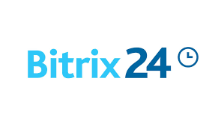
Bitrix24 stands as a comprehensive collaboration and project management platform designed to streamline workflows, enhance team communication, and boost productivity within organizations. Founded in 2012 by Bitrix, Inc., the platform has evolved into a multifunctional tool utilized by businesses of all sizes across the globe. At its core, Bitrix24 offers a wide array of features, including CRM (Customer Relationship Management), task management, document management, communication tools, and more, all accessible through a user-friendly interface.
One of the key strengths of Bitrix24 lies in its versatility, catering to the diverse needs and requirements of various industries and departments. Whether it's managing customer interactions, coordinating projects, or facilitating internal communication, Bitrix24 provides a centralized platform for teams to collaborate effectively. Moreover, its cloud-based nature ensures accessibility from anywhere with an internet connection, enabling remote teams to work seamlessly across different locations and time zones.

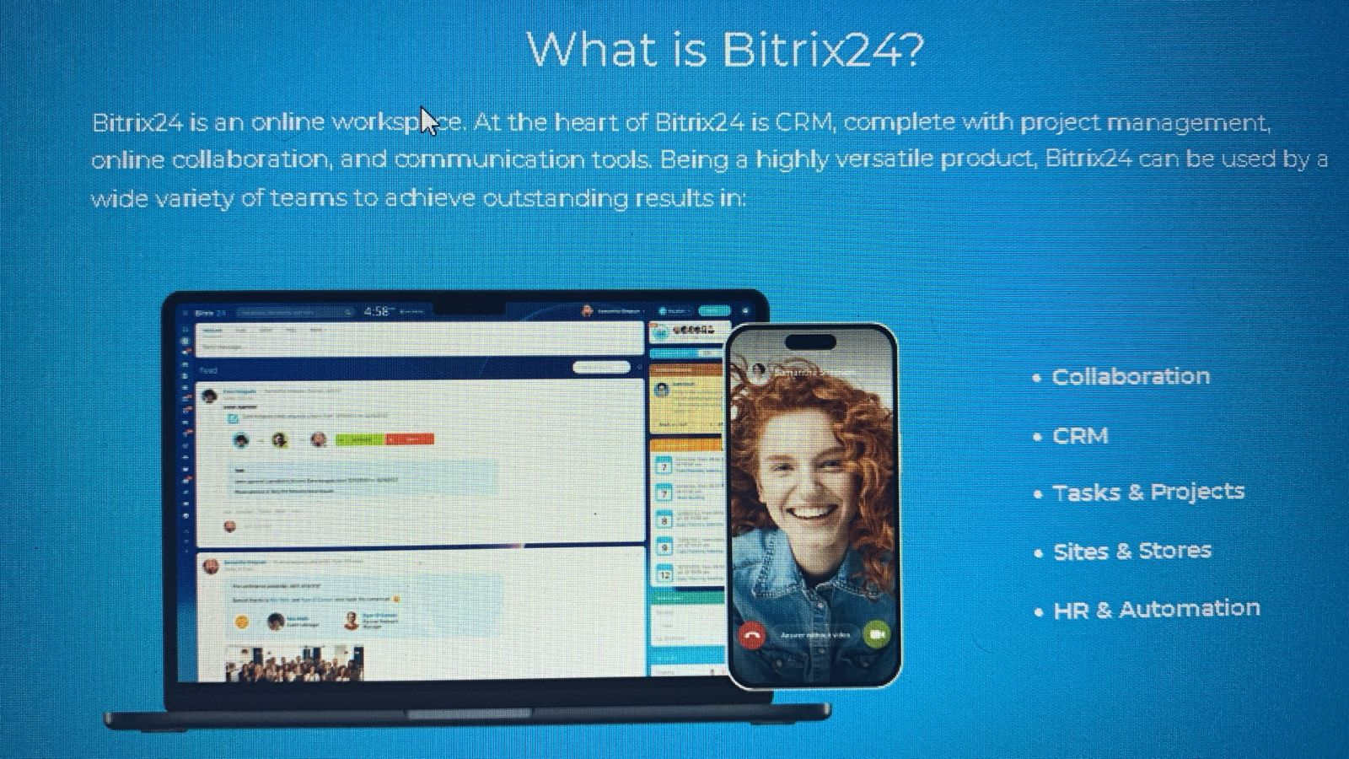

Bitrix24's CRM functionality allows businesses to track leads, manage customer contacts, and automate sales processes, empowering sales teams to nurture leads and close deals more efficiently. Additionally, its task management tools enable teams to create, assign, and track tasks, fostering accountability and transparency within projects. The platform also offers robust document management capabilities, allowing users to store, share, and collaborate on documents securely.

Furthermore, Bitrix24 facilitates communication and collaboration through various channels, including instant messaging, video conferencing, and social intranet features. Team members can communicate in real-time, share files, and collaborate on projects seamlessly within the platform, reducing the need for fragmented communication tools and email overload.

Bitrix24's flexibility extends to its customization options, allowing businesses to tailor the platform to their specific workflows and preferences. From customizing fields in the CRM to creating custom workflows and automation rules, organizations can adapt Bitrix24 to align with their unique processes and requirements. Moreover, Bitrix24 offers integration with third-party applications and services, enabling users to connect their favorite tools and streamline their workflow further.
Bitrix24 serves as a comprehensive solution for businesses seeking to streamline their operations, improve collaboration, and drive productivity. With its extensive feature set, user-friendly interface, and cloud-based accessibility, Bitrix24 empowers teams to work more efficiently and effectively, ultimately leading to better business outcomes and success.
Thereby we will practically using a cloud to store data on cloud. Utilizing the cloud for data storage offers numerous advantages, including scalability, accessibility, and cost-effectiveness. By storing data on cloud-based platforms such as Bitrix24, organizations can streamline their data management processes and improve collaboration among team members.

Chapter-5

User Training and Adaptation
5.1 Training users to use Forensic tools

Ensuring a smooth transition and effective utilization of the Bitrix24 platform requires a well-structured approach to user training and adaptation. This process begins with a comprehensive analysis of the specific learning needs across various user groups, spanning administrators, project leads, team members, and clients. By assessing their existing knowledge and proficiency levels, tailored training programs can be developed to cater to diverse skill sets.

The training curriculum should encompass all facets of the Bitrix24 ecosystem, including communication tools, project management functionalities, document collaboration capabilities, customer relationship management (CRM) features, and reporting dashboards. Modular courses, segmented by role and expertise, allow for targeted learning paths, complemented by practical exercises, case studies, and real-world scenarios for hands-on experience.

Delivering training through a multi-pronged approach, combining instructor-led sessions (virtual or in-person), self-paced online modules, and on-demand video tutorials, accommodates different learning preferences. Interactive methods, such as demonstrations, group discussions, and Q&A. Sessions, foster engagement and reinforce concepts. Comprehensive supporting materials, including user guides, quick reference cards, and checklists, facilitate easy reference and knowledge retention.

Continuous learning and support are paramount to sustaining user proficiency. A dedicated helpdesk or support team ensures timely assistance with queries and issues, while fostering user communities and knowledge-sharing forums encourages peer-to-peer learning and best practice dissemination. Regular refresher training and up-to-date materials keep users abreast of new features and platform updates.

Facilitating user adoption requires a multifaceted strategy. Identifying and empowering user champions and power users to act as advocates and mentors within their teams can significantly contribute to driving adoption. Clearly articulating the value proposition and benefits of Bitrix24, such as improved productivity, collaboration, and work experience, can further motivate users to embrace the platform.

A phased rollout approach, starting with pilot groups or departments, allows for gathering feedback and refining implementation processes before a larger-scale deployment. Continuously monitoring user adoption metrics, through surveys or focus groups, enables the identification and addressing of barriers or challenges faced by users.

Effective change management is critical to ensure a seamless transition from existing processes and tools to Bitrix24. Involving users early in the implementation process, gathering their input, and addressing concerns can mitigate potential resistance to change. Clear guidelines and policies regarding the use of Bitrix24, data governance, and security protocols ensure consistency and compliance across the organization.

By adopting a comprehensive user training and adaptation strategy, organizations can maximize the adoption and effective utilization of the Bitrix24 cloud project, ultimately enhancing team collaboration, productivity, and overall business success.
5.2 Adaptation in tools
The adaptation of forensic tools to evolving technological landscapes and emerging challenges is a crucial aspect of maintaining investigative capabilities and ensuring the admissibility of digital evidence. As new technologies emerge, forensic tools must adapt to accommodate diverse data formats, storage mediums, and acquisition methods. This process of adaptation is ongoing and requires continuous effort from tool developers and the forensic community.
One key area of adaptation is the ability to handle increasingly large and complex data sets. With the proliferation of cloud computing, Internet of Things (IoT) devices, and advanced multimedia formats, forensic tools must be capable of efficiently processing and analyzing vast amounts of data. Tool developers must focus on optimizing performance, implementing parallel processing techniques, and leveraging distributed computing resources to ensure timely and accurate analysis.
Another crucial aspect of adaptation is the support for emerging storage technologies and interfaces. As new storage devices and interfaces are introduced, forensic tools must be updated to ensure proper data acquisition and preservation. This includes support for various file systems, encryption mechanisms, and data formats used by these technologies. Failure to adapt to these changes can result in incomplete or corrupt data acquisition, potentially compromising the integrity of evidence.
Furthermore, the adaptation of forensic tools must address the evolving landscape of cybercriminal tactics and techniques. As malicious actors employ sophisticated obfuscation and anti-forensic methods, forensic tools must incorporate advanced detection and analysis capabilities. This may involve the integration of artificial intelligence and machine learning algorithms to identify patterns and anomalies, as well as the ability to analyze memory dumps, network traffic, and encrypted data streams.
Collaboration between tool developers, researchers, and law enforcement agencies is essential for effective adaptation. By sharing knowledge and insights, the forensic community can collectively identify emerging challenges and develop strategies to address them. This collaborative effort can lead to the development of new forensic techniques, protocols, and standardized approaches, ensuring consistency and admissibility of evidence across jurisdictions.
In addition to technical adaptation, forensic professionals must also adapt their skills and knowledge through continuous training and education. As new tools and techniques are introduced, forensic examiners must stay up-to-date with the latest developments and best practices. This may involve attending workshops, conferences, and certification programs to enhance their expertise and maintain proficiency in the ever-evolving digital forensics landscape.

Overall, the adaptation of forensic tools is a critical process that ensures the continued effectiveness and relevance of digital forensics in the face of technological advancements and evolving threats. By embracing innovation, collaboration, and continuous learning, the forensic community can stay ahead of the curve and maintain its investigative capabilities in an increasingly complex digital world.

Chapter-6
SOFTWARE AND HARDWARE REQUIRMENTS

6.1 Software requirements
  - None (I know it sounds absurd but none!!!)

6.2 Hardware requirements
  - Processor: Intel core i3 and above
  - Processor speed: 1.0GHz or above
  - RAM: 2GB RAM or above
  - Hard Disk: 64 GB hard disk or above
  - Target OS Windows, Mac, SIFT, Android, Kali, TAILs, Ubuntu

6.3 NOTE
  - Internet connections to maintain a friendly network across cloud is obvious…

Chapter-7
Proposed System Architecture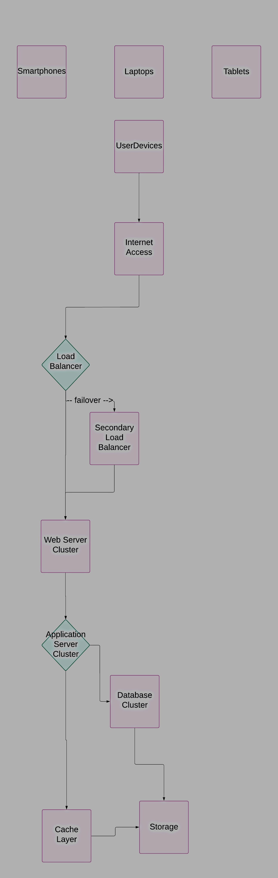
Cloud
7.1 OSI Architecture
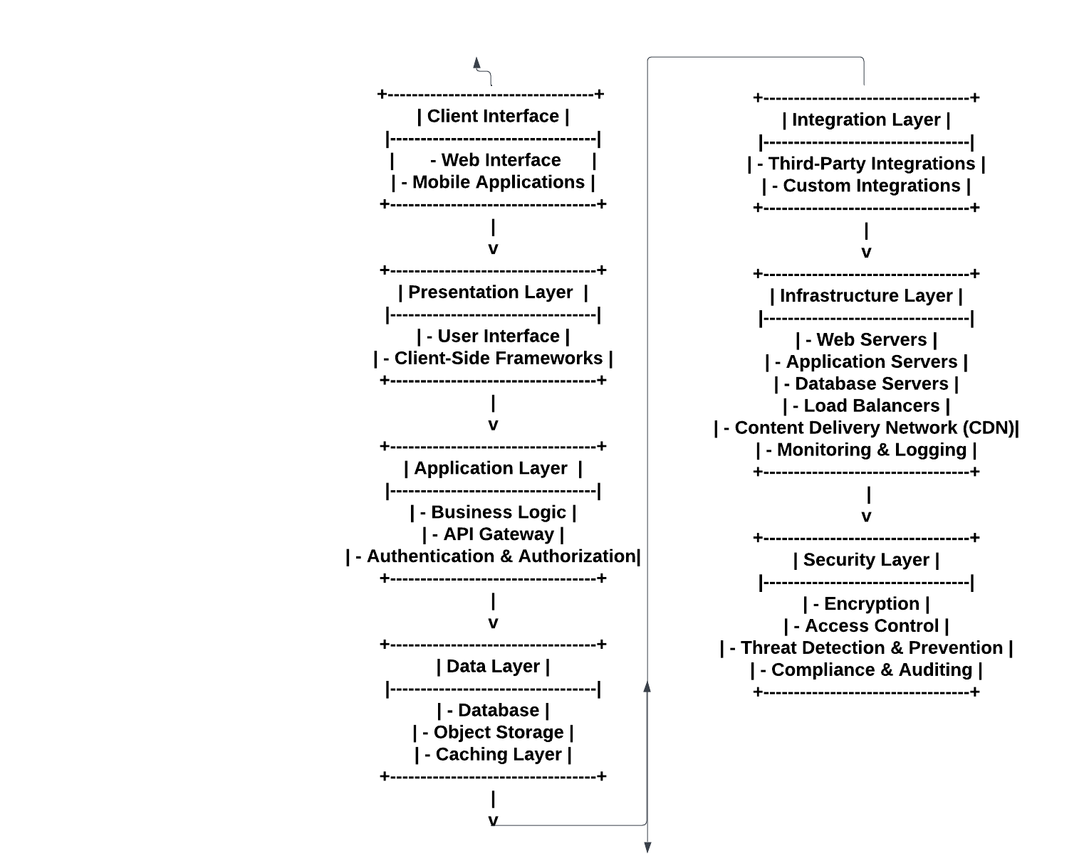

Chapter-8
Implementation

8.1 Initiation

To begin with, let’s access our target, which is a USB drive, which is used by an employee from Henkel, within it stores Data which is used by the company representing various stats of sales and much more. When dealing with a USB drive containing sensitive corporate data, forensic examiners must ensure that the tools and processes employed are properly adapted to handle the unique characteristics of such a storage device. USB drives often incorporate various file systems, encryption methods, and data formats, requiring forensic tools to be versatile and up-to-date
.
One of the initial considerations is the ability to acquire a forensically sound image of the USB drive without altering or compromising the original data. Forensic tools must support the specific file system used by the USB drive, which could range from common formats like FAT or ex-FAT to proprietary or encrypted file systems. Failure to properly handle the file system could result in incomplete or corrupted data acquisition, jeopardizing the integrity of the evidence.

The adaptation of forensic tools and processes is essential when investigating a USB drive containing corporate data from Henkel. By addressing file system compatibility, data parsing capabilities, encryption handling, and multi-source data correlation, and continuous skill development, forensic examiners can effectively navigate the complexities of corporate environments and ensure the admissibility and integrity of digital evidence.
8.2 Checking for Malware/Worms
Performing malware analysis on a USB drive with corporate data from Henkel requires a systematic approach. Firstly, creating a secure environment is essential to prevent malware spread. Here we can use the Pestudio tool for Forensic imaging of the drive preserves evidence for analysis. Forensic tools extract and examine files like documents and spreadsheets. Malware detection methods, including signature-based and behavioral analysis, identify threats. Analysis involves static and dynamic techniques to understand the malware's code and behavior. Memory and network analysis may reveal further insights. Collaboration with stakeholders ensures a coordinated response. Thorough documentation and reporting are vital for compliance and remediation. Adherence to forensic procedures and continuous training are crucial for effective analysis and response to evolving threats.

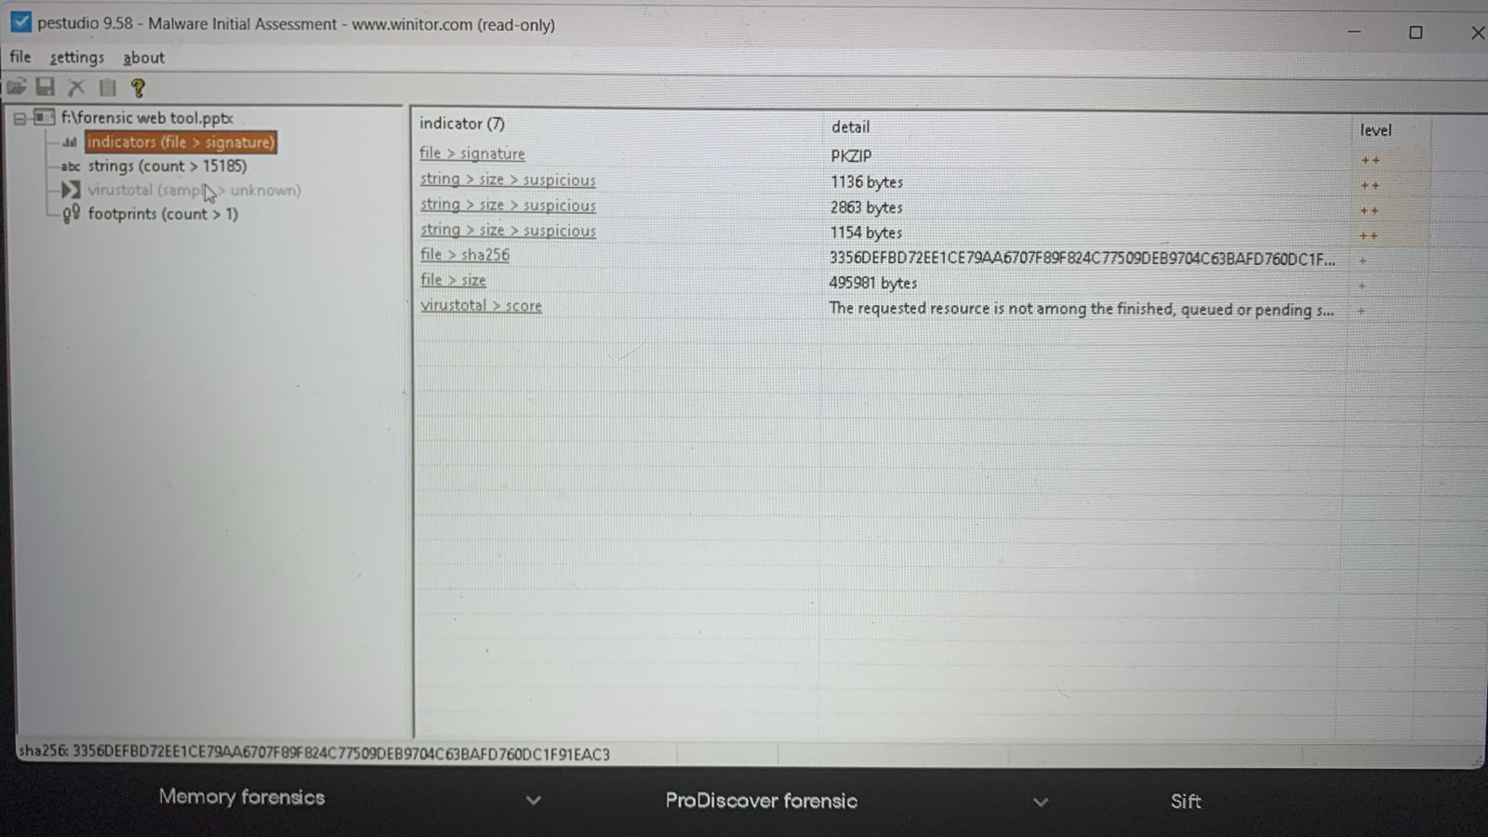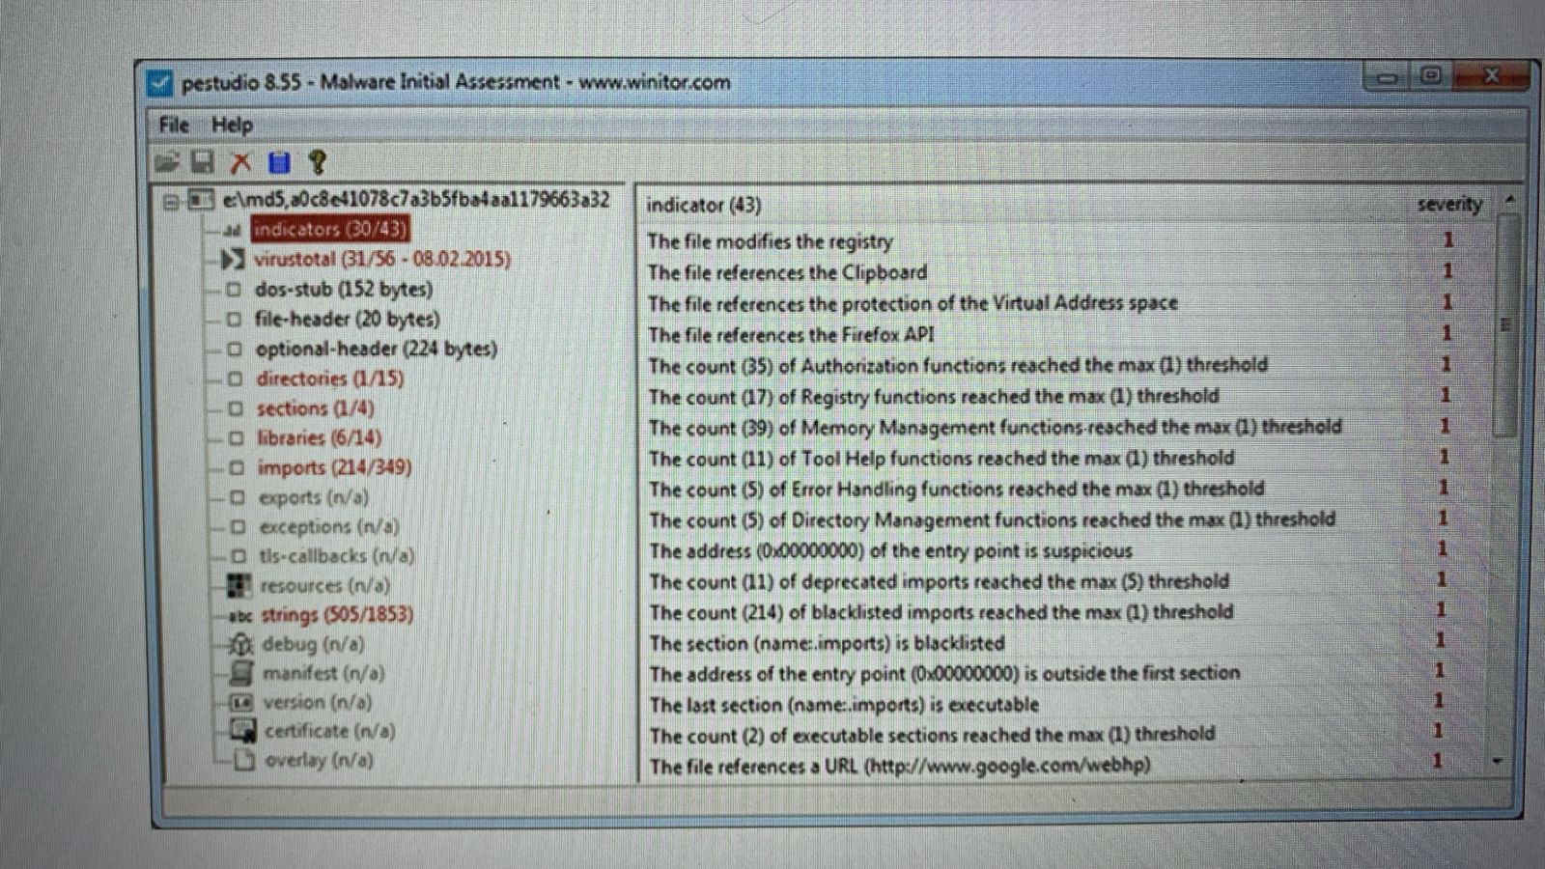

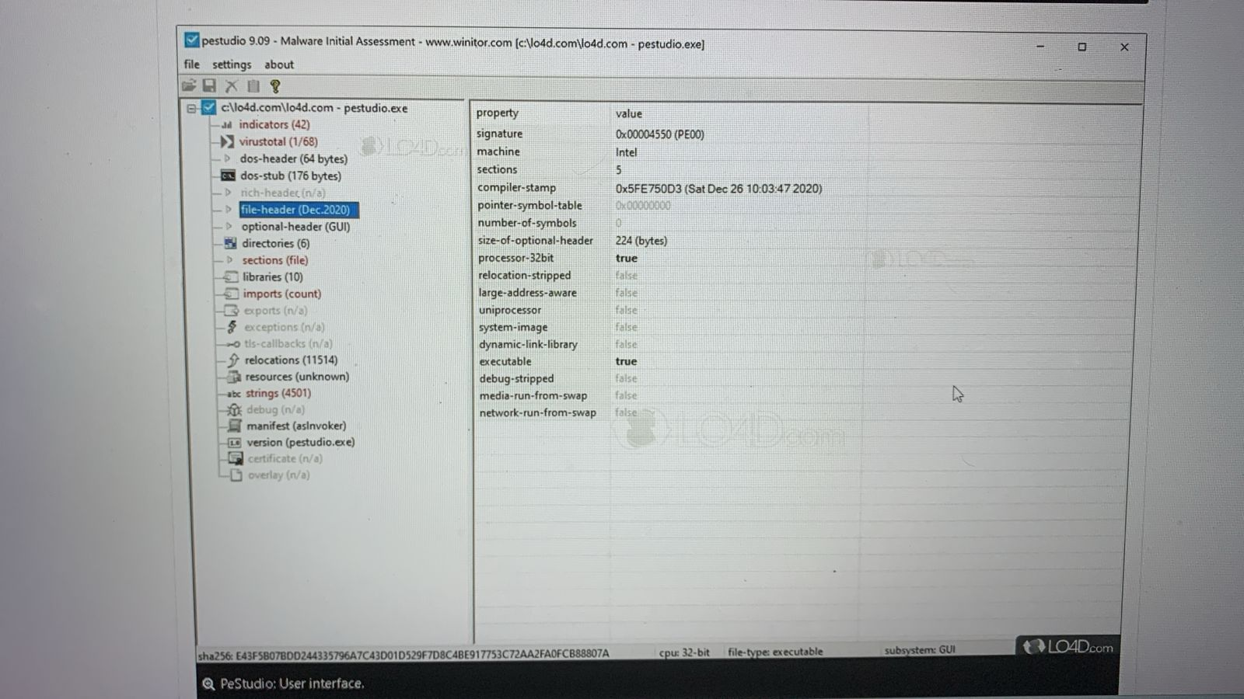

8.3 FTK

FTK Imager is a widely used digital forensics tool developed by AccessData. It is a data preview and imaging tool that allows investigators to acquire and analyze data from various sources, including hard drives, removable media, and mobile devices. FTK Imager is widely used in digital forensics investigations, particularly in law enforcement, corporate security, and incident response scenarios. It provides a reliable and efficient way to acquire and preview data from various sources, laying the foundation for further forensic analysis using other tools in the AccessData suite or third-party software.

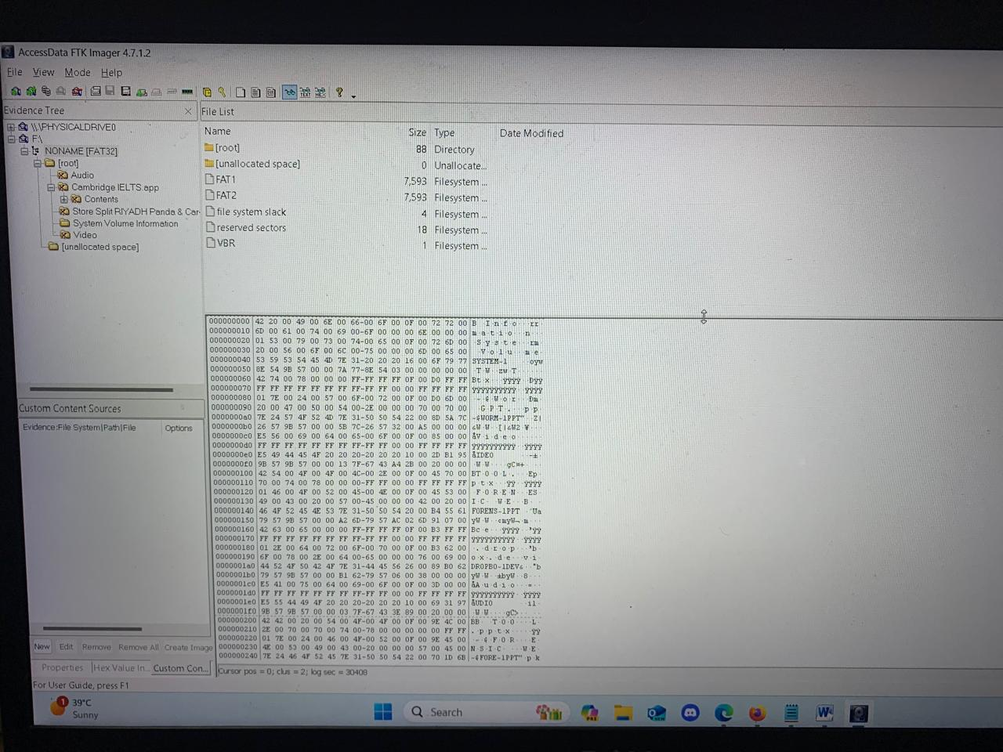
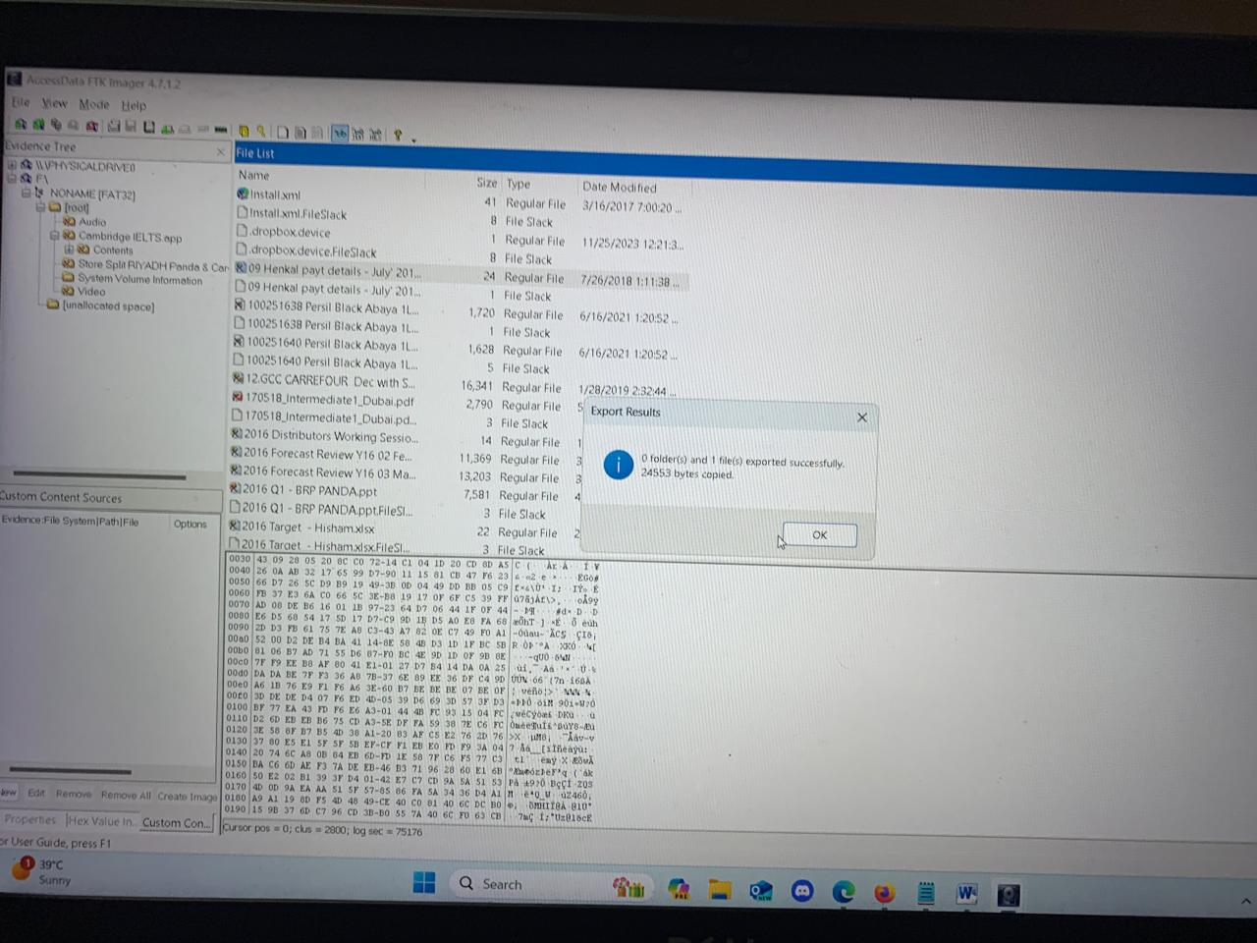
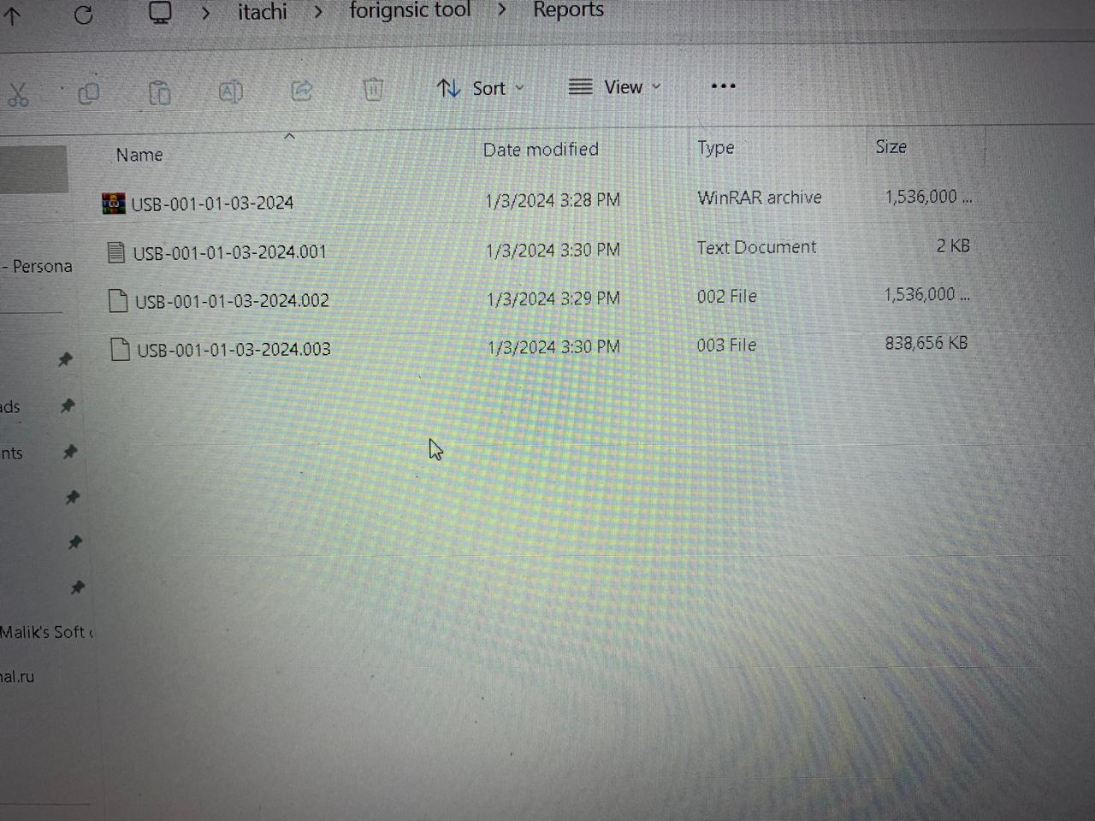

8.3 Autopsy

Autopsy is a popular open-source digital forensics platform used for analyzing disk images and recovering data from various sources. Developed by Basis Technology, Autopsy is designed to be a comprehensive tool for forensic investigations. Autopsy is widely used in law enforcement, incident response, and digital forensics investigations due to its comprehensive feature set, open-source nature, and active development community. It provides a user-friendly graphical interface, making it accessible to both novice and experienced forensic examiners.

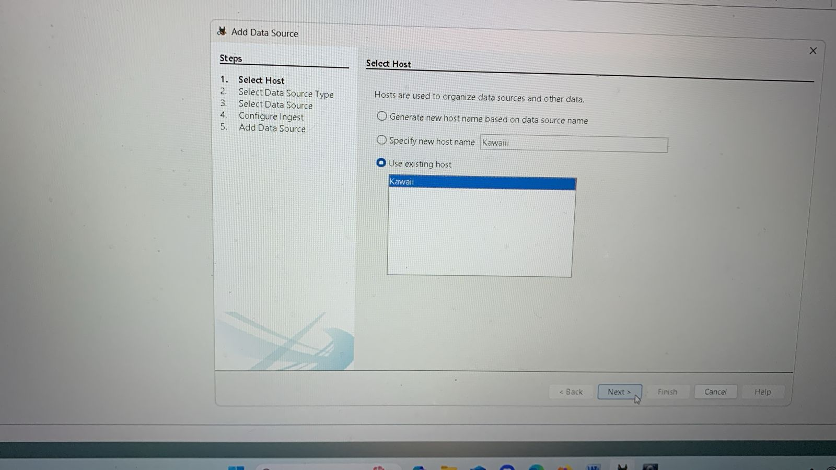
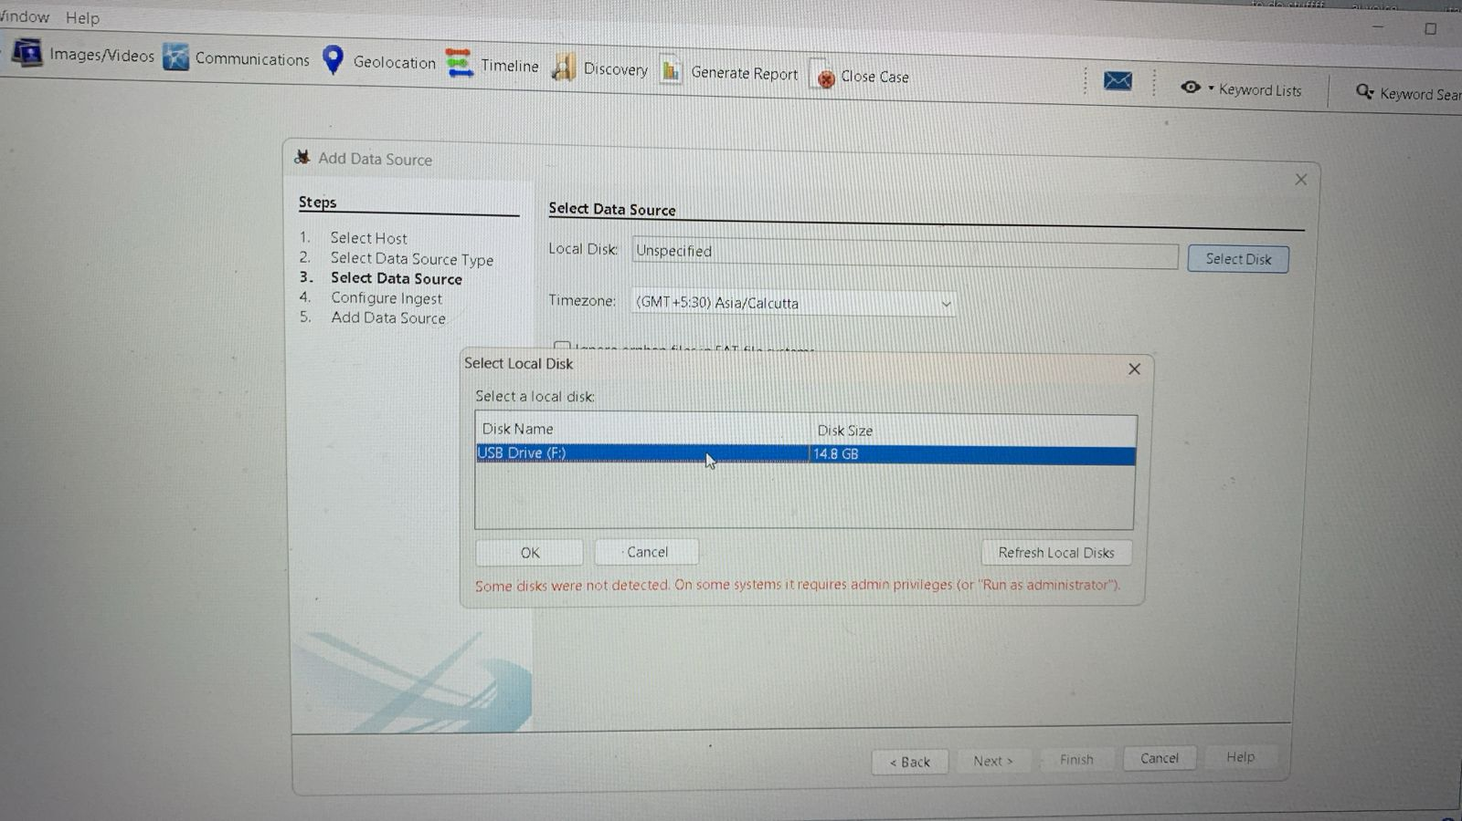
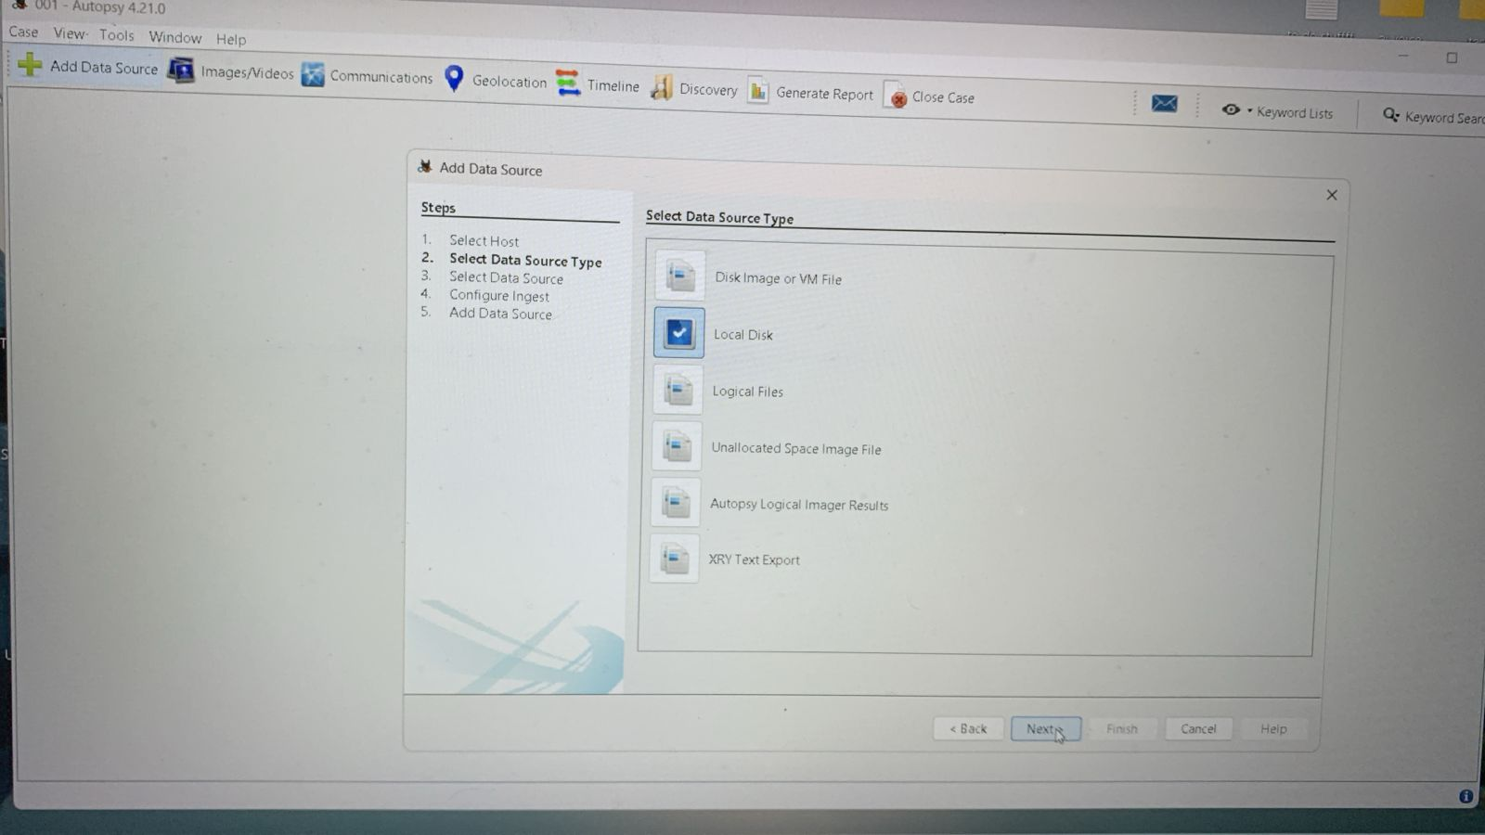
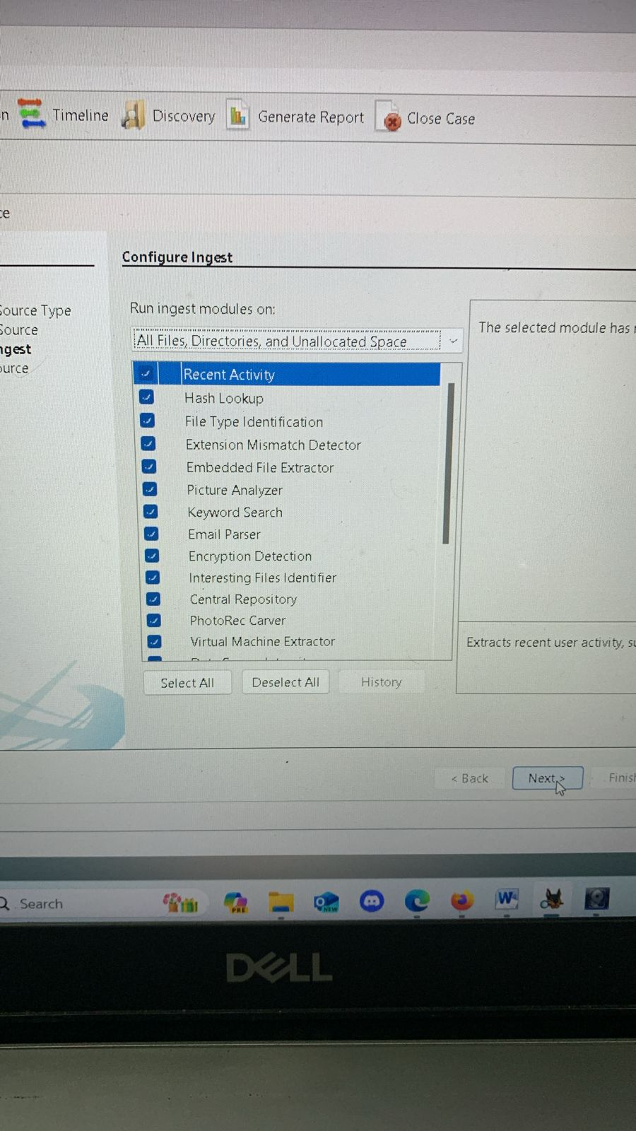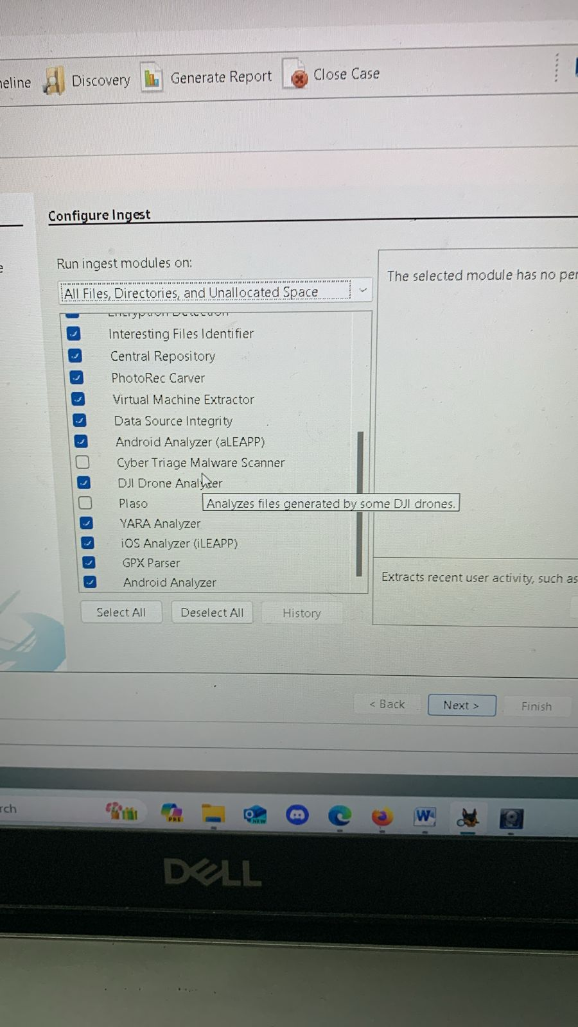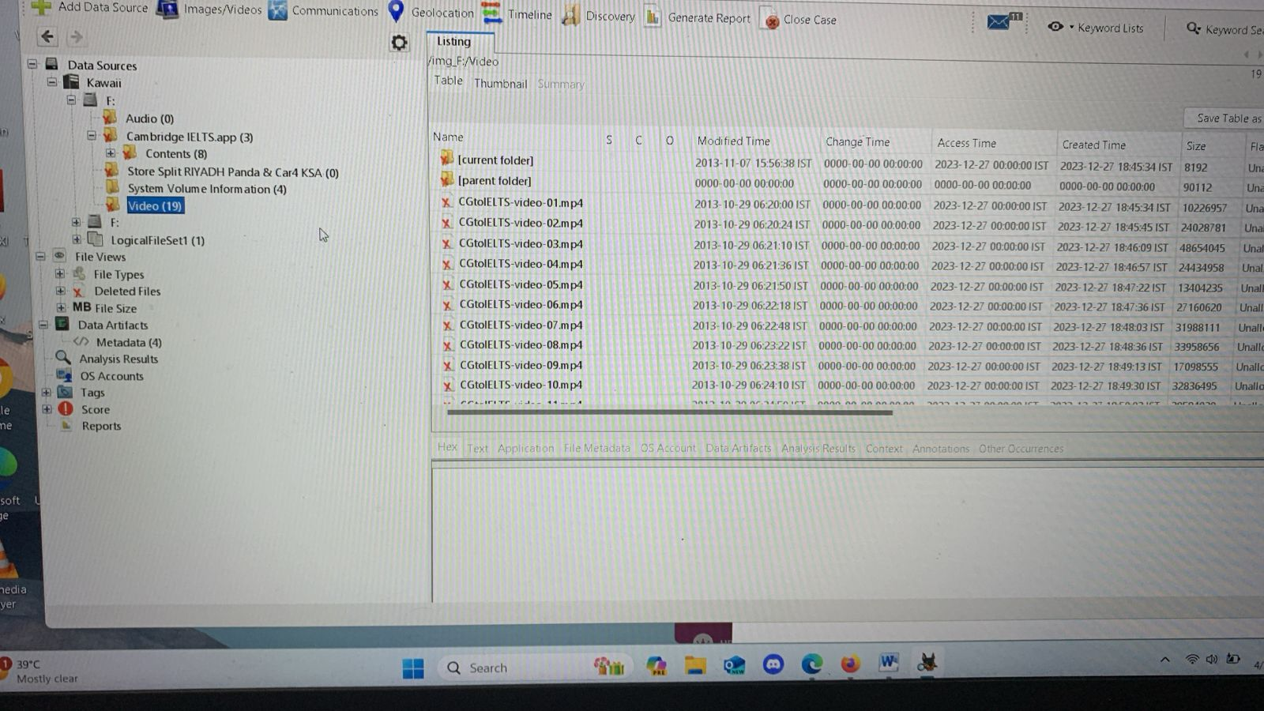

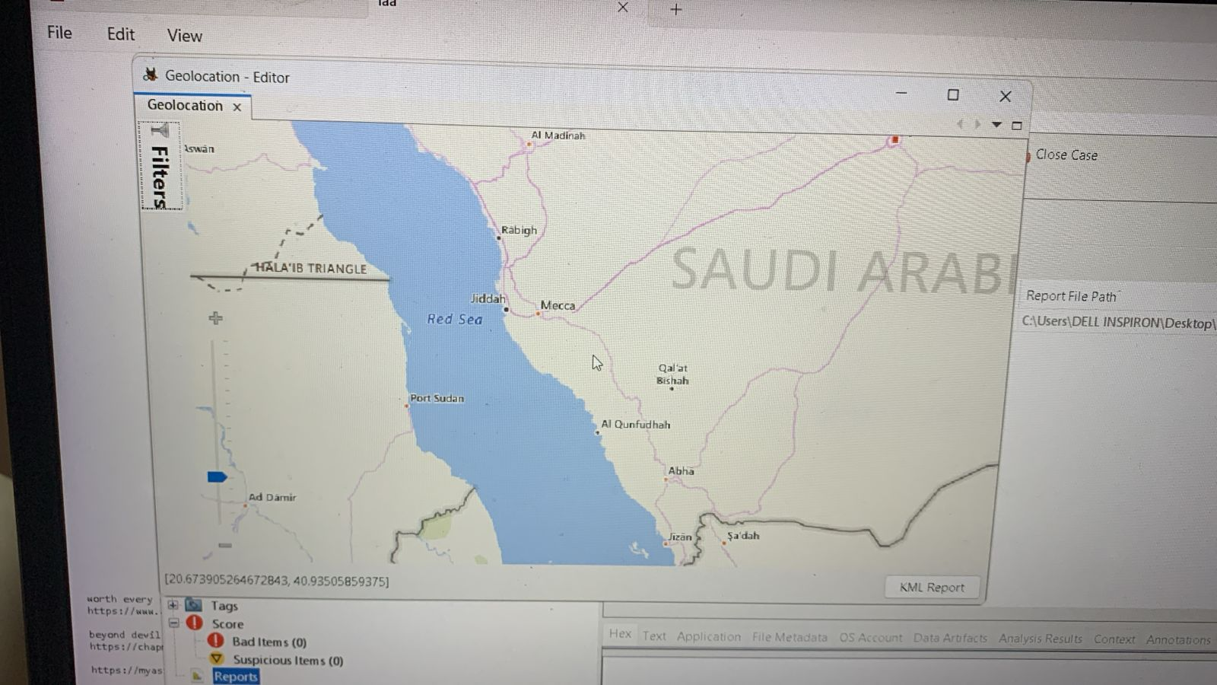

8.4 SIFT

The SIFT Workstation (SIFT stands for "SANS Investigative Forensic Toolkit") is a powerful forensic environment designed for digital forensic investigations and incident response. It is a bootable live Linux distribution developed and maintained by the SANS Institute. The SIFT Workstation is widely used by law enforcement agencies, incident response teams, and digital forensic professionals. It provides a comprehensive and centralized platform for conducting forensic investigations, with a focus on reproducibility, consistency, and ease of use. The regular updates and active community support make SIFT a valuable resource in the field of digital forensics.

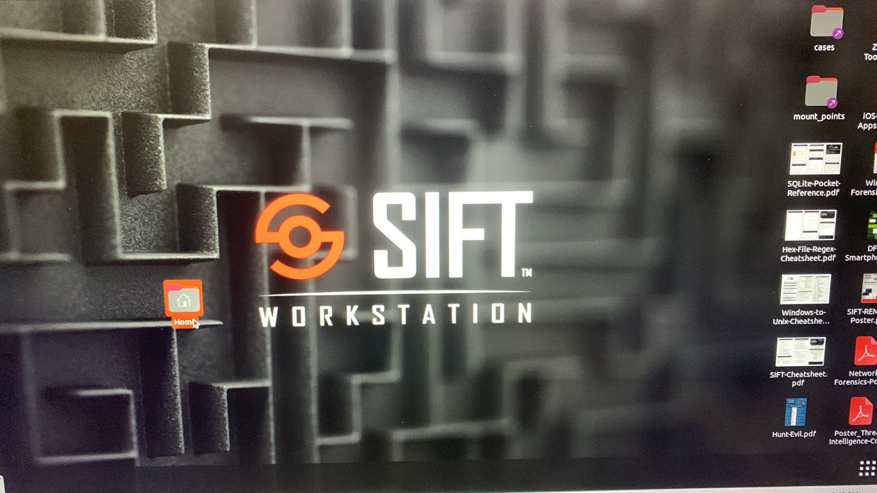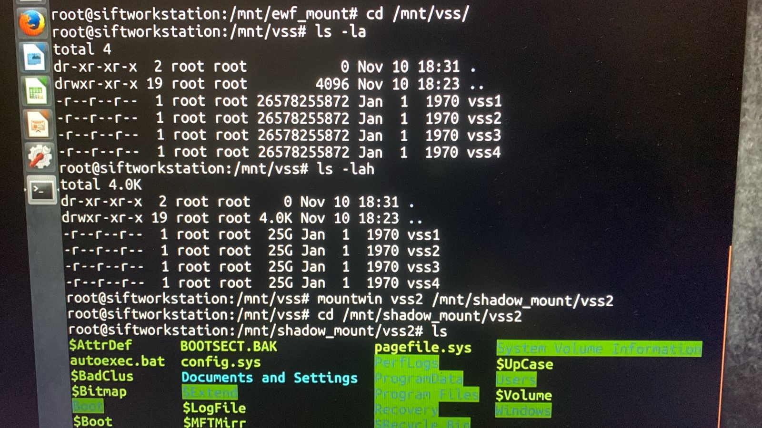
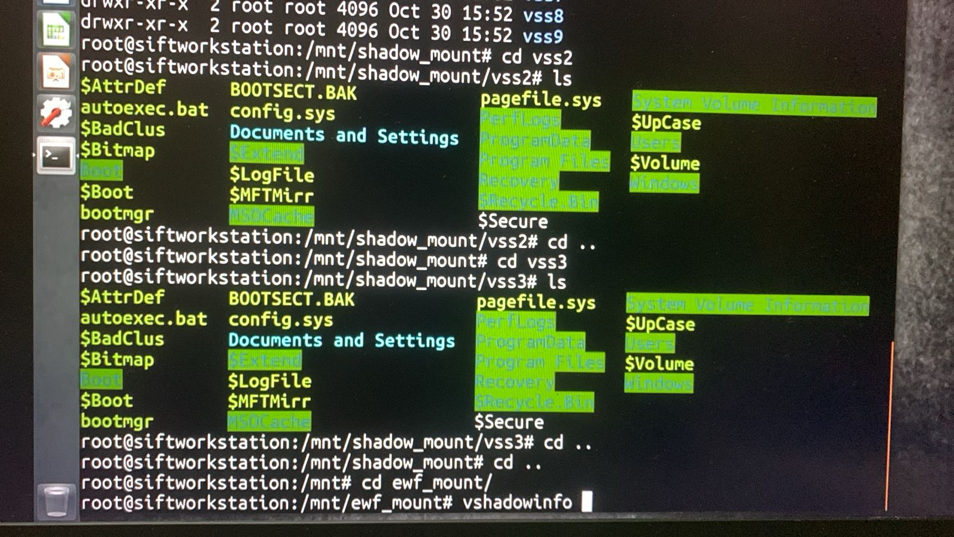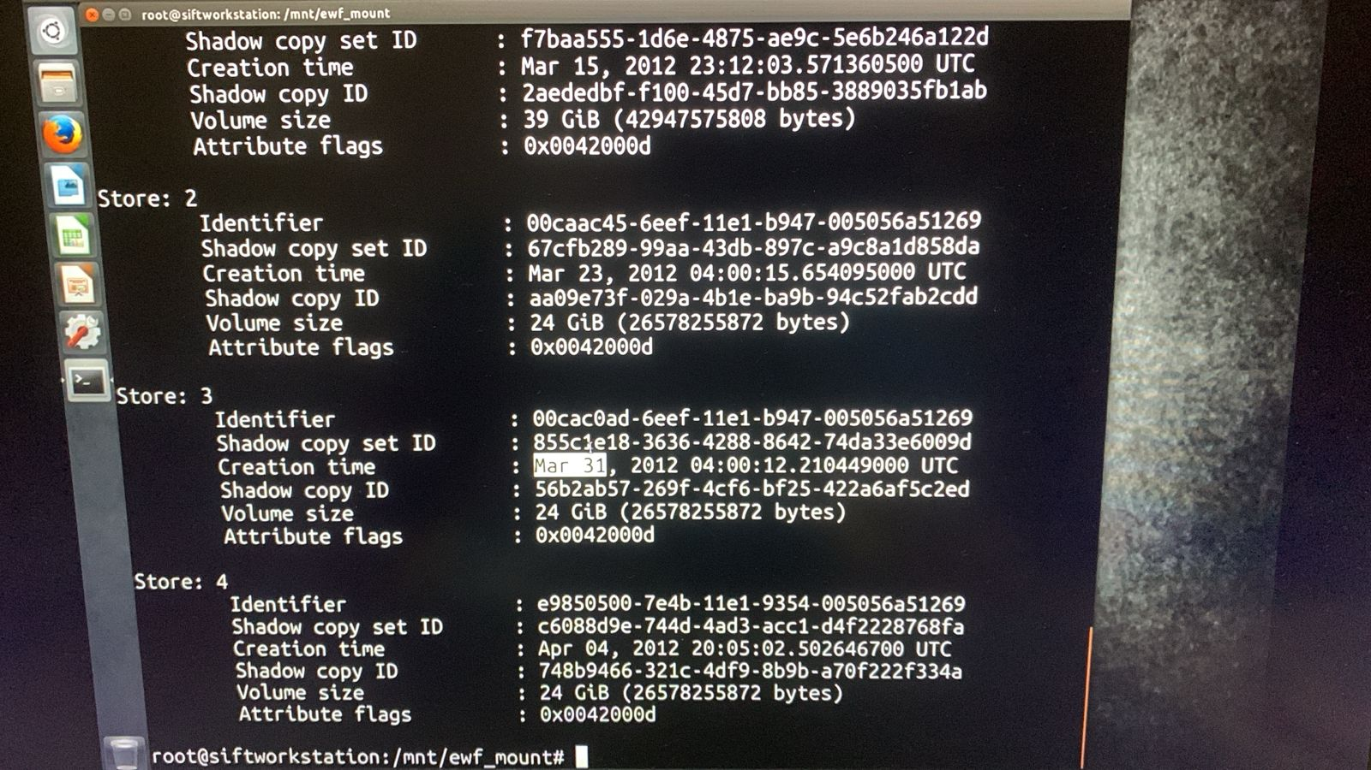

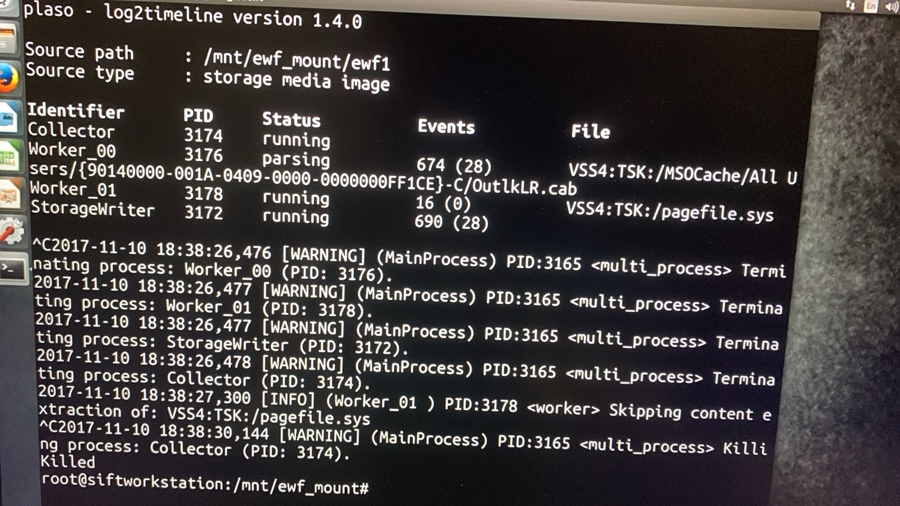

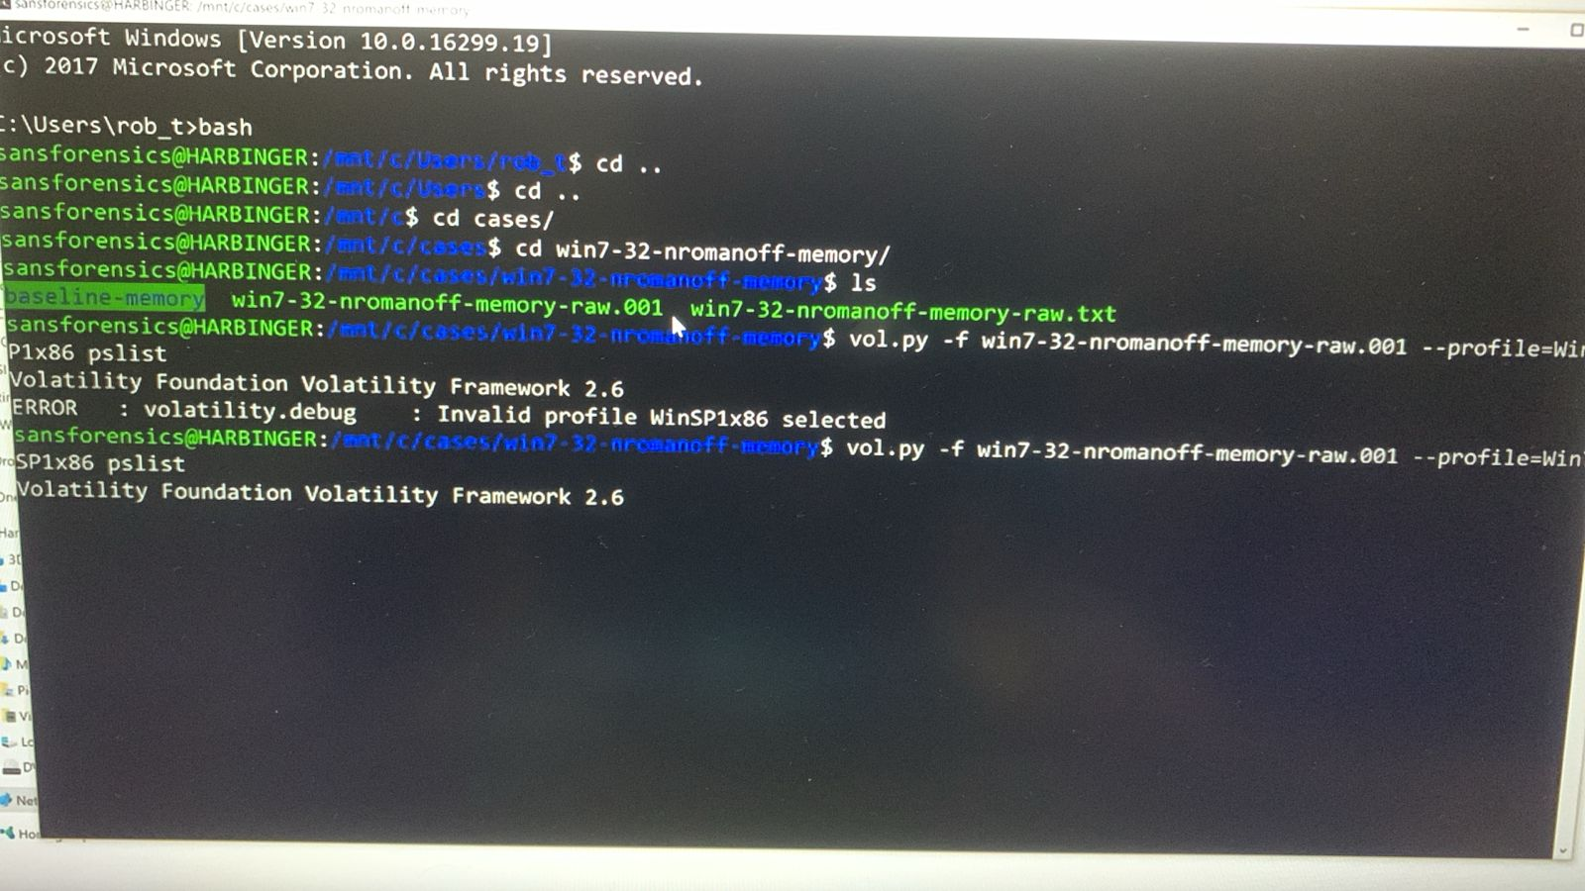

8.5 Volatility tool

Volatility is an open-source framework for extracting digital artifacts from volatile memory (RAM) dumps. It is widely used in digital forensics and incident response for analyzing the runtime state of a system and investigating malicious activities. Volatility is a powerful tool widely used by digital forensics investigators, incident responders, and security researchers. Its ability to analyze volatile memory and extract valuable artifacts makes it an essential tool for investigating advanced threats, malware incidents, and system compromises. The active development community and plugin ecosystem further enhance Volatility's capabilities and ensure its continued relevance in the field of memory forensics.

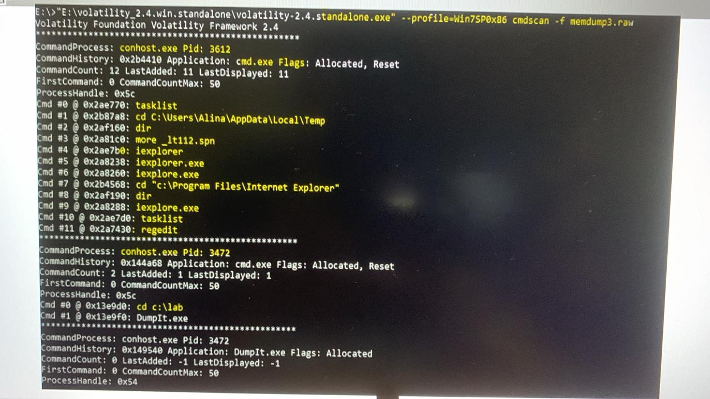
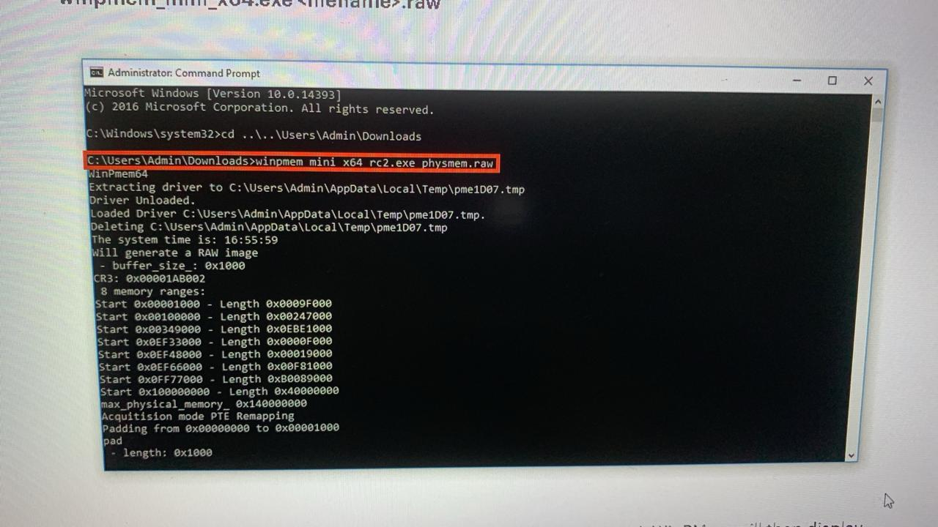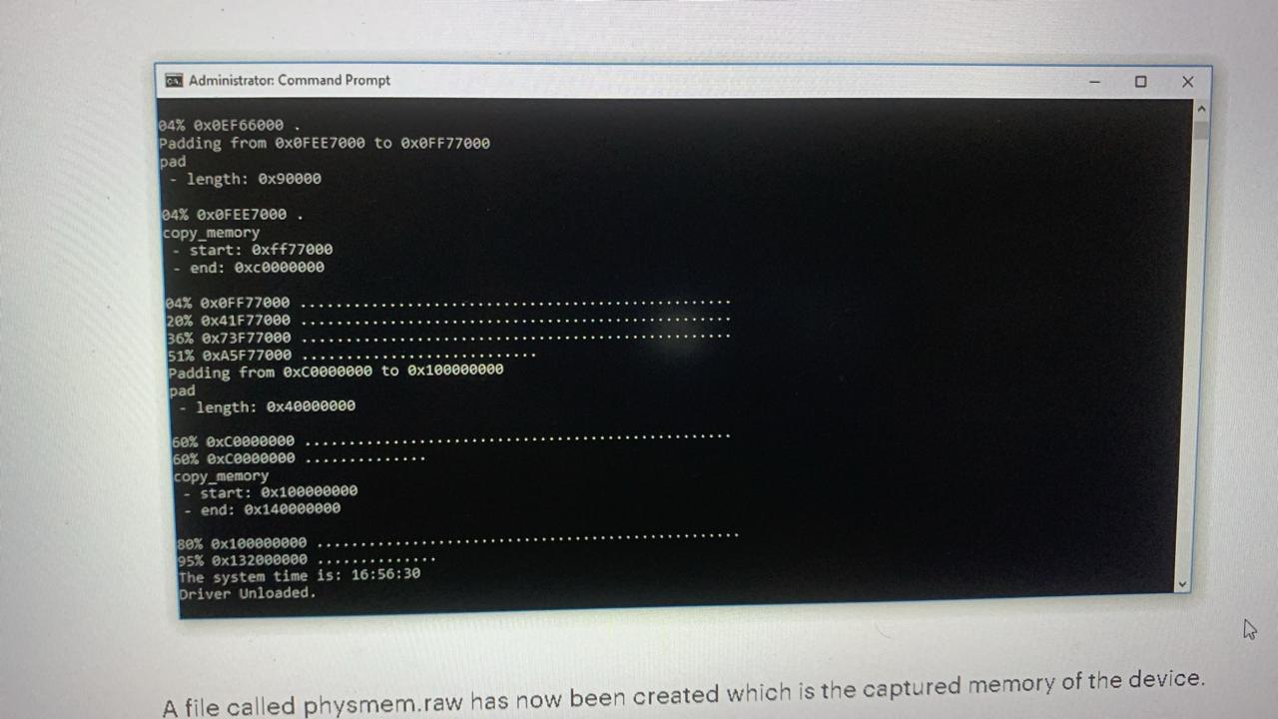

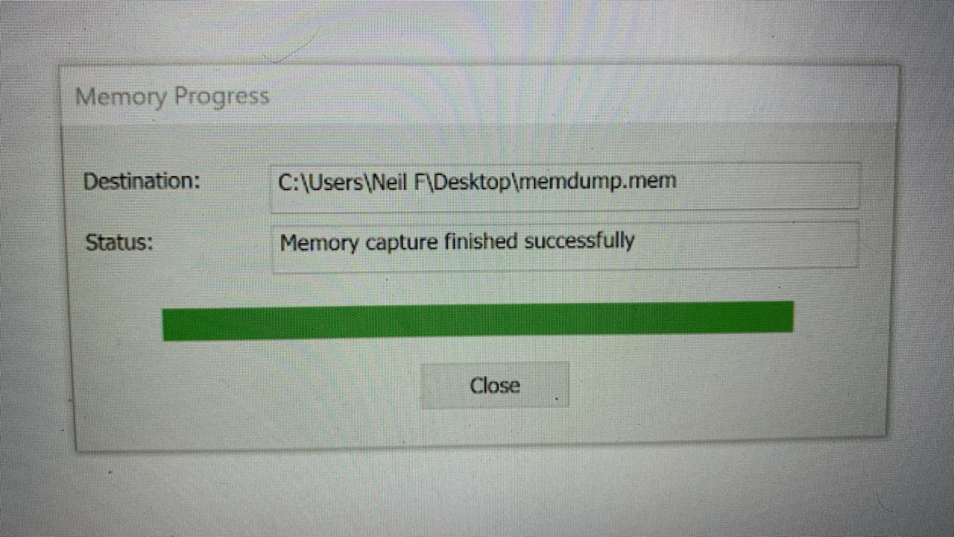

8.6 Kali framework
The Kali Linux distribution, known for its robust security tools and utilities, serves as a foundational framework for conducting cyber forensics investigations. At its core, Kali Linux is designed with a focus on penetration testing, digital forensics, and security auditing, making it a preferred choice for cybersecurity professionals and forensic analysts alike.
One of the key strengths of Kali Linux for cyber forensics is its extensive collection of pre-installed tools and utilities specifically tailored for forensic analysis and investigation. These tools encompass a wide range of functionalities, including disk imaging, file carving, memory forensics, network analysis, and malware analysis, among others. Examples include tools like Autopsy, Foremost, Sleuth Kit, Volatility, Wireshark, and many more, each serving a specific purpose in the forensic analysis process.
Furthermore, Kali Linux provides a highly customizable and flexible environment, allowing forensic analysts to tailor the operating system and toolset to meet the specific requirements of their investigations. Whether it's customizing the user interface, installing additional tools from the extensive Kali Linux repository, or configuring specialized forensic workflows, Kali Linux offers the flexibility needed to adapt to various forensic scenarios and investigative needs.
In addition to its robust toolset and customization options, Kali Linux emphasizes security and privacy, essential aspects of any cyber forensics investigation. The distribution includes built-in security features such as full disk encryption, secure shell (SSH) access, and anonymity tools like Tor, ensuring that forensic analysts can conduct investigations securely and protect sensitive data throughout the process.
Moreover, Kali Linux facilitates collaboration and knowledge sharing within the cybersecurity and forensic communities through its active community support, forums, and training resources. Cybersecurity professionals and forensic analysts can leverage these resources to exchange ideas, share best practices, and stay updated on the latest trends and techniques in cyber forensics.

The Kali Linux framework serves as a powerful platform for cyber forensics investigations, providing a comprehensive suite of tools, customization options, security features, and community support. By leveraging the capabilities of Kali Linux, forensic analysts can effectively conduct investigations, analyze digital evidence, and uncover insights crucial for addressing cyber threats and criminal activities.

8.7 Tails framework
TAILs, which stands for "The Amnesic Incognito Live System," is a privacy-focused operating system designed to preserve anonymity and security while browsing the internet or conducting sensitive activities online. TAILS achieves this by routing all internet traffic through the Tor network, encrypting files and communications, and leaving no digital footprint on the host system. This makes TAILS an invaluable tool for individuals and organizations concerned about privacy, security, and surveillance.
In the realm of cyber forensics, TAILS plays a significant role in conducting secure and anonymous investigations. Forensic analysts often utilize TAILS as a bootable live system, allowing them to conduct forensic analysis on suspect systems without altering or contaminating the original evidence. By booting into TAILS, analysts can bypass the host operating system, ensuring that no changes are made to the underlying storage devices.
One of the key advantages of using TAILS in cyber forensics is its focus on security and privacy. TAILS comes pre-configured with a suite of forensic tools and utilities, including disk imaging tools, file recovery utilities, network analysis tools, and cryptographic software. These tools enable forensic analysts to collect, preserve, and analyze digital evidence while maintaining the integrity and confidentiality of the data.
Furthermore, TAILS' integration with the Tor network ensures that all network traffic generated during the forensic analysis is anonymized and encrypted, protecting both the investigator's identity and the integrity of the investigation. This is particularly important when conducting investigations involving sensitive or confidential information, where maintaining anonymity and privacy is paramount.

Another advantage of using TAILS in cyber forensics is its "amnesic" nature. TAILS is designed to leave no trace of activity on the host system after shutdown, ensuring that any changes made during the forensic analysis are temporary and do not impact the integrity of the original evidence. This makes TAILS ideal for conducting covert or undercover investigations where maintaining stealth and discretion is critical.
In conclusion, TAILS framework serves as a powerful tool for cyber forensics, enabling forensic analysts to conduct secure, anonymous, and non-invasive investigations while preserving the integrity and confidentiality of digital evidence. By leveraging TAILS' privacy-focused features and integrated forensic tools, investigators can effectively navigate the complexities of digital investigations while upholding ethical and legal standards.

Chapter-9
Counter measures against OMG Cables

9.1 OMG cable detector


The OMG Cable Detector refers to a security tool developed by security researcher Mike Grover, also known as "MG." This device is a modified Apple Lightning to USB cable that has been altered to include various hacking capabilities. The OMG Cable Detector is designed to mimic a standard charging cable but includes hidden hardware and software components that allow it to perform malicious activities when connected to a device.

One of the key features of the OMG Cable Detector is its ability to act as a keystroke injection tool, enabling it to send predefined keystrokes to a connected device, such as a computer or smartphone. This capability allows attackers to execute commands, install malware, or exfiltrate sensitive information without the user's knowledge.

In simple words, if there is a red light visible in usb, we can conclude that the current usb port is safe from its driver. Else on the other hand, if there is not red light in the USB, The port has been exploited by the use of OMG cable and the driver needs to be changed.

The OMG Cable Detector highlights the potential security risks associated with using untrusted or tampered charging cables. It serves as a reminder of the importance of exercising caution when connecting devices to external peripherals, especially in public or unsecured environments.

To mitigate the risk of falling victim to attacks using devices like the OMG Cable Detector, users should only use charging cables from trusted sources and avoid connecting their devices to unknown or untrusted USB ports. Additionally, organizations can implement security measures such as device authentication, endpoint protection, and network segmentation to detect and prevent unauthorized access and malicious activities.
Obviously by having knowledge of the usage of questionable charging cable for your unit will go along way in preventing this occurrence. Sometimes we like picking arbitrary cables available at our workplaces or elsewhere, but the associated danger is huge. The users and staff must also be made conscious about this threat.
There is a small embedded chip in each of the O.MG cables and they have almost similar sizes with ordinary cables. This makes it very difficult to tell between an ordinary wire and the O.MG cables. This attack can occur in public places such as sharing charging or presentation cables. This is where we talk about Unified Endpoint management (UEM).
9.2 Additional Tips

Additionally, even if you use an unattended charger bought online to plug your device, an information thief can transmit your data to a remote attacker. The problem with O. MG cables is that most users assume they must be safe since they look like regular cellphone charging cord. This involves the use of any kind of cord whether it could be lightning, USB-C, USB-A, micro-USB and it does not matter whether the device is Apple or Android.
UEM has effective systems used to safeguard information even when it lands on the hand of malicious individuals. UEM solutions have security features that ensure protection of corporate information from insecure device use or other security threats.

9.3 UEM features
-USB file transfer control
-Files app USB drive access
-Accessing network drive within Files app.
-Media Management
-Restrict admin users only for the app installation.
-Administrators can use iOS feature called "prevention of pairing with non-configurator hosts" to restrict the devices that a given user is allowed to connect to.

9.4 Modern Point of View

In an increasingly competitive world, data security is a top priority for both individuals and corporations. Have you picked up an extra cord in meeting rooms or purchased generic cheap wires on Amazon? With hacking cables freely available on the internet, you must always be on the watch for a data breach.
From a software point of view, the OMP cable is nothing “innovative.” There are no new vulnerabilities neither on the software or the hardware of the personal computer.
The most interesting feature, however, concerns the shape of that cable. For example, if you find a stranger’s USB pen or a person randomly picks a flash disk from the street, some individuals would assume that, since they are not aware of a flash disk contents, it may be dangerous to plug a person’s computer into it. It is not unlikely that you would do this, though, just as some of these people wouldn’t hesitate to insert such a random charger cable found on a desk in the break room into their computers.
It goes like this- “it’s just a cable, what can it hurt”. In fact, O.MG Cable is just a cable, but one which contains all components of a small CPU such as logic, memory, clock and so on.

9.5 Practical approach
Therefore, the cable alone cannot penetrate into the information stored in your computer. You ask as if just by plugging in a cable would give some sort of access to the content, but it doesn’t. Therefore, the microprocessor only sends information to the computer, since it doesn’t get payloads from the computer directly. For any data transfer to take place, some software must be activated by sending keypresses (etc) via the microprocessor to get some data that will be sent back to the microprocessor through the cable. For example, when you are logout and the system has the FileVault enabled, there will be nothing that can be sent to the cable’s microprocessor.

Another thing is, if you could just imagine a microprocessor itself equipped with a wireless interface (imagine RF, radio, Bluetooth, or Wifi). In this case, it would be possible for an adversary situated somewhere nearby a victim that can be seen. Then the victim inserts the cable into the USB port of the computer without knowing that it is actually the attacker who wirelessly simulates keystrokes and mouse movement while the victim has turned her/his back. It is possible to carry out this when the user will have unlocked the machine.
It is fairly simple to prevent such an attack in theory. Keyboard and mouse should not be able to plug in the computer. In other words, this will have little to do with a very hard mind puzzle, an elaborate kind of attack.
9.6 Reality Check
The reality is that in practice home users are likely to get rather puzzled should they plug mouse and keyboard only to find them being totally non-functional. Thus, most common operating systems such as Windows, Mac and Linux enable you to plug in your keyboard, mouse, etc. without procedure.
Technically one can guard against O.MG cable by informing users on how not to use cables of unknown origins (organizationally). This measure ensures that the users know how to use a special shield adapter which connects only the power pins of the cable in the computer. Secondly, It includes for instance a message on the Touch Bar which a MacBook Pro user should confirm with a tap.

Chapter-10
Results
Pestudio

In this result image we can see that the data in the target drive is free from malware and worms. As the result score is clean for all the target data.

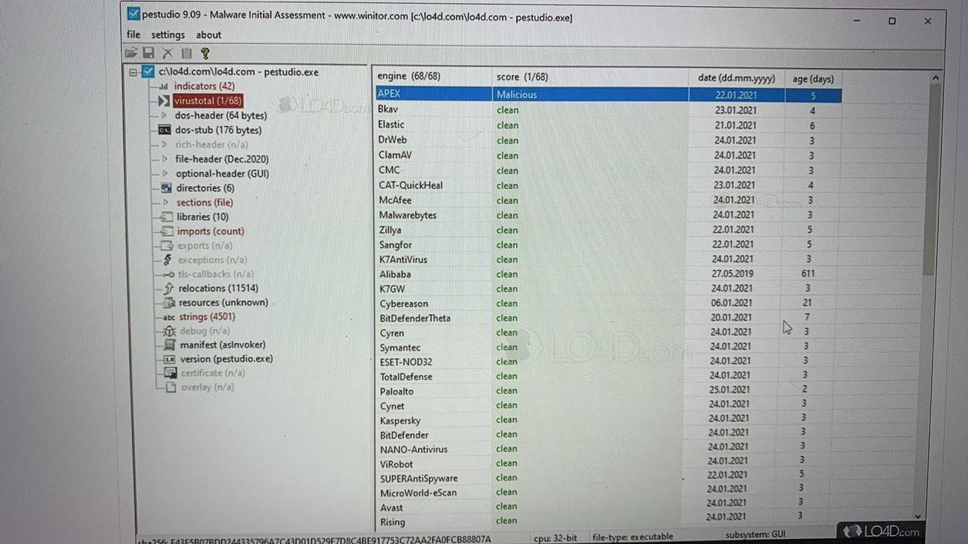

FTK Imager

In this result we can tally the SHA1 checksum and MD5 checksum as a part of image verification results. We can also have a perfect view image information and gist of drive analysis

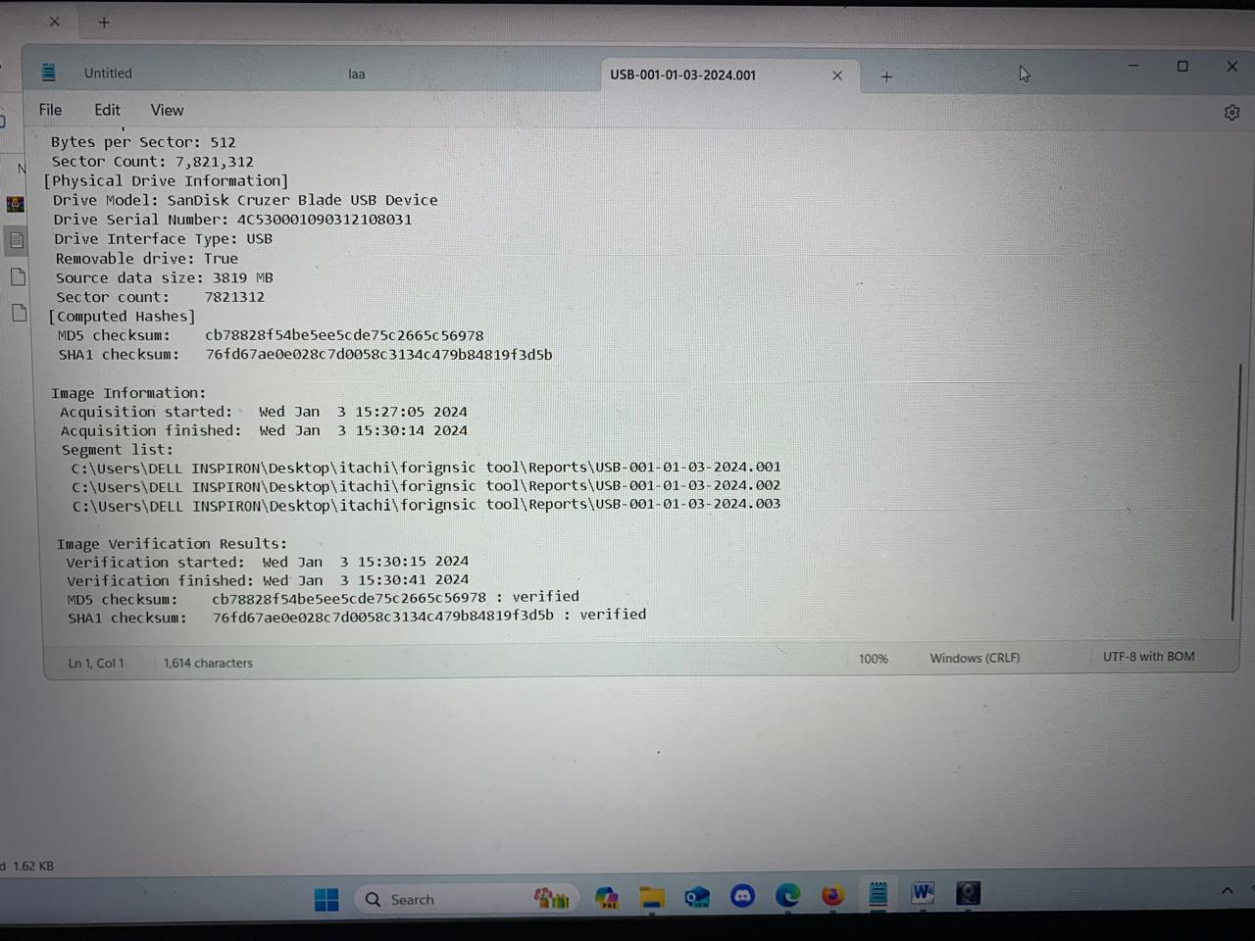

Autopsy

In this result we are able to extract the deleted data from the target drive and get the geo location of the time of retrieval. Along with this we are able to access data credentials, file extension, file type, address, hash values, permissions, Full path.

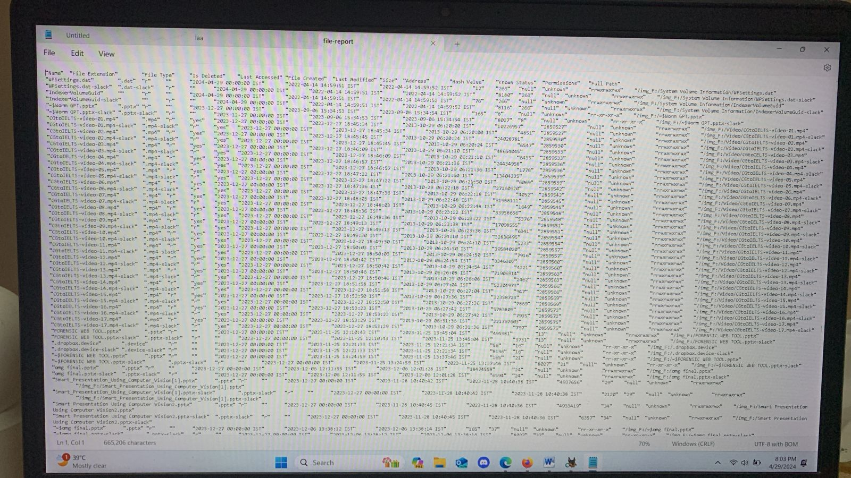
SIFT

The SIFT Workstation (SIFT stands for "SANS Investigative Forensic Toolkit") is a powerful forensic environment designed for digital forensic investigations and incident response. It is a bootable live Linux distribution developed and maintained by the SANS Institute.
The SIFT Workstation is widely used by law enforcement agencies, incident response teams, and digital forensic professionals. It provides a comprehensive and centralized platform for conducting forensic investigations, with a focus on reproducibility, consistency, and ease of use. The regular updates and active community support make SIFT a valuable resource in the field of digital forensics.

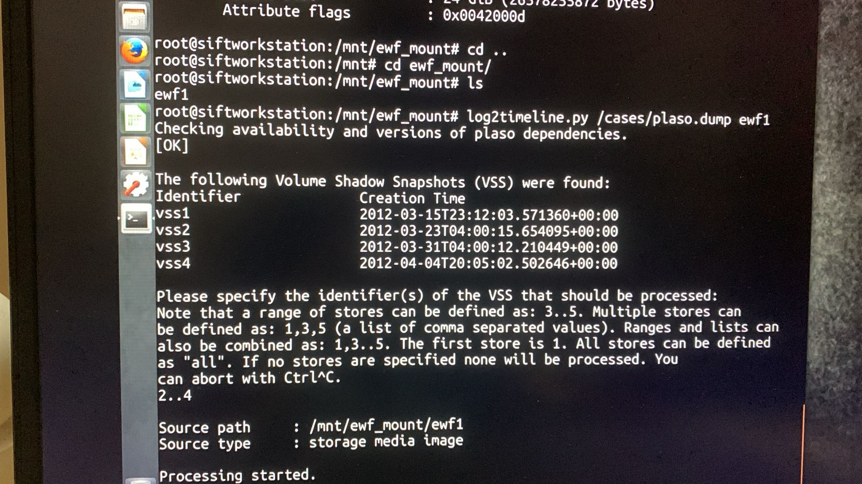

VOLATILITY TOOL

In this result we are able to extract PID, PPID, Thds, Hnds, Sess, Wow64, Start location and we are able to perform RAM foreiensic.

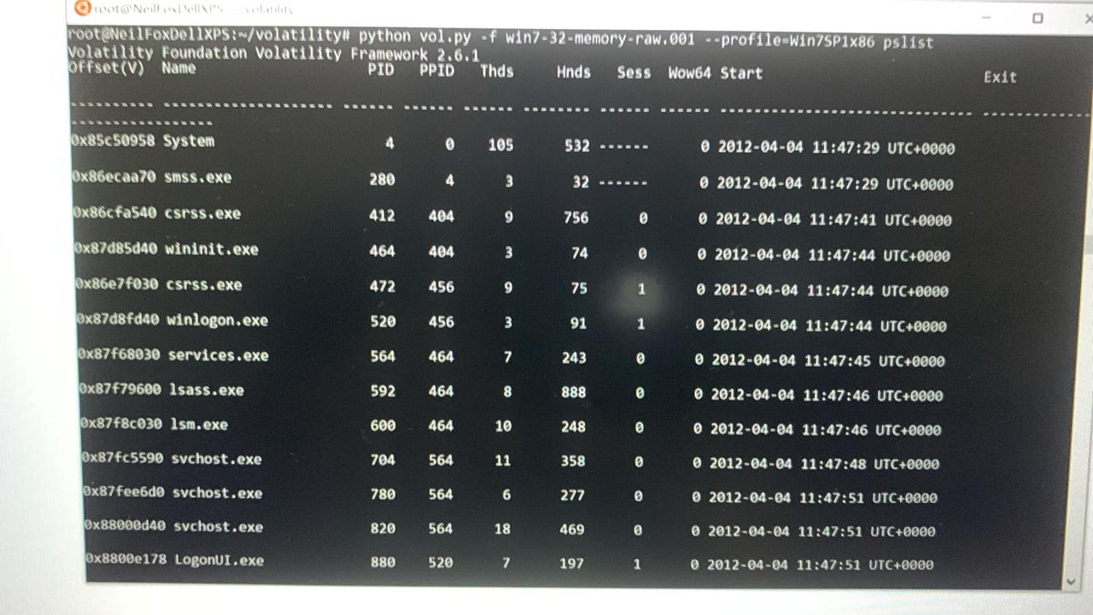

Chapter-11
Merits and Demerits
10.1 Merits:

- Comprehensive Collaboration Platform:
  - Bitrix24 provides a wide range of collaboration tools, including task management, document sharing, calendars, CRM, communication tools, and more, all integrated into a single platform.
  - This comprehensive suite of features allows teams to work together efficiently and effectively, eliminating the need for multiple disparate tools.
- User-Friendly Interface:
  - Bitrix24 is known for its intuitive and user-friendly interface, making it easy for users to navigate and utilize its various features.
  - Whether it's creating tasks, sharing documents, or communicating with team members, Bitrix24 offers a seamless user experience that requires minimal training.
- Cloud-Based Accessibility:
  - As a cloud-based platform, Bitrix24 allows users to access their work from anywhere with an internet connection.
  - This flexibility enables remote teams to collaborate effectively, facilitates mobile work, and ensures that team members can stay productive even when they're on the go.
- Scalability:
  - Bitrix24 is designed to scale with the needs of businesses of all sizes, from small startups to large enterprises.
  - Whether it's adding new users, expanding storage capacity, or customizing workflows, Bitrix24 can accommodate growth and adapt to changing business requirements.
- Customization Options:
  - Bitrix24 offers extensive customization options, allowing businesses to tailor the platform to their specific needs and preferences.
  - From custom fields and workflows to personalized dashboards and reports, Bitrix24 can be customized to align with unique business processes and objectives.

- Integration Capabilities:
  - Bitrix24 integrates seamlessly with a wide range of third-party applications and services, including popular tools like Google Workspace, Microsoft Office 365, Dropbox, and more.
  - This integration capability allows businesses to leverage their existing tools and workflows within the Bitrix24 platform, enhancing productivity and efficiency.

- Security Features:
  - Bitrix24 prioritizes security and offers robust security features to protect sensitive data and ensure compliance with data protection regulations.
  - This includes data encryption, access controls, IP restrictions, two-factor authentication, and regular security updates to mitigate potential security risks.
- Affordability:
  - Bitrix24 offers a range of pricing plans, including a free tier with basic features and paid plans with additional functionality.
  - This affordability makes Bitrix24 accessible to businesses of all sizes, including startups and small businesses with limited budgets.

10.2 Demerits:

Complexity:

Bitrix24 can be overwhelming for some users due to its extensive range of features and customization options.

Navigating through the various modules and settings may require a learning curve, especially for new users or those unfamiliar with similar platforms.

Performance Issues:

In some cases, users have reported performance issues with Bitrix24, such as slow loading times, lags in response, and occasional system downtime.

These performance issues can affect productivity and user experience, particularly for organizations with large user bases or complex workflows.

Integration Challenges:

While Bitrix24 offers integration with third-party applications and services, integrating external tools or customizing workflows may be challenging for non-technical users.

Limited compatibility with certain software or platforms may also hinder seamless integration with existing systems.

Limited Customization:

While Bitrix24 allows for extensive customization of workflows, forms, and automation rules, some users may find the customization options limiting or restrictive.

Advanced customization may require technical expertise or additional development resources, which may not be feasible for all organizations.

Mobile App Limitations:

While Bitrix24 offers mobile applications for iOS and Android devices, the mobile app may lack certain features or functionalities available on the web version.

Users may encounter limitations in accessing and managing tasks, documents, or CRM data on mobile devices.

Cost Considerations:

While Bitrix24 offers a free version with limited features, access to advanced features and additional storage space requires a subscription-based pricing model.

For small businesses or startups with budget constraints, the cost of upgrading to premium plans may be prohibitive.
- Security Concerns:
  - While Bitrix24 implements security measures such as data encryption, access controls, and regular security updates, some users may have concerns about the security of their data stored on the cloud.
  - Compliance with industry-specific regulations and data privacy laws may also be a consideration for organizations handling sensitive information.

Chapter-11
Conclusion & Future Work

In conclusion, the implementation of a "Digital Evidence Analyzer using Cloud" project leveraging Bitrix24 offers significant advancements in digital forensics capabilities. By harnessing the power of cloud computing resources, coupled with the comprehensive features of Bitrix24, the project aims to enhance the efficiency, scalability, and effectiveness of digital evidence analysis.

Through the integration of Bitrix24, the project provides a centralized platform for ingesting, processing, and analyzing digital evidence stored in cloud environments. Bitrix24's collaborative features facilitate seamless communication and coordination among forensic analysts, enabling real-time collaboration on case management, evidence review, and investigative tasks.

Moreover, Bitrix24's customization options allow for tailoring the platform to suit the specific requirements and workflows of digital forensics investigations. Customized workflows, automation rules, and reporting templates streamline the analysis process, reducing manual effort and enhancing productivity.

The project's utilization of cloud computing resources enables on-demand scaling and parallel processing, addressing the scalability challenges encountered by traditional forensic tools. This ensures timely analysis of large datasets without compromising performance, empowering forensic investigators to expedite investigations and deliver actionable insights.

One area of focus could be integrating Bitrix24 with emerging technologies such as artificial intelligence (AI), machine learning, and natural language processing (NLP). These technologies could enhance features like virtual assistants, automated document processing, and intelligent search capabilities. By leveraging AI and NLP, Bitrix24 could provide more intuitive and personalized experiences for users, streamlining tasks and improving productivity.

Bitrix24 could also prioritize improving its analytics and reporting capabilities. While the platform already offers analytics and reporting tools, there is always room for improvement. Future developments could include more advanced data visualization options, customizable dashboards, and predictive analytics to help businesses make data-driven decisions. By providing better insights into business operations and performance, Bitrix24 could empower users to make more informed decisions and optimize their workflows.

Another area of potential development is expanding Bitrix24's workflow automation capabilities. While the platform already offers workflow automation tools, future developments could focus on simplifying the creation and management of complex workflows. This could include a user-friendly visual workflow builder, pre-built templates for common business processes, and advanced rule-based automation capabilities. By streamlining workflow management, Bitrix24 could help businesses optimize their operations and reduce manual tasks.

Bitrix24 could also explore new ways to facilitate seamless collaboration and communication within teams and across organizations. This could include enhanced video conferencing features, real-time co-editing capabilities, and improved project management tools. By fostering better collaboration and communication, Bitrix24 could help teams work more efficiently and effectively, regardless of their geographical location or time zone.
These are just some potential areas for future work in Bitrix24, and the actual roadmap and priorities would depend on the company's strategic goals, market demands, and user feedback. By continuously evolving and improving its platform, Bitrix24 can remain a leading collaboration and communication solution for businesses of all sizes.

Chapter-12
REFERENCES

- Casey, Eoghan. "Digital Evidence and Computer Crime: Forensic Science, Computers and the Internet." Academic Press, 2011.
- Alazab, Mamoun, and Paul Watters. "Digital forensic investigation: An analysis of digital forensic models." 2013 IEEE International Conference on Cybercrime and Computer Forensic (ICCCF). IEEE, 2013.
- Chowdhury, G. G., and A. S. M. Sajeeb. "Cloud forensics: a review of issues, techniques, and open problems." 2013 IEEE International Conference on Green Computing and Communications and IEEE Internet of Things and IEEE Cyber, Physical and Social Computing. IEEE, 2013.
- Nelson, Bill, et al. "Guide to Computer Forensics and Investigations." Cengage Learning, 2016.
- Carrier, Brian D. "File System Forensic Analysis." Addison-Wesley Professional, 2005.
- Ahuja, Sanjay P., et al. "A framework for digital forensics in cloud computing environments." 2013 IEEE 5th International Conference on Cloud Computing Technology and Science. IEEE, 2013.
- Cohen, Fred. "Digital Forensics with Open Source Tools." Syngress, 2011.
- Sammes, Andrew, and Jenkinson, Brian. "Forensic Computing: A Practitioner's Guide." Springer, 2007.
- Ruoti, Scott, et al. "Cloud forensics definitions and critical criteria for cloud forensic capability: An overview of survey results." 2012 45th Hawaii International Conference on System Sciences. IEEE, 2012.
- Bitrix24 Blog. "Bitrix24: Blog Posts and Articles." [https://www.bitrix24.in/about/blogs/]
- Bitrix24 Helpdesk. "Bitrix24: Help and Documentation." [https://www.bitrix24.in/?utm_source=google&utm_medium=cpc&utm_campaign=1655996559439721043732&gad_source=1&gclid=CjwKCAjwrcKxBhBMEiwAIVF8rOM2ZFKSOhscAJZ0woyhWUI_T7mZNPkJpSpGi0RLaSWzNc0pKs--wxoCBoQQAvD_BwE]
- Bitrix24 Knowledge Base. "Bitrix24: Knowledge Base and FAQs." [https://www.bitrix24.in/partners/]
- Al-Sudani, Mohammad, et al. "Security Mechanisms for Data Sharing in Cloud Computing." Future Internet 11.5 (2019): 113.
- Mell, Peter, and Grance, Timothy. "The NIST Definition of Cloud Computing." National Institute of Standards and Technology, 2011.
- Subashini, S., and Kavitha, V. "A Survey on Security Issues in Service Delivery Models of Cloud Computing." Journal of Network and Computer Applications 34.1 (2011): 1-11.
- Amazon Web Services. "AWS Security Best Practices." [https://aws.amazon.com/architecture/security-identity-compliance/]
- Microsoft Azure. "Azure Security Documentation." [https://learn.microsoft.com/en-us/azure/security/]
- Google Cloud. "Google Cloud Security Whitepapers." [https://cloud.google.com/?_gl=1*e5ybkl*_up*MQ..&gclid=CjwKCAjwrcKxBhBMEiwAIVF8rIpcroLkAz0Dici_Ybc2ffmrnmVAeOz3rXjmquCG5cgRZ0R4uTLtxxoCHbQQAvD_BwE&gclsrc=aw.ds&hl=en]
- Symantec. "Symantec Internet Security Threat Report." [https://umbrella.cisco.com/info/threat-trends-report-cryptomining-malware-phishing trojans?utm_medium =searchpaid& utm_source= google&utm_campaign=UMB_APJC_IN_EN_GS_Nonbrand_Threats&utm_content=UMB-FY21-Q4-content-ebook-2021-cyber-security-threat-trends&_bt=688693661916&_bk=cybersecurity%20threat%20analysis&_bm=p&_bn=g&_bg=161647957321&gad_source=1&gclid=CjwKCAjwrcKxBhBMEiwAIVF8rHxsCkPWOzhrgP_kfQGt6ZcjArMhw-DwLudj4aBWF0VX5RlBroZUoRoCvw0QAvD_BwE]
- McAfee Labs. "McAfee Threats Report." [https://www.mcafee.com/blogs/internet-security/mcafee-2023-consumer-mobile-threat-report/]
- Kaspersky Lab. "Kaspersky Security Blog." [https://www.weirdware.com/2020/12/16/user-restrictions-not-the-answer-to-fileless-threats-kaspersky/]
- Check Point Software Technologies. "Check Point Research." [https://www.zscaler.com/demo/swg?_bt=693292980614&_bk=cyber%20security%20companies&_bm=b&_bn=g&_bg=159428957883&utm_source=google&utm_medium=cpc&utm_campaign=google-ads-na&gad_source=1&gclid=CjwKCAjwrcKxBhBMEiwAIVF8rMrjgjExsJAvRSoHxHXOjWahjJpD9NvbZYoACkmzjjK1_NbrSLp6IxoCcBUQAvD_BwE]
- Bajpai, Anuj, et al. "Digital Forensics in the Cloud: A Review of Service Models, Legal and Technical Issues." The International Journal of Computer Science and Information Security 12.4 (2014): 38.
- Quick, Darren. "Cloud Forensics: The New Wild West of Electronic Discovery." Forensic Magazine, 2015.
- Ruan, Kevin, et al. "Toward a Cloud Forensics Capability Maturity Model." Digital Investigation 10.1 (2013): 32-41.
- Casey, Eoghan. "Practical Digital Forensics." Packt Publishing, 2016.
- Peterson, Gilbert, and Shenoi, Sujeet. "Advances in Digital Forensics XIV." Springer, 2018.
- Bitrix24 Case Studies. "Bitrix24: Case Studies and Success Stories." [URL]
- Garfinkel, Simson, and Shelat, Abhi. "Remembrance of Data Passed: A Study of Disk Sanitization Practices." IEEE Security & Privacy 2.6 (2004): 17-27.
- Carrier, Brian D. "Defining Digital Forensic Examination and Analysis Tools Using Abstraction Layers." Digital Investigation 1.1 (2004): 29-37.
- Bitrix24 Research Reports. "Bitrix24: Research Reports and Market Analysis." Institute of Electrical and Electronics Engineers (IEEE) Xplore Digital Library.
- Association for Computing Machinery (ACM) Digital Library.
- Journal of Digital Forensics, Security and Law.
- International Association of Computer Investigative Specialists (IACIS). National Institute of Standards and Technology (NIST) Digital Forensics Resources
- Open Source Digital Forensics Conference (OSDFCon).
- International Conference on Digital Forensics & Cyber Crime (ICDF2C).
- Troy , RF Hacker - Physec Engineer - UAVs & UAPs
- Tokha Samir, consultant
- Tobirama, Moderator
- fanklin, Consolidated Electronic Wire & Cable
- Zwive xnewent, OSINT expert
- Syed Mustafa , Key accounts; Henkel

