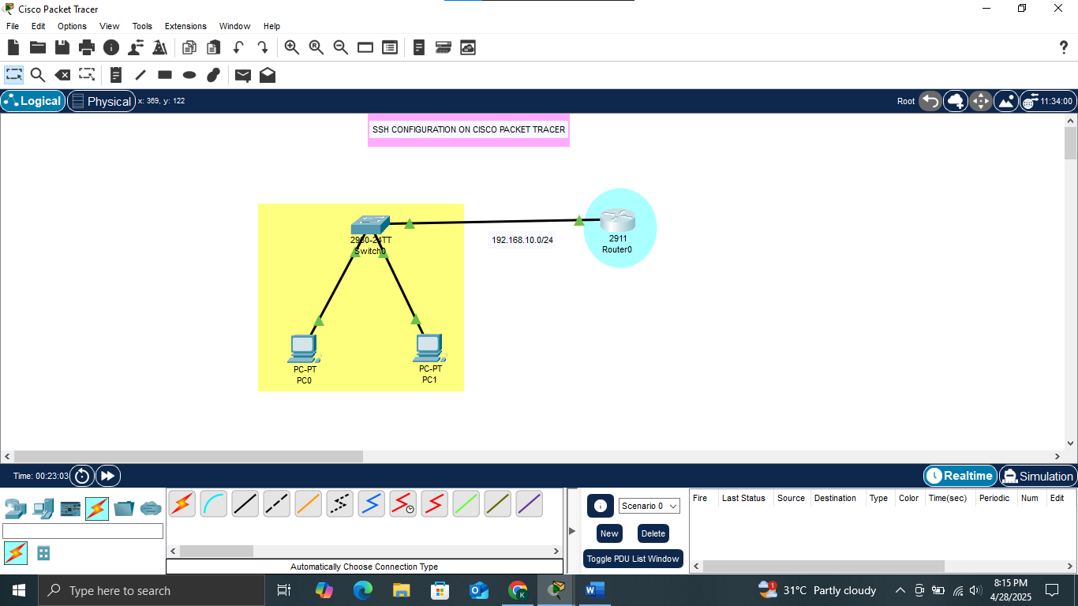

1. Configure IP addresses on router and PCs

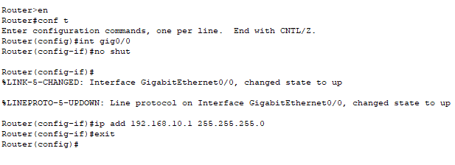

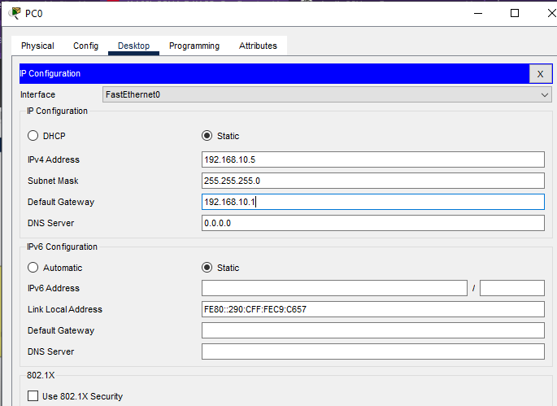

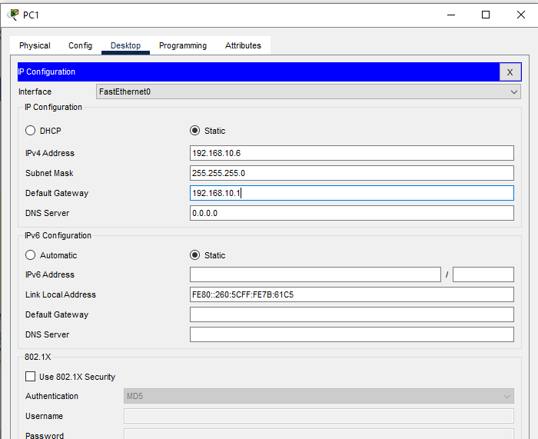

1. Test Ping from PC to router

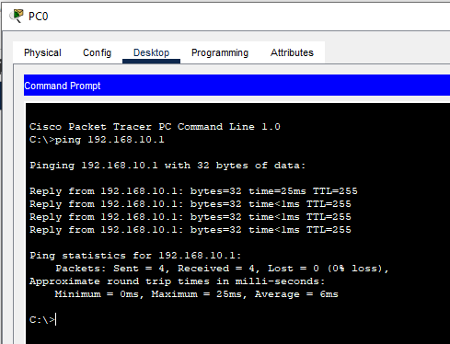

1. Configure hostname, enable password, domain name, username and password on router.

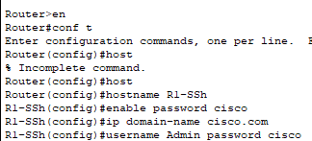

1. Generating crypto key using RSA with a length of 1024

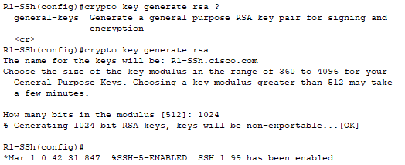

1. Login with vty and make it to use local database for authentication then finally allow SSH.



1. Enable SSH version 2



1. Test SSH using this command ssh -l username ip

