**FinaldTermdd2021**

**Name NabiyadYousaf**

**RollNo (18251598-027)**

**Subjectd Professional Practices**

**CourseCode SS-301**

**Instructor MamdHafsa Dar**

**Date 2 July, 2021**

**Q#1**

Ans:

In the work environment, loyalty suggest to misfortunes brought about by false confirmation executed by people. In all actuality, much of the time, these misfortunes are brought about by the exploitative confirmation of an organization's representatives. At the administration level, false exercises are difficult to address. The best practice is to forestall. Have cycles and assurances set up ahead of time.

Organizations need to ensure themselves against these likely misfortunes as the strategies for assault become more modern.

**Q#2**

Ans:

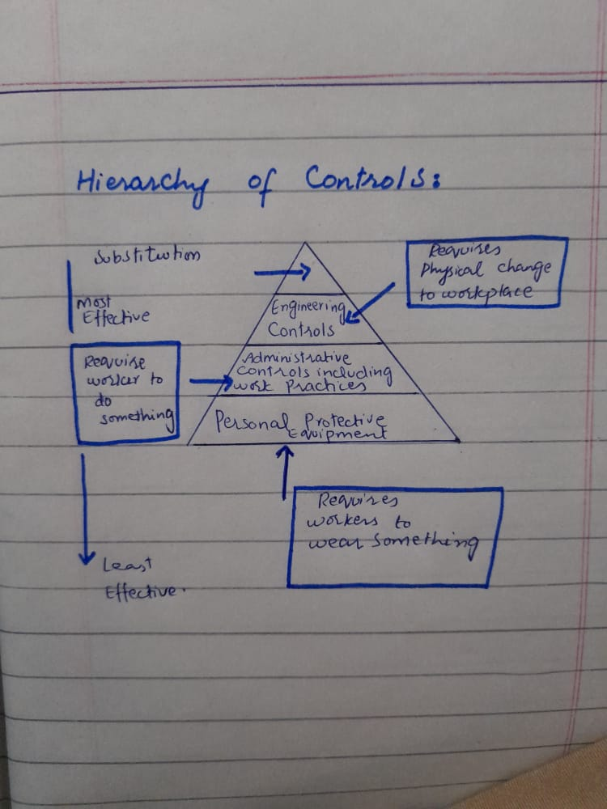

**Q#3**

Ans:

**Constrained Faced by manager while building a team:**

* Building a trust because trust is important or significant for any team
* Good talk or communication between team
* Impractical deadline
* Time Management
* Self-mindfulness of team members
* Turn-over jobs
* Control pressure for better performance

**Q#4**

Ans:

**Two most influential factors of effective project management:**

**Good/Open Communication:**

Good or open communication is very important for project management because if a team communicate each other they easily understand the requirements of project and client and then properly work on project.

**Proper risk management:**

Sometimes project not really work according to the requirements in this situation risk management is very important if a manager make sure that all the employees or worker work according to the requirements then failure of project risk is too low that’s why proper risk management is important.

**Q#5**

Ans:

**Safety Factors:**

* Circuit breaker
* Emergency sendoff system and fire alarm

These safety factors helps a company or individual person to avoid any injury or life lose.

**Q#6**

Ans:

|  |  |
| --- | --- |
| **Software Factory** | **Body Shopping** |
| It is collection of related software assets that are used to produce computer software or software products that are used to end user. It is involve in assembly process and outsource building software. | IT services providing companies work on body shopping which is software development. And body shopping is work according to the midterm contract. |

**Q#7**

Ans:

**Criminal Activates:**

* Copying data
* Illegal purposes
* Illegal access to data which can be used further harmful activates
* Fraud
* Blackmail

**Q#8**

Ans:

Employee Participation in decision-making process gives each employee the opportunity to share their opinions, and to share their knowledge with others because this is improve the relationship between manager and employee, it also encourages a strong sense of teamwork among employers or team members.

Employment tribunals responsible for insuring employment protection between employers and employees. Guarantee numbers are high influencing both managerial expenses and financial intensity. Changes have endeavored to lessen the quantity of cases and to work on the speed and proficiency of managing them. Adjusting worker assurance against cost-adequacy stays troublesome, be that as it may. Social affair proof on councils, remembering for guarantee prompting, goal, dynamic, and post-court results can illuminate strategy endeavors.

**Q#9**

Ans:

Cyber stalking is that you want a relation of any person with no interest. You constantly blackmail through sms phone calls or any other recourse then according to Pakistan’s cyber stalking law that person will be 3 years in jail/prison or 1000000 fine or both.

**Q#10**

Ans:

**Anthony**: Control is more important for management. If workers are not controlled by someone then there is no management.

**Witham**: Summary is all about freelancing

Witham Summary attract the freelancing community.

For Example: Witham talk about sub-contracts and to hire some employee on need. Payments will be done according to task. Freelancer is self-made person who cannot be controlled by management.

**Q#11**

Ans:

|  |  |
| --- | --- |
| **Professional Body** | **Social Organization** |
| Professional body work according to the interest of members and serve them. And also it is work according to the professional standards.  For people from all backgrounds they provide fair access to the profession. | Social Organization work for the interconnection of groups or relations to communicate each other.  This will helps groups to maintain or establish a powerful relation with each other. |

**Q#12**

Ans:

**Copyright material is fare:**

* The reason and character of your utilization
* Idea of protected work
* Sum and significance of the bit taken, and
* The effect of the usage upon the normal market

**Q#13**

Ans:

Partnership is the most suitable form of this business because in partnership partners share their profit and losses. And also make decision together for enhancing or improvement in business.

**Q#14**

Ans:

* The testament of fuse and any declarations of consolidation on difference in name any court requests or institutions changing the organization's constitution or endorsing a tradeoff, plan, remaking or blend
* A current assertion of capital (or proclamation of assurance for an organization restricted by ensure), and

**Q#15**

Ans:

**Motivation Importance:**

It is important for manager to motivate his team because motivation helps and also play an important role for a good work. When team is motivated they have a vision and they work according to that with great effort and also curiosity which provides good result to the company in result of good work.

**Q#16**

Ans:

**Q#17**

Ans:

A trademark is not necessary in this case because it is used by companies to recognize their products in other countries. Trade-mark is a recognizable sign, design, or expression which identifies products or services of a particular source from those of others. Since it is a small IT firm it does not need a trademark to distinguish its products from others.

**Q#18**

Ans:

|  |  |  |  |  |  |
| --- | --- | --- | --- | --- | --- |
| **IEEE/ACM Joint Software Engineering Code of Ethics for Software Engineers** | | | | | |
| **Role** | **Codes** | | | | |
| Self | Public | Product | Client/Employer |
| **Junior Developer** | Software engineers shall participate in lifelong learning regarding the practice of their profession and shall promote an ethical approach to the practice of the profession | Software Engineers shall act consistently with the public interest.  They keep in mind the importance of public and always keep in mind the interest of public | software engineer shall ensure that their product and related modifications meet the highest professional standards possible. | Software engineers shall act in manner that act in the best interest of the client and employers consistent with  The public interest |
| **Senior**  **Developer** | Project Manager shall participate in lifelong learning regarding the practice of their profession and shall promote an ethical approach to the practice of the profession | Senior Developer act consistently with the public interest.  They keep in mind the importance of public and always keep in mind the interest of public | Project manager shall ensure that their product and related modifications meet the highest professional standards possible. | Project Manager shall act in manner that act in the best interest of the client and employers consistent with  The public interest. |

**Q#19**

Ans:

When we talk about most significant IEEE code of ethics we can say that IEEE try to achieve the highest standards of integrity and venture to conduct business around the world in a responsible and ethical way.