Project Management Documentation

**Tech Stack Justification**

* React for fast, modular frontend. large ecosystem
* Express (Node.js) for lightweight, scalable API.
* MySQL (via Sequelize) for structured, relational product data.
* Hosting: AWS EC2 for API, S3 for static frontend and product images, RDS for MySQL.

**Architecture Overview (Diagram)**

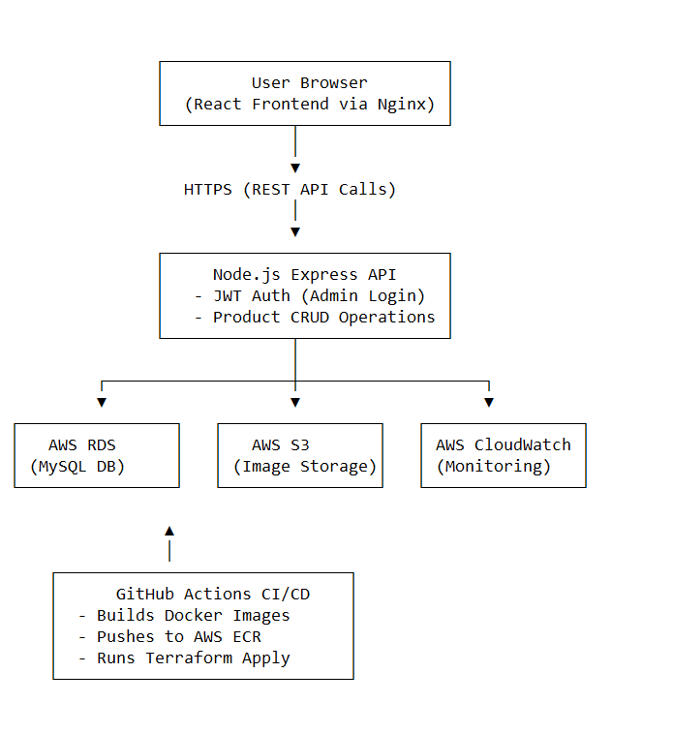

**Task Breakdown:**

| **Developer** | **Tasks** | **Timeline** |
| --- | --- | --- |
| Dev 1 | Frontend UI (React JS, CSS Library) | 1 day |
| Dev 2 | Backend API (Express, Sequelize, JWT) | 1 day |
| Dev 3 | Database setup + AWS deployment | 4 hours |

**Deployment Plan**

* Create RDS MySQL instance, set up security groups.
* Provision EC2 Ubuntu instance, install Node, Nginx, PM2.
* Pull code from repository, configure environment variables.
* Configure Nginx as reverse proxy, use PM2 to run the app.
* Build frontend and upload to S3; configure CloudFront.
* Set up backups (RDS snapshots), monitoring (CloudWatch), and logs (CloudWatch Logs).

**Future Enhancements**

* Sorting, search, and category filters.
* Integration with payment gateways (Stripe/PayPal).
* Image upload and CDN with pre-signed S3 URLs.
* Role-based access control and user management.
* Product categories CRUD, product images gallery.
* Server-side pagination and caching (Redis).