

**ELECTRICAL ENGINEERING DEPARTMENT**

**MICROPROCESSOR INTERFACING &**

**PROGRAMMING (EE-3002)**

**CEP REPORT**

**“DIGITAL TACHOMETER”**

* **Group Members:**

1. Shayan Hashmi (22k-4865)
2. Syed Ammar Zulfiqar (22k-4845)
3. Muhammad Sufyan (22k-4868)

* **Instructors:**

1. Engr. Muhammad Haris Mohsin
2. Syed Areeb Ahmed

### **INTRODUCTION:**

### Now, more than ever, the requirement for accurate rotational speed measurement in a number of different applications is essential. According to the industry, the best machinery should be running at spectacular performance, especially in sectors such as manufacturing, automotive, and renewable energy. Analog tachometers of the traditional kind tend to be incompatible in terms of accuracy and responsiveness to these demands. Overcoming these challenges, the digital tachometer used for real-time speed measurements allows for improved performance as well as enhanced safety and a lower environmental impact.

#### **Problem Statement with Targeted SDGs:**

#### Incorrect measurement of rotational speed values and drying quantities have the following consequences in industrial scenarios including automotive applications. Failure to check the speed on the go will not only the operator’s life but also the continuity of operation itself is really a question mark.

* **Targeted SDGs:**

**SDG 4: Quality Education:** A digital tachometer can serve as an essential tool for students about rotational speed measurements, sensors, and microcontrollers. Students can contribute to Science, technology, and engineering fields by designing such projects. Working on project ideas like digital tachometer involves both hardware and software skills, enhancing advanced knowledge and specific skills in a technical area.

* **Proposed Solution:**

The idea is to build a digital tachometer that interfaces with the rotational speed sensor, performs required processing using a micro-controller, and then displays the final output on an LCD screen. The initiative is supposed to make the machines work at their best while helping the system work as a whole as an efficient process.

* 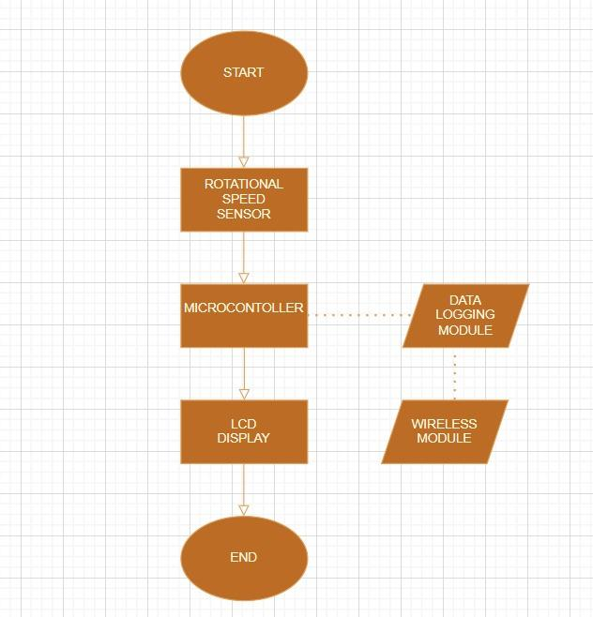**Block Diagram:**

1. **LITERATURE REVIEW:**

The advancement in the technology of microprocessors, sensor interfacing, and embedded systems have greatly changed the development of digital tachometers [1]. In industrial, mechanical, and automotive systems, the instruments of tachometers are the most important components that are responsible for the measurement of the rotational speed of items like motors or wheels. Precision, reliability, and accessibility have all improved with the transition from analog to digital tachometers [2]. With an emphasis on Arduino-based designs and the use of assembly language in microprocessor-based development, this literature review focuses on important studies and technologies linked to the use of digital tachometers.

Most of the analog electronics that are used in typical tachometers consist mainly of mechanical or magnetic connections to determine speed [3]. With the evolution of digital electronics, tachometers became linear and extremely accurate. The benefits of using digital tachometers are summarized by one of the research stating better precision, more noise immunity and the ability to be used on a wider variety of digital platforms and microcontrollers [4]. The Arduino-based controllers were the most economically priced, adaptable method of speed sensing through rotations and seamless integration has been established to be the best addition for all academic and industrial projects.

Arduino-controlled tachometers are a most loved alternative by individuals in view of their simplicity and effortlessness, also because it is simple to interface a hall-effect sensor or an infrared (IR) sensor with the Arduino. The actual speed in revolutions per minute (RPM) (i.e. the rotating speed of an object [1]) is calculated based on the data produced by the sensor and displayed by Arduino. Most solutions use high-level programming languages (like C/C++), but assembly language usage has its benefits in these projects. Assembly language is used to provide low-level hardware control that can assure effective operations for real-time systems [5] while you can utilize the least amount of memory possible when required.

The capability and accuracy of tachometers have been significantly improved with the latest advancement in sensor technology, in particular optical encoder. Optical encoders are the preferred choice for applications such as these, which require high accuracy levels because of their ability to make high-resolution readings. The speed readings also improve in accuracy and reliability because these sensors can be integrated with your Arduino programming using assembly language and are able to reduce the delay, this allows modifications in real Time. The high speed of digital tachometers in industrial and automotive applications shows that the performance can be significantly improved by having our hardware/software combo designed for a fast QU.

1. **METHODOLOGY**

* **Hardware Setup:**
* **Microcontroller Selection:**

An AVR microcontroller, like ATmega32, is used for signal processing and control.

* **Sensor Interface:**

A proximity sensor or an optical encoder will detect the rotational speed through the generation of pulses in each rotation. The output from the sensor goes to an external interrupt pin on the microcontroller.

* **LCD Display:**

A 16x2 LCD module is utilized for displaying RPM. The data and control pins connect to specified I/O pins on the microcontroller.

* **LED Indicator:**

An LED provides feedback for system status or error conditions.

* **Power Supply:**

A stable DC power supply powers the microcontroller, sensors, and display.

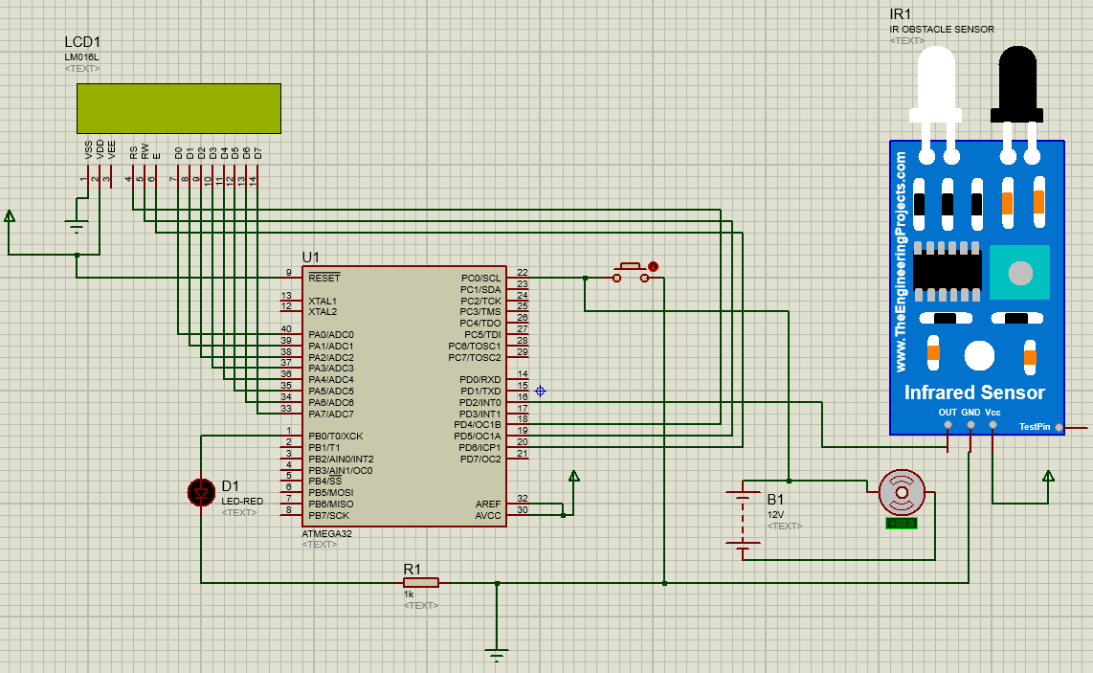

* **Software Design:**
* **Initialization:**
* The ports are configured to initialize the LCD, input pins for the sensor, and output pins for the LED.
* The microcontroller initializes the LCD module by enabling its data and control ports and clearing the enable pin.
* The stack pointer is set up to prepare for the program execution.
* **Interrupt Configuration:**

It is an external interrupt that recognizes pulses through the sensor. Each pulse corresponds to the rotation or rotation fraction depending upon the resolution of the encoder.

* **Signal Processing:**
* The microcontroller measures the incoming pulse period/frequency with its timer/counters.
* Assembly code uses registers to keep the pulse counts and carry out the arithmetic.
* Increment a counter at every pulse received by the interrupt.
* After a specified time cycle, say 1 second, multiply the count by 60 and divide by the encoder resolution to obtain the RPM.
* **Display Logic:**

The data received from RPM is converted to ASCII format and transmitted to LCD in a sequence to display the number.

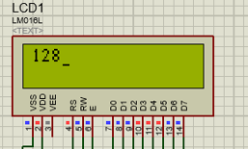

* **Feedback Mechanism:**

The LED blinks or changes its state to indicate the status of the motor working. This is done by toggling specific port pins.

* **Key Logic Explanation:**
* **Pulse Detection:**

An interrupt is generated for each pulse detected by the sensor, and the ISR increments a pulse counter**.**

* **Timer Utilization:**

The timer/counter is implemented to measure time periods to determine the RPM**.**

* **Data Conversion:**

The binary RPM reading is converted to decimal and ASCII to be displayed on the LCD**.**

* **Error Handling:**

Logic is implemented to identify sensor disconnection or an invalid reading**.**

1. **COSTING:**

|  |  |  |  |
| --- | --- | --- | --- |
| **SNO.** | , **COMPONENTS**, | , **DESCRIPTION**, | , **COST**, |
| 1. | , Microcontroller, | , AT MEGA 32 | 1300 |
| 2. | , Speed sensor, | ,Lm35 sensor | 350 |
| 3. | , Display module, | , LCD (16 X 2) | 750 |
| 4. | , Resistors, | , For current limiting, | 100 |
| 5. | , IC Holder | connecting IC | 200 |
| 8. | Vero board | , For implementing the circuit, | 200 |
| 9. | Connecting wires | , Jumper wires and soldering wire, | 300 |
|  | **Total**, **estimated**, **cost** |  | Rs. 3200 |

1. **RESULTS:**

* **Highly Accurate RPM Measurement:**

The tachometer measures the rotational speed of the motor in RPM to a very high degree of accuracy as against known speed benchmarks.

* **Real-Time Display:**

The 16x2 LCD screen shows the values of RPM almost in real time with minimal delay so the feedback is instant.

* **Sensor Sensitivity:**

The sensor could detect pulses with high precision and robust signal processing even during changes in motor speed.

* **Feedback Mechanism:**

The LED indicator operates as expected, providing visual feedback for system status and operational thresholds.

* **System Stability:**

The device performs reliably over extended operational periods without noticeable drift or inaccuracies in RPM measurement.

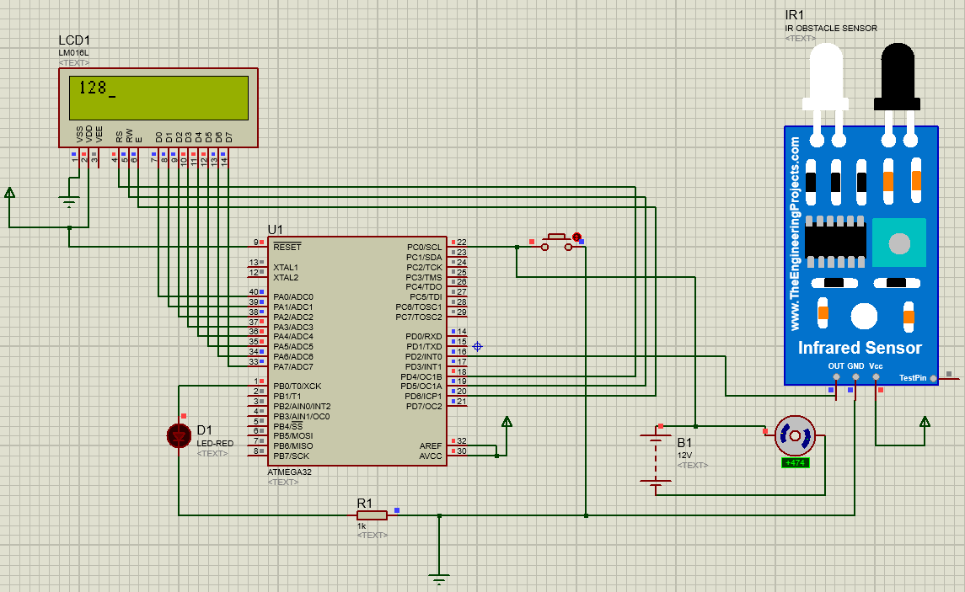

1. **DISCUSSION:**

The primary goal of the digital tachometer project was to design a system that could measure and display the rotational speed of a motor in RPM with a high degree of accuracy. This goal was well met through a combination of accurate hardware interfacing and efficient software programming. The discussion below details how every part of the project helped to meet its objectives:

* **Accurate RPM Measurement:**

The integration of a proximity sensor or optical encoder allowed for reliable pulse detection, directly proportional to the motor's rotational speed. These pulses were then processed by the microcontroller's timer/counter functionality to calculate RPM with high precision.

* **Efficient Signal Processing:**

The assembly language optimized signal processing logic to enable instant interrupt handling and real-time update of RPM values. The formula used for the computation of RPM ensured that pulse information was accurately translated into meaningful metrics of speed.

* **Real-Time Display:**

The LCD module provided a clear and direct visualization of the measured RPM. The written code for the initialization and control logic of LCD ensured smooth operations, while formatted data conversion ensured the correct display of the speed value on the screen.

* **Feedback Mechanism:**

LED indicator properly completed the system of measurement of RPM. It allowed visual clues to thresholds for operation and status of the system, which means better usability of the product and quick references for operators.

* **Achievement of Project Goals:**

By combining robust hardware design with optimized software logic, the digital tachometer met all its design requirements:

* Accurate and consistent measurement of motor speed.
* Reliable real-time feedback through the LCD and LED.
* Compact and efficient assembly code to ensure systemresponsiveness.

1. **CONCLUSION:**

This project successfully achieved the target objective of accurately measuring and showing rotational speed, in RPM, for the motor. It had all the necessary components: a pulse detection sensor, a microcontroller as a signal processor, and an LCD for output display. In totality, the entire system became reliable and efficient. So it has shown the importance of hardware interfacing and software-optimized logic in the correct application of embedded systems.

* **System Performance:**

The tachometer has high accuracy and real-time response, hence it suited applications that necessitated detailed speed monitoring.

* **Ease of Use:**

It has improved the user experience with a simple LCD display and a practical LED feedback mechanism.

* **Future Recommendations:**

Because of the modular design, it can have adaptations of the system that include upgrading with advanced display technologies and even wireless communication modules for remote monitoring.

* **Extended Display Choices:**

The display module can be replaced with a graphical one to improve data display to a finer level.

* **Remote Monitoring and Data Logging:**

Bluetooth or Wi-Fi module added for remote monitoring and mobile or computer-based data logging

* **Error Sensing:**

Addition of features for sensor failure as well as abnormal motor speeds.

* **Power-Saving Features:**

Further optimization of the circuit to bring down the power consumption such that the device can function on battery.

* **Integrating Multi-Sensors**

The system could easily be extended to employ multi-sensors for measuring the speed in multi-motor arrangements. Such improvements would continue to extend the capability of the digital tachometer while remaining consistent with evolving industrial and consumer application requirements.

1. **REFERENCES**

[1] R. Bonert, “Design of a High-Performance Digital Tachometer with a Microcontroller,” 1989.

[2] C. E. Robinson, “IEEE TRANSACTIONS ON INDUSTRY AND GENERAL APPLICATIONS Analog Tachometers.”

[3] Z. Shi *et al.*, “Design and Development of a Tachometer Using Magnetoelectric Composite as Magnetic Field Sensor,” *IEEE Trans Magn*, vol. 54, no. 7, Jul. 2018, doi: 10.1109/TMAG.2017.2721900.

[4] R. Palanisamy, S. Vidyasagar, V. Kalyanasundaram, and R. Sridhar, “Contactless digital tachometer using microcontroller,” *International Journal of Electrical and Computer Engineering*, vol. 11, no. 1, pp. 293–299, Feb. 2021, doi: 10.11591/ijece.v11i1.pp293-299.

[5] B. Khoshnevis, “MANAGING THE MICROCOMPUTER MEMORY TO SOLVE LARGER SCALE I.E. PROBLEMS,” 1986.

[6] D. Denić, G. Miljković, and D. Živanović, “Microcomputer Based Wide Range Digital Tachometer.”