Application 08: Blazor ToDo App Connected with Local Database
Task create, update, complete, and delete actions are persisted locally in SQLite through EF Core.
Project | Blazor Task Management System
Framework | .NET 10 Blazor Server with InteractiveServer components
Database | SQLite local file: todo_tasks.db
Repository | https://github.com/Syed-Aqib-555/Blazor-Task-Management-System

Objective
The objective of Application 08 is to connect the earlier Blazor ToDo application to a local database so tasks are not lost when the browser refreshes or the server restarts. The browser interface now uses a database-backed service for every create, update, complete, and delete operation.

Implementation Summary
- Added EF Core SQLite and configured the connection string in appsettings.json.
- Created TodoDbContext with a Tasks table, indexes for completion and due date, and seed records.
- Replaced the in-memory list service with TodoTaskService, which opens a database context for each operation.
- Built a professional task dashboard with metrics, filters, form validation, edit mode, completion toggles, and delete actions.
- Added a /database page that reads the same local SQLite file and displays server-side table rows for documentation evidence.

Database Design
Column | Purpose | Example
Id | Primary key generated by SQLite | 1
Title | Required task name | Review database manuals
Description | Optional notes | Check Week 13 notes
Priority | High, Medium, or Low | High
DueDate | Optional task deadline | 2026-05-27
IsCompleted | Completion state used by toggle action | 0 or 1
CreatedAt / UpdatedAt / CompletedAt | Audit timestamps | 2026-05-26 09:00

Code Screenshots
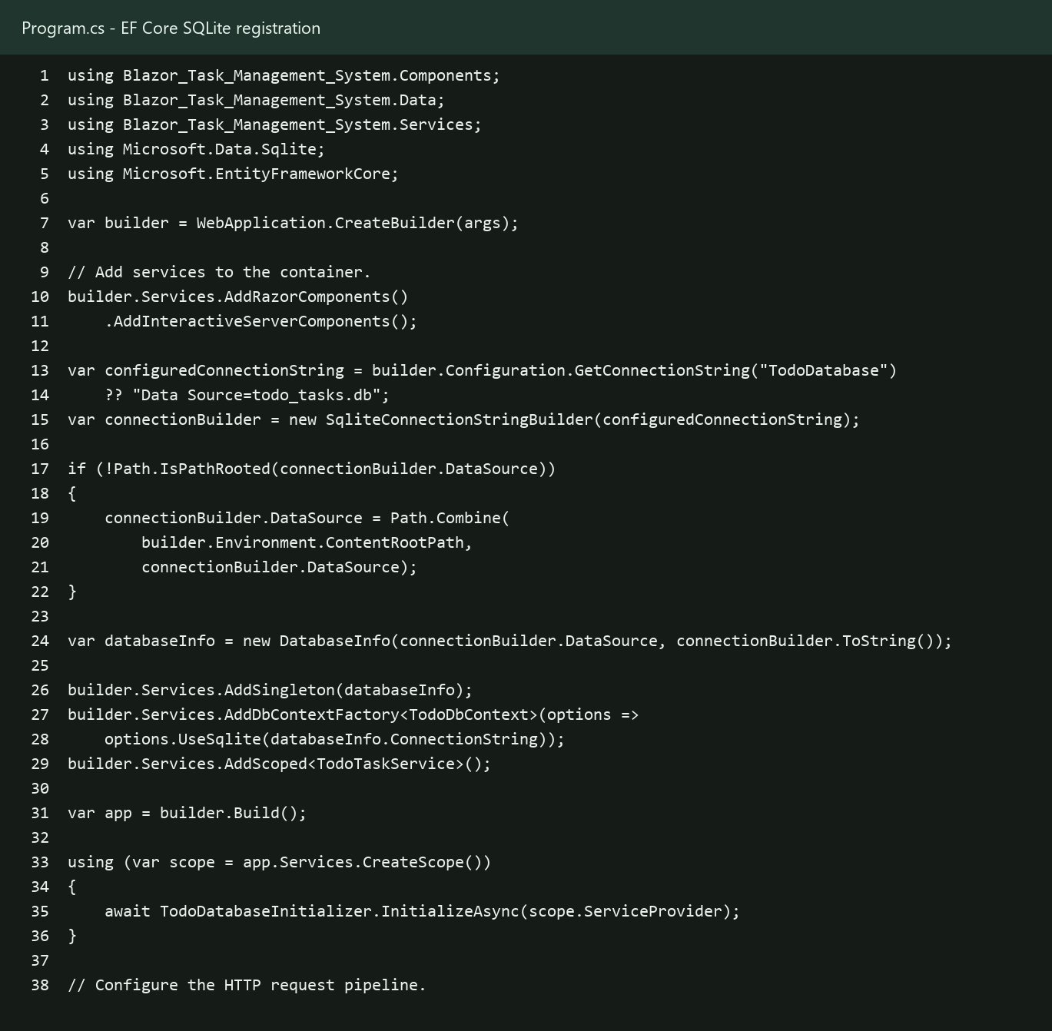
Figure 1. Program.cs registers the SQLite connection, EF Core DbContext factory, database information, and task service.
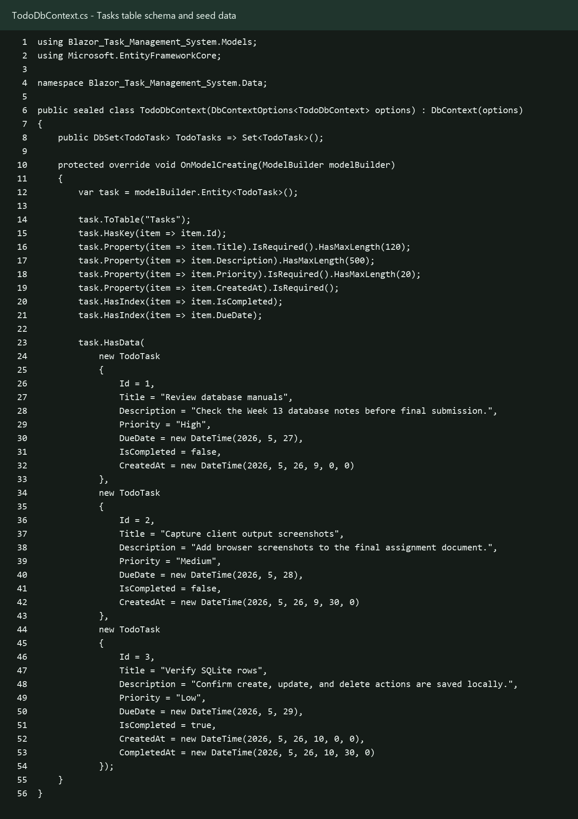
Figure 2. TodoDbContext maps the Tasks table and defines seed rows for the local database.
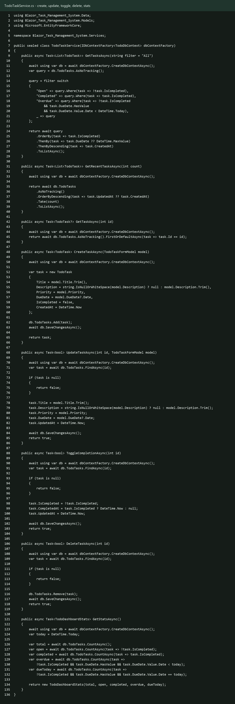
Figure 3. TodoTaskService performs create, update, toggle completion, delete, list, and statistics operations through EF Core.
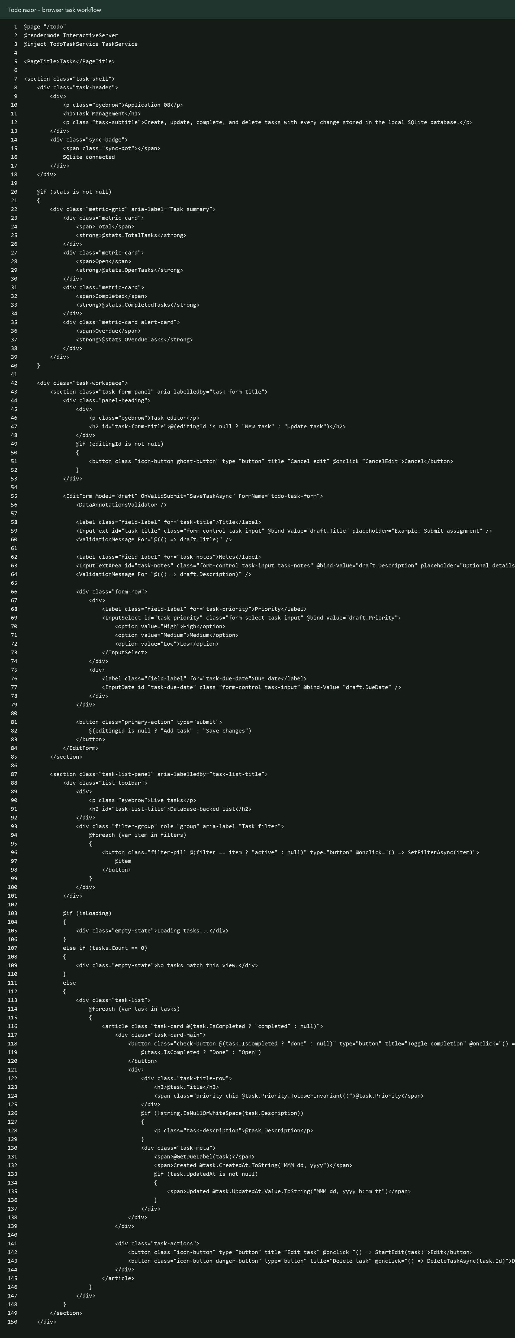
Figure 4. Todo.razor provides the client form, filters, task cards, edit buttons, completion toggles, and delete buttons.
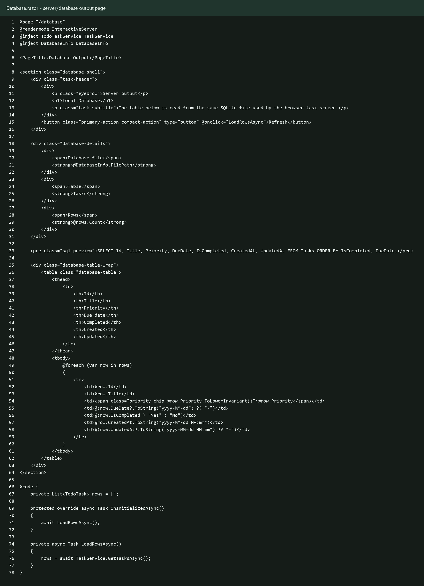
Figure 5. Database.razor shows the server/database output from the same SQLite file.

Output Evidence
HTTP route checks returned / = 200, /todo = 200, and /database = 200. The database file contains 3 rows.
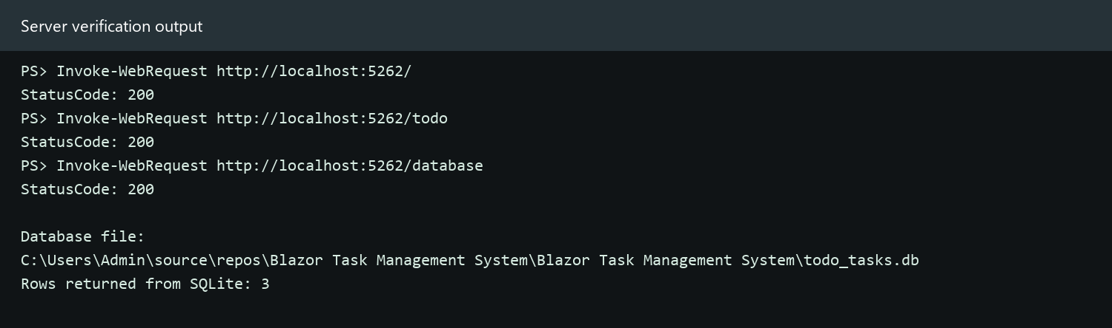
Figure 6. Server route verification and local SQLite database file output.
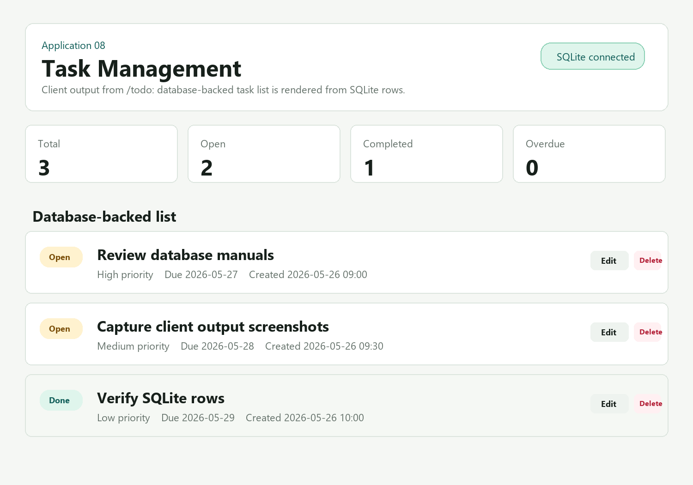
Figure 7. Client output evidence for the /todo task screen using rows loaded from SQLite.
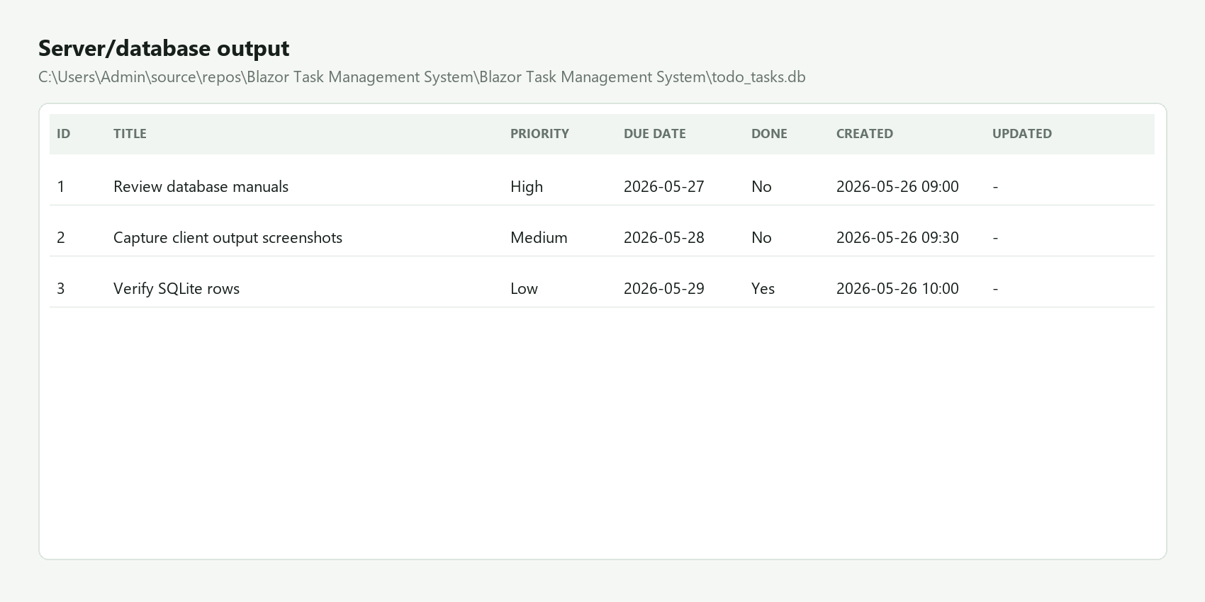
Figure 8. Server/database output from todo_tasks.db showing stored task rows.

CRUD Flow Explanation
- Create: the user fills the task form and selects Add task. TodoTaskService.CreateTaskAsync inserts the record into Tasks and SaveChangesAsync writes it to todo_tasks.db.
- Update: the user selects Edit, changes title, notes, priority, or due date, and saves. TodoTaskService.UpdateTaskAsync updates the row and sets UpdatedAt.
- Complete: the Open/Done toggle calls ToggleCompletionAsync, flips IsCompleted, and stores CompletedAt when the task is completed.
- Delete: the Delete button calls DeleteTaskAsync, removes the row from DbSet, and persists the change in SQLite.
- Read: /todo and /database both call GetTasksAsync, so browser output and database output stay consistent.

Run Instructions
Open PowerShell inside "C:\Users\Admin\source\repos\Blazor Task Management System\Blazor Task Management System" and run:
dotnet run --launch-profile http
Then open http://localhost:5262/todo for the task client and http://localhost:5262/database for the database output page.

GitHub Commit Requirement
The repository is configured with origin https://github.com/Syed-Aqib-555/Blazor-Task-Management-System.git. The final step is to create and push 50+ commits as requested, after the implementation and documentation are verified.

