Air University, Kharian Campus
Department of Computer Science

LAB REPORT
Lab 04 — Types in a file
Full Stack Development Lab
Fall 2026
Name | Syed Aqib
Roll number | 247251
Section | BSCS F24 A
GitHub URL | https://github.com/Syed-Aqib251/f24a-247251-lab4
Date | 3 October 2026
Instructor | Ali Hafeez

Tasks
I completed the Sheet, Till and Who is in pages to demonstrate JavaScript values, types and conversions.
Task 1 — The sheet
What I did
I created the Git repository and the Sheet page for Canteen. The shop name is white on a green header, as required for roll number 247251. I added the Item, Quantity, Price, Line and Note columns, an empty rows array and my roll number in the footer.
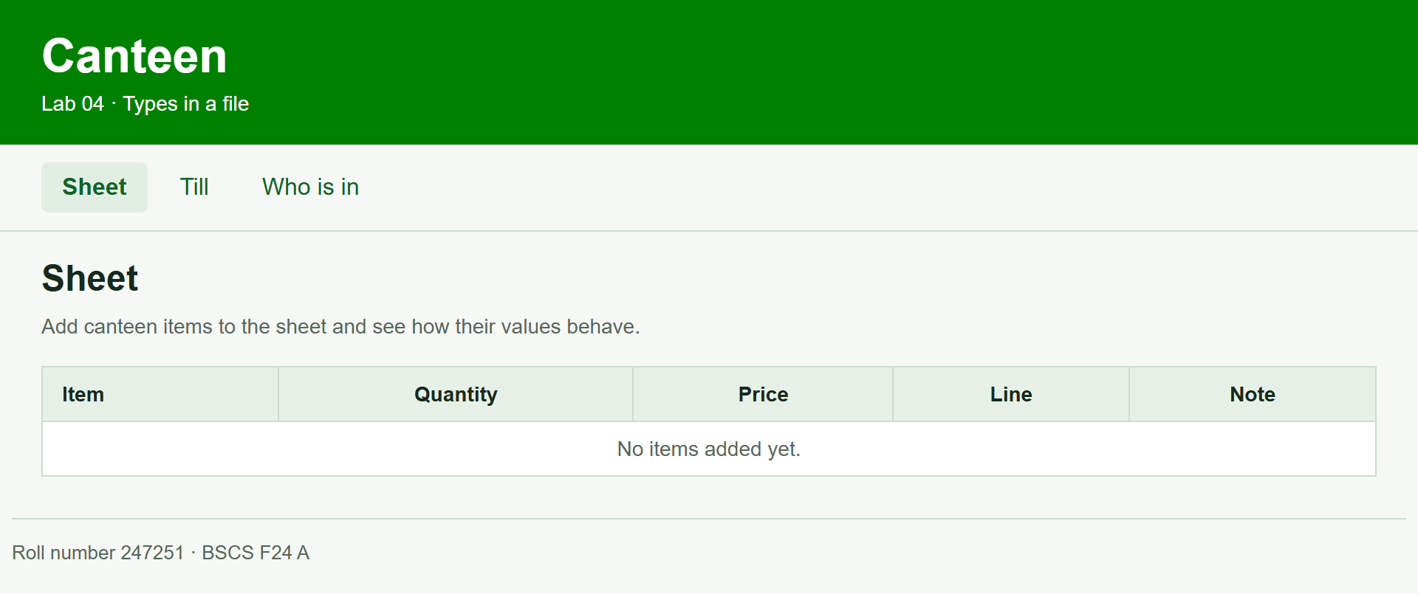

Task 2 — The form
What I did
I added Item, Quantity and Price inputs below the table, with an Add button. The form keeps the price as text so that later tasks can compare multiplication with string concatenation.
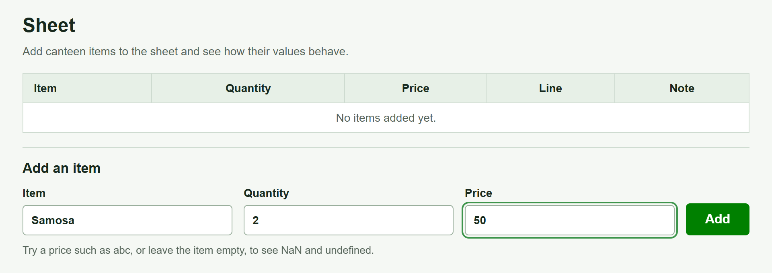

Task 3 — Add a row
What I did
I made Add create an object in the rows array and redraw the table. Quantity is converted to a number, while Price stays text. For Samosa with quantity 2 and price 50, Line is 100 and Note is 502. The inputs clear after Add.

Task 4 — A bad price
What I did
I entered abc as a price and left the item name empty. The row remains in the table: its Line is NaN, its Note is abc1 and its missing item property displays undefined. I did not replace these values with zero or remove the row.
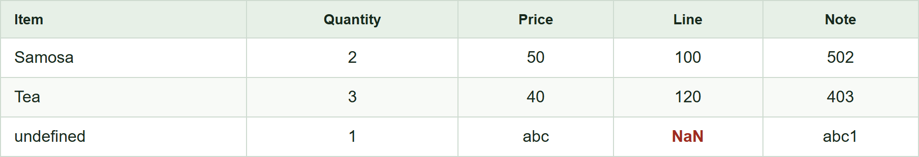

Task 5 — The total
What I did
I summed the numeric Line values and skipped NaN. The two valid rows total 220. I displayed typeof for the total and latest Note, compared price text with its numeric conversion using == and ===, and showed that typeof NaN is number.
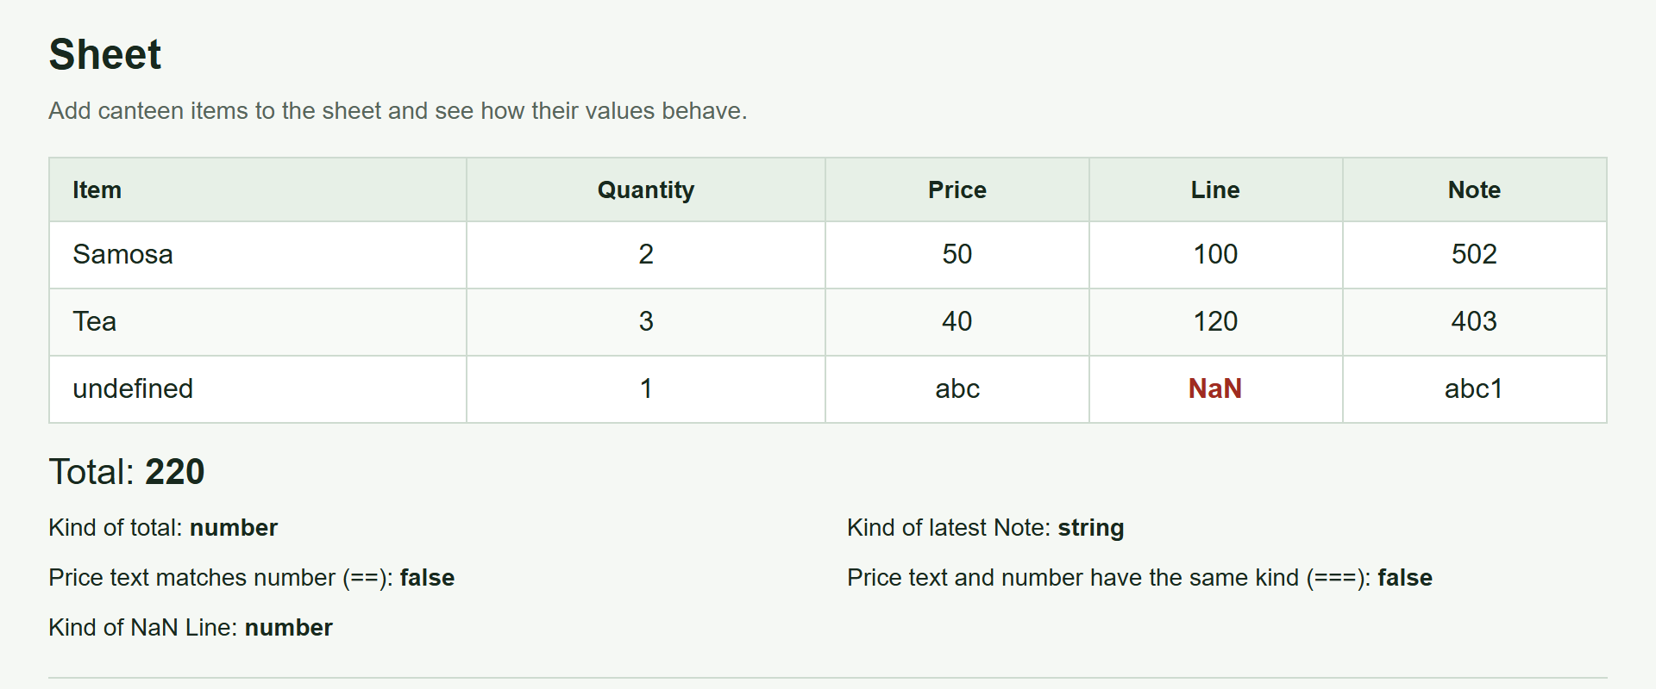

Task 6 — The till
What I did
I created till.html and linked it from the Sheet page. It uses the same Canteen header and navigation, with Bill and Paid inputs and a Take button for processing a payment.
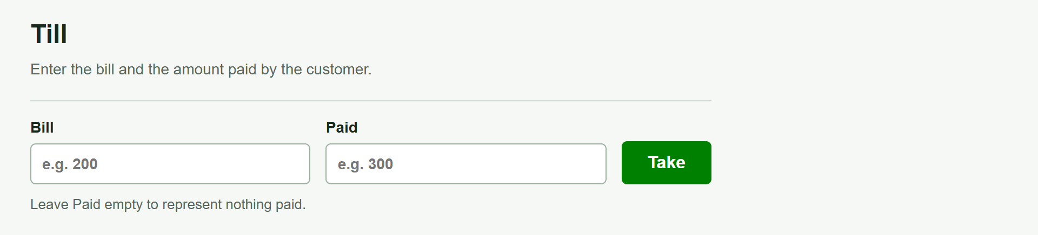

Task 7 — The change
What I did
I calculated Paid minus Bill. With a bill of 220 and a payment of 300, the change is 80 and half the change is 40. If the payment is smaller than the bill, the page shows the amount owed. The function call appears before its declaration to demonstrate hoisting.
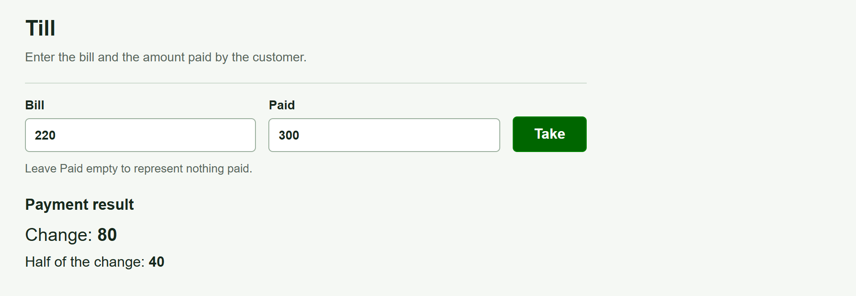

Task 8 — Nothing paid
What I did
I made an empty Paid input store null. With a bill of 220 and no payment, the stored value displays null, typeof displays object, and the amount still owed is 220.
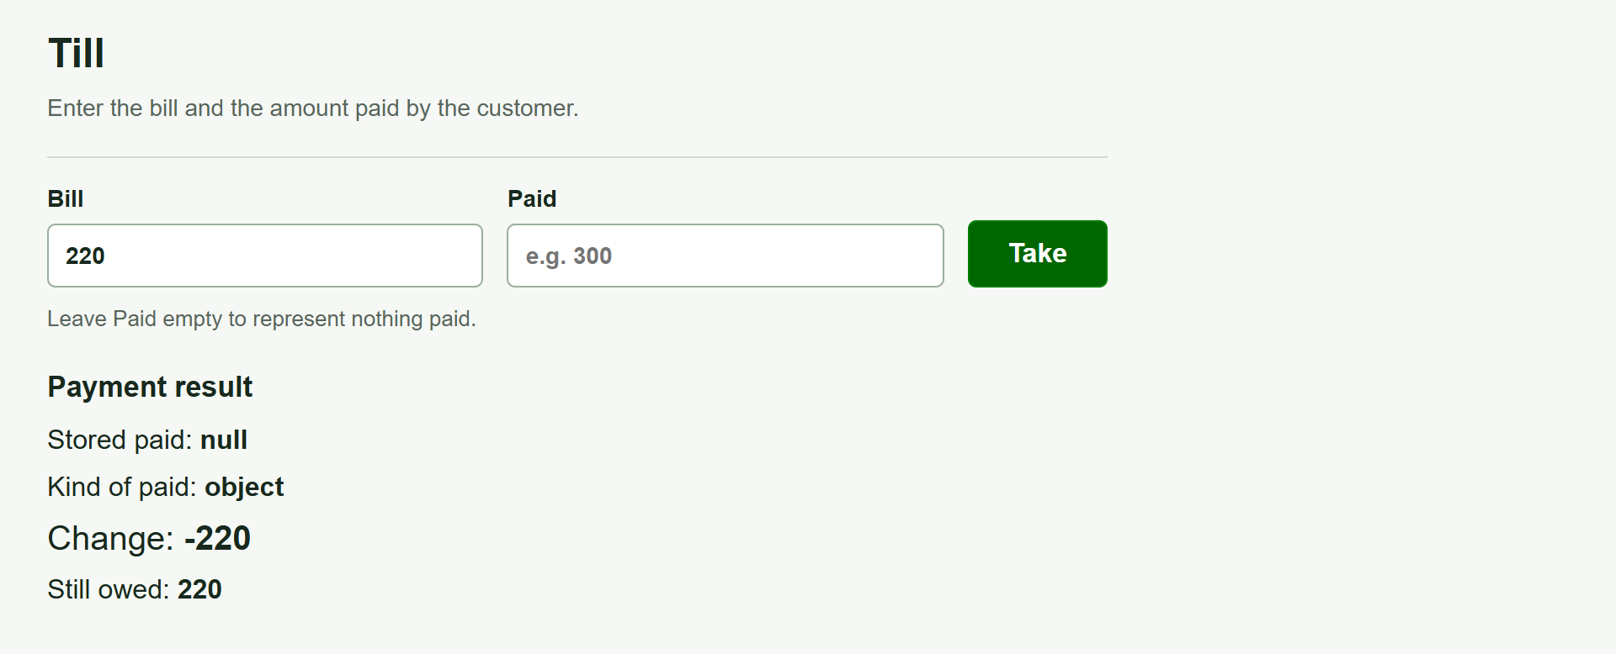

Task 9 — Who is in
What I did
I created who.html with a Name input and Here and Out buttons. Here adds a person with inShop set to true; Out adds a person with inShop set to false. I linked this page to the Sheet and Till pages.
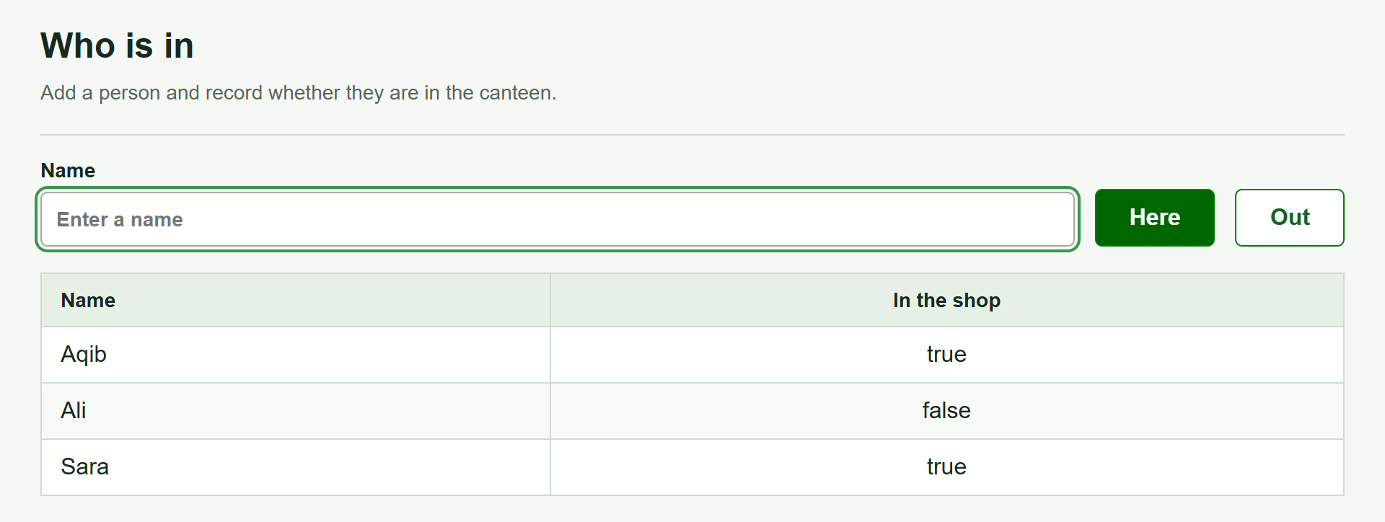

Task 10 — The count
What I did
I rendered the people array by destructuring each object into name and inShop. I counted only people whose inShop value is true. Aqib and Sara are Here, Ali is Out, so the count is 2.
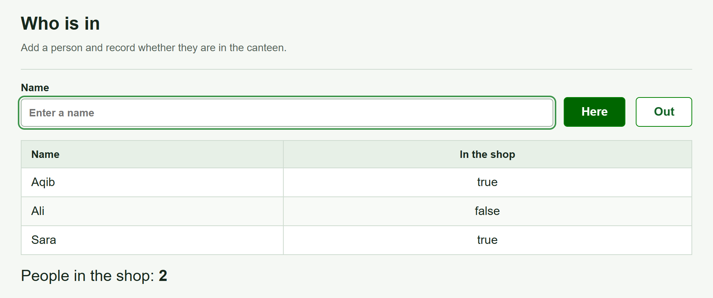

Task 11 — No answer
What I did
I added an initial Visitor object without an inShop property. The table shows undefined for that person, and the count excludes this unanswered status. The two true answers still produce a count of 2.
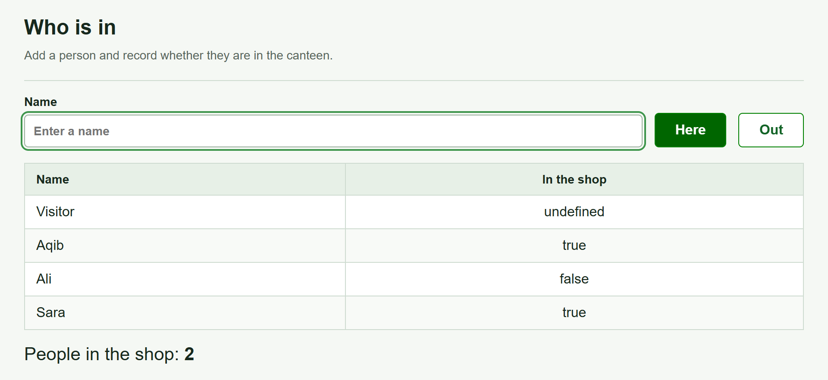

Task 12 — Report
What I did
I prepared the Word report with my details and evidence for all 12 tasks. I committed each task with its required message and pushed the 12 task commits to the GitHub repository. The screenshot shows the Report commit and the uploaded Word file.
