

***Team Name –*  Tech Phantom**

|  |  |  |  |
| --- | --- | --- | --- |
| **Team Leader** | **Name** | Syed Ashik Mahamud |  |
| Institution | BRAC University |  |
| Email | Syed.ashik.mahamud@g.bracu.ac.bd |  |
| Phone | 01762259976 |  |
| **Member 2** | **Name** | Salsabil Tanjim |  |
| Institution | BRAC University |  |
| Email | salsabil.tanjim@g.bracu.ac.bd |  |
| Phone | 01866834256 |  |
| **Member 3** | **Name** | Bijoya sarkar |  |
| Institution | BRAC University |  |
| Email | bijoya.sarkar@g.bracu.ac.bd |  |
| Phone | 01759025684 |  |
| **Member 4** | **Name** | Md. Sajid Ullah Sohan |  |
| Institution | BRAC University |  |
| Email | sajid.ullah.sohan@g.bracu.ac.bd |  |
| Phone | 01749298058 |  |

**Team Details**

The following information must be included in the initial paper

1. What is your target problem and solution? (Max 150 words)

Ans:

Our target problem for this project is fire resistance. Fire tragedy is a significant hazard to human life and properties in Bangladesh. We aim at establishing an effective technology platform to encounter fire accidents across the country, through which we’ll be able to minimize the casualties during any such incident. This platform will be an automatic fire alarm device allowing for real-time data analysis, tracking, and monitoring which can be used by individuals, corporations, or industrial establishments.

Its versatile security has a quick, easy, accurate, and low-cost fire sensing and location-intimating device for users to get support in critical situations. The system can be positioned at any remote location that the consumer can quickly access with the aid of GSM technology. In this, it is proposed that NodeMCU acquire signals from different sensors and control to manage communication with the property owners. This is carried out by sending SMS immediately to the owner in the initial stage and to the fire brigade in the critical stage to resolve the fire hazards. Moreover, this device will call for additional medical support in severe situations.  Different sensors incorporated within the system are smoke, fire, and flammable gas sensors. It helps to estimate specific threshold values in hazardous conditions and alarms the buzzer accordingly. If in a high emergency, the system sends SMS consisting of the area and address location to the user / in-charge person, fire brigade, and medical support team respectively.

1. Give the technical details i.e. diagrams, 3D models, platforms, modules, dependencies, sensors, components etc. of your project:

Ans:

**System components**

* **Node-MCU:**Node-MCU is an open-source firmware and development kit that helps to build prototype. It includes firmware which runs on the ESP8266 Wi-Fi SoC from Espressif and hardware which is based on the ESP-12 module. It uses an on-module flash-based SPIFFS file of Systems. It is asynchronous and event-driven. Many functions, therefore, have parameters for callback functions.The ESP8266 Node-MCU has total 17 GPIO pins broken out to the pin headers on both sides of the development board. These pins can be assigned to all sorts of peripheral duties, including: A 10-bit ADC channel, UART interface, PWM outputs, SPI, I2C & I2S interface, I2S interface etc. The programmable ROM is programmed on-board via the USB, allowing the programming step to be easily integrated into the product manufacturing and testing process. Maintaining the Integrity of the Specifications.
* **SIM900A Modem (GSM):** SIM900A Modem is built with Dual Band GSM from SIMCOM. It works on frequencies 900 / 1800 MHz. The frequency bands can also be set by AT Commands. The baud rate is configurable from 1200-115200 through AT command. It is ultra compact and wireless module and allows connecting PC as well as microcontroller with RS232 Chip. It is suitable for SMS, Voice as well as DATA transfer application in M2M interface. It provides facility for audio calls and SMS attend the incoming calls through simple AT commands. This is a complete very powerful single-chip with serial and TTL outputs.
* **Data Acquisition Sensors:**

There are four different components for acquiring data from the site.

* **Temperature & Humidity Sensor:**

Ambient temperature and humidity is measured using DHT11 air temperature humidity sensor. The DHT11 is a basic, ultra low-cost digital temperature and humidity sensor. It uses a capacitive humidity sensor and a thermistor to measure the surrounding air, and spits out a digital signal on the data pin. Its fairly simple to use, but requires careful timing to grab data. And new data collected from it once every 2 seconds.

* **Flame Sensor:**

Flame sensor is a device used to detect the presence of fire in its surrounding. For this system we have used Infrared Flame Sensor to detect the fire. It consists of a photodiode coated with black epoxy which makes it sensitive to the infrared radiations having wavelength between 700nm to 1mm and can detect fire up to distance of 100cm within 60 degrees of angle of detection. Detection process is based on the Infrared (IR) wavelength emitted by the flame.

* **MQ2 Gas Sensor**

It is metal oxide semiconductor sensor used for sensing the concentration of gases in the air. It comprises a sensing material whose resistance improves as it comes into contact with gas. This change in the value of resistance is used for the detection through voltage divider network. It can detect Propane, Hydrogen, Methane etc concentrations in the range of 200 ppm to 10000 ppm.

* **MQ5 Gas Sensor**

This sensor detects the presence of gas in an area. This module is useful for gas leakage detection of LPG, Natural gas, town gas and or smoke etc. Use the onboard potentiometer to adjust the sensitivity.

* **Relay module**

A relay switch is operated by an electromagnet which requires a small voltage for activation which is provided from the NodeMcu. When any one input from the sensor sense above threshold limit, the relay switch activates the bulb to switch ON. It helps to show the emergency status of the hazards area. Assembling all these components together makes a system, as shown in block diagram Figure 1

* **16-Channel Analog/Digital Multiplexer Breakout Module:**

The 16-Ch Analog / Digital Mux Module mounts a 74HC4067, a 16-channel

multiplexer/demultiplexer IC that can route both analog and digital signals in both

directions.

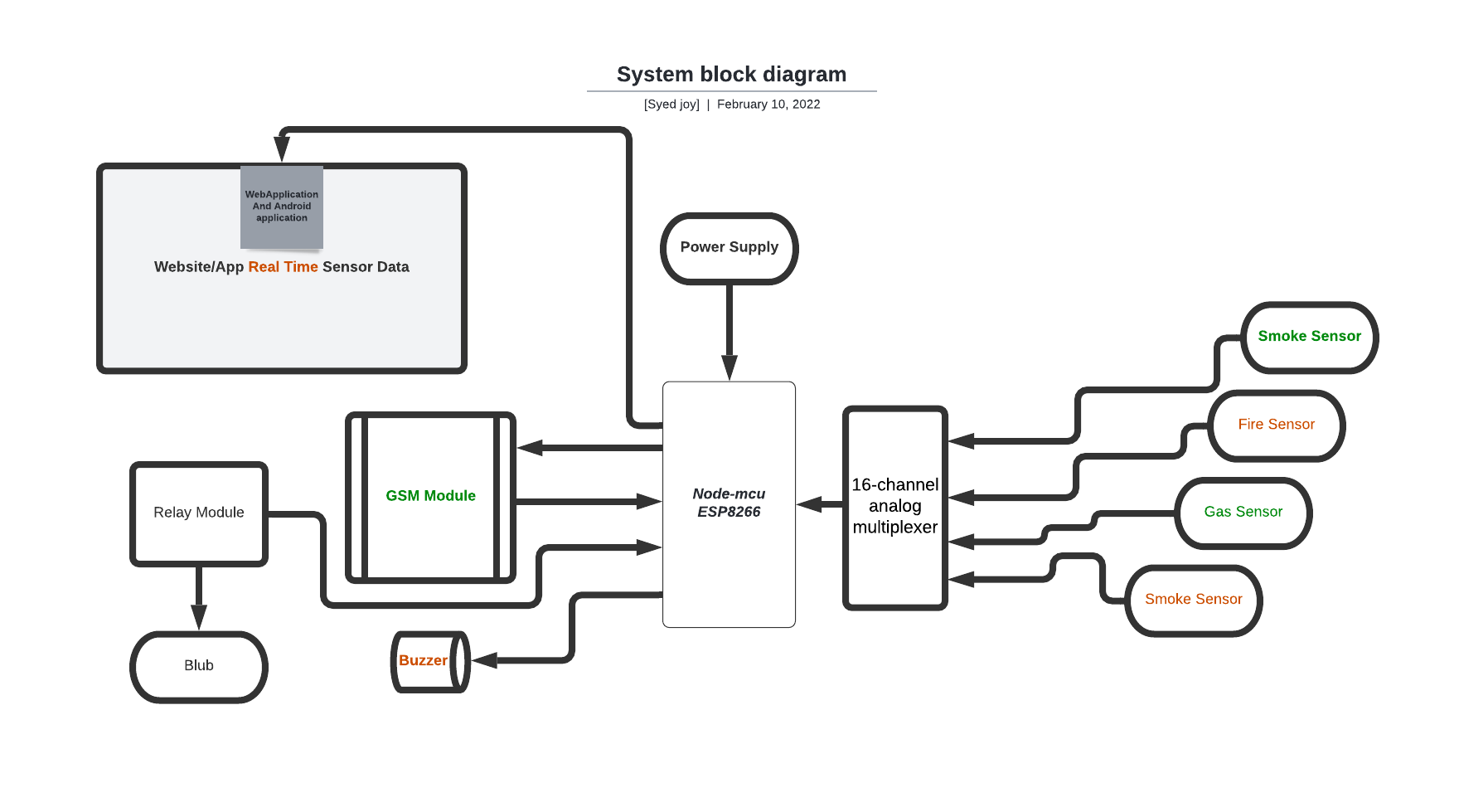

**Fig:1(System Diagram)**

**System operation**

* **Hardware**

The actual circuit connection is shown in figure 2. In this circuit, two main components are used. One is NodeMCU and another is a GSM module. Sensors are interfaced with NodeMCU as input devices while the GSM will execute the process after getting a signal from NodeMCU. The relay circuit will be activated for alarming fire hazards to switch ON bulb and buzzer sounding. The circuit connection shows NodeMCU powered by the Boost Buck module. Different sensors for detection are connected through this module for power requirements. The entire sensor devices are interfaced with NodeMCU as input devices. We use a Mux to connect all the sensors to NodeMCU. The flame sensor acts as an electromagnetic radiation receiver. This sensor uses the infrared flame flash method, which allows the sensor to work through a coating of oil, dust, water vapor. While the smoke detection sensor MQ2 is used to detect the gases like methane, propane, concentrations if any present. This sensor includes a sensing part, primarily ceramic based on aluminum oxide, filled with Tin dioxide, embedded in a mesh of stainless steel. When immersed in the air at high temperatures, oxygen is adsorbed on the surface of the sensing material. Instead, donor electrons in tin oxide are drawn to this oxygen and hence the present flow is stopped. Such oxygen atoms interfere with the reduction of pollutants, thus reducing the surface density of the adsorbed oxygen when pollutants are present. Current will now pass via the sensor, producing analog voltage values. The quantities of these voltages are calculated to determine the gas concentration. Tension levels are higher when gas production is small. MQ5 is responsible for detecting smoke. The gas sensor module consists of an exoskeleton in steel that houses a sensing device beneath it. By connecting leads thissensing aspect is subject to current. If a gas interacts with this sensor, it is first ionized and then adsorbed by the sensing part. This changes the resistance of the sensing element which alters the value of the current going out of it. This adsorption creates a potential difference on the element which is conveyed to the NodeMCU unit through output pins in form of current. DHT11 sensor consists of a capacitive humidity sensing element and a thermistor for sensing temperature. The humidity sensing capacitor has two electrodes with a moisture-holding substrate as a dielectric between them. Change in the capacitance value occurs with the change in humidity levels. This tests the modified principles of resistance and transforms them into digital shapes. This sensor uses the Negative Temperature coefficient of the thermistor to measure the temperature, which causes its resistance value to decrease with an increase in temperature. This sensor typically consists of semiconductor ceramics or polymers to achieve a greater resistance value except with the slightest temperature shift. The messaging GUI is designed for sending warning SMS. Sim900 interacts on the UART platform with an external device. The default Contact baud rate is 9600 bps. This requires setup and functional AT commands for it. NodeMCU Serial UART is used to interface the communication with sim900. Arduino IDE is used to compile and compose code. In the serial channel, the initialization feature is initialised. AT commands are sent to GSM in the loop function. Note the cell number type to which the SMS must be submitted. The power is kept forever at the end of the loop process while(1) process. If while (1) is not present, the loop feature runs continuously and SMS are continuously sent to the recipient.

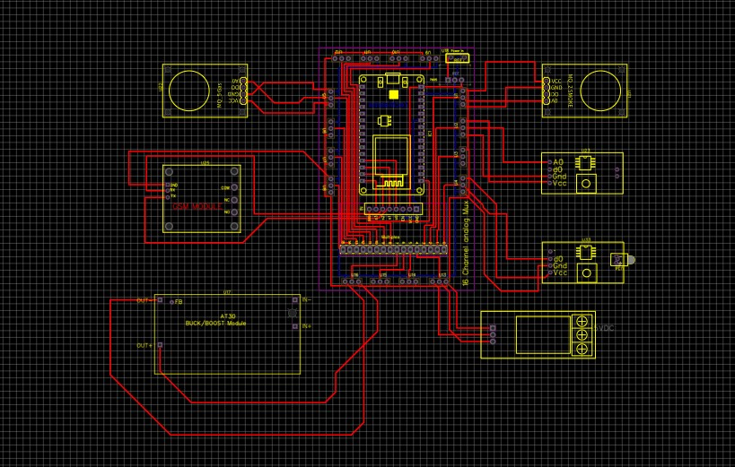

Fig:2 (CircuitDiagram)

**Flow Chart of The System**

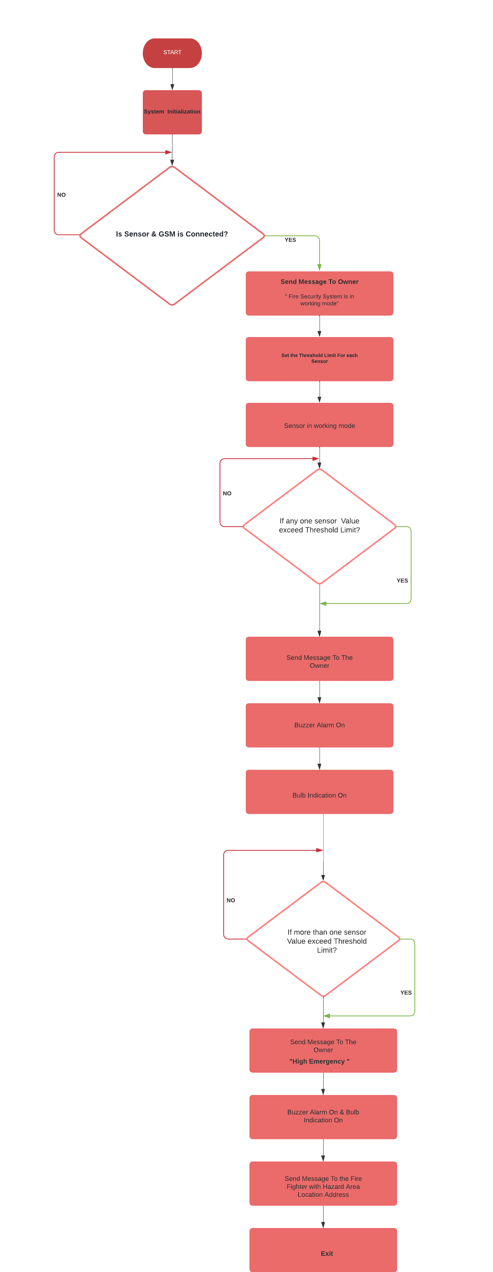

The beauty of this system is that fire fighter receive message with the address of hazardous area too. This enables them to directly track the spot for preventive actions. The address is stored in memory of the installed device to avoid major losses in such hazardous conditions by instantly informing fire fighters team.

The system responses in the form of SMS under different situations to the owner and fire fighter are shown in Figure 3 & 4 respectively. Throughout the experiments, the system's transmission period from fire detection to warning message (SMS) via GSM network was on average 15 seconds for the owner as well as the fire fighter, which is fast enough to take the appropriate steps to stop the fire threat.

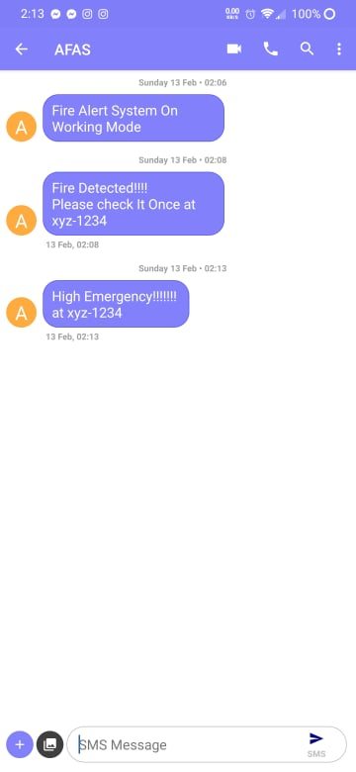 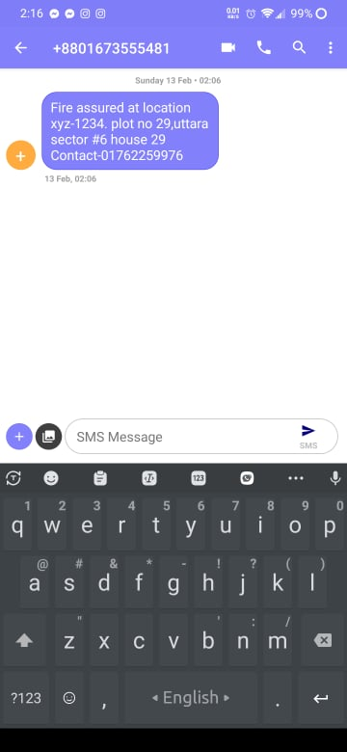

**Figure 3: *Alerting SMS reached to owner*** **Fig 4: *Alerting SMS reached to Fire fighter with location intimation***

**Website Mobile Interface :** We builder a Server and connect the Server with

esp8266 .So That a user can See the real-time data on their phone over the

world.Moreover a user can train themself virtually without any cost and know more

about fire prevention and protection.

 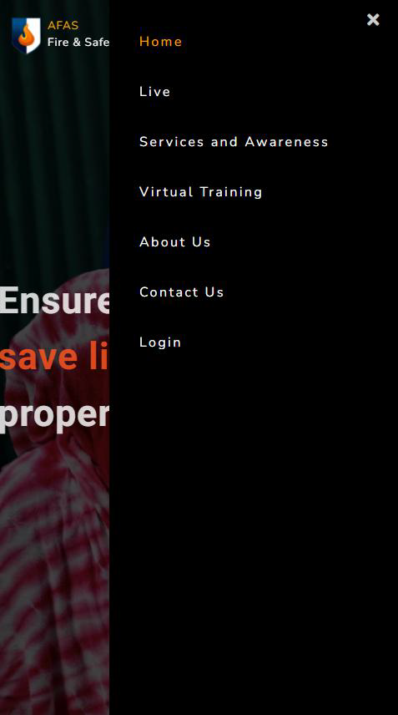

 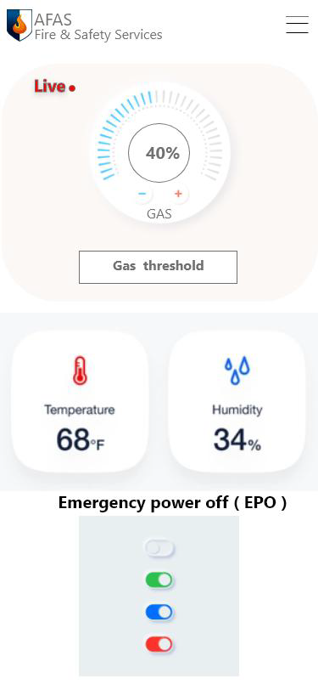

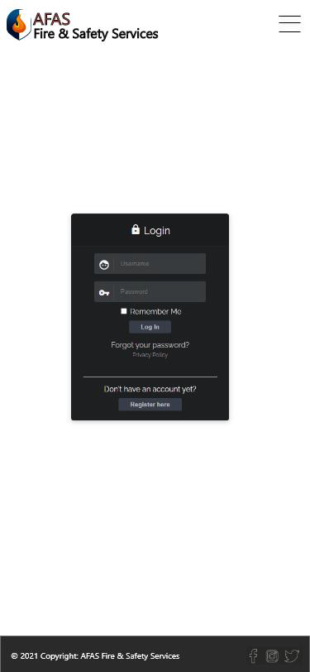 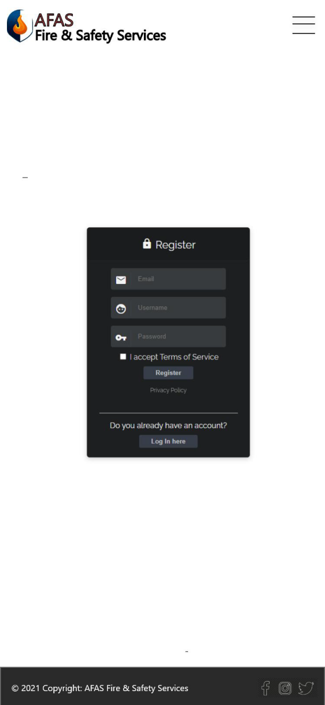

1. Explain your project sustainability in the context of Bangladesh: (Max 100 words)

Ans:

We think that our project is quite sustainable in the context of Bangladesh for a few reasons. Firstly, it is a cost-effective system. Secondly, the user can see the real-time data through a web/android application and cut off the electric supply immediately in case of any emergency. Moreover, it is a comparatively small device that can provide good portability according to the user's need and it can be used for industrial as well as household purposes. Finally, this system provides an early fire warning which will help to prioritize the immediate rescue operations by the owner and or firefighters respectively so that damages will be reduced effectively.

1. Why you think your invention is different and better from any existing solution in market? (Max 100 words)

Ans:

We think that our invention is different and unique because most conventional fire alarm systems in Bangladesh are manual. There are automated alarm systems as well but they are mostly expensive. Also, the systems don't provide real-time data from the sensors and don't alert the owner, fire service or medical support by analyzing all the data, all of which our system can ensure within a more cost effective way and will be within the reach of common people of Bangladesh. Moreover, it sends the GPRS location of the incident to the owner and nearby fire service when the situation gets hazardous.