**Name: Syed Bakhtawar Fahim**

**Seat No. B20103066**

**Submitted To. Ma’am Farheen Faisal**

**Program to print a single character on screen**

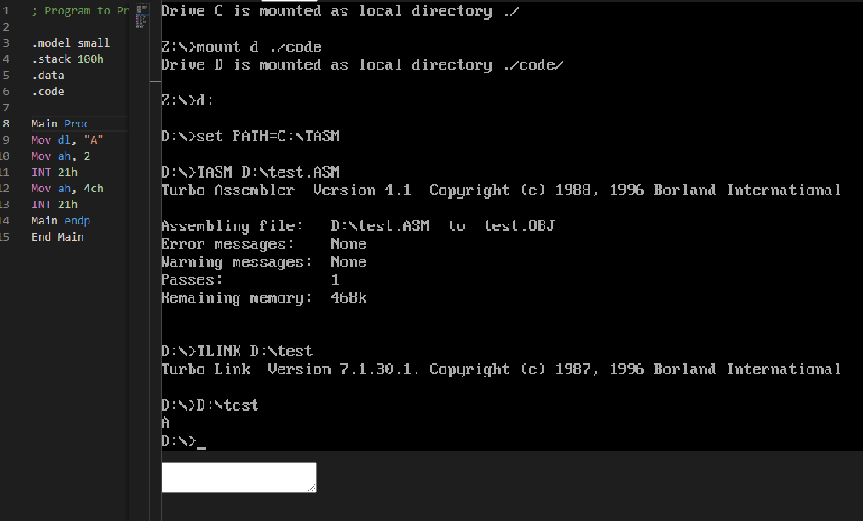

**PROGRAM TO PRINT NAME WITH CHARACTER**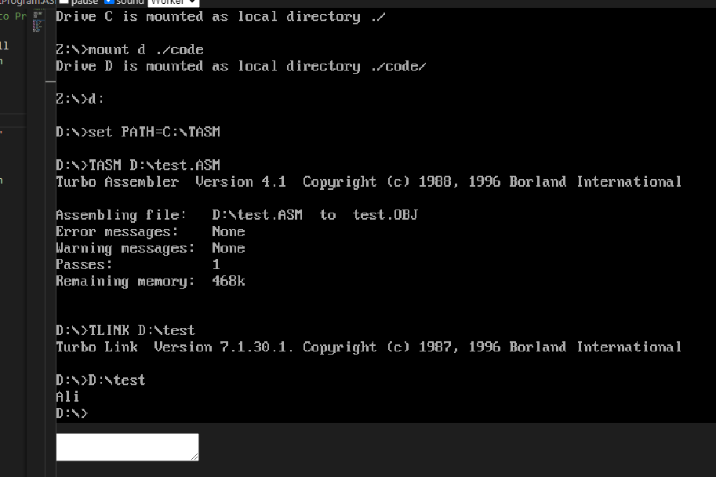

**PROGRAM TO TAKE INPUT CHARACTER AND PRINT ON SCREEN**

