Syed Bilal Hassan | Machine Learning Engineer Assessment

Freight Rate Prediction - Validation Approach & December Chart

1. Problem and key facts about the data
Predict posted_rate for 12,000 loads in validation.csv using 48,000 labelled loads in train_test.csv. The two files do not overlap in time: training covers 2025-01-01 to 2025-10-31, validation covers 2025-11-01 to 2025-12-31. This is therefore a forecasting task, and 8 of the 72 cities in validation (12% of rows) never appear in training.

2. How I validated and split the data
A random train/test split would be misleading here: loads on the same day share a market level, so a random split lets the model learn each day's level from neighbouring rows - something it cannot do for the future. I therefore used forward-in-time validation that copies the real task:
- Time split: three expanding-window folds - train on Jan-Jun and test on Jul-Aug; train Jan-Jul, test Aug-Sep; train Jan-Aug, test Sep-Oct. Every test window is ~2 months long and strictly after its training data, exactly like Nov-Dec follows Jan-Oct.
- Unseen-city simulation: in each fold I also removed every training row touching 8 randomly chosen cities and report the error on test rows that touch them, mimicking the 8 unseen cities in the real validation set.
- No leakage: no feature uses labels from the evaluation window. The daily market level is built from features only (market_index averaged per day), so it can legitimately be computed for Nov-Dec.
- Corrupted labels: ~1.4% of posted_rate values are corrupted (off by a factor of roughly 2-6x, a clear gap in the residuals). They are removed from training and, for reporting only, from the test metrics, because no model can predict them. RMSE including them is shown separately.
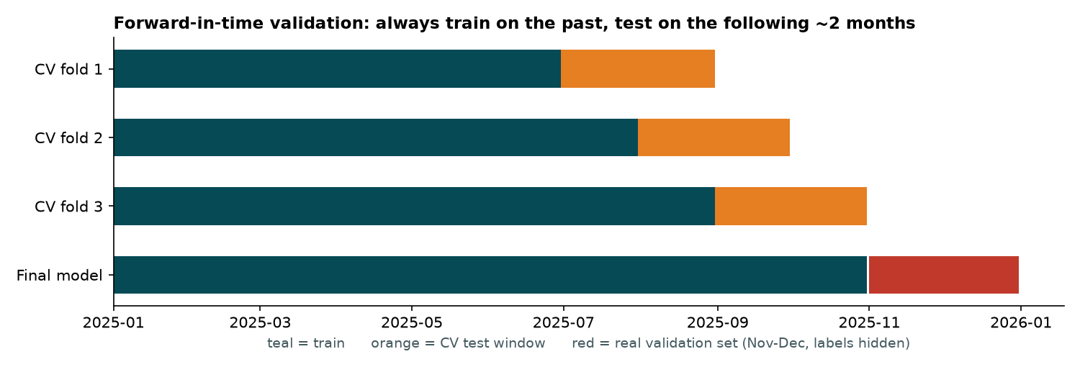
Figure 1 - Forward-in-time validation scheme

3. Data-quality issues and how they were handled
- Negative weight: 292 train / 145 validation rows have negative weight. The absolute value matches the positive distribution exactly, so these are sign errors and are fixed with abs().
- Missing values: weight (0.6%) and market_index (0.8%) have gaps. Weight is left as NaN for the tree model, which handles it natively; market_index is only used as a daily average so gaps do not matter.
- Corrupted target values: 677 training rows (1.41%) flagged by a two-pass robust residual check on log(rate). Dropping them improved MAPE on trustworthy rows from 2.04% to 1.77%.
- quote_signal: quote_signal switches between regimes month to month (about 2.3 in June, 1.9 in July, flat 2.05 in Nov-Dec) and mostly acts as a date fingerprint. Once trend and quarter-end terms are in the model it adds only ~0.04 pp, with fold results that disagree, and its high months coincide with the quarter-end effect, so it is excluded as an unstable proxy. (Nov-Dec levels resemble August, so the exclusion is a risk-based choice, not a claim that Nov-Dec is unprecedented.)
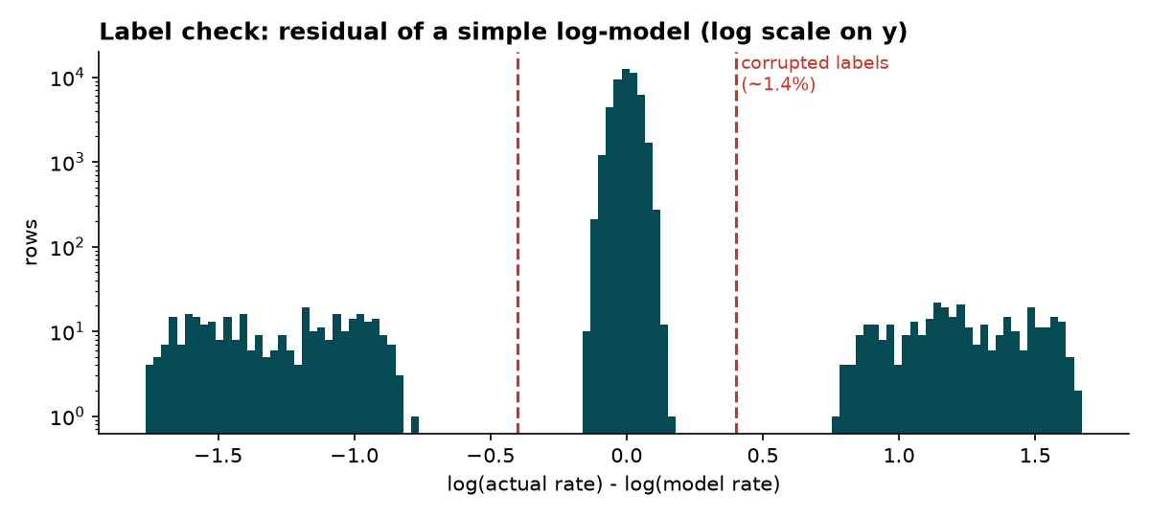
Figure 2 - Corrupted labels separate cleanly from the good rows

4. Model
The model predicts log(rate) as a linear part plus a gradient-boosted tree fitted to what is left. The linear part holds the terms that must extrapolate into the future - log distance and its square, equipment, the daily market index (+0.14 per index point), a slow upward drift (~0.02 per 100 days) and a quarter-end ramp (+3.9% over the last 31 days of a quarter). The trees learn the non-time structure from distance, weight, equipment and the pickup/delivery coordinates, so unseen cities are handled through geography instead of a city name.
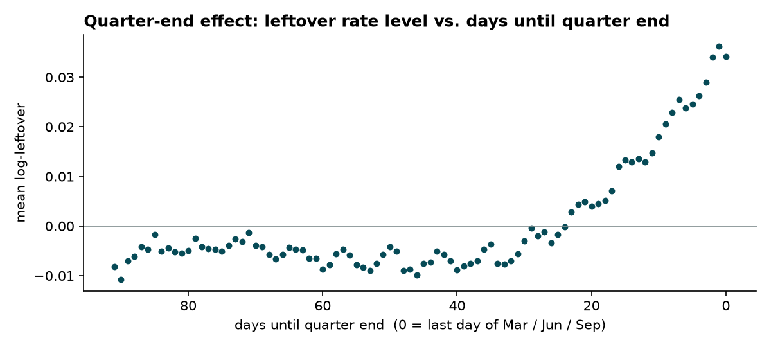
Figure 3 - Quarter-end effect discovered in the residuals

5. Cross-validation results
Model | MAE ($) | MAPE (%) | RMSE ($)
1. Distance + equipment only (linear) | 78.8 | 3.51 | 109.1
2. Naive GBM on raw columns, no cleaning | 83.3 | 3.56 | 120.2
3. Final model WITHOUT trend + quarter-end terms | 81.6 | 3.49 | 110.2
4. Final model, labels NOT cleaned | 47.4 | 2.04 | 67.9
5. FINAL MODEL | 41.6 | 1.77 | 59.9

Metrics are averaged over the three folds, on rows with trustworthy labels. On test rows touching unseen cities the final model reaches MAE $47.0 and MAPE 1.82%, so geography-based features generalise to new cities. If the corrupted labels are counted, RMSE is ~$620 for every model; that floor is label noise, not model error.

6. Fixed December prediction chart (from score.py)
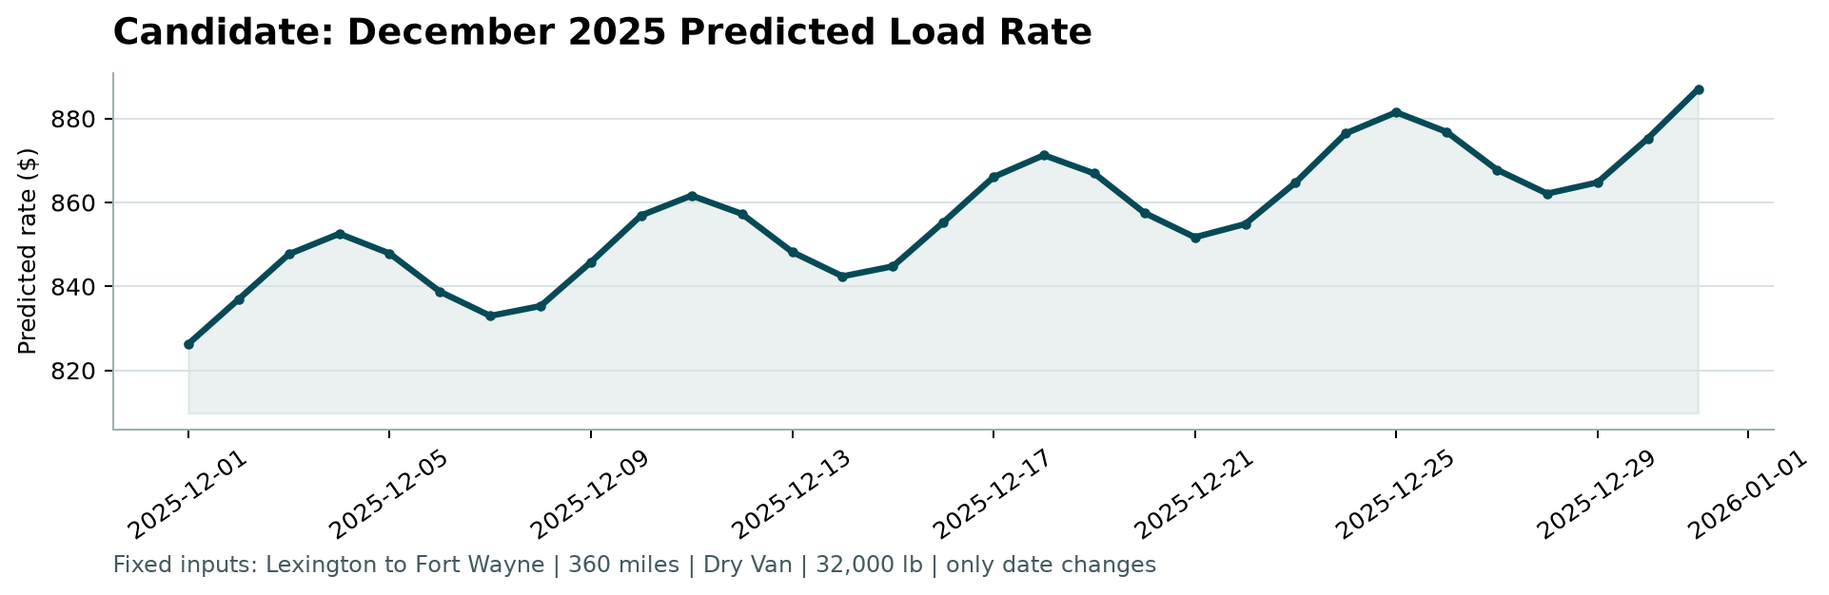
Figure 4 - candidate_december.png produced by the provided score.py
The prediction moves from $826 on Dec 1 to $887 on Dec 31 (range $826 to $887). Two effects are visible: a 7-day wave that comes from the weekly cycle in the market index, and a steady climb driven by the slow drift plus the quarter-end ramp. Because the chart file contains no market_index, I used the daily average of market_index across validation.csv rows on each date and looked up lat/lon from the city names.
Main assumption/limitation: The quarter-end ramp was learned from Q1-Q3 (the training data has only October in Q4), so the end-of-December rise assumes the same calendar pattern repeats in Q4.

