SSLA Based Traffic Sign and Lane Detection for Autonomous cars

In this paper author is introducing concept for self-driving car by using OPEN-CV2 and Machine Learning algorithms. CV2 Hough algorithm is used to detect LANE while driving car and Machine Learning algorithm get trained on available TRFFAIC SIGNS and in video if any such signal available then Machine Learning algorithm will predict and recognized.

To train this algorithms we need to have high configuration system with TERABYTES RAM and Harddisk with good speed processor but our normal 8GB system will not trained such huge dataset so we took some traffic signals and then trained ML model so our system can detect LANE and SIGNS but not with high accuracy and to get 100% output we need to trained model with Heavy Configuration system.

We have trained ML model with below signs

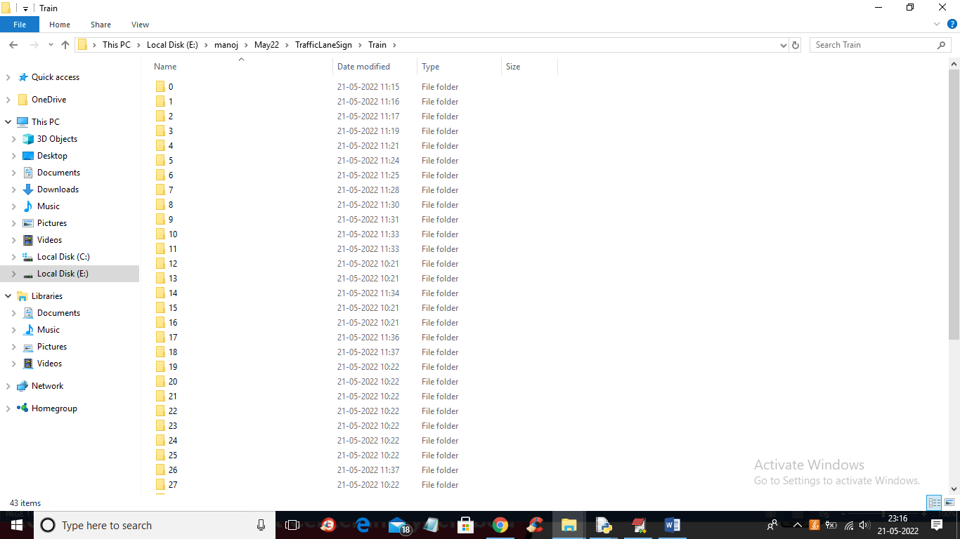

In above screen we have 43 different signs but we trained with few SIGNS and just go inside any folder to view sign images

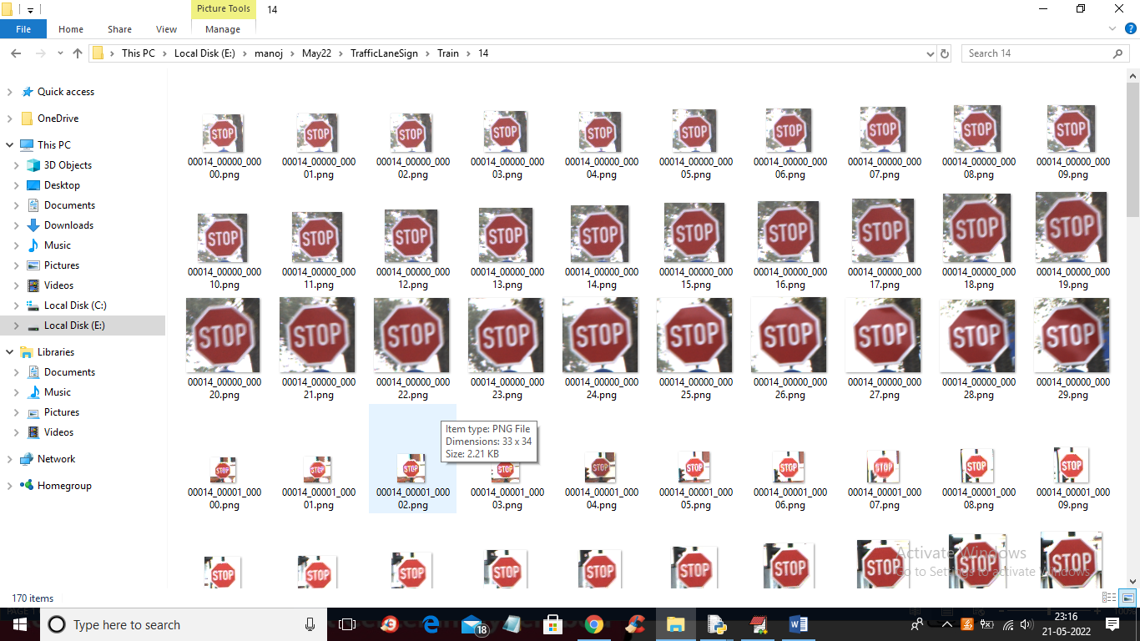

So we will used above images to train ML model

To implement this project we have designed following modules

1. Generate & Load Machine Learning Model: using this module we will train ML model and then load it
2. Upload Video & Detect Hough Lane, Signal: using this module we will upload TEST video and then CV2 HOUGH algorithm will detect LANE and ML will detect and recognize traffic signs.

Note: we are unable to find proper video with traffic signs and LANE so we are using two different videos as input where one contains LANE and other contains TRFFAIC SIGN. Application will able to process both

SCREEN SHOTS

To run project double click on ‘run.bat’ file to get below screen

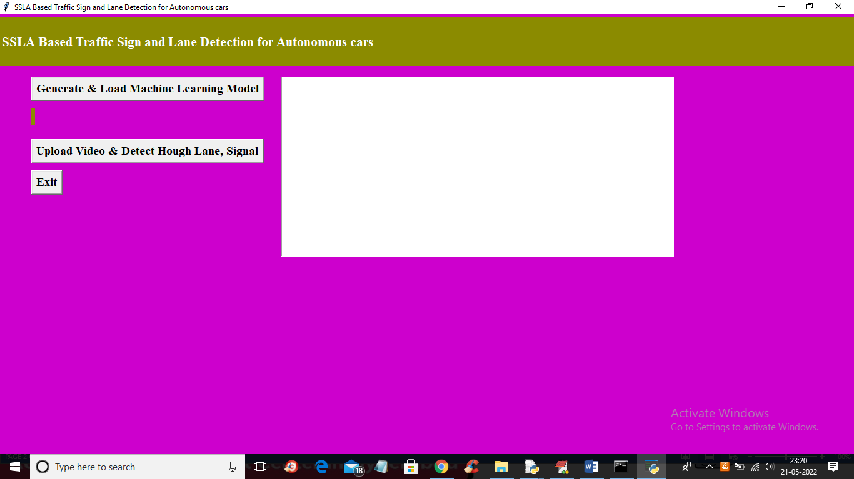

In above screen click on ‘Generate & Load Machine Learning Model’ to generate and load ML model and get below output

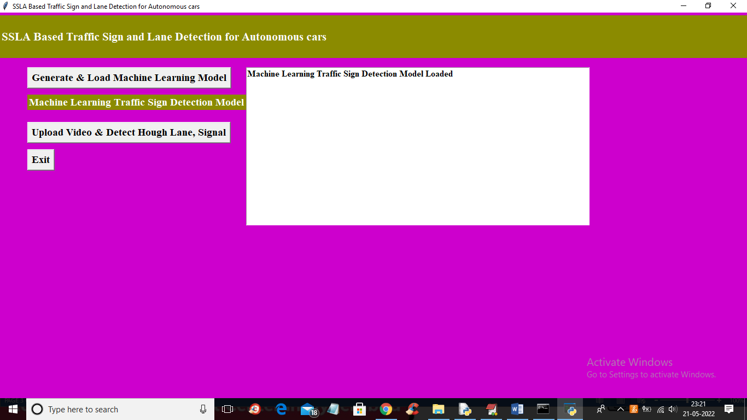

In above screen we can see model loaded and now click on ‘Upload Video & Detect Hough Lane, Signal’ button to upload video and get below output

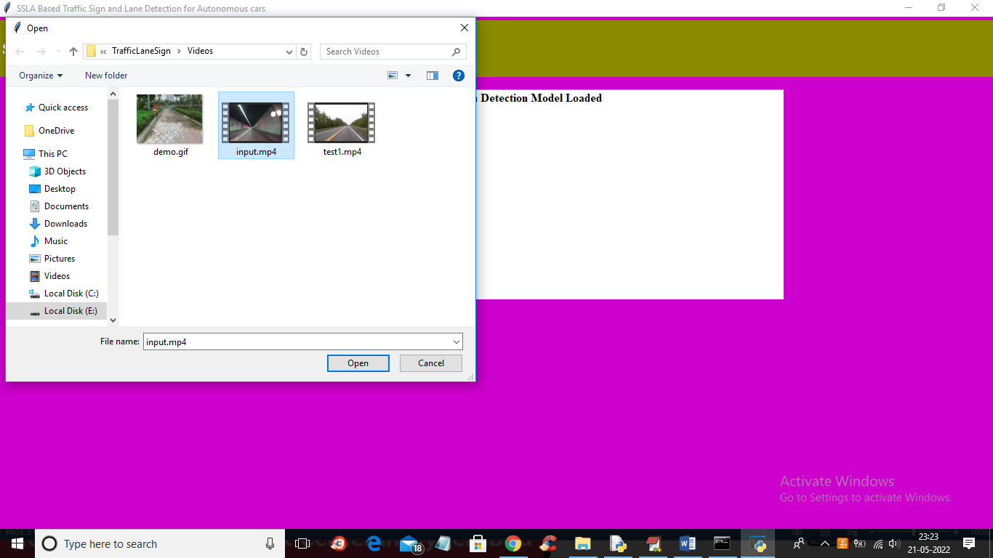

In above screen selecting and uploading ‘input.MP4’ file and then click on ‘Open’ button to get below output

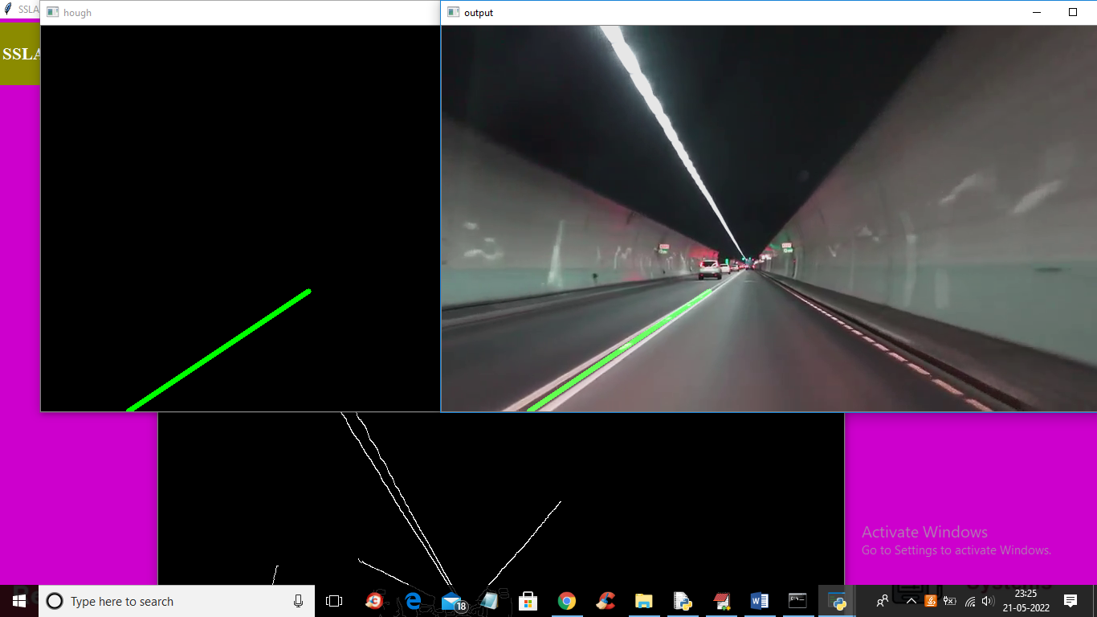

In above screen we can see the green line as lane detection and the same line we can see in BLACK HOGH window and CANNY EDGE DETECTION WINDOW but this video has not TRAFFIC signs so we will upload other video

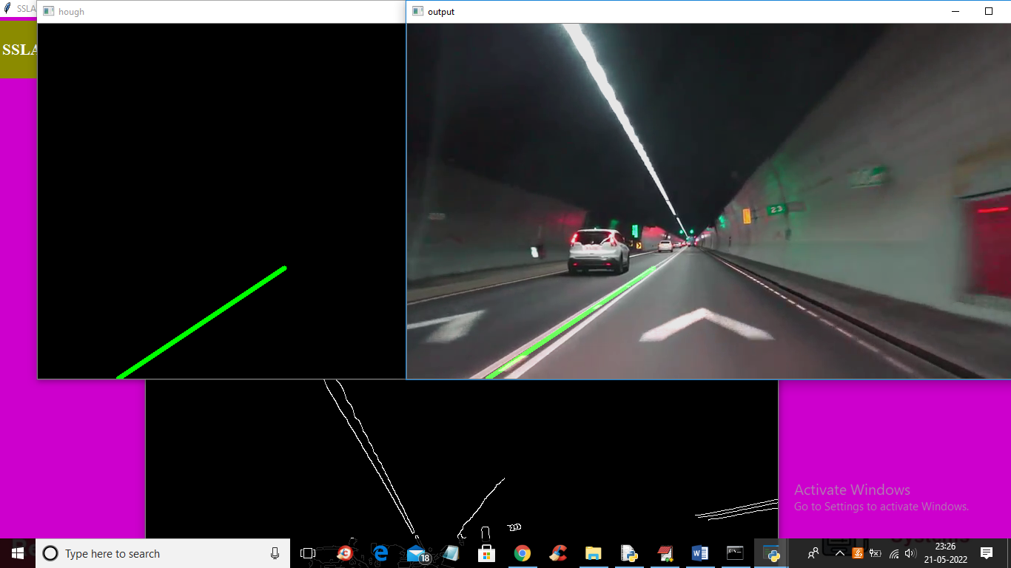

In above screen with green line application clearly detecting LANE and now see other output video

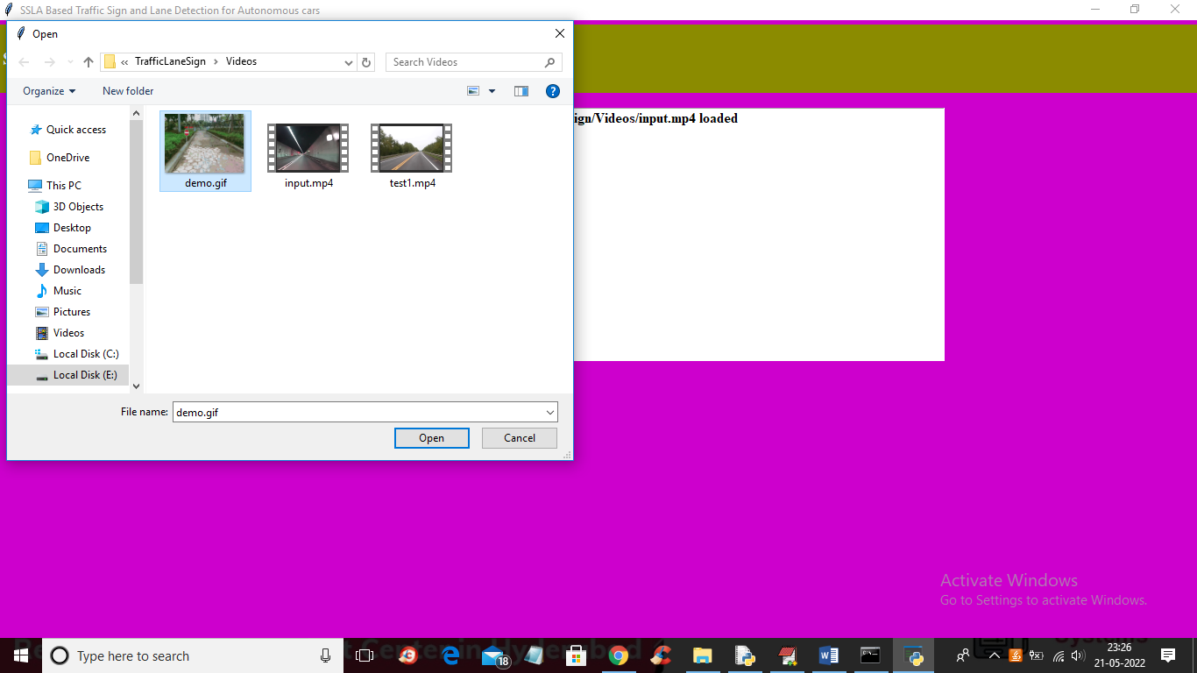

In above screen selecting and uploading ‘demo.gif’ file and then click on ‘Open’ button to get below output

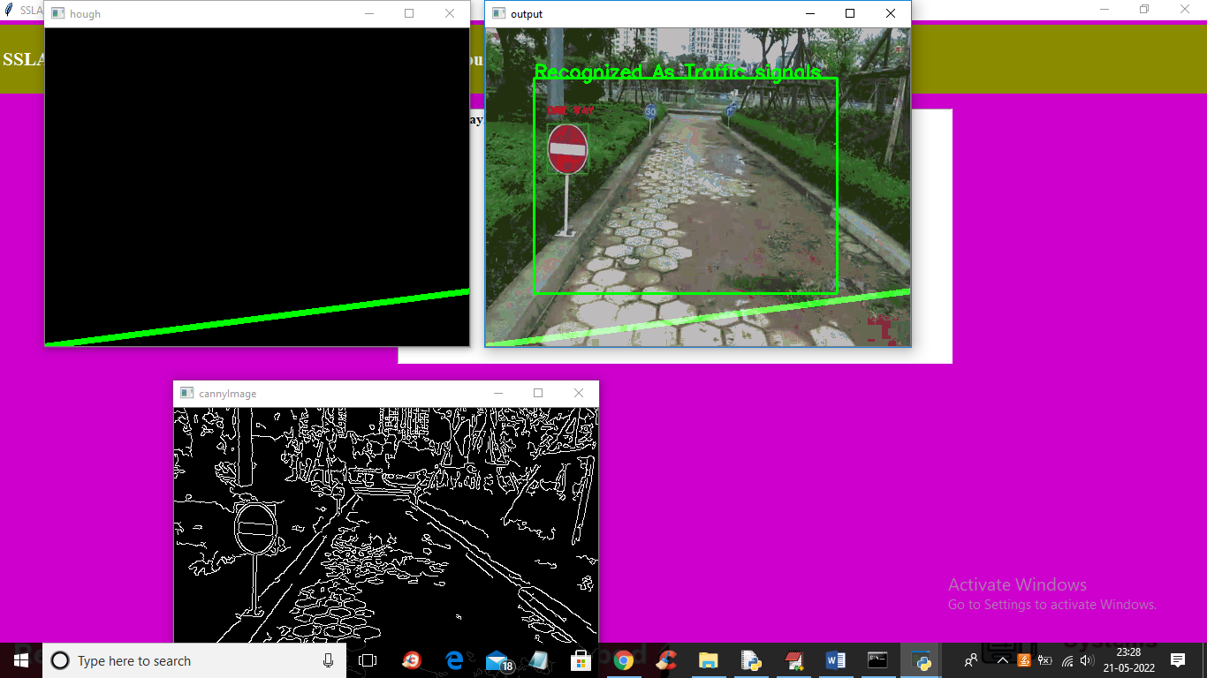

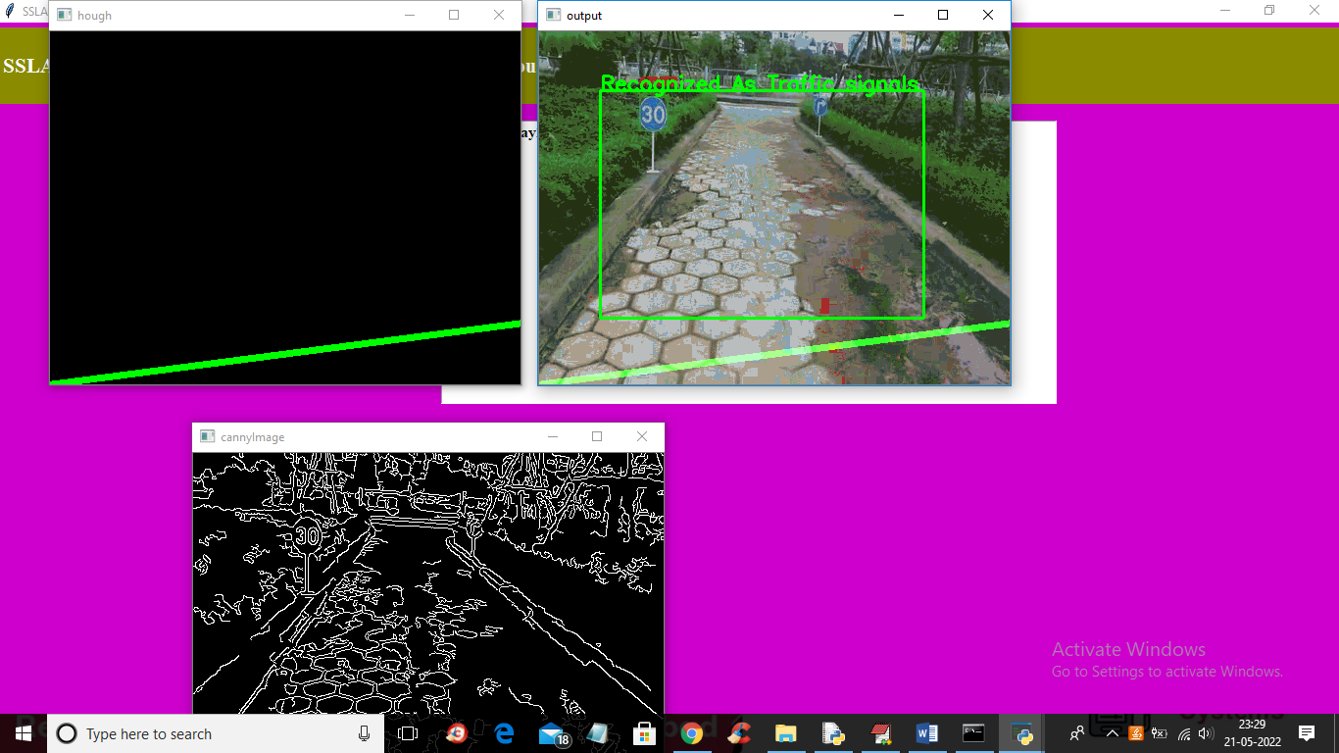

In above screens we can see ML model able to detect TRAFFIC SIGNS and similarly application detecting LANES also and both output LANE showing is GREEN LINE and SIGN showing with green colour bounding BOXES.

NOTE: to get traffic signs recognition you need video with clear sign visible and this application able to detect below showing signs

['Speed limit (20km/h)', 'Speed limit (30km/h)', 'Speed limit (50km/h)', 'Speed limit (60km/h)', 'Speed limit (70km/h)', 'Speed limit (80km/h)', 'End of speed limit (80km/h)','Speed limit (100km/h)','Speed limit (120km/h)', 'No passing', 'Stop', 'No Entry', 'General caution', 'Traffic signals']