1. Problem Description
Our project is a Library and Resource Management System. We made it because we wanted to solve a real-world problem: keeping track of books in a library is very difficult if everything is done on paper. Our program lets a library manage its books, users, and borrowing records automatically using a computer program. The program has two types of users. Normal users can register an account, log in, borrow books, return books, search for books, and view their history. An admin can add new books to the library, remove books, update book details, view all borrow records, and see reports of overdue books. All data (books, users, borrow records) is saved in text files so that nothing is lost when the program is closed and reopened. The whole project is built in C++ using Object-Oriented Programming concepts that we learned in CS-116.
2. Distinguishing Features and OOP Concepts Implemented
2.1 Distinguishing Features
- Two separate login systems: one for regular users and one for the admin.
- Automatic fine calculation: if a user returns a book late, the system calculates a fine of Rs.10 per day.
- Borrow limit enforcement: a user cannot borrow more than 2 books at the same time.
- Negative balance blocking: if a user has unpaid fines (negative balance), they cannot borrow new books.
- Persistent data storage: all data is saved to and loaded from text files (users.txt, resources.txt, records.txt).
- Search functionality: users can search for any book by title, author, or category.
- Custom exception system: we have 5 custom exception classes that give clear error messages for different problems.
- Overdue report: the admin can view a full list of all books that are currently issued or overdue.
2.2 OOP Concepts Implemented
Classes and Objects
We made 7 classes in our project: Resource, BorrowRecord, Person, User, Admin, library, and LibraryException. Each class is responsible for one part of the system. Objects of these classes are created at runtime to manage actual data like books and users.
Encapsulation
All important data in our classes is declared as private. For example, the balance field in User is private, and it can only be changed using addBalance() or deductBalance() methods. This protects the data from being changed incorrectly from outside the class.
Inheritance
Both User and Admin classes inherit from the abstract base class Person. This means they automatically get the common fields like username, firstName, lastName, and password. Also, our 5 exception classes (ResourceNotAvailableException, InsufficientBalanceException, etc.) all inherit from LibraryException.
Abstraction
The Person class is an abstract class because it has a pure virtual function: virtual void display() = 0. This means you cannot create a Person object directly. It forces every child class (User and Admin) to provide their own version of the display() function.
Polymorphism
The display() function is declared virtual in Person and is overridden in both User and Admin. When display() is called on a Person pointer, the correct version runs depending on whether the object is a User or Admin. This is runtime polymorphism.
Operator Overloading
In the Resource class, we overloaded the == operator so two Resource objects can be compared by their ID number. We also overloaded the << operator so a Resource can be printed directly to cout in a formatted way.
Exception Handling
We created a custom exception hierarchy with LibraryException as the base class and 5 specific exceptions inheriting from it. In the borrowResource() and returnResource() functions, we use throw to raise these exceptions and catch() blocks in the menu functions to display proper error messages to the user.
File Handling
We used ifstream and ofstream to load and save all data. When the program starts, loadAll() reads data from users.txt, resources.txt, and records.txt. After every important action (register, borrow, return), saveAll() writes everything back to the files so no data is lost.
3. Flow of the Project and Class Diagram
When the program starts, it loads all saved data from the text files. Then it shows the main menu with three options: User Login, User Registration, and Admin Login. If a new user registers, they enter their details and the system saves them. A registered user can log in and then access the user menu where they can borrow books, return books, search, check their profile, and add balance. The admin logs in with a fixed username and password (admin / admin123) and can manage books and view all records. All actions automatically save to files before the program closes.
Below is the Class Diagram showing all classes, their attributes, methods, and relationships:
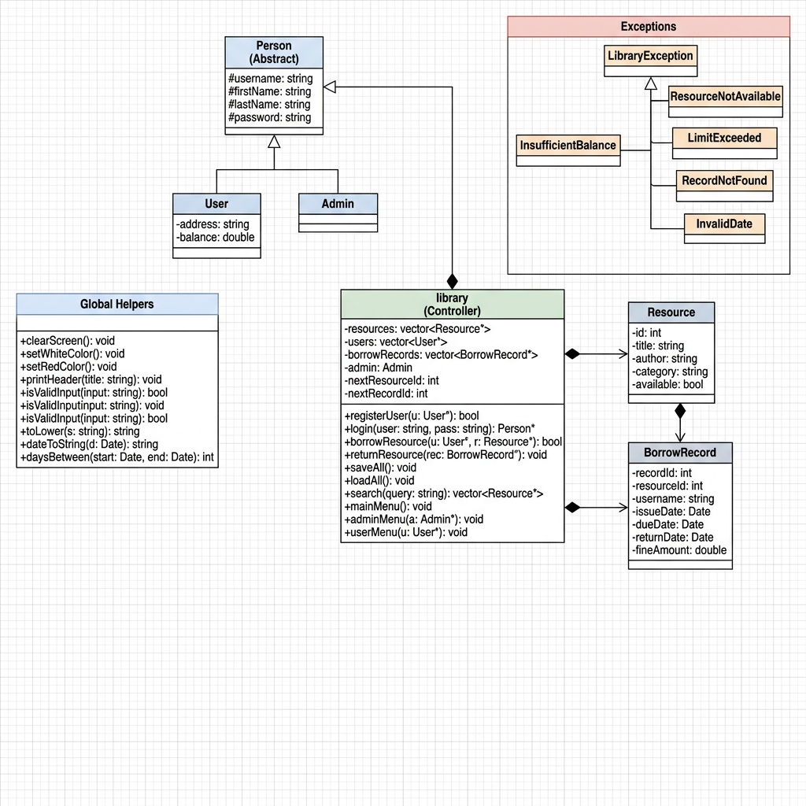
Figure 1: UML Class Diagram of the Library Management System
4. Most Challenging Part
The most challenging part for us was implementing the exception handling system and connecting it properly to the rest of the code. In the beginning, we were just using if-else statements and printing error messages, but the teacher wanted us to use proper C++ exception classes with throw and catch. We had to create 5 different custom exception classes that all inherit from one base class (LibraryException), and then throw the right exception at the right place inside borrowResource() which has 10 different validation steps. Another challenging part was the file handling. Reading data back from text files correctly, especially for the borrow records which have many fields, took a lot of debugging because even one extra newline or space would cause the program to crash or read wrong data.
5. New Things Learned in C++ While Working on This Project
- Custom Exception Classes: We learned how to create our own exception classes by inheriting from std::exception and overriding the what() function.
- Vector of Objects: We learned to store full class objects inside a std::vector and how to access and modify them using index.
- File I/O with ifstream and ofstream: We learned how to open, read, write, and close text files properly in C++.
- Operator Overloading: We learned how to overload the == and << operators to make comparing and printing objects easier.
- Pure Virtual Functions and Abstract Classes: We learned that a class with at least one pure virtual function (= 0) cannot be instantiated directly.
- Date Arithmetic Using struct tm: We learned to use the C time library (mktime, difftime) to calculate the number of days between two dates.
- SetConsoleTextAttribute (Windows API): We learned how to change the color of console text using the Windows API for a better user experience.
6. Individual Contributions of Each Group Member
Name | Roll No. | Contribution
Syed Muhammad Irtiza Abbas Rizvi | CS-25089 | Designed overall system architecture. Implemented the library controller class, all three menu systems (mainMenu, userMenu, adminMenu), and the complete file handling logic (loadAll and saveAll).
Muhib Ur Rub Qasmi | CS-25086 | Developed the Resource class with all its attributes and methods. Implemented operator overloading (== and <<). Handled admin-side resource management (add, remove, update resources).
Syed Zayan Mehmood | CS-25090 | Implemented the BorrowRecord class. Developed all date utility helper functions (getTodayDate, addDays, daysBetween, dateToString) and the fine calculation algorithm for overdue items.
Muhammad Hammad Ul Saboor | CS-25080 | Designed the Person, User, and Admin class hierarchy using inheritance and polymorphism. Implemented the complete exception class hierarchy and developed all input validation logic.
Note: All group members participated in debugging, testing, and verifying the final program together.
7. Future Expansions
- Graphical User Interface (GUI): We could add a GUI using a library like Qt or SFML to make the program more user-friendly.
- Database Integration: Instead of saving to text files, we could connect the program to a proper database like MySQL for safer and faster data storage.
- Multiple Admins: Currently only one admin account exists. In the future, we could allow multiple admin accounts with different permission levels.
- Online Reservations: Users could reserve a book online before coming to the library to physically pick it up.
- Email Notifications: The system could automatically send an email to a user when their book is about to become overdue.
- Fine Payment Gateway: Add an online payment option so users can pay their fines directly through the program.
8. Test Case Runs
Below are at least three test case screenshots showing the program running:
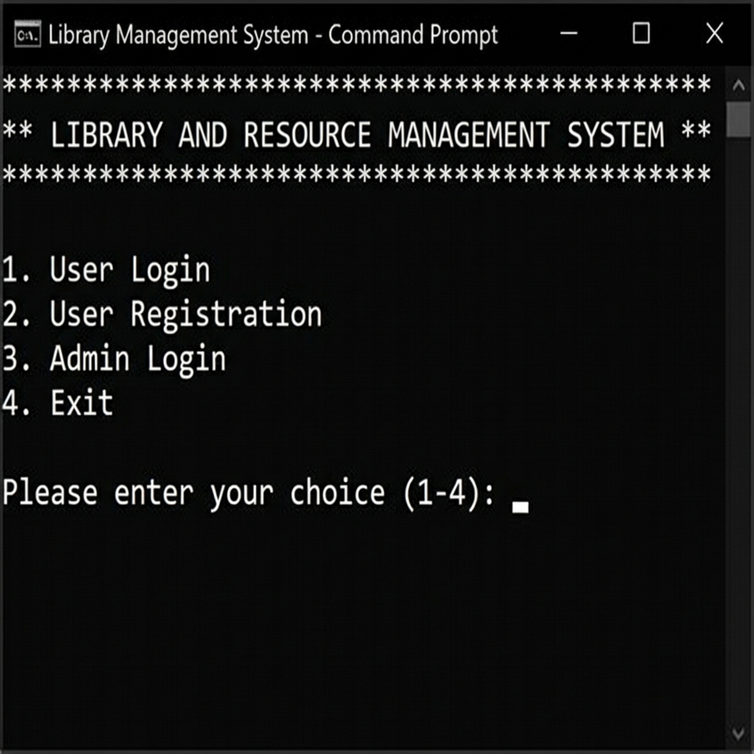
Test Case 1: Main Menu and Initial Options

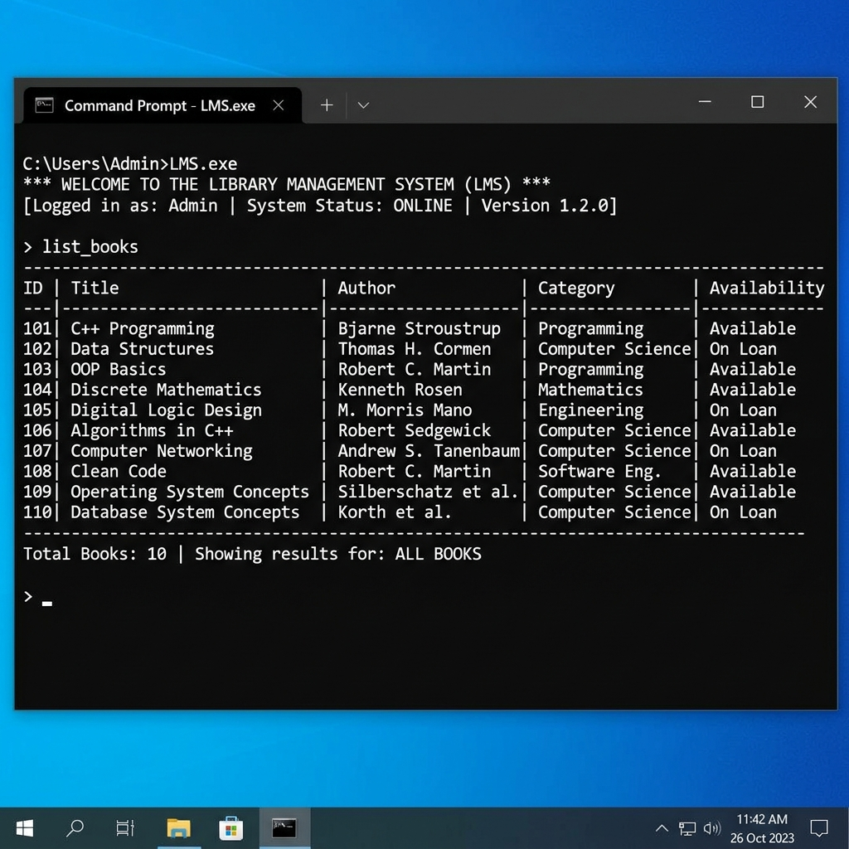
Test Case 2: Viewing Available Books in the Library

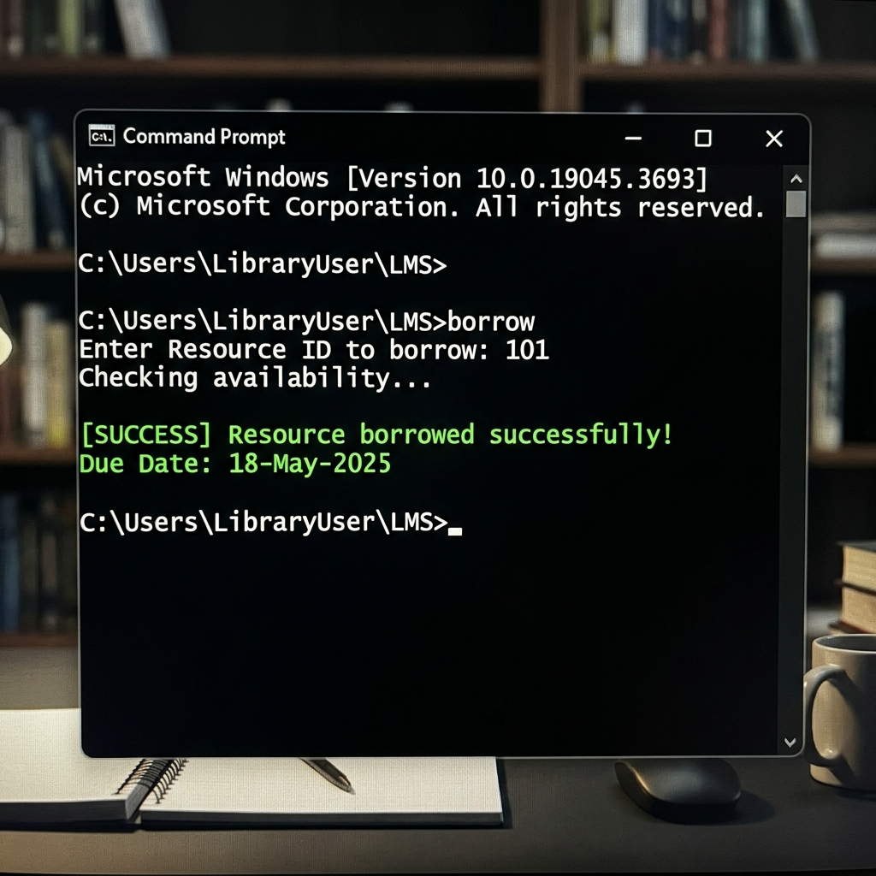
Test Case 3: Successfully Borrowing a Book and Fine Calculation

