Docker Architecture and Lifecycle
AIM: To understand Docker architecture and the container lifecycle, install Docker, and execute Docker commands to manage images and interact with containers.
Objectives:
- To understand the fundamentals of containerization using Docker.
- To study the architecture and components of Docker.
- To understand the lifecycle of a Docker container.
- To install and configure Docker on a system.
- To execute commonly used Docker commands for image and container management.
- To interact with running containers and observe their behavior.
Description:
Docker is an open-source containerization platform that enables applications and their dependencies to be packaged into lightweight and portable containers. Unlike traditional virtual machines, containers share the host operating system kernel, making them more efficient in terms of resource utilization and startup time. Docker helps developers:
- Build applications consistently across environments.
- Simplify deployment processes.
- Improve scalability and portability.
- Isolate applications from one another.
- Reduce dependency-related issues.
Docker Architecture:
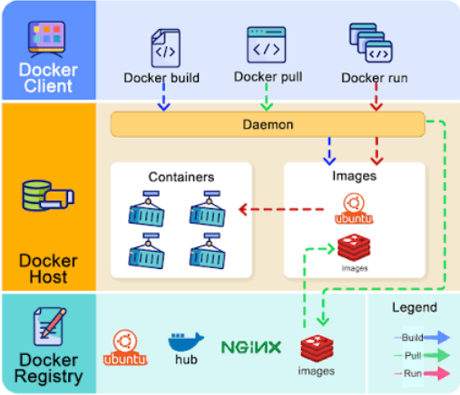
Docker follows a client-server architecture consisting of several components.
Docker Client :The Docker Client is the interface through which users execute Docker commands.
- docker run
- docker pull
- docker ps
The client communicates with the Docker daemon to perform requested operations.

Docker Daemon: The Docker Daemon (dockerd) is responsible for:
- Building images.
- Managing containers.
- Handling Docker networks.
- Managing Docker volumes.
- Communicating with Docker clients.

Docker Host: The Docker Host is the machine on which Docker is installed and running. It contains:
• Docker Engine • Images • Containers Networks • Volumes

Docker Registry : A Docker Registry stores Docker images. Examples include:
• Docker Hub • Private Docker Registry • Enterprise Container Registry

Docker Images:
A Docker image is a read-only template used to create containers. Characteristics:
- Contains application code and dependencies.
- Can be reused multiple times.
- Acts as a blueprint for containers.
- Stored locally or in registries.
Examples: ubuntu, nginx, mysql, python

Docker Containers:
A container is a running instance of a Docker image. Containers provide:
- Process isolation.
- Application portability
- Lightweight execution.
- Rapid startup.

Docker Container Lifecycle:
A Docker container passes through several states during its lifecycle.
Created: The container has been created but is not running.
Running: The container is actively executing processes.
Paused: The container processes are temporarily suspended.
Stopped: The container is no longer running but still exists on the system.
Removed: The container has been deleted from the Docker host.

Procedure :
- Download and install Docker Desktop or Docker Engine.
- Verify that Docker has been installed successfully.
- Study the major components of Docker architecture.
- Understand the Docker container lifecycle.
- Pull a Docker image from Docker Hub.
- Create and start a container from the image.
- View running and stopped containers.
- Interact with a container using Docker commands.
- Stop, restart, and remove containers.
- Remove unused Docker images.
- Record observations regarding image and container management.

Execution:
Step 1: Install Docker
Download and install Docker Desktop from the official Docker website. After installation, start Docker Desktop and ensure the Docker service is running.

Step 2: Verify Docker Installation
Open Command Prompt, PowerShell, or Terminal and execute: docker --version A successful installation displays the installed Docker version.
Step 3: Verify Docker Service
Check whether Docker is functioning properly: docker info This command displays Docker Engine information and confirms communication with the Docker daemon.
Step 4: Download an Image
Pull the Ubuntu image from Docker Hub: docker pull ubuntu Docker downloads the required image layers and stores them locally.
Step 5: View Available Images
Display all downloaded images: docker images The command shows: • Repository name • Tag • Image ID • Creation date • Image size
Step 6: Create and Run a Container
Create and start a container using the Ubuntu image: docker run -it ubuntu bash Explanation: • -i : Interactive mode. • -t : Allocates a terminal. • ubuntu : Image name. • bash : Starts the Bash shell. The terminal prompt changes to indicate execution inside the container.
Step 7: Interact with the Container
Execute commands within the running container:
- pwd
- ls
- whoami
These commands demonstrate interaction with the containerized environment
Step 8: Exit the Container
Exit the running container: exit The container stops after exiting the shell session.
Step 9: View Container Lifecycle Status
Display all containers: docker ps -a
Observe the container status: • Up (Running) • Exited (Stopped)
This demonstrates lifecycle state transitions.
Step 10: Restart the Container
Start the stopped container again: docker start <container_id>
Verify the status: docker ps
Step 11: Access the Running Container
Connect to the container: docker exec -it bash This opens an interactive shell session within the container.
Step 12: Remove the Container
Stop the container if necessary: docker stop Remove it: docker rm This deletes the container from the Docker host.
Step 13: Remove the Image
Delete the image: docker rmi ubuntu This removes the image from local storage

Conclusion:
The experiment provided practical understanding of Docker architecture and containerization concepts. Docker images and containers were managed using standard Docker commands, and the complete container lifecycle—from creation to removal—was studied. The experiment demonstrated how Docker enables lightweight, portable, and efficient application deployment through container technology.

