Docker file and Image Building
AIM: To study Dockerfile instructions and use a Dockerfile to create a container image for a simple web application..
Objectives:
- To understand the purpose and structure of a Dockerfile.
- To study commonly used Dockerfile instructions.
- To create a simple web application that can be served using Nginx.
- To write a Dockerfile for the web application.
- To build a Docker image using the Dockerfile.
- To run a container from the newly created image.
- To access and verify the web application through a web browser
Description:
A Dockerfile is a text file containing a sequence of instructions used by Docker to construct an image. Instead of manually configuring a container every time an application needs to be deployed, the required environment and application files can be described in a Dockerfile. A Dockerfile therefore acts as a reproducible set of instructions for creating a Docker image.
Dockerfile Instructions:
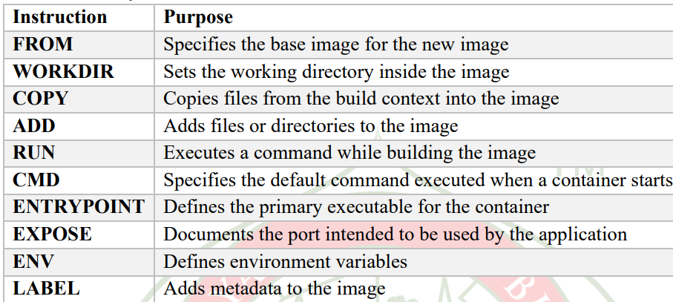
Base Image:
The FROM instruction specifies the starting point for the image. For this experiment:
FROM nginx
The official Nginx image provides a ready-to-use web server environment.
Copying Application Files:
The COPY instruction transfers files from the Docker build context into the image. For the sample application:
COPY index.html /usr/share/nginx/html
The HTML file is copied into the default directory from which Nginx serves static web content.
Docker Image Building Process:
The Docker image is created using:
docker build -t myapp .
Here:
- docker build starts the image-building process
- -t myapp assigns the name myapp to the image.
- . specifies the current directory as the build context.
During the build, Docker reads the Dockerfile and executes its instructions to create the image. Running the Image as a Container:
After building the image, a container can be created using:
docker run -p 8080:80 myapp
The port mapping means: Host Port 8080 → Container Port 80
Therefore, requests sent to port 8080 on the host are forwarded to Nginx running on port 80 inside the container
Procedure :
1. Verify that Docker is installed and running.
2. Create a directory for the sample web application.
3. Create an HTML file containing the web-page content.
4. Create a file named Dockerfile in the application directory.
5. Add appropriate Dockerfile instructions.
6. Build a Docker image from the Dockerfile.
7. Verify that the newly created image is available locally.
8. Create and run a container using the image.
9. Map the container's web-server port to a port on the host system.
10. Open the application in a web browser and verify its output.
Execution:
Step 1: Create the Application Directory
Open PowerShell or Terminal and create a directory for the web application:
mkdir myapp
cd myapp
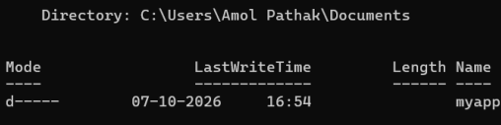
Step 2: Create the HTML File
Create a file named index.html.
For example:
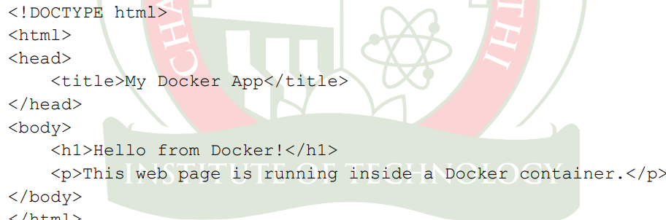
Step 3: Create the Dockerfile
Inside the same directory, create a file named: Dockerfile
The Dockerfile should contain:
FROM nginx
COPY index.html /usr/share/nginx/html
The first instruction selects Nginx as the base image, while the second copies the application's HTML file into the Nginx web directory. The reference experiment uses this same minimal Dockerfile structure for the sample application.
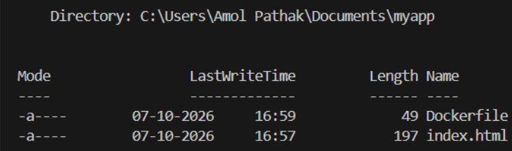
Step 4: Verify Docker
Before building the image, verify that Docker is available: docker --version
Optionally, obtain detailed Docker information using: docker info
Step 5: Build the Docker Image
From the directory containing the Dockerfile, execute:
docker build -t myapp .
Docker reads the Dockerfile and generates the myapp image. The build process should indicate successful completion. The reference execution shows the image being successfully built and tagged as myapp:latest. Figure 3: Successfully building the Docker image
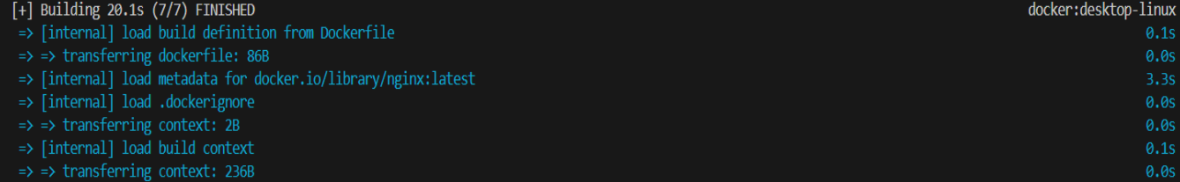
Step 6: Verify the Image
List the locally available Docker images:
docker images
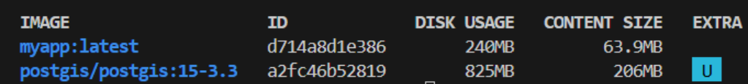
Step 7: Run the Container
Start a container from the newly created image:
docker run -p 8080:80 myapp
Here, port 8080 of the host is mapped to port 80 of the Nginx container. The reference experiment uses the same port mapping to run the myapp image.
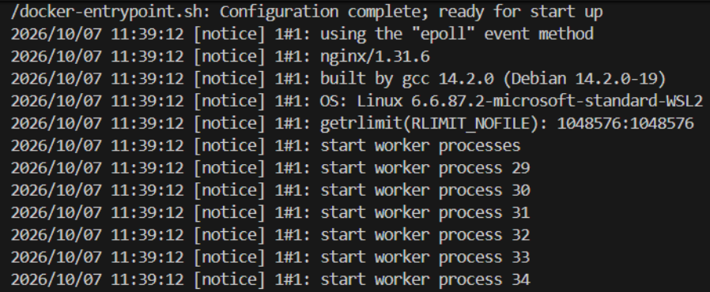
Step 8: Access the Web Application
Open a web browser and enter: http://localhost:8080
The HTML page created in Step 2 should be displayed. This confirms that:
1. The Dockerfile was processed successfully.
2. The Docker image was created.
3. A container was started from the image.
4. Nginx is serving the HTML file.
5. The application is accessible through the mapped host port.
Step 9: Verify the Running Container
Open another terminal and execute: docker ps
This displays the currently running containers. The output should show the myapp container and its port mapping
Conclusion:
The experiment provided practical understanding of Dockerfile-based image creation. The FROM and COPY instructions were used to construct an Nginx-based image containing a sample HTML application. The resulting image was built and executed as a container, demonstrating how Dockerfiles provide a repeatable method for packaging and deploying web applications.

