Proposed Title: Traffic-Sense: Harnessing Interpretable Machine Learning to Revolutionize Urban Traffic Congestion Prediction.
Count | Student Name | Registration Number | Department | Signature
1. | Aditya Kumar | 20ETCS002004 | CSE
2. | Aishwarya V | 20ETCS002007 | CSE
3. | Syed Khubaib Shaheen | 20ETCS002141 | CSE
4. | Utkarsh Singh Bharadwaj | 20ETCS002147 | CSE
GUIDE | Dr. Thompson S |  | CSE

Introduction to the Topic:
Urban traffic congestion poses significant challenges in cities worldwide, leading to increased travel times, fuel consumption, and air pollution. Congestion hinders efficient transportation, limiting access to essential services and hindering economic growth. Heavy traffic congestion can also result in road safety hazards, increasing the risk of accidents and injuries. Addressing traffic congestion is crucial for enhancing urban mobility, reducing environmental impact, and improving overall quality of life in cities. Accurate prediction of traffic congestion can aid in proactively planning traffic management strategies and optimizing transportation systems.

Aim: The aim of the project is to develop a robust and accurate system that can anticipate traffic congestion in urban areas. By leveraging historical traffic data, real-time sensor information, and machine learning algorithms, the project aims to accurately predict traffic. congestion patterns, optimize traffic flow, and implement effective management strategies to alleviate congestion and enhance transportation efficiency.

Low-level System Design:
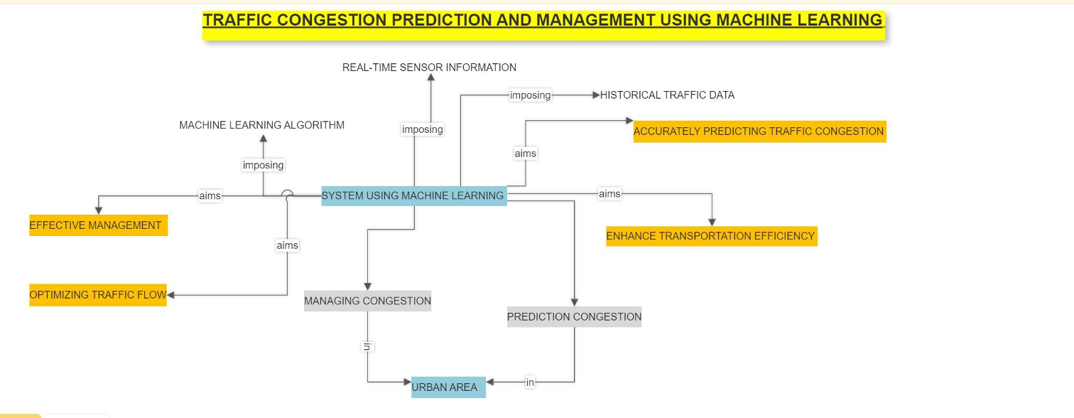
Methodology:
Objective | Method/ Methodology | Description
1 | Literature Review | Identify and review relevant papers, articles and studies related to traffic congestion prediction. Analyse state-of-art methodologies and challenges and synthesizing these findings to establish a strong foundation.
2 | Data Collection | Collect real-time traffic camera images or video streams from diverse urban areas, capturing various traffic conditions and scenarios. Ensure data privacy and compliance with ethical guidelines.
3 | Image Pre-processing | Apply image pre-processing techniques to enhance the quality of traffic camera images, including noise removal, contrast enhancement, and distortion correction. Normalize the images to ensure uniformity and consistency in the data.
4 | Image Segmentation | Segment the pre-processed traffic camera images into relevant regions and extract features from each segmented region, including vehicle count, density, speed, lane occupancy, and road occupancy.
5 | Web-Based Application Development | Design and develop a user-friendly web-based application that integrates the trained interpretable machine learning model and Provide a real-time traffic congestion prediction feature accessible to users through the web interface.

Objectives:
Sl. No | Objectives
1 | To conduct a comprehensive literature review on existing research related to urban traffic congestion prediction using machine learning and image analysis techniques.
2 | To collect real-time traffic camera images or video streams from various urban areas for the purpose of training and testing the machine learning model.
3 | To apply image preprocessing techniques, including image enhancement, noise removal, and to improve the quality and reliability of the traffic camera images.
4 | To segment the traffic camera images into distinct regions, such as vehicles, road infrastructure, and other relevant objects, to enable effective feature extraction.
5 | To develop a user-friendly web-based application that integrates the interpretable machine learning model, allowing users to access real-time traffic congestion predictions and visualize the important contributing factors.

Expected Output: The expected results of this project can be summarized as follows:
- Trained and Validated Model
- Real-time Prediction System
- Improved Urban Mobility
- Scalable and cost effective solution.
- Helps in raising awareness and can contribute to further researches.
Comments (For Official Use):

