Table of Contents
EXECUTIVE SUMMARY 1
Section A – Visualizations 1
Section B – Descriptive Statistics 5
Section C – Confidence Interval 6
Section D – Hypothesis Test 6
Section E – Corelation Analysis 7
Section F – Regression Analysis 8
Section G– Residual Analysis 10
Section H – Statistical model 11
Section I – Conclusion 11

EXECUTIVE SUMMARY
A market research was being done on Honda civic models from (2019-2024) on how their price is being influenced by factors like mileage, registration and many more. So a data set of 300 cars were collected from autotraders.uk and then sampling was applied and a sample of 100 were picked on which analysis were done through various visualizations methods to find out which are the important influencing variables that affects the price of the cars. Some factors like petrol hybrid models, which initially showed appositive correlation with price later in the regression analysis showed a significant decrease compared to petrol models. It suggested that at first it looked like a valuable factor but when many variables were removed and independently judged it showed signs of opposite effect. Similar was the case with diesel fuel type and automatic gear boxes . Then parsimonious model was worked upon and 5 factors were highlighted which put significant effect on the car price and the model passed the Residual Analysis test and so the model was approved to calculate the car prices then for Honda civic 2019-2024.
The sample is considered representative of the local second hand Honda civic market because it includes a diverse range of vehicles across multiple conditions, fuel types and price point sourced from Uks most running automative marketplace.

Section A – Visualizations
To start off with the decision making we started off with a few visualizations First visualization is of histogram for the overall price distribution of Honda civic in the sample. It will help understand the market price range identifying the trends.
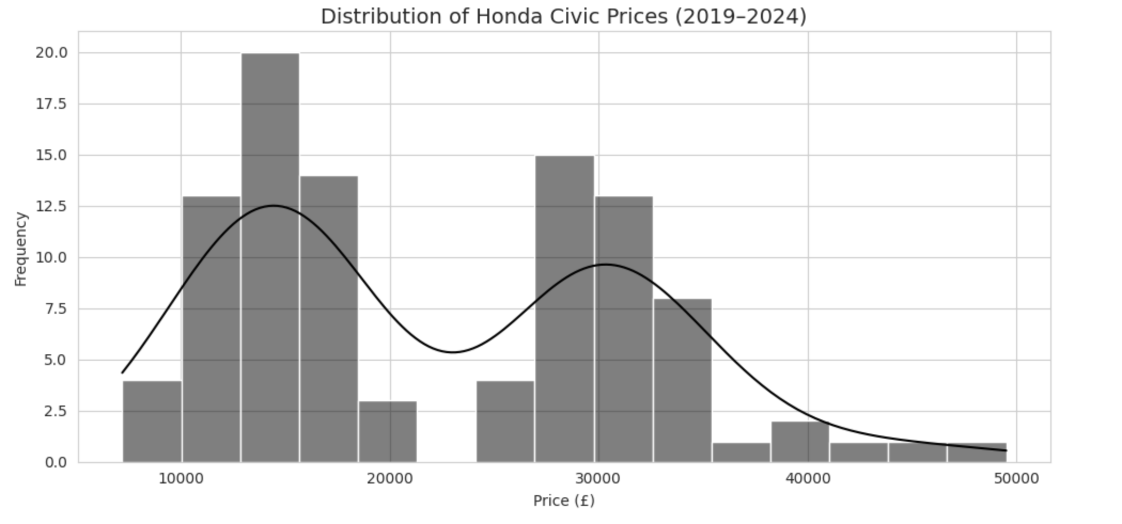
- The histogram follow Tufte-Proportionality as bars have been scaled equally respect to frequency and axis begins from zero for both the axis.
- The histogram follows Cole-Clarity and Clutter rule as it shows no congested gridlines, no border clear axis labelled and clean title.
- It follows Gesalt-Proximity as all the bars are at the same distance and grouped naturally based on bin.
- It also follows Munzner-Encoding as it uses length and position on a common scale, which best suits for quantitative values.
- The histogram showed binomial distribution with two common price clusters-(13000-15000)-(28000-30000)
The scatter plot is done to explore the relationship between mileage and resale price (both numerical values), with manual and automatic gearboxes used as color coding. It shows how high mileage leads to price reduction(negative slope), and at low mileage automatic cars are pricey then manual which indicates auto cars carry high resale value initially.Car4all should prioritize low mileage automatic cars for higher return but faster depreciation and vice versa for manual cars.
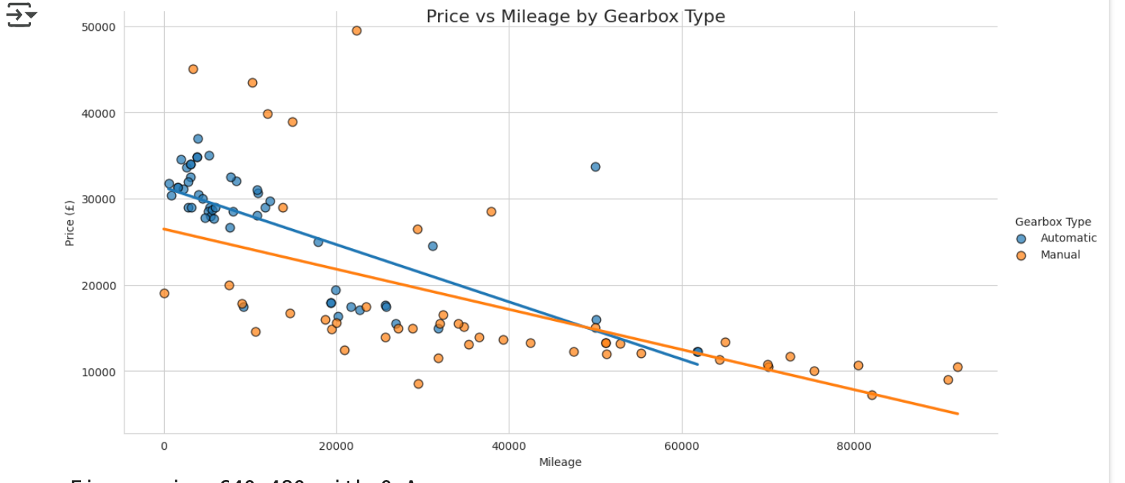
Principles being followed are:
Tufte-Data Driven: It shows clear mileage-price relation, and no design distortion.
Cole-Clean Design: Hue(Gearbox) was used effectively, with proper axis labelling and no irrelevant markers.
Gesalt-Similarity: Color coding is used group by gearbox
Munzner-Position Encoding: Two-axis positioning is best for exploring relationships and making out an output.

The boxplot visualization compares the price with fuel type like petrol, diesel and hybrid. It visualizes the mean, IQ range, and the outlier values giving information how price is being affected. The boxplot explains that Petrol cars have some outliers that have very pricey cars and it may be due to low mileage or registration date like 2023-2024.Diesel cars are the cheapest while petrol hybrid are the priciest.
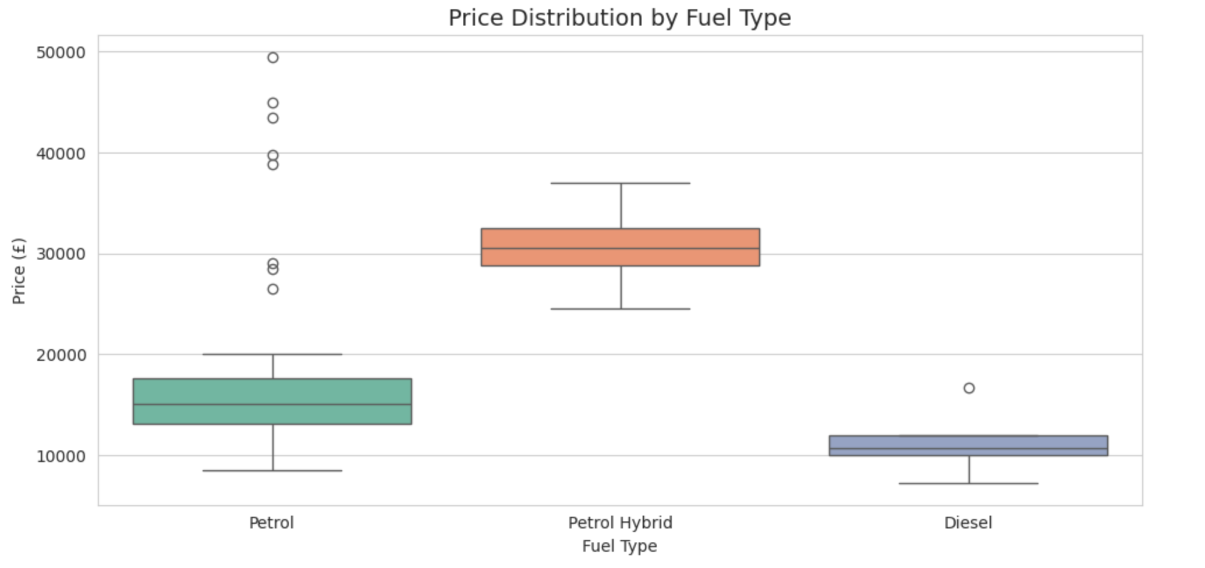
Principles being followed are:
Tufte-Appropriate Dimensions: Uses one vertical dimension only to represent price.
Cole-Decluttered: It keeps clean lines and whitespaces, uses only necessary ink.
Gesalt-Enclosure: The boxes created covers data groups, allowing for intuitive comparison with each other.
Munzner-Vertical Positioning: Boxplot relies on a vertical position along a common scale, which is the most suitable effective encodings for quantitative data.

Section B – Descriptive Statistics
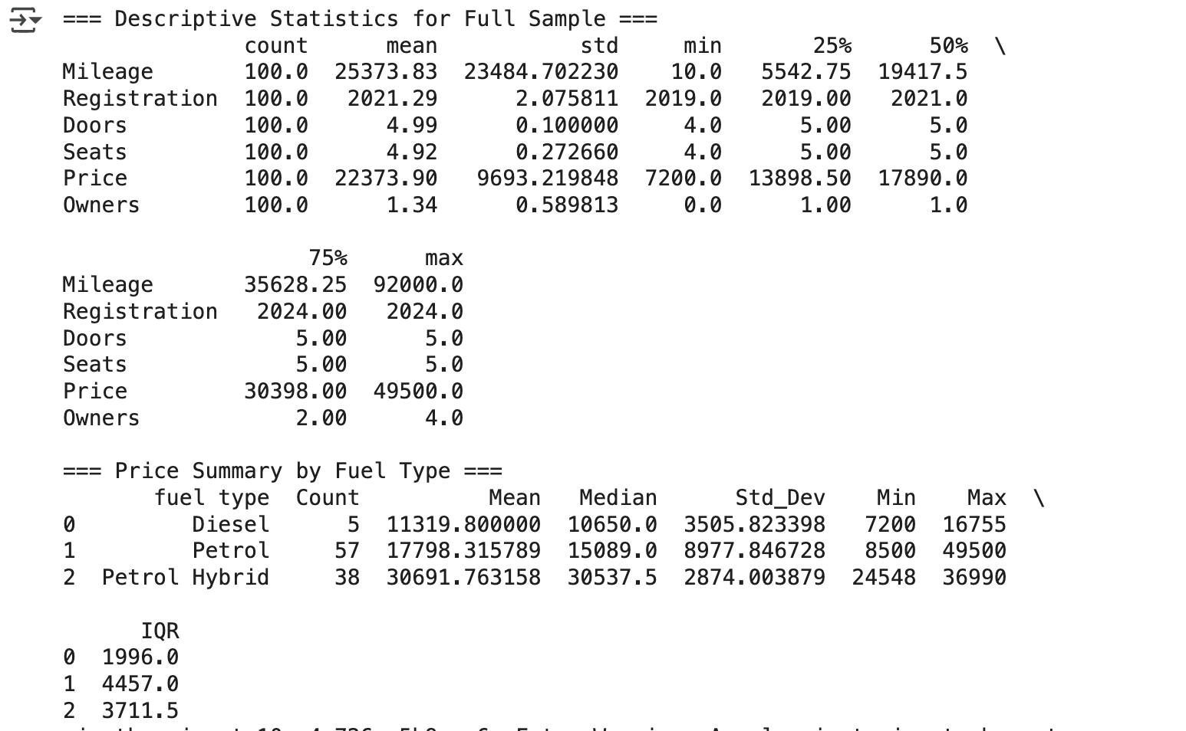
The table suggests that for Mileag ,it spans over from min-10 to max 92000 which shows it has a wide range cars from new to heavily-driven.
For Registration: It includes only the model 2019-2024 ,which confirms the dataset includes only the recent models.
For Doors and Seats: Almost every car had 5 door and 5 seats making all the cars suitable for family use.
For price: The price ranges from 7200-49500 which shows that prices are wide spread.
Fuel type:
Diesel has the lowest mean price of 11320 pounds with the lowest IQR range as well which shows a decline in the diesel car market in uk cities.
Petrol is the most common fuel type as it has the highest count in the sample, and has the highest variety as it shows an average of 17798 pounds and an IQR of 4457.
In contrast, petrol hybrid demonstrates the highest average and median prices(£30,692 and £30,538 respectively).This sussgest that consumers are becoming more interested towards fuelefficient cars.
These statistical analysis creates a link back to the graphs like for histogram the spread from 7200-49500 can be seen through the summary table as well and visually through the spreading of bars on the histogram and the right skewness shape. Moreover, IQRS and median values for the fuel type matches same with what’s on the boxplot.
The strong variability in mileage (10-92000 miles) is very visible in the scatter plot through its spread.

Section C – Confidence Interval

Assuming that the price of second hand Honda civic are normally distributed, the estimated mean from a sample of 100 cars turned out to be 22374.Using this data, we can be 95% confident that the averages ale price of Honda civic for all such vehicles in the population lies between 20451-24297,and there’s a 5% chance that the mean price is out of this range.
If more certainty is required then 99% confidence interval is done which increases the range to be more accurate at 19828-24920,and there’s a 1% chance that true mean lies outside this range.
It gives a benchmark to the to the car4all to guide pricing decisions, evaluate the supplier quotes and compare local and national prices.

Section D – Hypothesis Test
The average price was taken from Car Guru for Honda Civic in London and the average price within this range turned out to be 20584 pounds.
T-test is being applied to match if the average price of honda civic matches with that of the sample we took within the same model.
H0: The sample mean price of the car of this data set is same that to of London
H1: The sample mean price of the car of this data set is different to that of London.
After applying t-test, it was found that since p>0.05 we reject the null hypothesis and say that there is a difference between both the mean prices of Honda civic btw London and Brimingham.

Section E – Corelation Analysis
Now we will find about the correlation of the dependent variable(price) and a few independent variable that may have potential impact on it like ( Mileage, Registration, Fuel Type, Engine ,Gearbox).Below are the results:

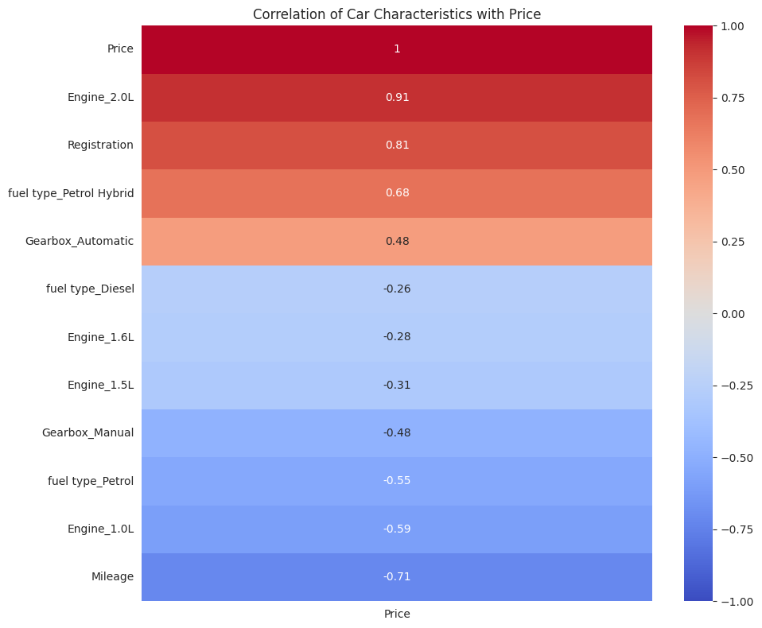

Engine size 2.0l-Has a strong positive correlation which shows that large engine size is strongly linked to higher car prices.
Registration year also has a positive correlation which shows that newer cars tend to have higher resale values.
Petrol Hybrid fuel type also has positive correlation making the hybrid car expensive due to its fuel-efficient technology.
Gearbox Automatic have higher prices then manuals.
Diesel fuel type has negative correlation making the car prices cheaper compared to automatic ones.
Engine 1.6l/1.5 smaller engines correlate with lower prices due to low performance
Manual Gearbox are associated with lower prices.
Fuel type Petrol shows a strong negative correlation with price.
Mileage shows a strong negative correlation, confirming that higher mileage reduces resale value.
Cars with 2.0l engine, recent model years and hybrid fuel type with automatic gearbox will fetch more value to cars in the second hand market, and suggests to car4all that they should prioritize acquiring newer higher hybrid cars with high specs for better profits.
Mileage, manual transmission and smaller engines contribute to lower prices of the second had car market as old high mileage cars are considered less valuable.

Section F – Regression Analysis
Next we will do is Regression analysis to confirm the significance of the variables on the price. All the variables were found to be statistically significant with p<0.05. Multicollinearity was achieved due to large negative coefficients values as many dummy variables were being taken for engine, gearbox, fuel type triggering dummy variable trap. To build a parsimonious model then, one category from each one of it was dropped and then the model was run again.The new model gave the following where mileage, registration, engine(1.5,2) and petrol hybrid are statistically significant.
the new variables were
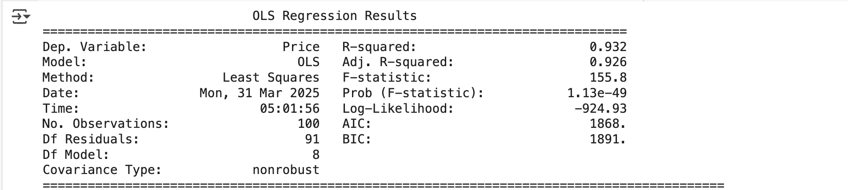
P<0.05
VARIABLE | COEFFICIENT | P-VALUE | INTERPRETATION
Mileage | -0.0841 | 0.000 | For every mile increased price reduces by 0.08 pound
Registration | +1647.74 | 0.000 | Newer model cars worth are more and adds price of 1648 pounds
Engine 1.5L | +2091 | 0.011 | Add 2091 pound over 1.0l engines
Engine 2.0L | +19840 | 0.000 | Highest premium, add 19840 pounds
Petrol Hybrid | -12480 | 0.000 | Reduces price significantly compared to petrol
P>0.05
Variable | P-value | Comment
Deisel | 0.706 | No clear impact on price
Engine-1.6L | 0.557 | Statistically weak
Gearbox- Automatic | 0.345 | No meaningful difference vs manual
Insignificant variables that have no impact on the price. The parsimonious model was selected based on the adjusted r^2 (0.926) which shows strong variation in car price, with few predictors. Key predictors such as mileage, registration years and engine size were retained due to p<0.05. Multicollinearity was removed to ensure stable coefficient estimates.

Section G– Residual Analysis
To assess the quality of our final (parsimonious) regression model, we conducted a residual analysis based on these fundamental regression assumptions.
- Linearity-Residuals are randomly scattered around the 0 line for the residual’s vs fitted values plot.
- Independence of errors: No specific time series or autocorrelation structure in the data.
- Homoscedasticity (constant variance):The spread of residuals is roughly evenly distributed
- Normality of Residuals:Residuals appear slightly skewed but still it followsthe normal line on Q-Q plot.
- No Multicollinearity:Already managed by dropping one dummy per variable per category(Engine,Gearbox,Fuel Type)
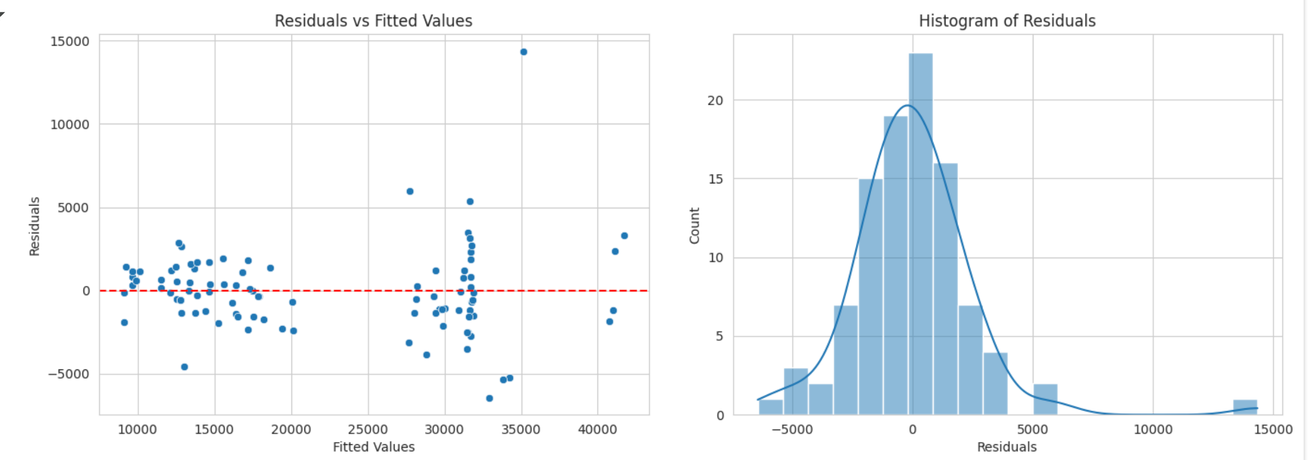
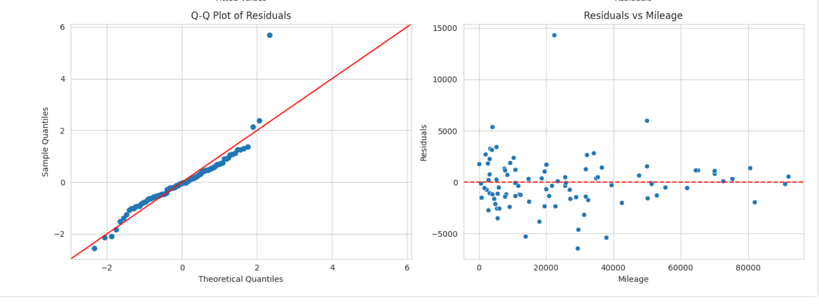
Overall, the model meets all the 5 key regression assumptions and having adjusted R square of 0.926 shows an excellent model fit.

Section H – Statistical model
The equation for the price calculator is:
PRICE= 3513.58 – 0.084 X Mileage + 1647.74 X Registration – 12480.45 x Petrol Hybrid +2091.60 x Engine 1.5L + 19840.47 x Engine 2.0L
Taking the input for the missing variables and completing the equation will give the price.

Section I – Conclusion
From steps 4-9, the analysis incorporated effective visualizations, suitable statistical methods, and business-focused interpretation. Descriptive statistics and graphical plots helped in identifying key pricing trends, while confidence intervals provided a reliable range of predicted car prices. Utilizations of a one-sample t-test revealed that local prices were greater than the London region, and this provided valuable regional insight.
Correlation analysis identified strong relationships between the price (dependent variable) and independent variables including mileage, engine size, and registration year. A parsimonious regression model with only statistically significant predictors was built which included-Mileage, Registration, Petrol-Hybrid, Engine Size (1.5,1.6)- and the not so significant variables were ignored and then tested with residual analysis to make sure it met all the requirements.
The model cleared all the 5 key assumption throught the residual analysis making it the best model.
Overall, second hand car prices can be predicted in birmingham for honda civic (2019-2024) model,and different third party showrooms can now also make its decision to change the prices based on the key 5 significant variables that affect it overall.

