-- Q1: Retrieve all employees’ first_name and their departments.

SELECT first_name,department FROM employee2;

-- Q2: Update the salary of all employees in the 'IT' department by increasing it by 10%.

UPDATE employee2

SET salary = salary+(salary*0.1);  
  
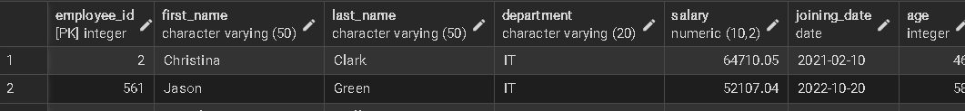

-- Q3: Delete all employees who are older than 34 years.

DELETE FROM employee2

WHERE age >34;

-- Q4: Add a new column `email` to the `employees` table.

ALTER TABLE employee2

ADD COLUMN email VARCHAR(100);  
  
-- Q5: Rename the `department` column to `dept_name`.

ALTER TABLE employee2; RENAME COLUMN department TO dept_name;  
  
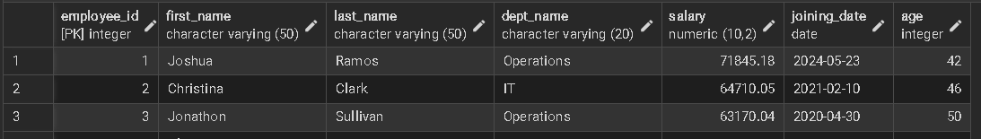

-- Q6: Retrieve the names of employees who joined after January 1, 2021.

SELECT first_name ,last_name ,joining_date FROM employee2

WHERE joining_date >'2021,01,01';  
  
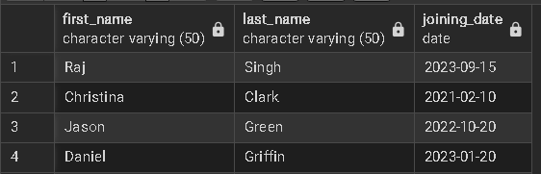  
  
-- Q7: Change the data type of the `salary` column to `INTEGER`.

ALTER TABLE employee2

ALTER COLUMN salary TYPE INTEGER USING salary :: INTEGER;  
  
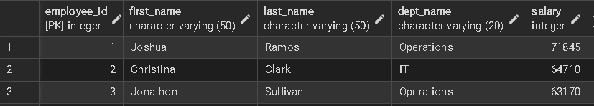  
  
-- Q8: List all employees with their age and salary in descending order of salary.

SELECT first_name,last_name,age,salary FROM employee2

ORDER BY salary DESC;  
  
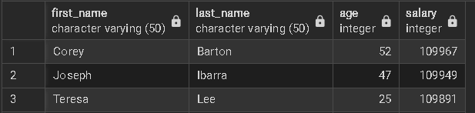  
  
  
-- Q9: Insert a new employee with the following details:

-- (employee_id,'Raj', 'Singh', 'Marketing', 60000, '2023-09-15', 30)

INSERT INTO employee2(employee_id, first_name, last_name, department, salary, joining_date, age)

VALUES(1001,'Raj', 'Singh', 'Marketing', 60000, '2023-09-15', 30);  
  
-- Q10: Update age of employee +1 to every employee

UPDATE employee2

SET age = age +1;  
  
-- Q11: Find all employees who joined after 2022-01-01.

SELECT * FROM employee2

WHERE joining_date >'2022-01-01';  
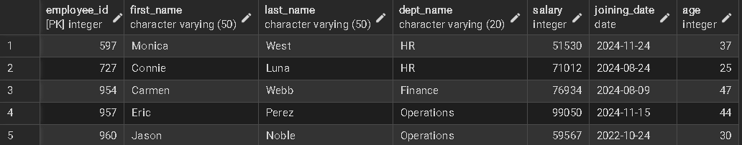  
  
-- Q12: Find the average salary of employees in each department.

SELECT dept_name, AVG (salary) AS avgrage_salary FROM employee2

GROUP BY dept_name;

-- Q13: Find employees who are older than 30 years.

SELECT * FROM employee2

WHERE age >30;  
-- Q14: Find the highest salary in the IT department.

SELECT MAX (salary) AS highest_salary FROM employee2

WHERE dept_name = 'IT';  
-- Q15: Update the email column for all employees with appropriate values.

UPDATE employee2

SET email = LOWER(CONCAT(first_name,'.',last_name,'@example.com'));  
-- Q16: Find the total number of employees in each department.

SELECT dept_name,COUNT(*) AS total_employees FROM employee2

GROUP BY dept_name;  
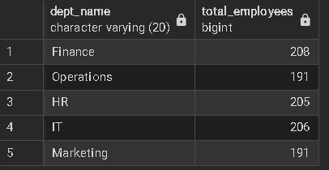  
-- Q17: Sort employees by their joining_date from the newest to the oldest.

SELECT * FROM employee2

ORDER BY joining_date DESC;  
  
-- Q18: Retrieve employees whose salary is between 50,000 and 70,000.

SELECT salary FROM employee2

WHERE salary BETWEEN 50000 AND 70000;  
-- Q19: Find employees who have 'a' in their first name.

SELECT * FROM employee2

WHERE first_name LIKE '%a%';  
-- Q20: Count the total number of employees in the table.

SELECT COUNT (*) AS total_employees FROM employee2;  
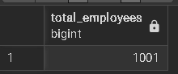  
-- Q21: Retrieve employees grouped by their department, sorted by department name.

SELECT dept_name,COUNT(*) AS total_employees FROM employee2

GROUP BY dept_name

ORDER BY dept_name;  
  
-- Q22: Find employees who joined in the year 2023.

SELECT * FROM employee2

WHERE EXTRACT(YEAR FROM joining_date)= 2023;

-- Q23: Delete all employees who belong to the 'HR' department.

DELETE FROM employee2

WHERE dept_name = 'HR';

-- Q24: Retrieve the minimum salary in the company.

SELECT MIN(salary) AS minimum_salary FROM employee2;  
  
-- Q25: Retrieve employees whose age is NULL.

SELECT * FROM employee2

WHERE salary IS NUll;  
