

**Crop Price**

**Project Team Members**

Syed Mubeen Hussain

Ali Raza Abbasi

Hamza Hashmi

Zohaib

Aktadar

**Faculty**: **SIR JUNAID ABBASI**

 **­­**

**December 23, 2022**

**Aptech computer education**

**METRO STAR GATE**

Project Certification

This is to certify that.

SYED MUBEEN HUSSAIN (1278713)

ALI RAZA ABBASI (1280134)

Hamza Hashmi (1274976)

Zohaib (1287613)

Aktadar

Has successfully designed & developed

**Calligraphy.**

**Crop Price**

Date of Submission: 23hDecember 2022.

# **Index**

1. **Introduction**
2. **Objectives**
3. **Problem Statement**
4. **Hardware/ Software Requirements**

# **Introduction**

The thirst for learning, upgrading technical skills and applying the concepts in real life environment at a fast pace is what the industry demands from IT professionals today. However busy work schedules, far-flung locations, unavailability of convenient time-slots pose as major barriers when it comes to applying the concepts into realism. And hence the need to look out for alternative means of implementation in the form of laddered approach.

The above truly pose as constraints especially for our students too! With their busy schedules, it is indeed difficult for our students to keep up with the genuine and constant need for integrated application which can be seen live especially so in the field of IT education where technology can change on the spur of a moment. *Well, technology does come to our rescue at such times!!*

Keeping the above in mind and in tune with our constant endeavour to use Technology in our training model, we at Aptech have thought of revolutionizing the way our students learn and implement the concepts using tools themselves by providing a *live and synchronous eProject learning environment!*

**So what is this eProject?**

eProject is a step by step learning environment that closely simulates the classroom and Lab based learning environment into actual implementation. It is a project implementation at your fingertips!! An electronic, live juncture on the machine that allows you to

* Practice step by step i.e. laddered approach.
* Build a larger more robust application.
* Usage of certain utilities in applications designed by user.
* Single program to unified code leading to a complete application.
* Learn implementation of concepts in a phased manner.
* Enhance skills and add value.
* Work on real life projects.
* Give a real life scenario and help to create applications more complicated and useful.
* Mentoring through email support.

The students at the centre are expected to complete this eProject and send complete documentation with source code to eProjects Team

Looking forward to a positive response from your end!!

# **Objectives of the project**

The Objective of this program is to give a sample project to work on real life projects. These applications help you build a larger more robust application.

The objective is not to teach you the concepts but to provide you with a real life scenario and help you create applications using the tools.

You can revise them before you start with the project.

It is very essential that a student has a clear understanding of the subject.

Kindly get back to eProjects Team in case of any doubts regarding the application or its objectives.

# **Problem Statement**

# Crop Price Android Application

This application focuses on helping farmers. Its purpose is to give profits to farmers. The basic idea of this application is online auction. It allows farmers to sell their crops at best price.

**EXISTING SYSTEM**

Every time farmers have to sell their crops at market to authorized distributors for fixed prices set by market management which is loss for them (this system works manually).

There are some online systems through which farmers can sell their crops online, but farmers are not able to get proper profits with this system.

**Limitations**

* Farmers have to sell their crops at fixed prices.
* Farmers have to travel and sell their crops on regular basis by spending their money.
* Farmers have to sell their crops only to authorized distributors.
* Illiterate farmers cannot use present existing online systems.

**PROPOSED SYSTEM**

The application can be accessed by two types of users (buyers and sellers). As farmer is illiterate, he accesses this application with the help of another trusted party. Buyers can demand their desired crops using this application. Buyers can submit their feedback regarding the crops which they won in auction. Through this application advertisement of fertilizers and pesticides can be done by third party. Information about schemes given by government for farmers can be uploaded in this application.

It takes the information regarding the crop from seller which is advertised and auctioned by third party. The information regarding the crops are visible to users who want to buy the crops. Generally auction happens for certain period of time. After the auction the buyer who is ready to pay highest price for particular crop gets the crop. For the purpose of conducting auction third party will be benefited.

**Advantages**

* By using this system farmers can get more profit compared to manually existing systems.
* Illiterate farmers can easily use this system with the help of trusted third party.
* Farmers need not go to market for selling their crops.
* There are no fixed prices for crops instead farmers can set their own reasonable prices.
* Based on reviews given by buyers, sellers can produce the crops.
* Farmers can enjoy the government schemes through these application.

**Conclusion**

Through this application farmers can get acceptable prices for their crops.

# **Hardware/Software Requirements**

**Hardware**

* Android mobile with a minimum version 2.2.
* The processor is not less than 500MHZ.
* RAM is not less than 2048MB.
* SD card with a minimum of 512MB.
* Resolution is not less than 480*800pixs.

**Software**

Use software as per your requirement

* Windows OS/JAVA/Android SDK/Notepad/SQL/Android 2.2 or Later



**Authorized Sign by**

Sir Junaid Abbasi

Splash Screen

This is a intro screen

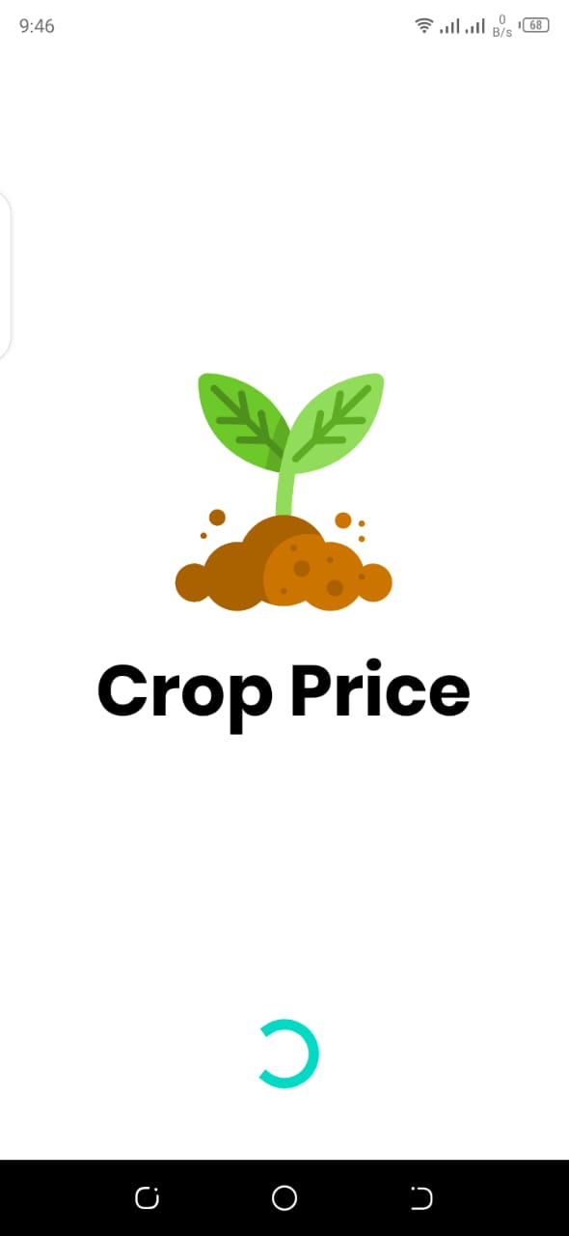

Chooser Screen

This is chooser screen user can select account

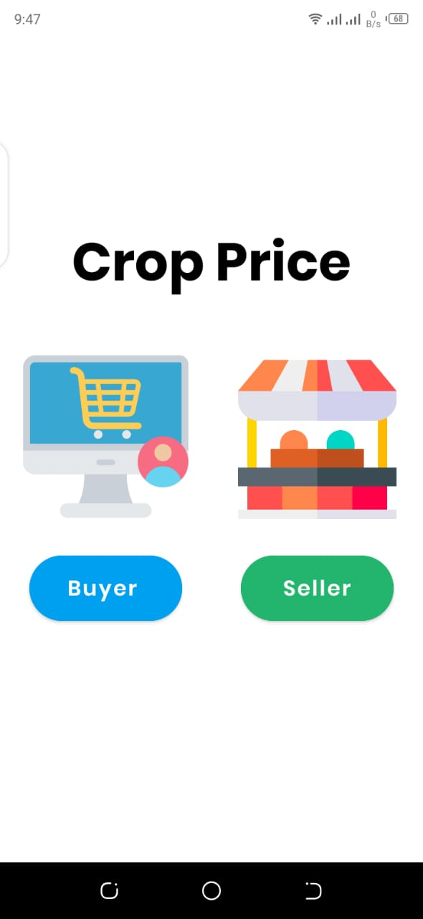

Buyer Login Screen

This is buyer login screen user can easily login

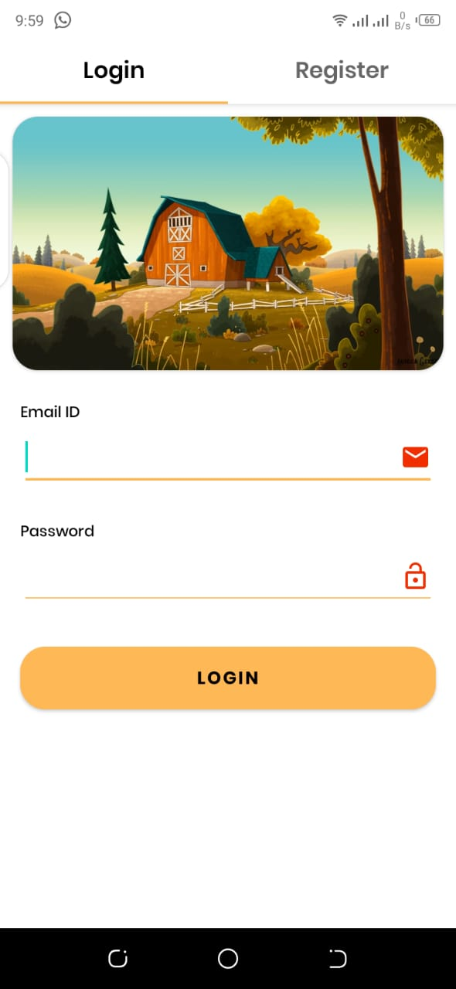

Buyer Register Screen

This is buyer register screen user can easily create our account

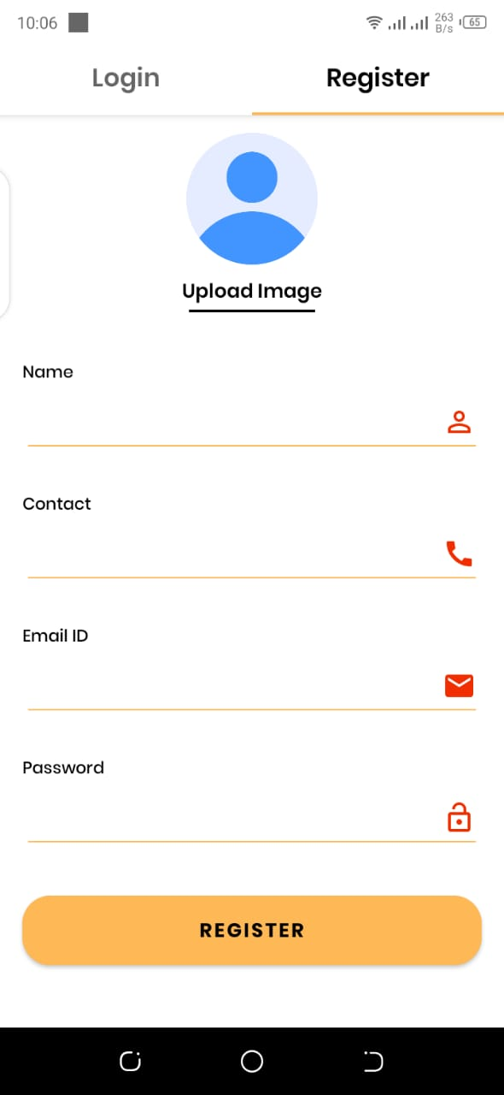

Home Screen

This is home screen

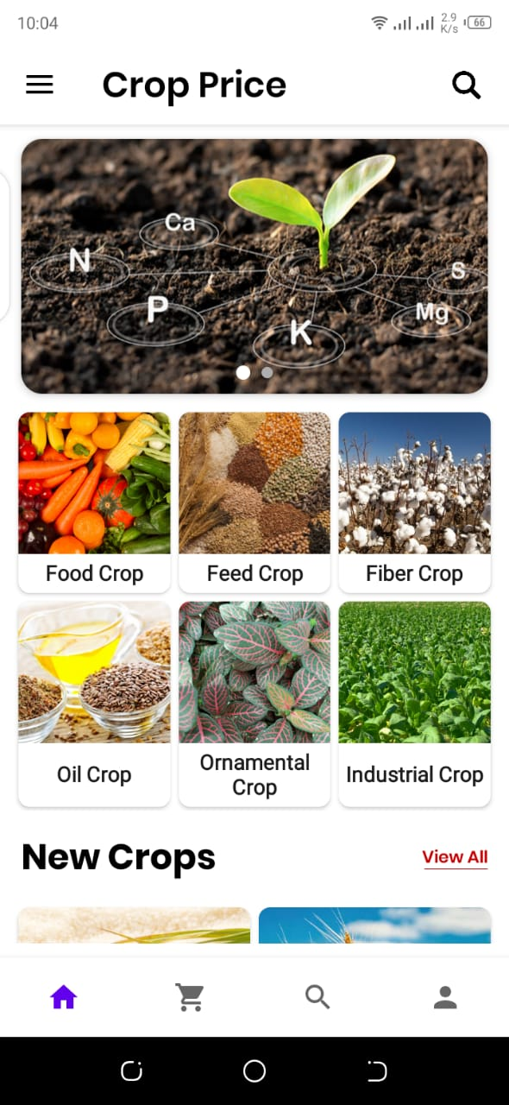

CategoryWise Crop Screen

This is category wise crop

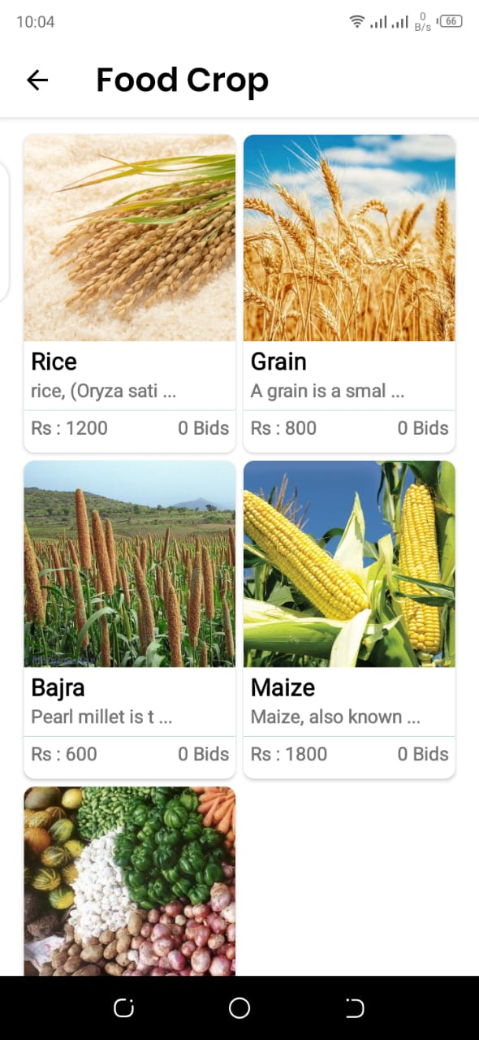

Shop Screen

This is shop screen user can browse all crops

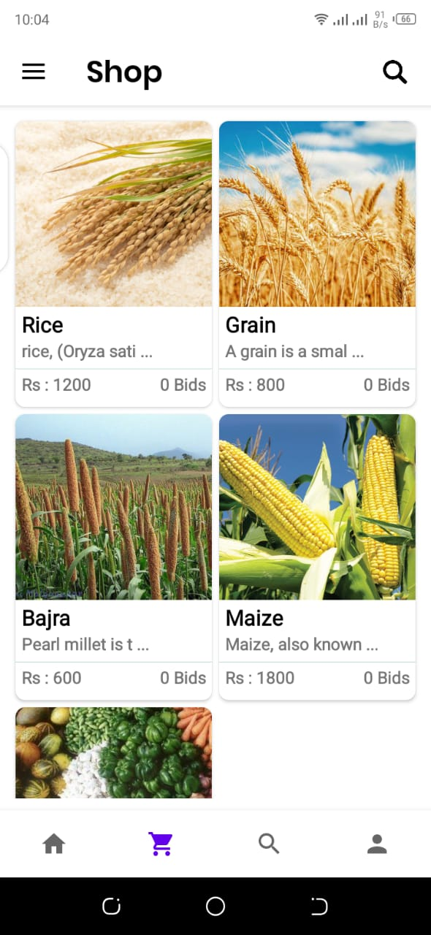

Add Crop Screen

This is add crop screen seller can add crop easily

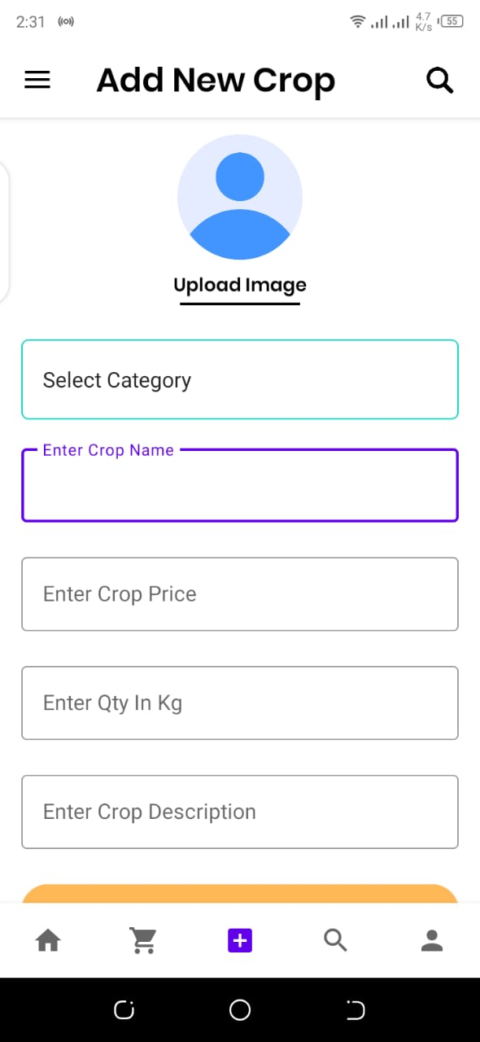

Search Crop Screen

This is search crop screen

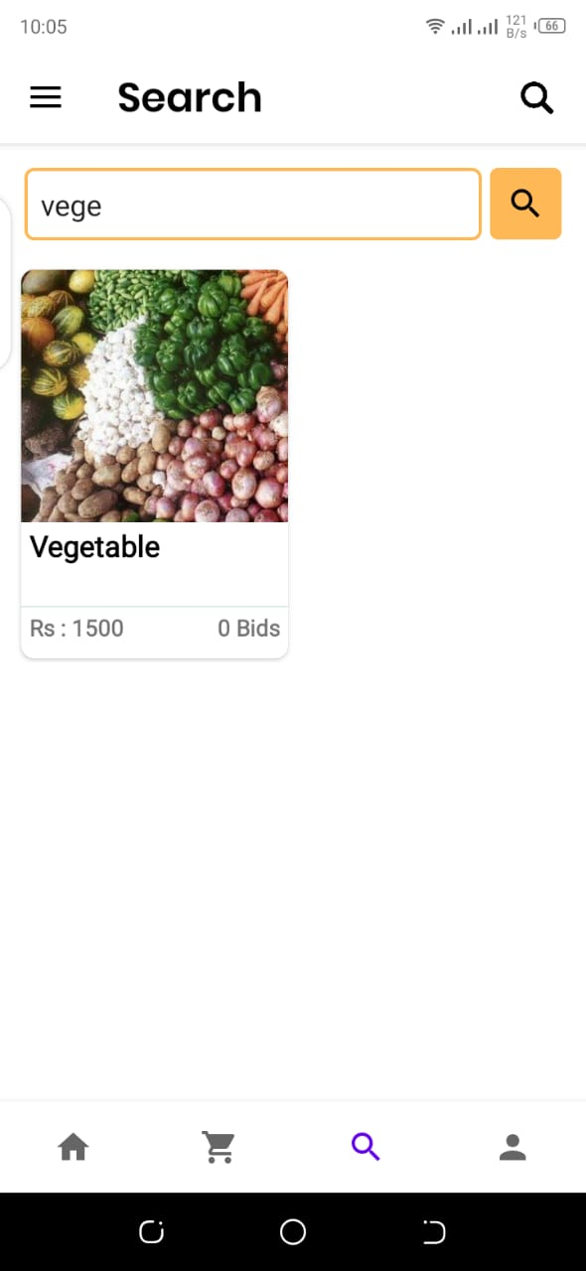

Seller Profile Screen

This is seller profile screen

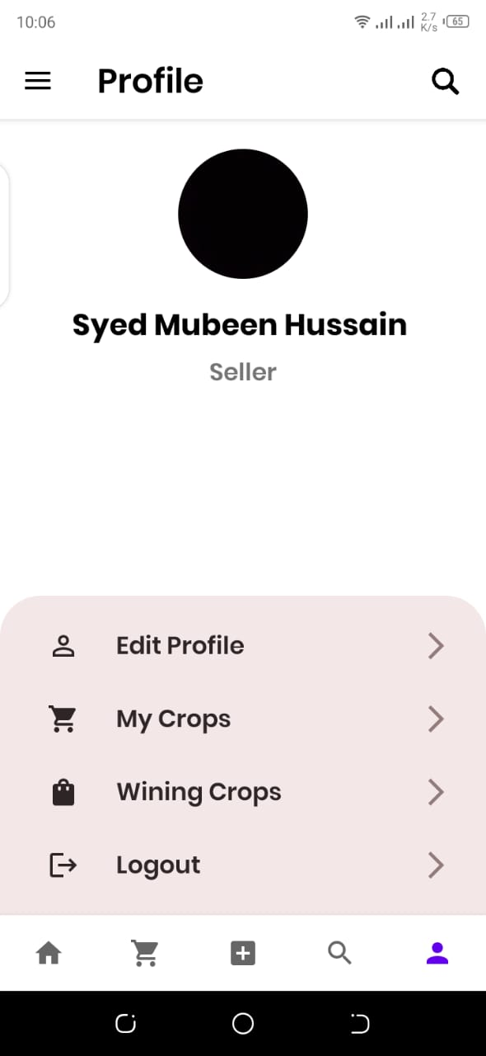

Seller Profile Screen

This is seller profile screen

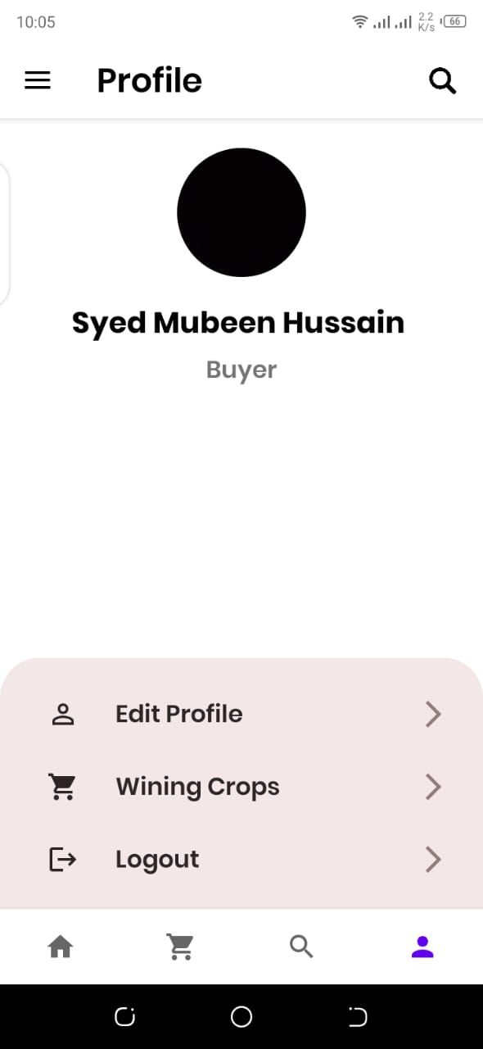

Buyer/Seller Profile Edit Screen

This is profile screen buyer and seller same screen

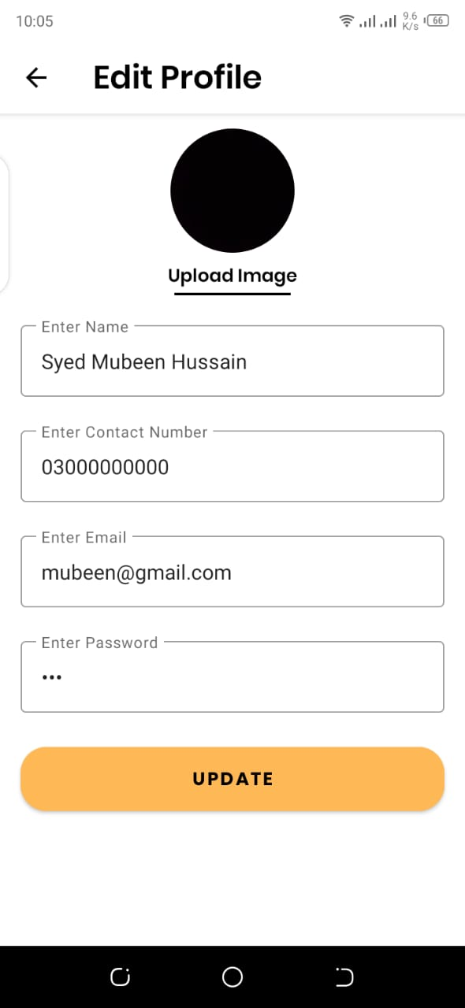

Wining Crops Screen

This is wining screen buyer and seller same screen

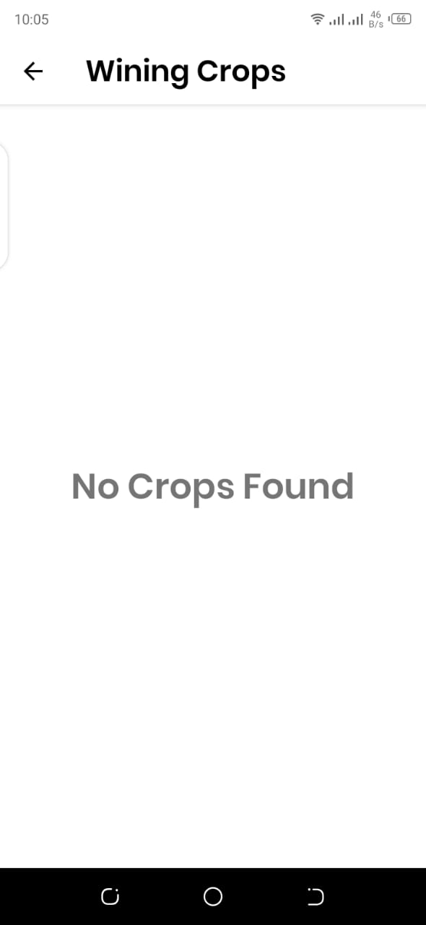

About Screen

This is about screen buyer and seller same screen

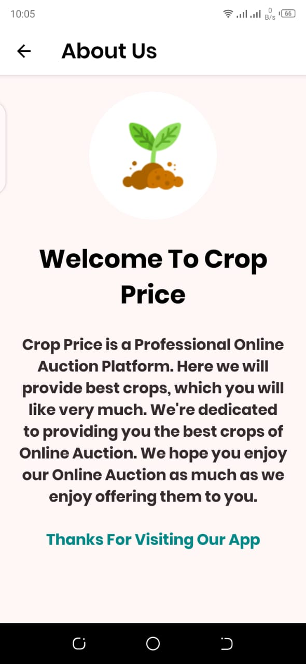

Contact Screen

This is contact screen buyer and seller same screen

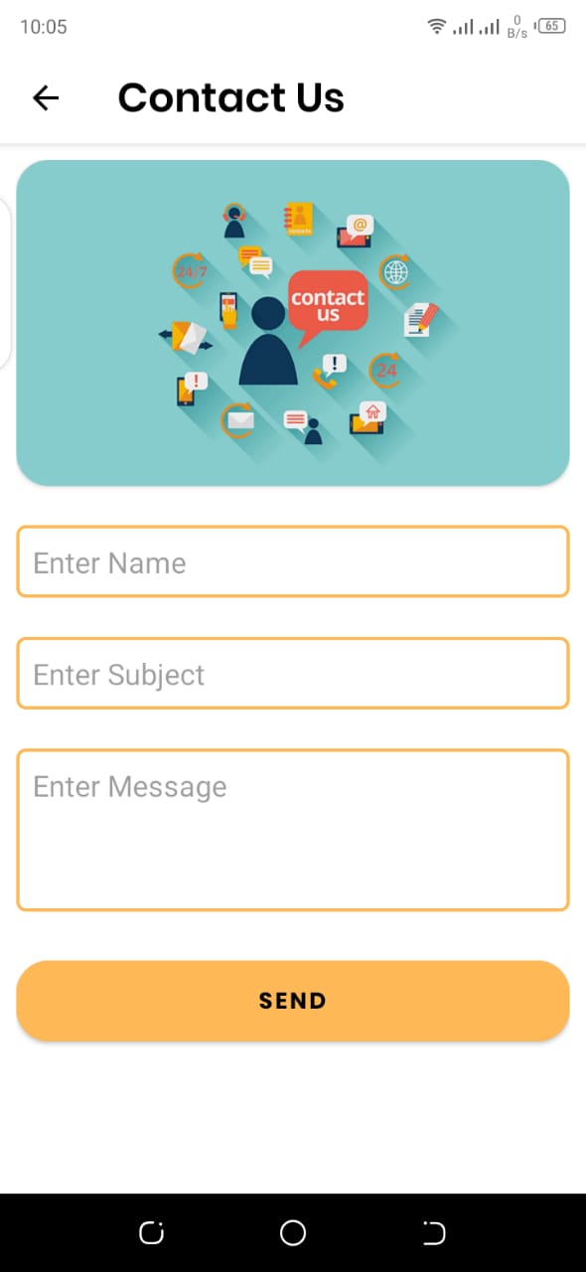

Drawer Menu

This is drawer menu

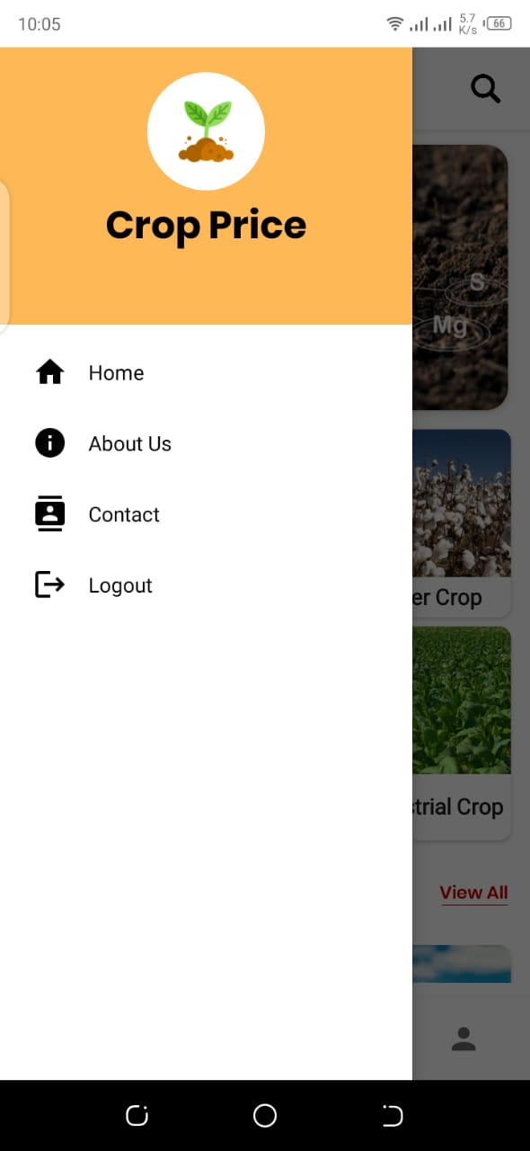

Seller Login Screen

This is seller login screen seller can easily login in our account

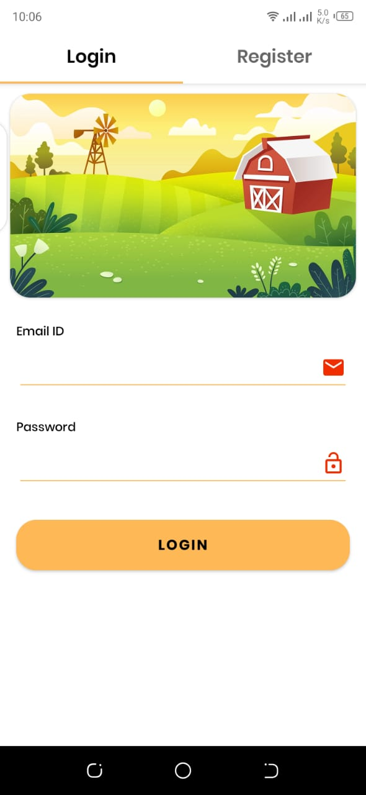

Seller Register Screen

This is seller register screen seller can easily create our account



Buyer / Seller Single Crop Screen

This is buyer/seller single crop screen seller/buyer can easily add a bid and check price and description after time up highest bidder can add feedback

