Image:

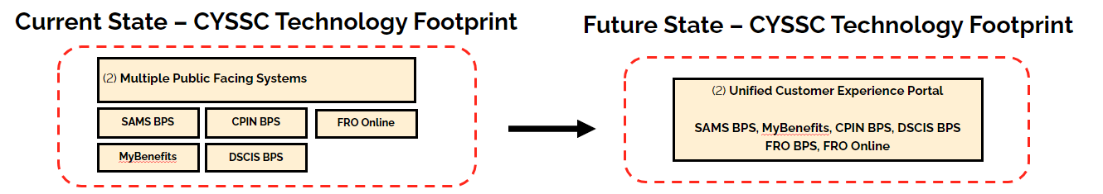

Image Translation:

The image depicts a diagram showing a transition plan from a "Current State – CYSSC Technology Footprint" to a "Future State – CYSSC Technology Footprint." It outlines the consolidation of multiple technology systems into a unified platform.  
  
In the "Current State," there are six separate systems listed:  
  
1. SAMS BPS  
2. CPIN BPS  
3. FRO Online  
4. MyBenefits  
5. DSCIS BPS  
  
These systems are described as "(2) Multiple Public Facing Systems," suggesting they are individual platforms or interfaces that are currently in use and available to the public.  
  
The "Future State" shows that these systems will be consolidated into a single "(2) Unified Customer Experience Portal." The list underneath includes the following:  
  
1. SAMS BPS  
2. MyBenefits  
3. CPIN BPS  
4. DSCIS BPS  
5. FRO BPS  
6. FRO Online  
  
The arrow between the two states indicates a transition or transformation from a fragmented landscape with multiple systems to a streamlined one with a unified customer-facing portal where the listed systems are presumably integrated or accessible through this single portal. The purpose of this transformation is to likely improve efficiency, user experience, and possibly reduce costs or complexity associated with maintaining multiple systems.