**Lab # 01:**

**“Introduction to Database”**

**Lab Objectives:**

* Concept of Database
* Different terminologies in Tabular Database
* Introduction to MS Access
* Creating Database with MS Access

**Introduction:**

**Database:**

A database-management system (DBMS) is a collection of interrelated data and a set of programs to access those data. The collection of data, usually referred to as the database, contains information relevant to an enterprise. The primary goal of a DBMS is to provide a way to store and retrieve database information that is both convenient and efficient.

A DBMS is the database itself, along with all the software and functionality. It is used to perform different operations, like addition, access, updating, and deletion of the data.

**Microsoft Access:**

Microsoft Access is a well-known database management system produced by Microsoft and is part of the Microsoft 365 office suite. Microsoft Access combines Microsoft’s relational Jet Database Engine with software development tools and a graphic user interface (GUI).

We will be using MS Access to design and implement of Database concept for few labs.

**In-Lab Tasks:**

**Task # 01:**

**Student:**

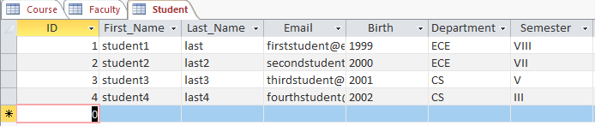

**Faculty:**

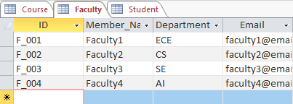

**Course:**

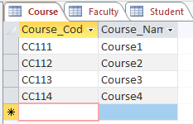

**Post-Lab Tasks:**

**Task # 01:**

**First 3 columns:**

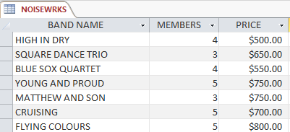

**Remaining Columns:**

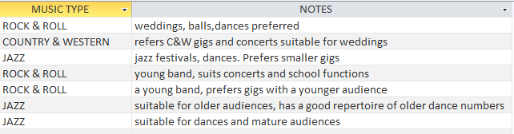

**Whole Table Look:**

