**Lab # 02:**

**Lab Title:**

**“Database keys, Format, Caption, Input masks and Validation rules”**

**Lab Objectives:**

* Learn about primary and foreign keys
* Learn about the input masks (different symbols and their uses)
* Learn about the validation rules and their applications

**Introduction:**Database keys, formats, captions, input masks, and validation rules are crucial components of a well-structured database. Keys ensure unique identification, formats maintain data consistency, captions provide user-friendly labels, input masks guide data entry, and validation rules enforce data quality. These elements collectively enhance data integrity and usability.

**In-Lab Tasks:**

We will attempt in lab tasks in the following data base to demonstrate the functionality of validation rule and input masks

1. ID Number represents SIN
2. Phone Number represents TelNum
3. Postal Code for task 3
4. Date of birth for task 4
5. Salary Column for task 5

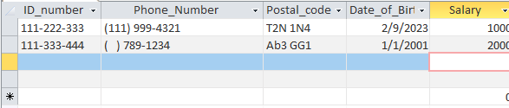

As we can see that we have got the data entered in the required format, now if we try to not follow the format of input data according to rules and masking set it will gives us an error. In some columns we have also added the functionality if somehow someone left it empty it won’t give us an error like phone number country code.

**Post-Lab Tasks:**

Columns 1st and 2nd represents task 4, column 5th is for task 3, column 4th is for task 2, and column 3rd is for task 1.

