**Lab # 03:**

**“Designing of Forms, Reports creation of Relationships”**

**Lab Objectives:**

* Learn about the form design and reports
* Relationships between tables
* Design a query

**Introduction:**  
Microsoft Access is a powerful database management system that goes beyond just storing data. It empowers users to design intuitive user interfaces through forms, generate insightful reports, and establish relationships between tables, all of which are crucial for efficient data management and analysis.

In this context, "Designing Forms" refers to the creation of user-friendly data input screens that simplify data entry and retrieval processes. Forms allow users to interact with the database effortlessly, making it easier to add, edit, or view records. This feature is essential for enhancing user productivity and ensuring data accuracy.

"Creating Reports" in Microsoft Access involves generating customized, professional reports from your data. These reports can include summaries, charts, and graphs, providing valuable insights for decision-making. Reports are instrumental in presenting data in a format that is easy to understand and share with others.

Finally, "Establishing Relationships" signifies the ability to define connections between different tables in your database. Relationships ensure data integrity and consistency by preventing the duplication of information and allowing for efficient data retrieval. By establishing relationships, you enable your database to manage complex data relationships effectively.

**In-Lab Tasks:**

**Task # 01:**

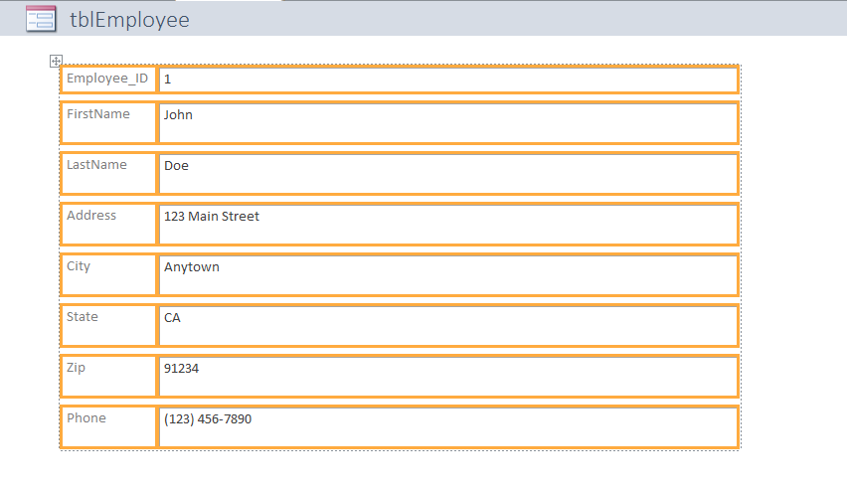

The above form was generated for the table given below.

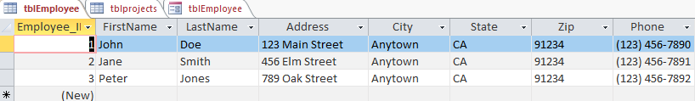

You can also enter further data into the table by using the form view , as in our first figure we see that there is a container window for each attribute of each element in table so we can add data by using form , we can also customize the view of form based on our requirements and liking.

**Task # 02:**

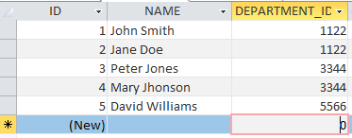

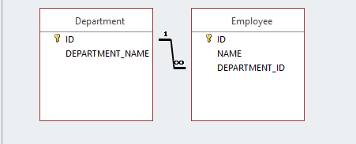

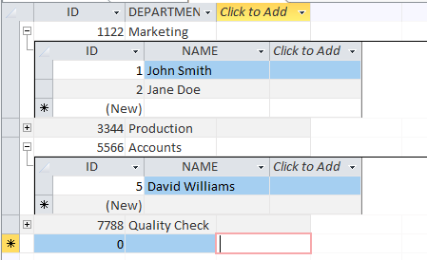

In this task we created an employee table where each employee has a unique id , also every employee is part of a certain department , in department table there is information regarding each department and each department has a unique id , so multiple employees can have a same department but 1 employee can have only one department so this is one-to-many relationship. Department – to – employee relationship.

**Task # 03:**

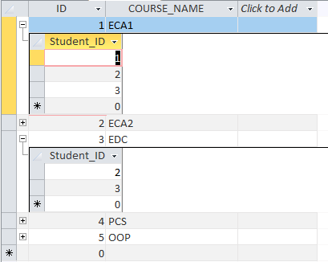

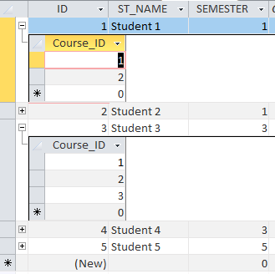

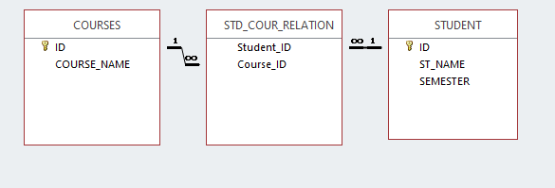

In this task with the help of one extra table called junction table is used , the purpose of this table is to implement the logic of many-to-many relationship within our database , in this example one student can study multiple subjects while at the same time one course can be studied by multiple students.

Post-Lab Tasks:

Task # 01:

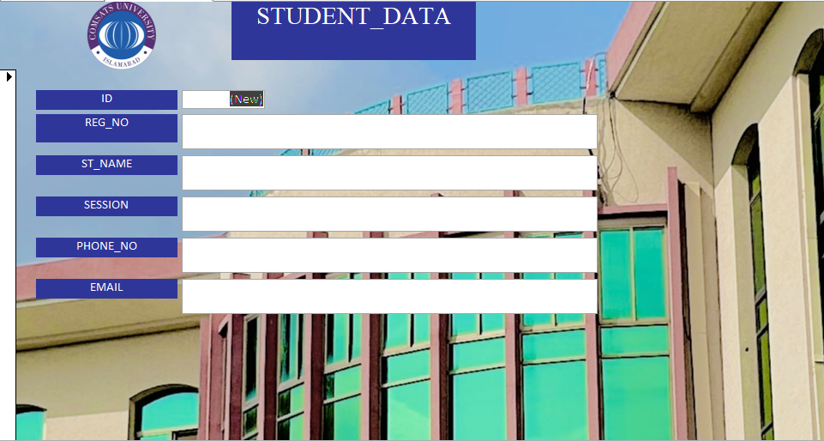

In the above task we have created a form with background image of our university campus , and also added logo in the header , small changes were made to font and coloring as well. We will enter data in this form and that data will be stored in our table that we created in the first step. Here is look of the empty table

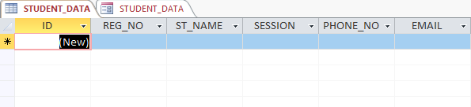

Now let’s enter some data and see the results of what will happen

