**Lab-Mid :**

**Name : Syed Shahir**

**Reg No#fa21-bce-014**

**Question # 01:**

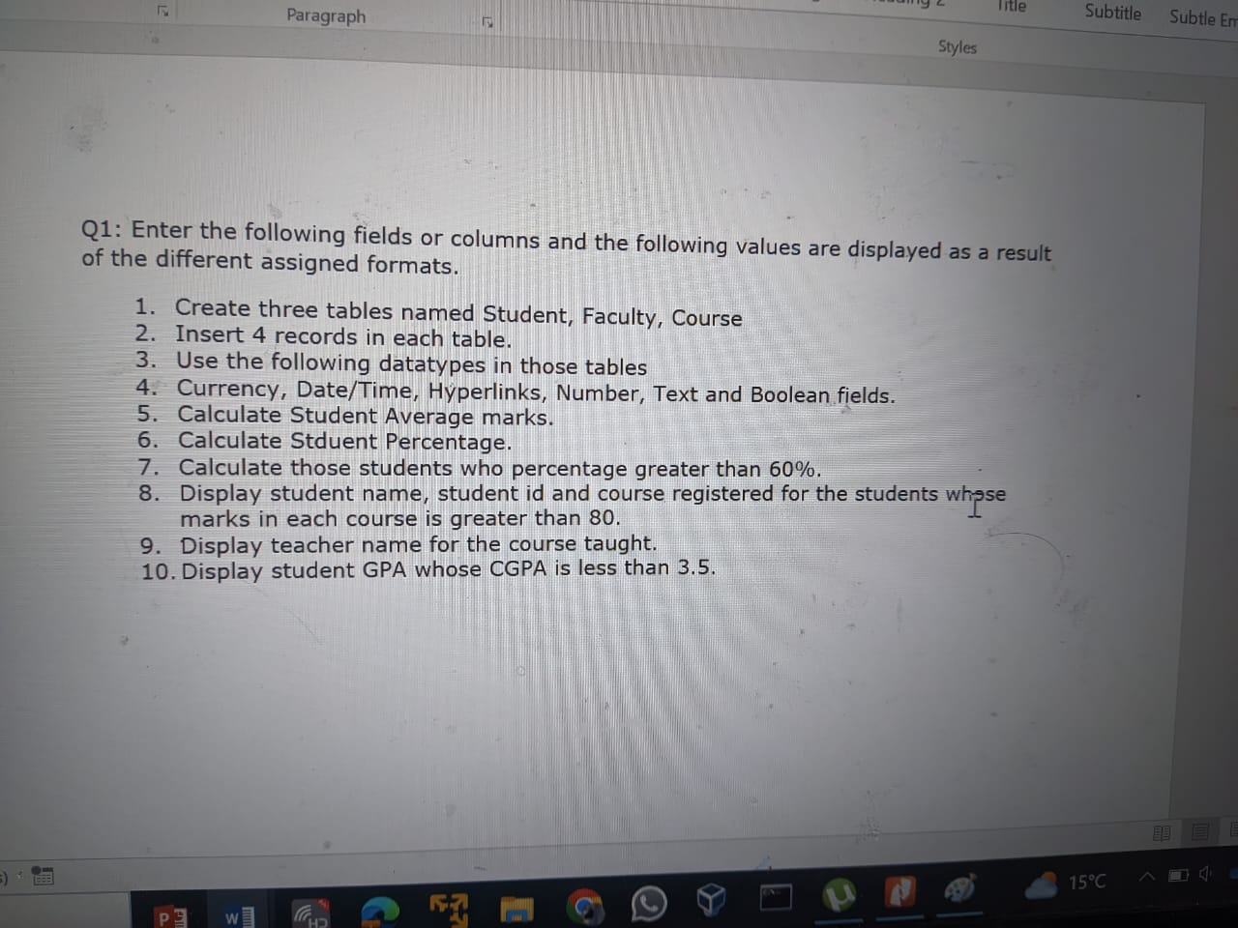

**Question # 02:**

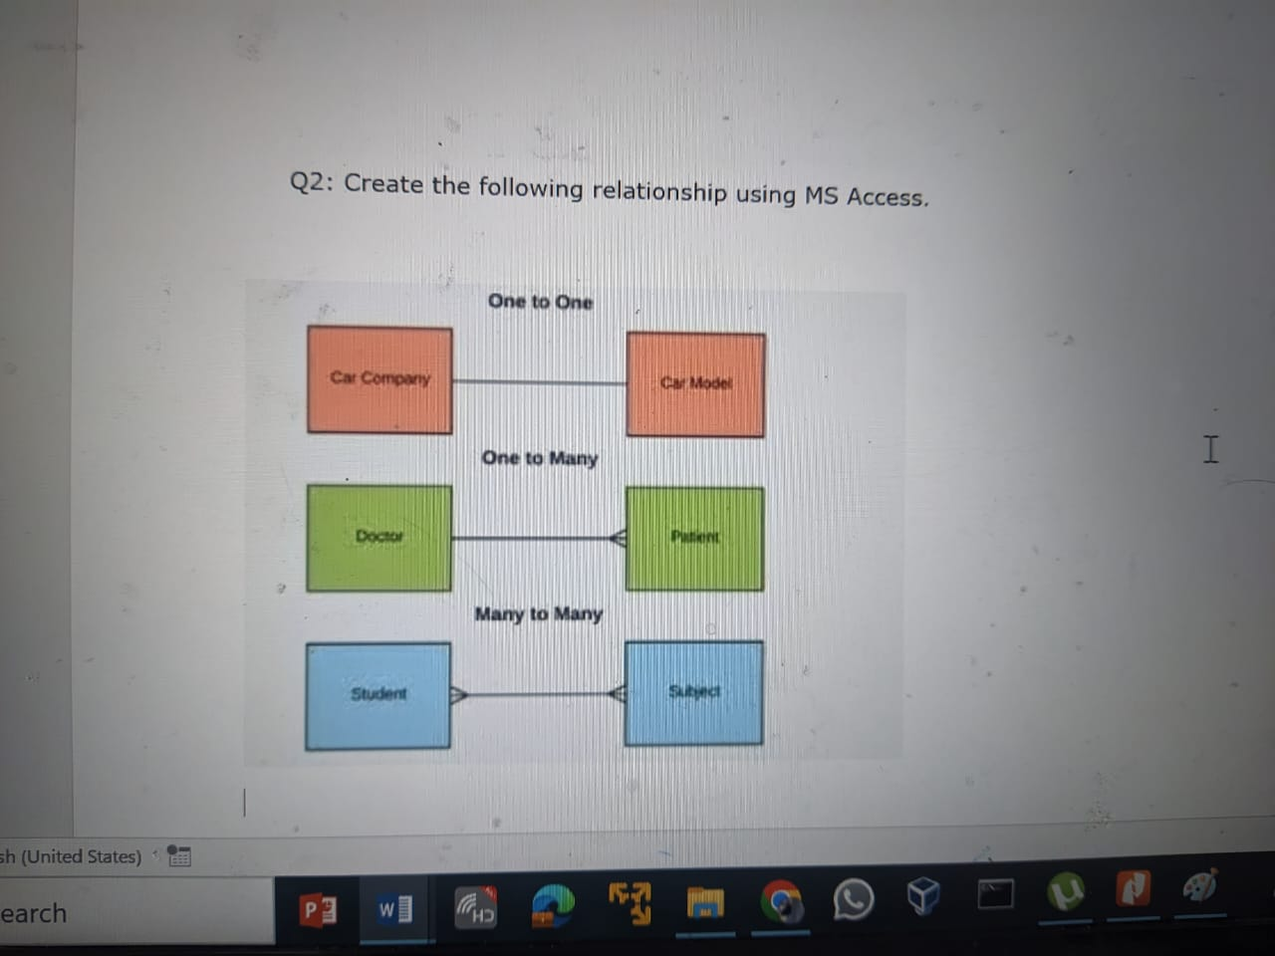

**Question # 03:**

