**Lab # 04:**

**Lab Title:**

**“Relationships, Simple Query Designing and Advance Queries”**

**Lab Objectives:**

The objectives of this lab are as follows

* Learn about the different types of relationships
* Retrieving data based on some criteria
* Performing some calculations on the attributes of tables

**Introduction:**

Relationships refer to how different pieces of information are connected or linked to each other. Just like friendships between people, data in a database can have relationships. These relationships define how data from one 'thing' is associated or linked to data from another.

Query designing is like crafting specific questions to get the exact information you need from a database. Imagine you're asking a librarian for books about space. You'd ask a precise question so they can find the right books for you.

Advanced queries in databases are like solving complex puzzles. Once you're comfortable with basic queries (like finding specific students in a class), advanced queries take it up a notch. It's like trying to find all the students who got an A in both Math and Science, or sorting products not just by price but also by popularity. These queries involve more intricate commands and logic. You might combine different conditions, use calculations, or even gather information from multiple tables at once. They help uncover deeper insights from the data, allowing you to do more complex analysis and get very specific results.

**In-Lab Tasks:**

**Task#01:**

**Relationship:**

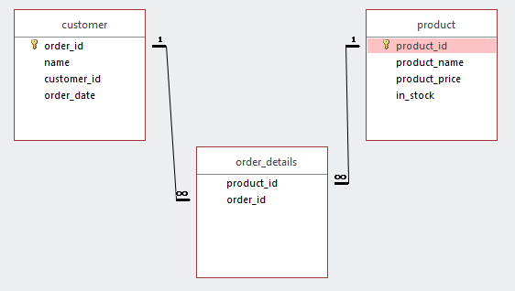

**Tables:**

**Customer Table:**

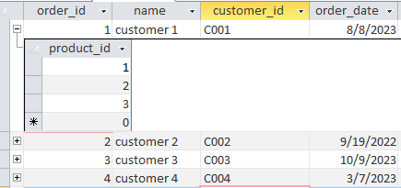

**Junction Table**: **Product Table:**

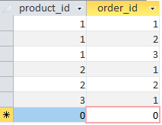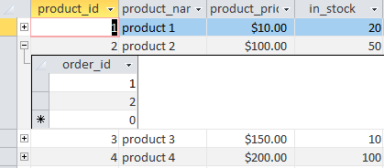

**Task#02:**

**Relationships:**

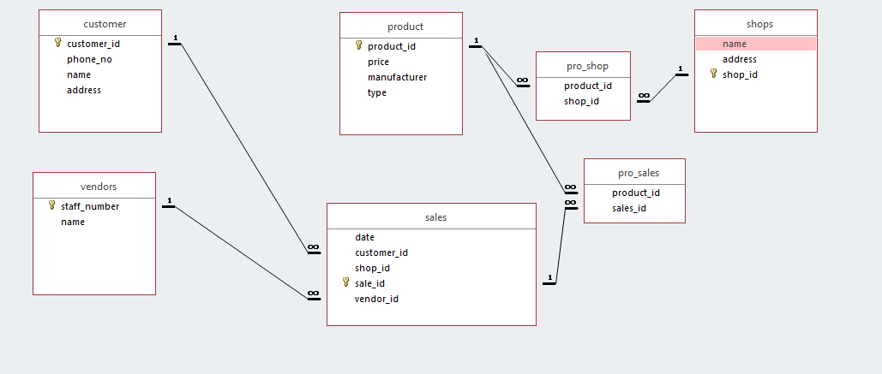

**Task#03:**

We will be sowing all the data of table employee and projects, the following query will be used

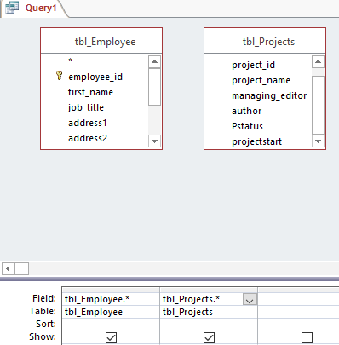

**Task#04:**

We will be showing the employee ID, employee name, job title and zip code, to do this the following query will be used

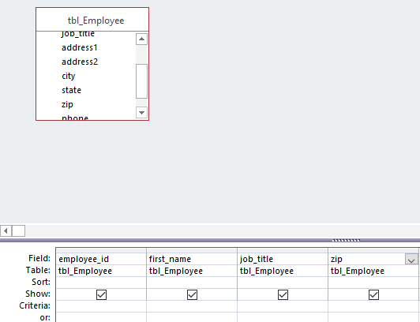

**Output:**

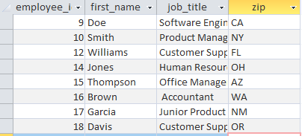

**Task#05:**

If any employee has phone type as mobile we will show them only, the following query will be used

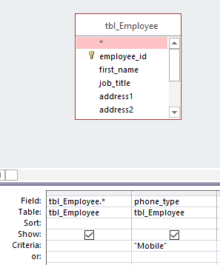

**Output:**



**Post-Lab Tasks:**

**Task#01:**

In the task we will have to print the songs which satisfy the following condition , price >= 1.00 and copies >= 1000.the output table will have only the title and id .

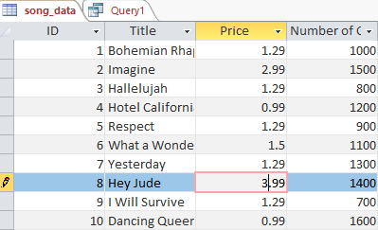

Query Design Output

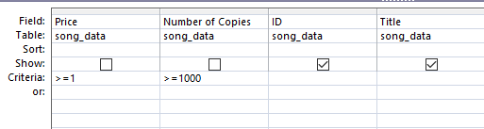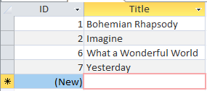

**Task # 02:**

If the number of copies are greater than 1000 than “enough copies” else “not enough copies”, also modifying the column name , the new column name is “Status”.

**Expression builder: Output:**

