**Lab # 06:**

**Lab Title:**

**“Importing and exporting data from Access, Make-Table and Union Queries”**

**Lab Objectives:**

* How to import dataset from another source excel into access
* Exporting data table in pdf format
* Applying make-table union queries

**Introduction:**

Importing and exporting data in Access is like moving information in and out of a big filing cabinet. It's about taking stuff from other places and putting it into Access or taking things from Access and using them somewhere else.

Make-Table and Union Queries are like making new lists or combining different lists in Access. Make-Table lets you create a new list with specific information from existing ones, while Union Queries help mix details from different lists into one.

Together, these tools in Access help organize information better, making it easier to work with and find what you need.

**Tasks:**

**Task#01:**

Importing data from excel, exporting data in pdf file

**Excel Sheet:**

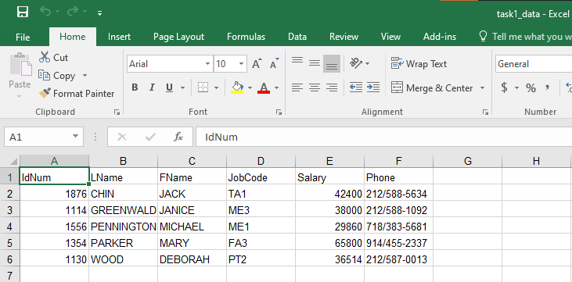

**Importing data from Excel:**

The following steps are followed

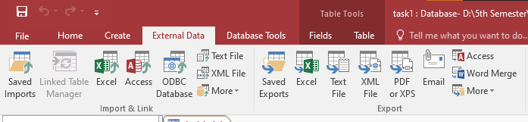

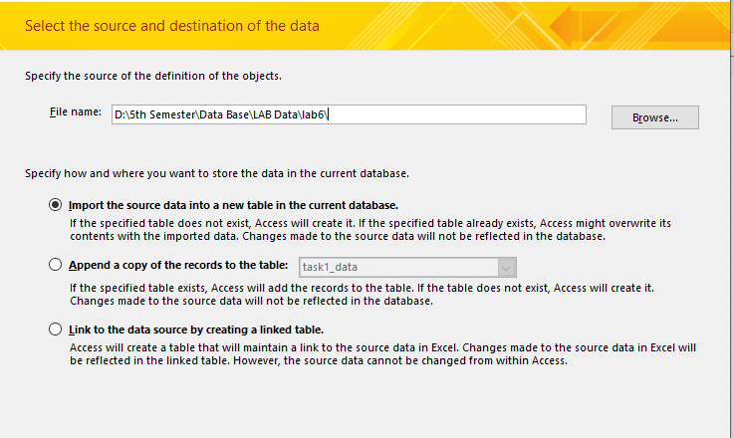

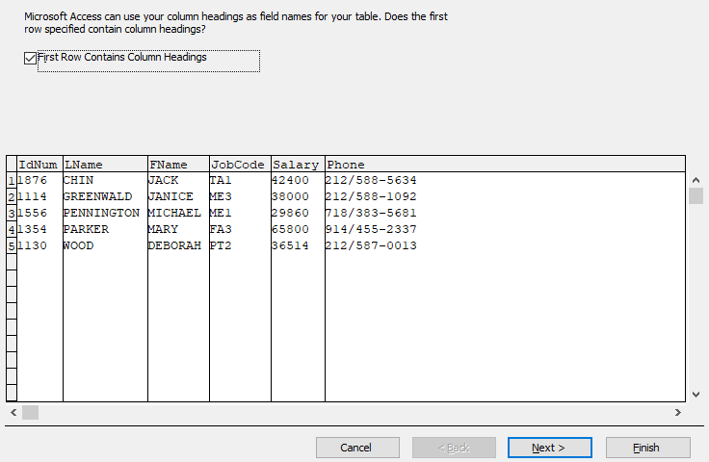

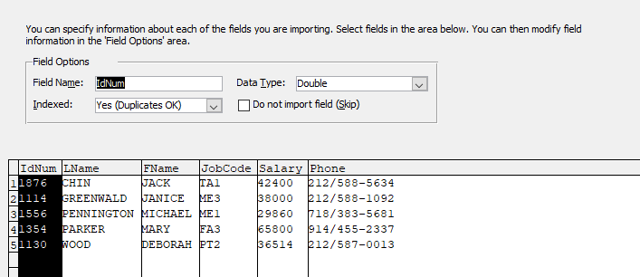

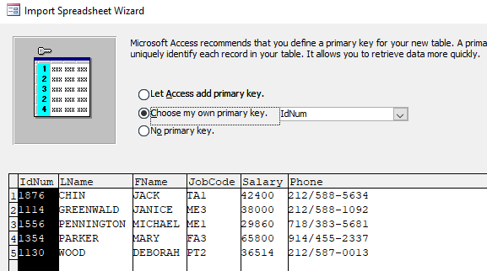

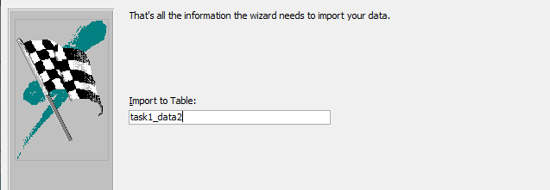

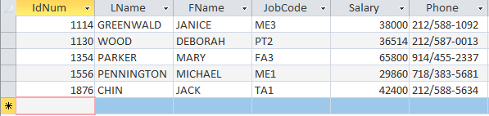

**Exporting the data to PDF format:**

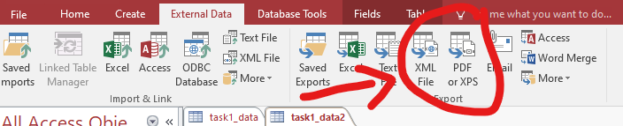

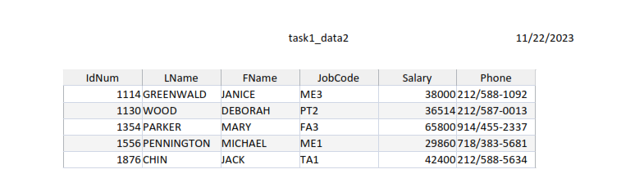

**Task#02:**

In this task we will be combining 2 tables with the help of union

**Query1:**

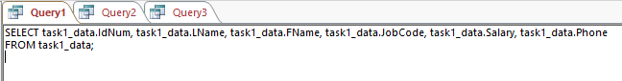

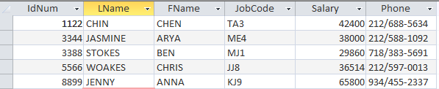

**Query2:**

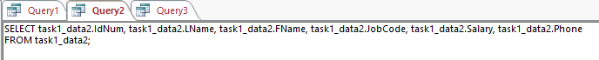

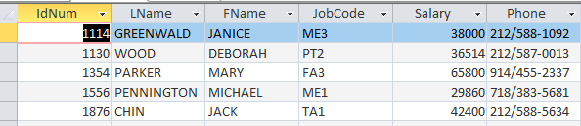

After these queries select union

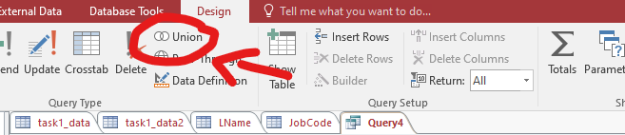

Now the following code to be written in Query 3 for union of 2 tables

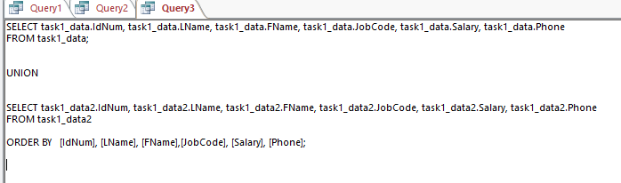

**Output:**

