Develop a Database Sappack
1. Open a command prompt or terminal and go to destined folder where the snappack is to be created

2. Run "mvn org.apache.maven.plugins:maven-archetype-plugin:2.4:generate -DarchetypeCatalog=http://maven.clouddev.snaplogic.com:8080/nexus/content/repositories/master/" command and answer the prompts as below:

- Choose a number or apply filter (format: [groupId:]artifactId, case sensitive contains): : 1
- Choose com.snaplogic.tools:SnapArchetype version:
1: 1.7
2: 1.8
3: 1.9
4: 1.10
5: 1.11
Choose a number: 5: 2
- Define value for property 'groupId': : com.snaplogic.snaps
- Define value for property 'artifactId': : oracledemo
- Define value for property 'version': 1.0-SNAPSHOT: : 2020.1.0
- Define value for property 'package': com.snaplogic.snaps: : com.snaplogic.snaps.oracledemo
- Define value for property 'organization': : snaplogic
- Define value for property 'assetPath': /snaplogic/shared: : (just hit Enter)
- Define value for property 'snapPack': oracledemo: : (just hit Enter)
- Define value for property 'user': : syed (enter whatever you want)
- Hit Y upon final confirmation
3. Using any IDE such as IntelliJ, open the oracledemo folder as a maven project
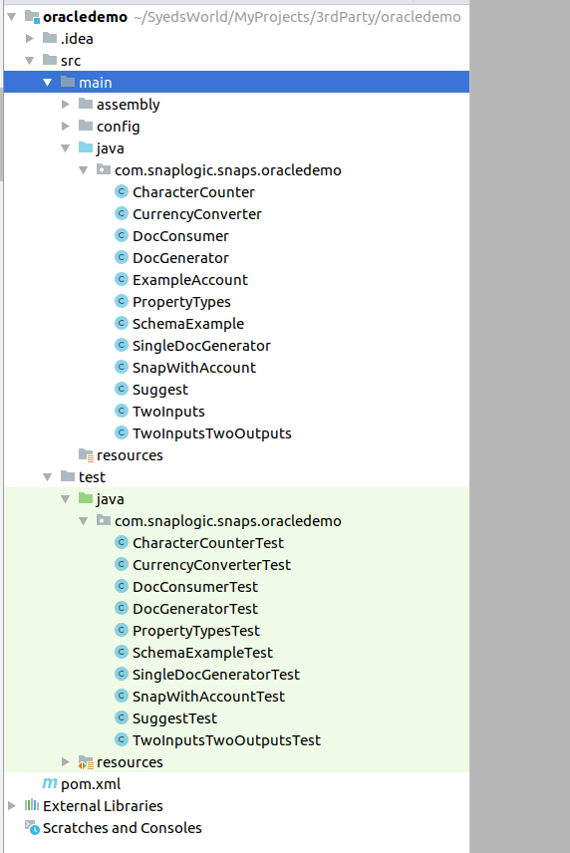
4. Delete all the existing source files in src/main/java and src/test/java folders
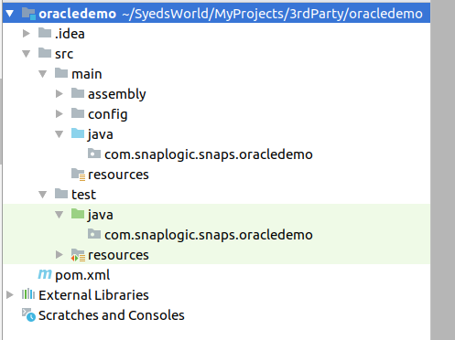

5. Create an account class (say OracleAccount) with six properties:
- DB Host
- DB Port
- DB Name
- DB User
- DB Password
- Driver Class
Note: Cache all the connections created in the account so that they are all closed at the snap terminattion.

6. Create a snap class (say OracleSelect) with one property:
- Query
Note: The snap should be linked to the account created

7. Update the pom.xml to reflect the correct snaps and accounts.
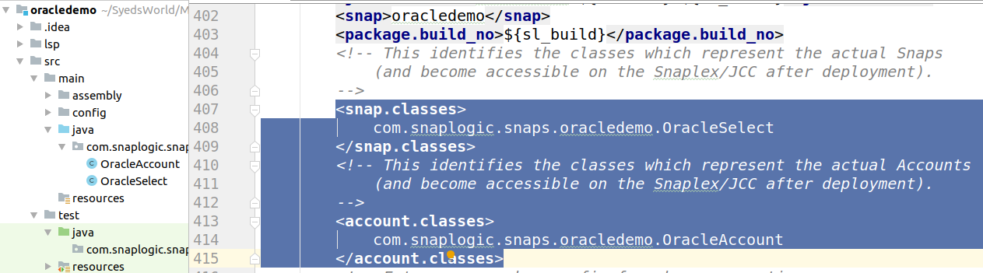
8. Add ojdbc dependency to the pom.xml.
I have used ojdbc6 versioned 11.2.0.3 from This Link.
Note: You need to add the repository as well in pom.xml as per the link.

9. Build the snappack at the command prompt.
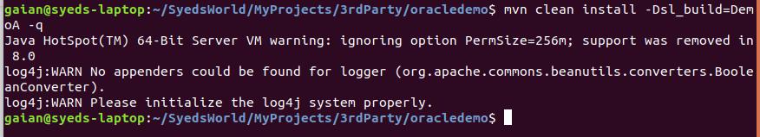

10. Deploy the snappack as a private pack via Manager.
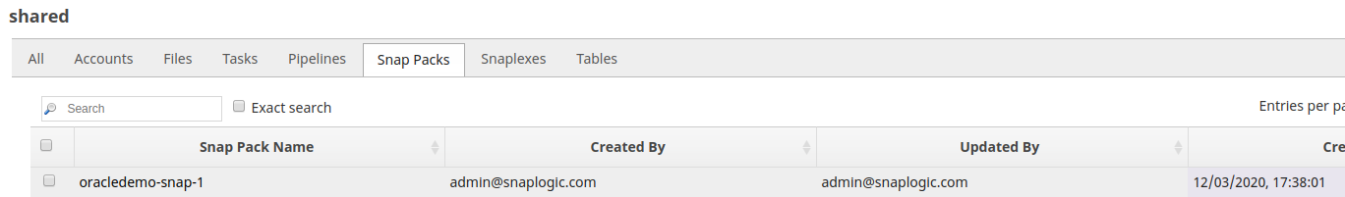

11. Create a pipeline with Select snap and account.



