DATABASE SYSTEMS LAB
Semester Project — Milestone 1 Submission

Gemstone Sales & Inventory Management System
ERD (Entity-Relationship Diagram) + Relational Database Schema

Submitted to | Mr. Ali Hassan
Student 1 Name | Syed Sudais Sohail
Program & Group | CS-A
Student 2 Name | Muhammad Mustafa Iqbal
Program & Group | CS-A
Submission Date | 28 April, 2026
Milestone | Milestone 1 — ERD & Relational Schema

1. Version Control Document
This document tracks all changes made to the Milestone 1 submission across revisions.

Milestone | Date | Version | Author(s) | Remarks
ERD Diagram & Schema | 28 Apr 2026 | 1.0 | Syed Sudais Sohail & Muhammad Mustafa Iqbal | Initial submission

2. System Entities Overview
The following 8 entities have been identified for the Gemstone Sales & Inventory Management System. All entities are derived from the project's functional requirements.

# | Entity Name | Description
1 | USERS | Staff who log in to operate the system; role-based access (admin / staff).
2 | CATEGORIES | Classifies gemstones into named types (e.g. Ruby, Emerald, Sapphire).
3 | GEMSTONES | Core entity — stores all physical attributes: weight, clarity, colour, origin, price.
4 | SUPPLIERS | Vendors who supply gemstones; linked to purchase records.
5 | CUSTOMERS | Buyers; linked to sale records and feedback.
6 | PURCHASES | Records every gemstone purchase transaction from a supplier.
7 | SALES | Records every gemstone sale transaction to a customer.
8 | INVENTORY | Tracks current stock level for each gemstone; auto-updated on purchases/sales.

3. Entity-Relationship Diagram (ERD)
The ERD below was designed using draw.io and exported as a digital diagram (crow's foot notation). Primary keys are underlined; foreign keys are shown in blue.

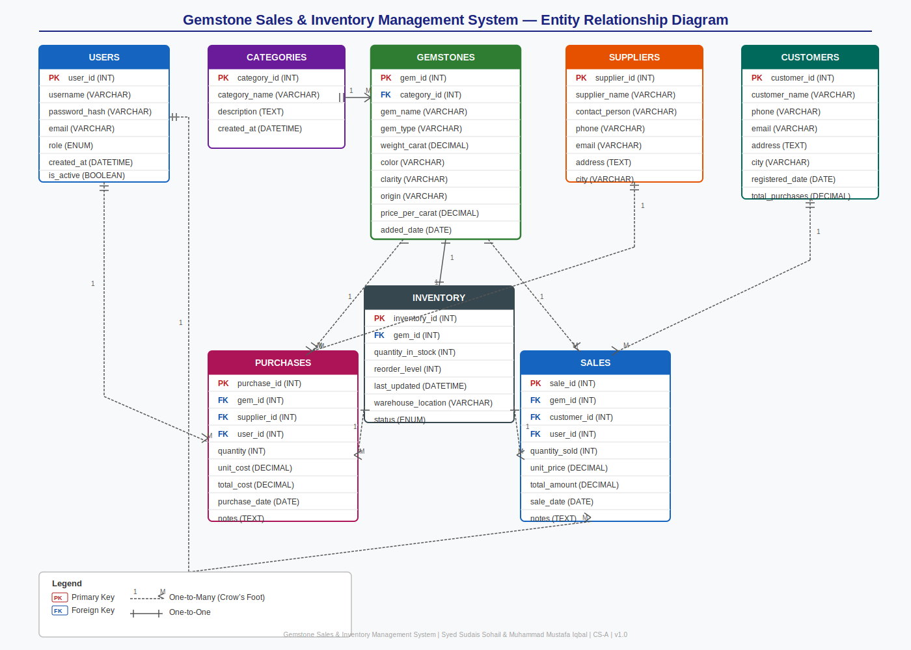

Figure 1 — ERD: Gemstone Sales & Inventory Management System (Crow's Foot Notation)

4. ERD Relationships Summary
The following table defines all relationships between entities, their cardinality, and the foreign key that enforces the relationship.

From Entity | To Entity | Cardinality | Description
CATEGORIES | GEMSTONES | 1 : N | One category classifies many gemstones. category_id FK in GEMSTONES.
SUPPLIERS | PURCHASES | 1 : N | One supplier appears in many purchase records. supplier_id FK in PURCHASES.
CUSTOMERS | SALES | 1 : N | One customer can have many sales records. customer_id FK in SALES.
GEMSTONES | PURCHASES | 1 : N | A gemstone may be bought in multiple transactions. gem_id FK in PURCHASES.
GEMSTONES | SALES | 1 : N | A gemstone may be sold in multiple transactions. gem_id FK in SALES.
GEMSTONES | INVENTORY | 1 : 1 | Each gemstone has exactly one inventory record. gem_id UNIQUE FK in INVENTORY.
USERS | PURCHASES | 1 : N | Each purchase is recorded by one staff member. user_id FK in PURCHASES.
USERS | SALES | 1 : N | Each sale is recorded by one staff member. user_id FK in SALES.
INVENTORY | PURCHASES | 1 : N | Stock levels are incremented on each purchase.
INVENTORY | SALES | 1 : N | Stock levels are decremented on each sale.

5. Relational Database Schema
Each table is described with column names, data types, key constraints (PK / FK), nullability, and a brief description.

Users:
Column Name | Data Type | Key | Null? | Description
user_id | INT AUTO_INCREMENT | PK | NO | Unique identifier for each system user
username | VARCHAR(50) |  | NO | Login username — must be unique
password_hash | VARCHAR(255) |  | NO | Bcrypt-hashed password string
email | VARCHAR(100) |  | YES | Contact email address
role | ENUM('admin','staff') |  | NO | Access level — admin or staff
created_at | DATETIME |  | NO | Account creation timestamp
is_active | BOOLEAN |  | NO | Soft-delete flag (default TRUE)

Category:
Column Name | Data Type | Key | Null? | Description
category_id | INT AUTO_INCREMENT | PK | NO | Unique category identifier
category_name | VARCHAR(100) |  | NO | Name of the gemstone category
description | TEXT |  | YES | Optional longer description
created_at | DATETIME |  | NO | Record creation timestamp

Gemstone:
Column Name | Data Type | Key | Null? | Description
gem_id | INT AUTO_INCREMENT | PK | NO | Unique gemstone identifier
category_id | INT | FK | NO | References CATEGORIES(category_id)
gem_name | VARCHAR(150) |  | NO | Display name of the gemstone
gem_type | VARCHAR(100) |  | YES | Specific variety (e.g. Pigeon Blood Ruby)
weight_carat | DECIMAL(10,3) |  | NO | Weight in carats
color | VARCHAR(80) |  | YES | Colour description
clarity | VARCHAR(80) |  | YES | Clarity grade (e.g. VVS1, eye-clean)
origin | VARCHAR(100) |  | YES | Country or mine of origin
price_per_carat | DECIMAL(12,2) |  | NO | Listed price per carat
added_date | DATE |  | NO | Date gem was entered into system

Supplier:
Column Name | Data Type | Key | Null? | Description
supplier_id | INT AUTO_INCREMENT | PK | NO | Unique supplier identifier
supplier_name | VARCHAR(150) |  | NO | Company or individual name
contact_person | VARCHAR(100) |  | YES | Primary contact name
phone | VARCHAR(20) |  | YES | Contact phone number
email | VARCHAR(100) |  | YES | Contact email address
address | TEXT |  | YES | Street address
city | VARCHAR(80) |  | YES | City

Customer:
Column Name | Data Type | Key | Null? | Description
customer_id | INT AUTO_INCREMENT | PK | NO | Unique customer identifier
customer_name | VARCHAR(150) |  | NO | Full name of the customer
phone | VARCHAR(20) |  | YES | Contact phone number
email | VARCHAR(100) |  | YES | Contact email address
address | TEXT |  | YES | Delivery / billing address
city | VARCHAR(80) |  | YES | City
registered_date | DATE |  | NO | Date customer was registered
total_purchases | DECIMAL(14,2) |  | YES | Cumulative spend (computed field)

Purchase:
Column Name | Data Type | Key | Null? | Description
purchase_id | INT AUTO_INCREMENT | PK | NO | Unique purchase record identifier
gem_id | INT | FK | NO | References GEMSTONES(gem_id)
supplier_id | INT | FK | NO | References SUPPLIERS(supplier_id)
user_id | INT | FK | NO | References USERS(user_id) — staff who recorded
quantity | INT |  | NO | Units purchased
unit_cost | DECIMAL(12,2) |  | NO | Cost per unit at time of purchase
total_cost | DECIMAL(14,2) |  | NO | quantity × unit_cost
purchase_date | DATE |  | NO | Date of the purchase transaction
notes | TEXT |  | YES | Optional remarks

Sales:
Column Name | Data Type | Key | Null? | Description
sale_id | INT AUTO_INCREMENT | PK | NO | Unique sale record identifier
gem_id | INT | FK | NO | References GEMSTONES(gem_id)
customer_id | INT | FK | NO | References CUSTOMERS(customer_id)
user_id | INT | FK | NO | References USERS(user_id) — staff who recorded
quantity_sold | INT |  | NO | Units sold
unit_price | DECIMAL(12,2) |  | NO | Selling price per unit
total_amount | DECIMAL(14,2) |  | NO | quantity_sold × unit_price
sale_date | DATE |  | NO | Date of the sale transaction
notes | TEXT |  | YES | Optional remarks

Inventory:
Column Name | Data Type | Key | Null? | Description
inventory_id | INT AUTO_INCREMENT | PK | NO | Unique inventory record identifier
gem_id | INT | FK | NO | References GEMSTONES(gem_id) — unique
quantity_in_stock | INT |  | NO | Current units available
reorder_level | INT |  | NO | Threshold to trigger restocking alert
last_updated | DATETIME |  | NO | Timestamp of last stock adjustment
warehouse_location | VARCHAR(100) |  | YES | Physical shelf or bin location
status | ENUM('in_stock','low','out') |  | NO | Current stock status label

Gemstone Sales & Inventory Management System

