DS LAB 1

K226007

Syed Yousha

BSR-3C

Task1:

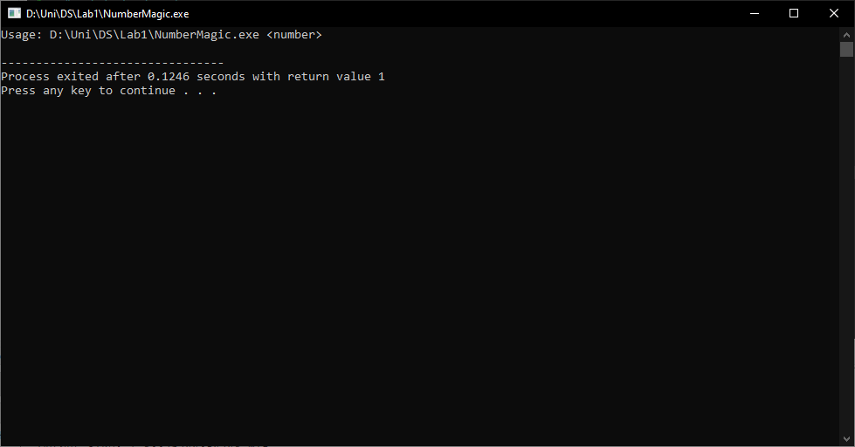

#include <iostream>

#include <math.h>

#include <stdlib.h>

using namespace std;

int main(int argc, char *argv[]) {

if (argc != 2) {

cout << "Usage: " << argv[0] << " <number>" << endl;

return 1;

}

int num = atoi(argv[1]);

cout << "Odd Numbers: ";

for (int i = 1; i <= num; i += 2) {

cout << i << " ";

}

cout << endl;

cout << "Even Numbers: ";

for (int i = 2; i <= num; i += 2) {

cout << i << " ";

}

cout << endl;

return 0;

}

Task 2:

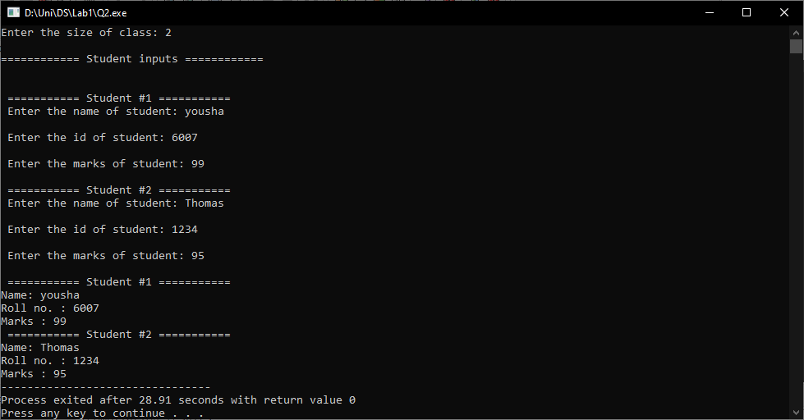

#include <iostream>

using namespace std;

class Student

{

string name, roll;

int marks;

public:

Student(){}

Student(string n, string r, int m): name(n), roll(r), marks(m)

{}

void display()

{

cout<<"\nName: "<<name;

cout<<"\nRoll no. : "<<roll;

cout<<"\nMarks : "<<marks;

}

};

int main()

{

string name, roll;

int marks, size;

cout<<"\nEnter the size of class: ";

cin>>size;

Student *stud = new Student[size];

cout<<"\n============ Student inputs ============\n\n";

for (int i = 0; i < size; i++)

{

cout<<"\n =========== Student #"<< i+1<<" ===========";

cout<<"\n Enter the name of student: ";

cin>>name;

cout<<"\n Enter the id of student: ";

cin>>roll;

cout<<"\n Enter the marks of student: ";

cin>>marks;

stud[i] = Student(name, roll, marks);

}

for (int i = 0; i < size; i++)

{

cout<<"\n =========== Student #"<< i+1<<" ===========";

stud[i].display();

}

return 0;

}

Task3:

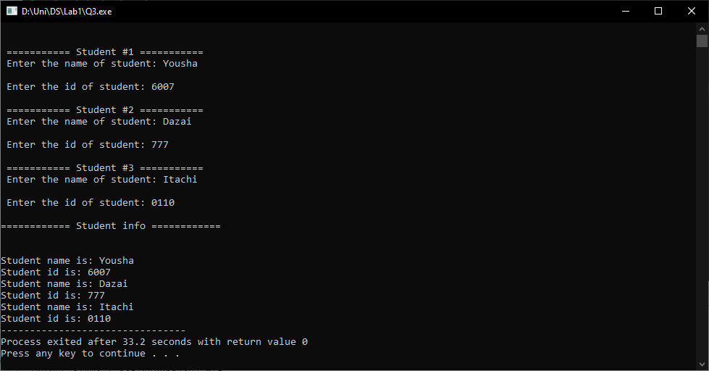

#include <iostream>

using namespace std;

class Admission_depart

{

string name, id;

public:

Admission_depart(){}

Admission_depart(string n, string i):name(n),id(i)

{}

void get_details()

{

cout<<"\nStudent name is: "<<name;

cout<<"\nStudent id is: "<<id;

}

};

int main()

{

int size = 3;

string name;

string id;

Admission_depart *stud = new Admission_depart[size];

cout<<"\n============ Student inputs ============\n\n";

for (int i = 0; i < size; i++)

{

cout<<"\n =========== Student #"<< i+1<<" ===========";

cout<<"\n Enter the name of student: ";

cin>>name;

cout<<"\n Enter the id of student: ";

cin>>id;

stud[i] = Admission_depart(name, id);

}

cout<<"\n============ Student info ============\n\n";

for (int i = 0; i < size; i++)

{

stud[i].get_details();

}

delete[] stud;

return 0;

}

Task 4:

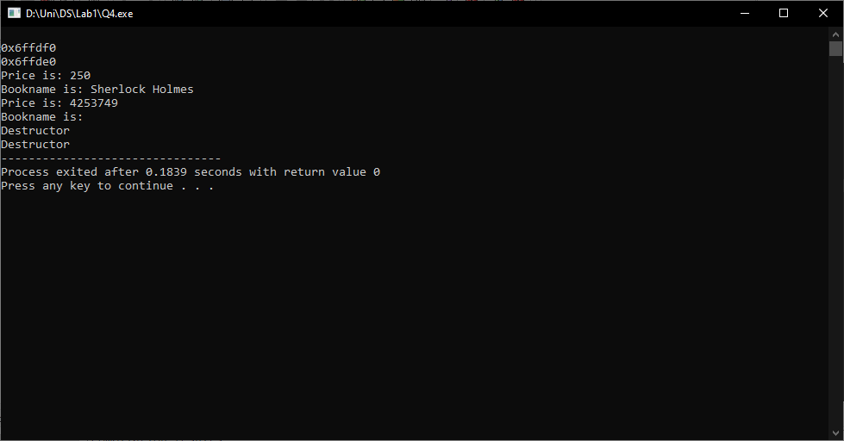

#include <iostream>

using namespace std;

class BookPrice{

string bookname;

int price;

public:

BookPrice(){}

BookPrice(string b, int p): bookname(b), price(p)

{}

BookPrice(const BookPrice &obj)

{

this->bookname = bookname;

this->price = price;

}

//For safety

BookPrice operator = (const BookPrice &obj)

{

if(this != &obj)

{

this->bookname = obj.bookname;

this->price = obj.price;

}

return *this;

}

void display()

{

cout<<"\nPrice is: "<<price;

cout<<"\nBookname is: "<<bookname;

}

~BookPrice()

{

cout<<"\nDestructor";

}

};

int main()

{

BookPrice a("Sherlock Holmes", 250);

BookPrice b = a;

// a = BookPrice("Rumi", 250);

cout<<endl<<&a;

cout<<endl<<&b;

a.display();

b.display();

}

Task 5:

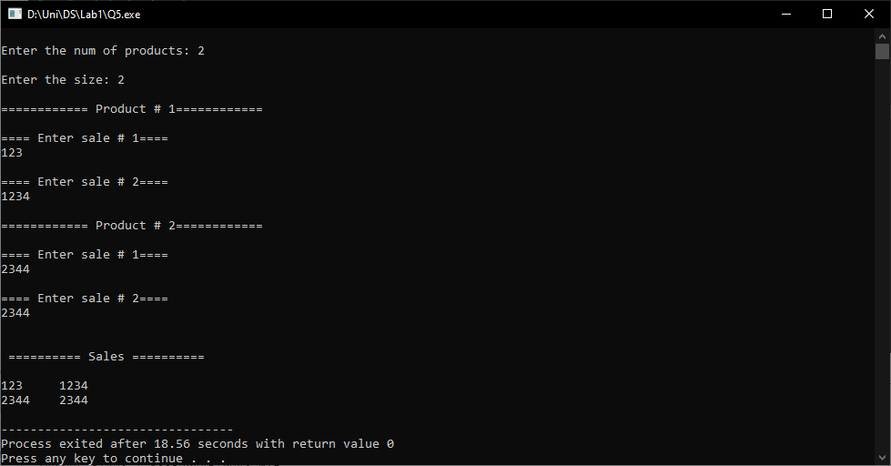

#include <iostream>

using namespace std;

class Sales

{

int **arr;

int products;

int no_sales;

public:

Sales(int p, int s): products(p), no_sales(s)

{

//setting array

arr = new int*[products];

for(int i=0; i<products; i++)

{

arr[i] = new int[no_sales];

}

//input

for(int i=0; i<products; i++)

{

cout<<"\n============ Product # "<<i+1<<"============ \n";

for(int j=0; j<no_sales; j++)

{

cout<<"\n==== Enter sale # "<<j+1<<"==== \n";

cin>>arr[i][j];

}

}

}

void display()

{

cout<<"\n\n ========== Sales ==========\n\n";

for(int i=0; i<products; i++)

{

for(int j=0; j<no_sales; j++)

{

cout<<arr[i][j]<<"\t";

}

cout<<endl;

}

}

};

int main()

{

int prod, size;

cout<<"\nEnter the num of products: ";

cin>>prod;

cout<<"\nEnter the size: ";

cin>>size;

Sales obj(prod, size);

obj.display();

}

Task 6:

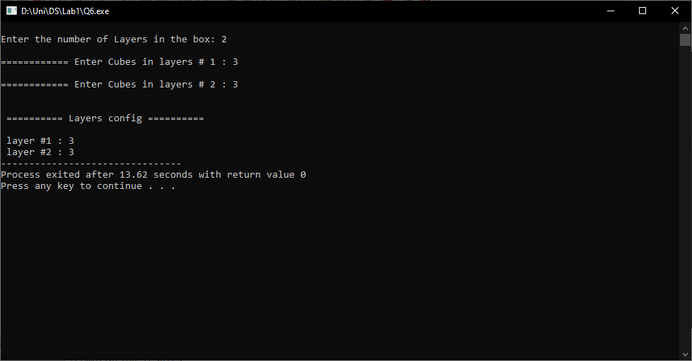

#include <iostream>

using namespace std;

class Box

{

int layers, *arr;

public:

Box(){}

Box(int l):layers(l)

{

arr = new int[layers];

//input

for(int i=0; i<layers; i++)

{

cout<<"\n============ Enter Cubes in layers # "<<i+1<<" : ";

cin>>arr[i];

}

}

void display()

{

cout<<"\n\n ========== Layers config ==========\n";

for(int i=0; i<layers; i++)

{

cout<<"\n layer #"<< i+1<<" : ";

cout<<arr[i];

}

}

~Box()

{

delete[] arr;

}

};

int main()

{

int layers;

cout<<"\nEnter the number of Layers in the box: ";

cin>> layers;

Box obj(layers);

obj.display();

return 0;

}