**Lab 3 DS**

**K226007**

**Syed Yousha**

**BSR-3C**

Task 3:

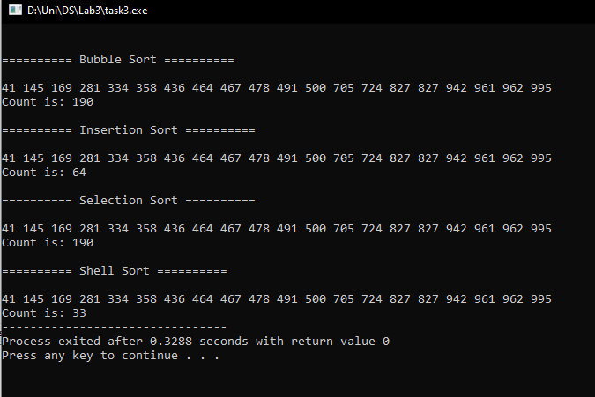

#include <iostream>

#include <cstdlib>

#include <cstring>

using namespace std;

void bubbleSort(int array[], int size)

{

int count = 0;

for (int i = 0; i < size; ++i)

{

for (int j = 0; j < size - i - 1; ++j)

{

count++;

if (array[j] > array[j + 1])

{

int temp = array[j];

array[j] = array[j + 1];

array[j + 1] = temp;

}

}

}

cout << "\n\n========== Bubble Sort ==========\n\n";

for (int i = 0; i < size; i++)

{

cout << array[i] << " ";

}

cout << "\nCount is: " << count;

}

void insertionSort(int array[], int size)

{

int i, key, j, count = 0;

for (i = 1; i < size; i++)

{

key = array[i];

j = i - 1;

while (j >= 0 && array[j] > key)

{

count++;

array[j + 1] = array[j];

j = j - 1;

}

array[j + 1] = key;

}

cout << "\n\n========== Insertion Sort ==========\n\n";

for (int i = 0; i < size; i++)

{

cout << array[i] << " ";

}

cout << "\nCount is: " << count;

}

void SelectionSort(int arr[], int n)

{

int count = 0;

for (int i = 0; i < n - 1; i++)

{

int min_index = i;

for (int j = i + 1; j < n; j++)

{

count++;

if (arr[j] < arr[min_index])

{

min_index = j;

}

}

int temp = arr[i];

arr[i] = arr[min_index];

arr[min_index] = temp;

}

cout << "\n\n========== Selection Sort ==========\n\n";

for (int i = 0; i < n; i++)

{

cout << arr[i] << " ";

}

cout << "\nCount is: " << count;

}

void shellsort(int arr[], int n)

{

int count = 0;

for (int gap = n / 2; gap > 0; gap /= 2)

{

for (int i = gap; i < n; i++)

{

int temp = arr[i];

int j = 0;

for (j = i; j >= gap && (arr[j - gap]) > temp; j -= gap)

{

count++;

arr[j] = arr[j - gap];

}

arr[j] = temp;

}

}

cout << "\n\n========== Shell Sort ==========\n\n";

for (int i = 0; i < n; i++)

{

cout << arr[i] << " ";

}

cout << "\nCount is: " << count;

}

int main()

{

int size = 20;

int arr[size];

for (int i = 0; i < size; i++)

{

arr[i] = rand() % 1000;

}

int temp[size];

memcpy(temp, arr, size * sizeof(int));

bubbleSort(temp, size);

memcpy(temp, arr, size * sizeof(int));

insertionSort(temp, size);

memcpy(temp, arr, size * sizeof(int));

SelectionSort(temp, size);

memcpy(temp, arr, size * sizeof(int));

shellsort(temp, size);

return 0;

}

Task 4:

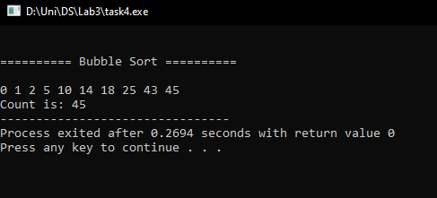

#include <iostream>

#include <cstdlib>

#include <cstring>

using namespace std;

void bubbleSort(int array[], int size)

{

int count = 0;

for (int i = 0; i < size; ++i)

{

for (int j = 0; j < size - i - 1; ++j)

{

count++;

if (array[j] > array[j + 1])

{

int temp = array[j];

array[j] = array[j + 1];

array[j + 1] = temp;

}

}

}

cout << "\n\n========== Bubble Sort ==========\n\n";

for (int i = 0; i < size; i++)

{

cout << array[i] << " ";

}

cout << "\nCount is: " << count;

}

int main()

{

int arr[] = {10, 2, 0, 14, 43, 25, 18, 1, 5, 45};

int size = sizeof(arr)/ sizeof(int);

bubbleSort(arr, size);

}

Task 5:

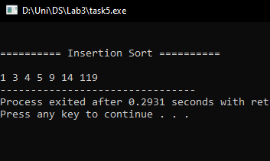

#include <iostream>

#include <cstdlib>

#include <cstring>

using namespace std;

void insertionSort(int array[], int size)

{

int i, key, j;

for (i = 1; i < size; i++)

{

key = array[i];

j = i - 1;

while (j >= 0 && array[j] > key)

{

array[j + 1] = array[j];

j--;

}

array[j + 1] = key;

}

cout << "\n\n========== Insertion Sort ==========\n\n";

for (int i = 0; i < size; i++)

{

cout << array[i] << " ";

}

}

int main()

{

int myarr[] = {9, 5, 1, 4, 3, 14, 119};

int size = sizeof(myarr) / sizeof(int);

insertionSort(myarr, size);

}

Task 6:

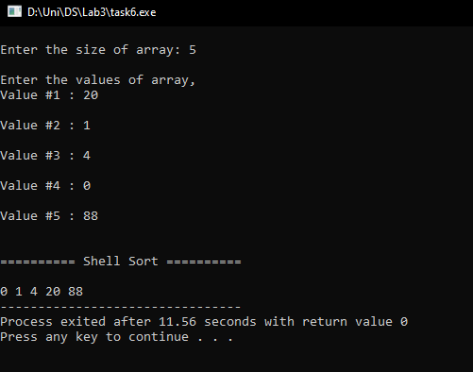

#include <iostream>

#include <cstdlib>

#include <cstring>

using namespace std;

void shellsort(int arr[], int n)

{

for (int gap = n / 2; gap > 0; gap /= 2)

{

for (int i = gap; i < n; i++)

{

int temp = arr[i];

int j = 0;

for (j = i; j >= gap && (arr[j - gap]) > temp; j -= gap)

{

arr[j] = arr[j - gap];

}

arr[j] = temp;

}

}

cout << "\n\n========== Shell Sort ==========\n\n";

for (int i = 0; i < n; i++)

{

cout << arr[i] << " ";

}

}

int main()

{

int size;

cout<<"\nEnter the size of array: ";

cin>>size;

int *arr = new int[size];

cout<<"\nEnter the values of array,";

for (int i = 0; i < size; i++)

{

cout<<"\nValue #"<<i+1<<" : ";

cin>>arr[i];

}

shellsort(arr, size);

}

Task 7:  
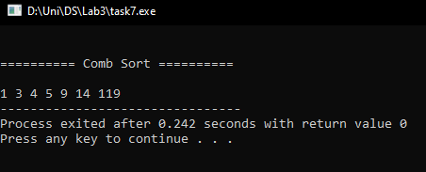

#include <iostream>

#include <cstdlib>

#include <cstring>

using namespace std;

void combSort(int arr[], int size)

{

int gap = size;

bool swapped = true;

while (gap > 1 || swapped == true)

{

//Comb sort formula

gap = (gap*10)/13;

if (gap < 1)

{

gap = 1;

}

swapped = false;

// k226007 swapping

for (int i = 0; i < size-gap; i++)

{

if (arr[i] > arr[i+gap])

{

swap(arr[i], arr[i+gap]);

swapped = true;

}

}

}

cout << "\n\n========== Comb Sort ==========\n\n";

for (int i = 0; i < size; i++)

{

cout << arr[i] << " ";

}

}

int main()

{

int myarr[] = {9, 5, 1, 4, 3, 14, 119};

int size = sizeof(myarr) / sizeof(int);

combSort(myarr, size);

}