FAST National University of Computer

and Emerging Sciences
Karachi Campus

Compiler Construction (CS-4031)

Assignment – 1

Submitted By: Name: Yousha
Roll No: K226007

Context-Free Languages (CFL)

Arithmetic Expressions Grammar
Grammar G1:
E → E + T | E - T | T
T → T * F | T / F | F F → (E) | id
This grammar supports +, -, *, / operators with parentheses.
Leftmost Derivation for a * (b + c / d) - e:
E ⇒ E - T ⇒ T - T ⇒ T * F - T ⇒ id * F - T ⇒ id * (E) - T ⇒ id * (E + T) - T ⇒ id * (E + T / F) - T ⇒ id * (E + id / F) - T ⇒ id * (E + id / id) - id ⇒ a * (b + c / d) - e.
Rightmost Derivation:
E ⇒ E - T ⇒ E - id ⇒ E - e ⇒ T - e ⇒ T * F - e ⇒ id * F - e ⇒ id * (E) - e ⇒ id * (E + T) - e ⇒
id * (E + T / F) - e ⇒ id * (E + id / F) - e ⇒ id * (E + id / id) - e ⇒ a * (b + c / d) - e.
Ambiguity:
This grammar is ambiguous because expressions like a - b - c can have two parse trees. To fix it, define operator precedence:
E → E + T | E - T | T
T → T * F | T / F | F F → (E) | id.

Proof for L = { aⁿ bᵐ cⁿ | n, m ≥ 1 }

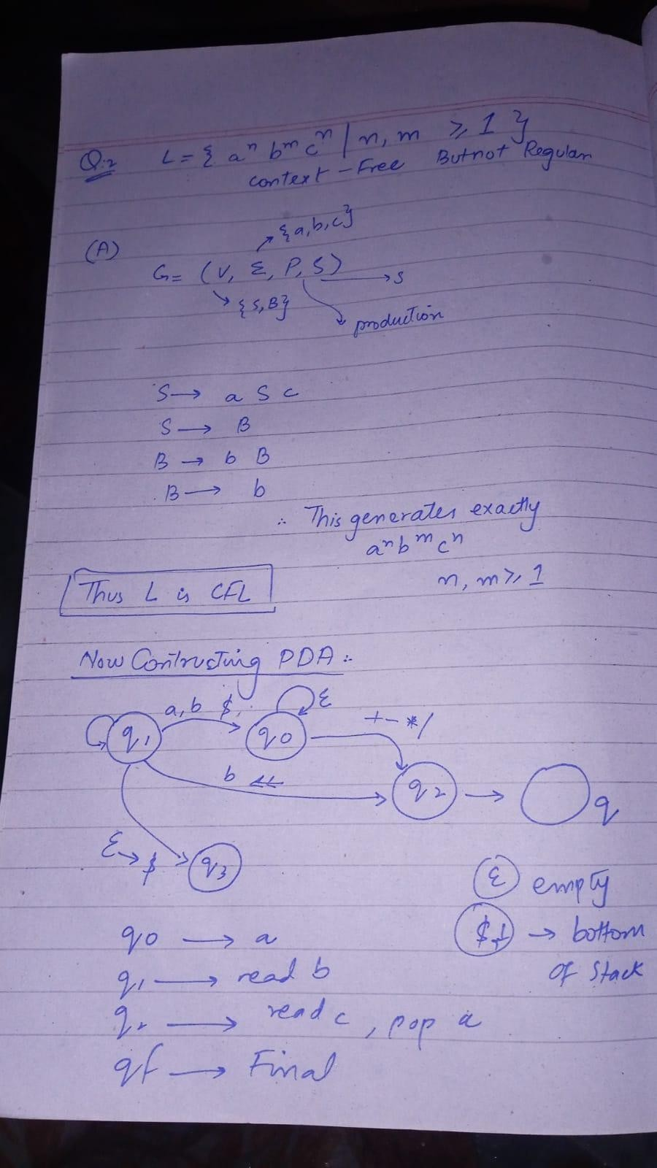 .

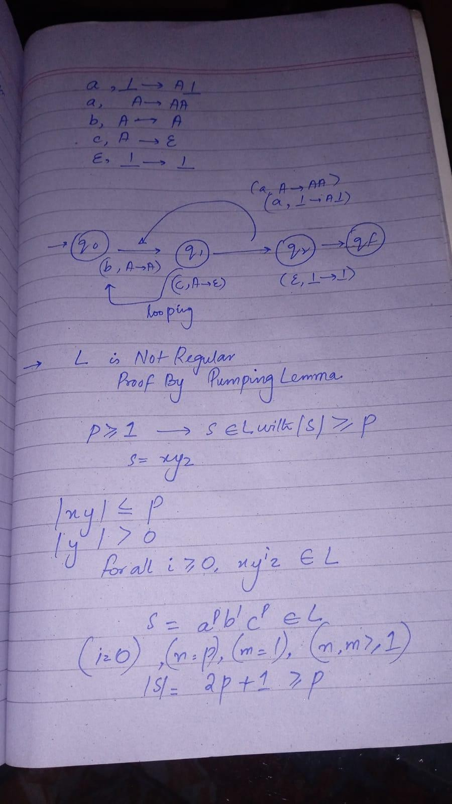

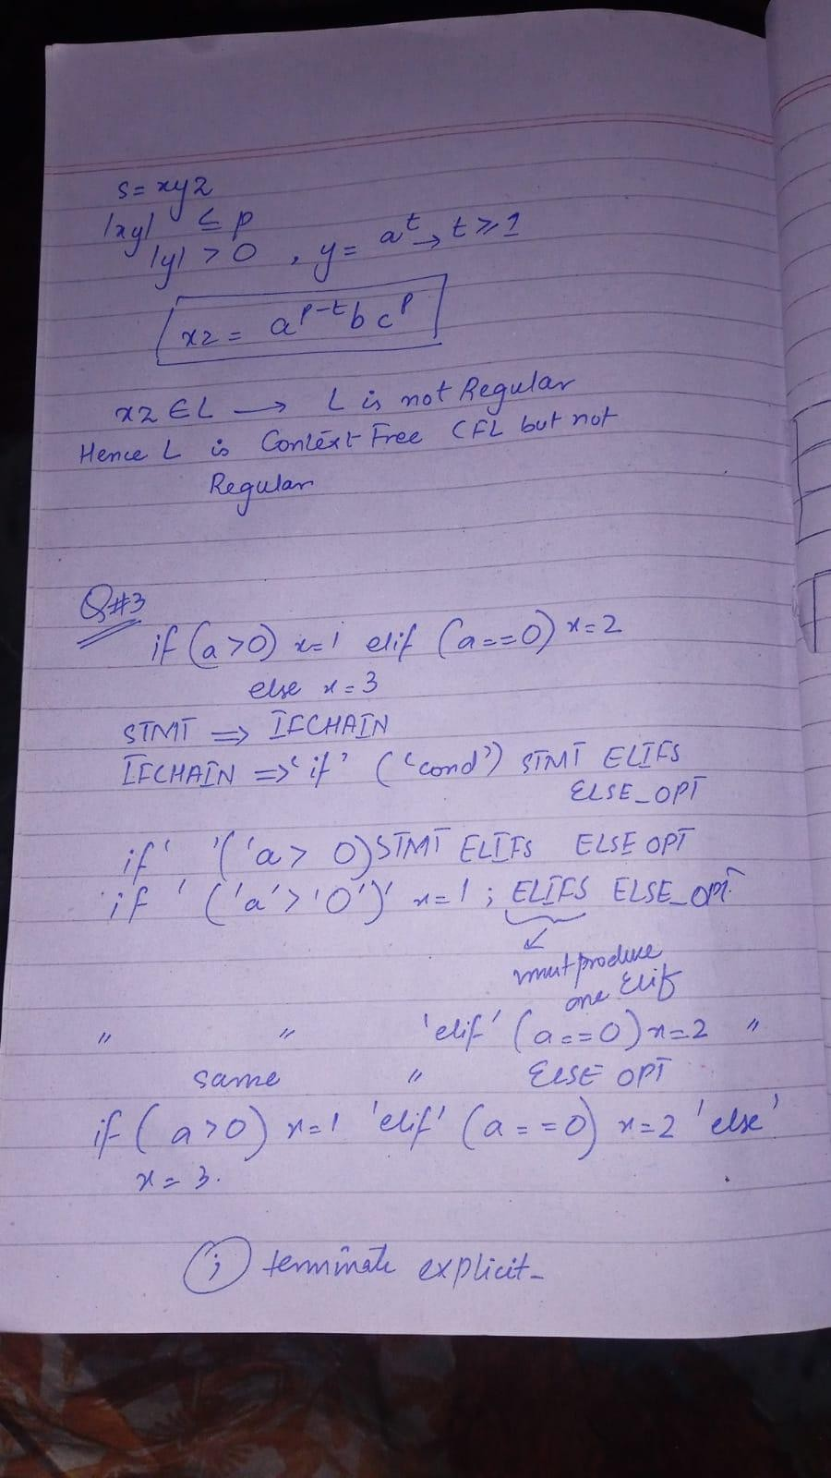

Conditional Constructs (if–elif–else)
Grammar:
in above pic

Recursive Function Calls
Grammar:
S → id ( L ) | id ( S ) | id L → S | S , L
Derivation for main(sum(add(a,b))):
S ⇒ id(L) ⇒ main(L) ⇒ main(S) ⇒ main(id(S)) ⇒ main(sum(S)) ⇒ main(sum(id(L))) ⇒
main(sum(add(L))) ⇒ main(sum(add(id,id))) ⇒ main(sum(add(a,b))). Recursion depth is represented by repeated non-terminal nesting.

Semicolon vs Implicit Termination
Grammar 1 (With semicolons):
S → stmt ; S | stmt ;
Grammar 2 (Without semicolons):
S → stmt S | stmt
Semicolon-based syntax aids error recovery and parsing since delimiters help the parser identify statement boundaries clearly.

Context-Free Grammar (CFG)
  - Palindromic Strings

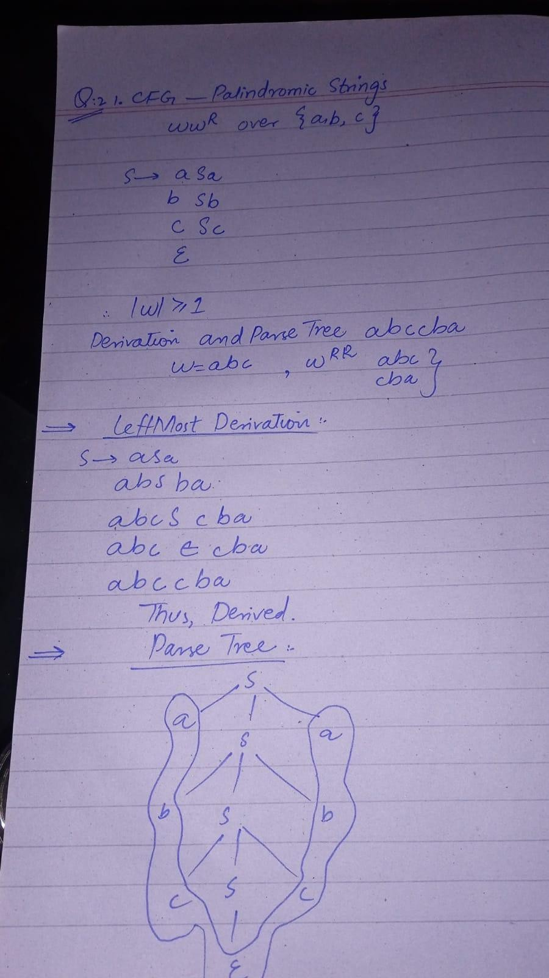

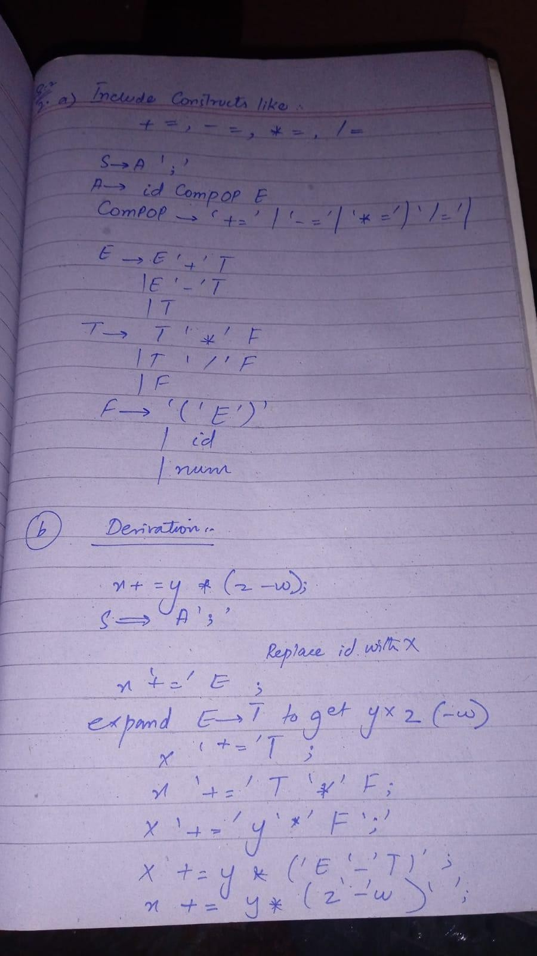

  - Compound Assignments (ans inn pic)
  - Nested Control Structures
Grammar:
S → while (C) S | if (C) S else S | stmt
Nested derivation example: while(C1) if(C2) stmt else stmt. WhileStmt
├─ 'while'
├─ '(' Cond ')'
│ ├ a
│ ├ '>'
│ └ 0
└─ Block
├ '{'
├ StmtList
│ └ IfStmt
│ ├ 'if'
│ ├ '(' Cond ')'
│ │ ├ b
│ │ └ 5
│ └ Stmt (Assign) → b = b + 1 ;
└ '}'

Ambiguity in Unary Minus
Ambiguous Grammar:
E → E + E | E - E | -E | id Unambiguous Grammar:
E → T | E + T | E - T
T → F | -F F → id | (E)
This enforces correct precedence (unary > multiplication > addition).

Switch-Case Grammar
    - SW ⇒ 'switch' '(' Expr ')' '{' CASES DEF '}'
    - Expr ⇒ id → x:
    - ⇒ switch ( x ) { CASES DEF }
    - Build CASES as two CASEs: CASES ⇒ CASE CASES and then CASES ⇒ CASE ε:
    - ⇒ switch ( x ) { CASE CASE DEF }
    - First CASE ⇒ 'case' num ':' STMTLIST with num=1 and STMTLIST → STMT STMTLIST and STMT → Assign ';' with Assign → y = 10:
    - ⇒ switch ( x ) { case 1 : y = 10 ; CASE DEF }
    - Second CASE similarly for case 2 : y = 20 ;:
    - ⇒ switch ( x ) { case 1 : y = 10 ; case 2 : y = 20 ; DEF }
    - DEF ⇒ 'default' ':' STMTLIST and STMTLIST → STMT → y = 0 ;
    - ⇒ switch ( x ) { case 1 : y = 10 ; case 2 : y = 20 ; default : y =
0 ; }

Parse-tree :
SW
├─ 'switch'
├─ '(' Expr ')' (Expr → x)
└─ '{'
├─ CASES
│ ├ CASE (case 1 : STMTLIST y=10;)
│ └ CASE (case 2 : STMTLIST y=20;)
├─ DEF (default : STMTLIST y=0;)
└─ '}'

Lexical Analyzer

Regular Expressions
- Test Input
float _x1 = 10.5; // initialize variable.
Lexical Analysis Process
We apply the regular expressions sequentially to recognize tokens.

Lexeme | Token Type | Category / Meaning
float | Keyword | Data type keyword
_x1 | Identifier | Variable name
= | Assignment Operator | Assigns a value
10.5 | Floating-point Number | Numeric constant
; | Separator | Statement terminator
// initialize variable. | Comment | Single-line comment

- Token Output Stream
<KEYWORD, "float">
<IDENTIFIER, "_x1">
<ASSIGN_OP, "=">
<FLOAT_LITERAL, "10.5">
<SEMICOLON, ";">
<COMMENT, "// initialize variable.">

Token Specification
- Token Specification Table

Token Name | Pattern / Regular Expression | Description
FOR | for | Keyword
WHILE | while | Keyword
BREAK | break | Keyword
ID | [a-zA-Z_][a-zA-Z0-9_]* | Identifier
NUM | [0-9]+ | Integer constant

Token Name Pattern / Regular Expression Description

RELOP | `<= | >=
ARITHOP | `+ | -
ASSIGN | = | Assignment operator
INC_OP | `++ | --`
LPAREN / RPAREN | `( | )`
SEMICOLON | ; | Statement terminator
WHITESPACE | [ \t\n\r]+ | (Ignored by lexer)

- Input
for( i=0; i<=10; i++) break;
Step-by-Step Lexical Analysis

Lexeme | Token Type | Description
for | FOR | loop keyword
( | LPAREN | open parenthesis
i | ID | identifier
= | ASSIGN | assignment operator
0 | NUM | integer constant
; | SEMICOLON | statement terminator
i | ID | identifier
<= | RELOP | relational operator
10 | NUM | integer constant
; | SEMICOLON | statement terminator
i | ID | identifier
++ | INC_OP | increment operator

Lexeme Token Type Description

) | RPAREN | close parenthesis
break | BREAK | keyword
; | SEMICOLON | statement terminator

- Token Output Stream
<FOR, "for">
<LPAREN, "(">
<ID, "i">
<ASSIGN, "=">
<NUM, "0">
<SEMICOLON, ";">
<ID, "i">
<RELOP, "<=">
<NUM, "10">
<SEMICOLON, ";">
<ID, "i">
<INC_OP, "++">
<RPAREN, ")">
<BREAK, "break">
<SEMICOLON, ";">

Token Classification
Keywords are matched before identifiers. Lexeme tables maintain token type, value, and category for each scanned element.

FA Role
Finite Automata is used to detect patterns in identifiers, numbers, and invalid tokens. Each transition corresponds to a character match.

Custom Python Operator
To add @@ operator and repeat keyword, modify token table and lexical rules: OPERATOR: @@ → STRING_CONCAT
KEYWORD: repeat
Both added in rule section and reserved word list.

Symbol Table Manager

1 — Symbol table structure for variables, arrays, functions with nested scopes

Design goals
  - Fast lookup (identifier → symbol info) within a scope.
  - Support nested scopes (block/function scopes).
  - Store types, storage info, array dimensions, function signatures, scope level, and offsets.
  - Support insertion on declarations, lookup on use, deletion on scope exit.

Data structures (recommended)
- Scope stack: stack of scope records; top = current scope.
- Scope record: contains:
  - scope_id (int or lexical name)
  - parent pointer (optional)
  - symbols: a hash table (preferred) mapping name → SymbolEntry
  - metadata: start line, end line, level
- SymbolEntry` structure:
  - name (string)
  - kind ∈ {variable, array, function, parameter, class, method}
  - type (for variable/array element type; for function: return type)
  - dimensions (for array; list of ints or [] for dynamic)
  - params (for function: list of (name,type))
  - scope_id (where declared)
  - offset / storage (stack offset or global address)
  - visibility (public/protected/private for OO)
  - is_defined / is_declared
  - extra (flags: const, static, extern)

  - overloads (for methods: pointer/list to overloaded signatures)

Visual: scope-stack + per-scope hash table
global_scope (hash)
foo -> SymbolEntry(...) x -> SymbolEntry(...)

(stack) function_scope (hash)
x -> SymbolEntry(...) <-- shadows global x i -> SymbolEntry(...)

block_scope (hash)
temp -> SymbolEntry(...)

Basic operations (pseudo-code)
enterScope(name)
new_scope = ScopeRecord(name, parent=current_scope) push scope_stack, current_scope = new_scope
exitScope()
popped = pop scope_stack
delete popped.symbols (or let GC reclaim) current_scope = top(scope_stack)
insertSymbol(name, entry)
if current_scope.symbols.contains(name) then
// Redeclaration in same scope: report error or allow (policy) error "redeclaration of " + name
else
current_scope.symbols[name] = entry
lookup(name) // lexical (closest) lookup
scope = current_scope while scope != null:
if scope.symbols.contains(name): return scope.symbols[name]
scope = scope.parent return NOT_FOUND
lookupInCurrentScope(name)
return current_scope.symbols.get(name) or NOT_FOUND

(continued) — Demonstrate insertion, lookup, deletion during block entry/exit
Example program snippet
1: int x = 0; // global

2: void foo() {
3: int x = 5; // shadows global x 4: int a[10];
5: {
6: int x = 7; // shadows foo's x 7: a[2] = x;
8: } // inner block exit 9: x = x + 1;
10: }
Deletion is automatic by pop: memory offsets may be reclaimed or reused.

— Symbol table behavior parsing a program: shadowing and scope resolution
Example to demonstrate shadowing and resolution:
int x = 1; // global void f() {
int x = 2; // shadows global x
{
int y = x + 1; // resolves x → local x (2)
}
g();
}
void g() {
int x = 3; // separate scope, shadows global for g x = x + 1; // resolves to g's x
}

During parsing:
- While parsing f, the parser calls enterScope(f); x=2 inserted into f's scope.
- Inside the inner block, enterScope(block); y inserted. Lookup x finds f's x
(closest), not global x.
- After block exit, y removed.
- When parsing g, enterScope(g) creates a new scope; x=3 inserted in g scope — not related to f's x.
- Scope resolution algorithm: always search current scope then ascend parents until a match is found (lexical scoping).
Shadowing: When a name in an inner scope duplicates an outer name, inner one shadows; lookup returns inner symbol.

— Lexer updates symbol table causing conflict or duplicate entry; resolution policy
Scenario (lexer adds identifiers on first sight)
Some compilers perform a symbol-table update in lexer for simple languages or for symbol tables of macros/forward declarations. Consider:
Input:
int foo;
int foo = 5; // redeclaration in same scope
If the lexer inserts foo as soon as it sees the first int foo;, then the parser sees int foo
= 5; and attempts insertion again in same scope. This is a duplicate declaration
conflict.
How conflicts arise
- Duplicate declaration (same scope): same name declared twice.
- Different kinds with same name: e.g., int x; then function x() (depending on language this may be allowed or not).
- Lexer-level premature insertion: lexer may not know scope depth or declaration completeness; e.g., processing typedef vs identifier.
Conflict resolution policies
  - Reject as error (most languages): report redeclaration error with location info.
    - During insertSymbol, if name exists in current scope → error.

Allow forward declaration / update entry:
    - If earlier entry was only a declaration (not definition), second line may be a definition: update is_defined flag and fill offsets.
  - Permit overloading (functions with different signatures):
    - Instead of single entry, maintain an overload set; insertion adds to list after signature check.

Shadowing allowed in inner scope:
    - If duplicate found in outer scope and insertion occurs in inner scope → allowed (shadowing).
  - Lexer policy: normally lexer does NOT insert into symbol table except tokenizing; insertion should occur in parser/semantic phase once declaration is recognized.

Best practice: do not let the lexer modify the final symbol table. Only the parser/semantic analyzer should create/modify symbol entries when a declaration is confirmed. If lexer must interact (e.g., for reserved words), it should only return tokens and let parser handle symbol table insert.

— Evaluate symbol table designs: Hash table vs Linked list for large programs
Two common designs
  - Per-scope hash table: each scope has its own hash table mapping names → SymbolEntry.
  - Per-scope linked list / symbol list: each scope stores symbols in a linked list or array (linear search).
Time complexity

Insertion
  - Hash table: average O(1) per insert (amortized), worst-case O(n) if many collisions.
  - Linked list: O(1) to append (if tail pointer) but O(1) only for insertion; but check for duplicates may require O(k) where k = symbols in scope.

Lookup (name resolution)
  - Hash table: average O(1) per scope; if need lexical lookup, may ascend scopes (O(h) where h = number of nested scopes that must be searched; but average small). Overall average O(h).
  - Linked list: O(k) to search current scope; worst-case O(k_total) across scopes if linear search in each; expensive for large scopes.

Deletion (scope exit)
  - Hash table: O(#symbols_in_scope) to free or drop pointer to the hash table
— inexpensive.
  - Linked list: O(#symbols_in_scope) to free — similar.
Memory usage
- Hash table uses more memory (buckets, load factor overhead), but scales better.
- Linked list uses less overhead per symbol but poor performance for lookups.

Collisions & maintenance
- Hash table needs a good hash and resizing policy; collisions resolved by chaining (lists) or open addressing.
- Linked list avoids hashing but loses fast lookup.
Conclusion / recommendation
- For large programs and performance-sensitive compilers: per-scope hash tables (or tries) are strongly preferred. They provide average O(1) lookup/insertion and fast error-checking.
- Use separate chaining and resize strategy to keep average bucket length small.
- For very memory-constrained or extremely simple languages, a linked list or linear symbol table per scope may be acceptable but will perform poorly for large scopes (e.g., many local variables, large module).
Hybrid approach: global hashmap for current-scope lookups + lexical scope chain pointers for parent resolutions; or a global symbol table with scope-qualified keys (name, scope_id).

— Symbol table schema for an object-oriented mini-language (classes, inheritance, method overloading)
Design must store classes, attributes, method signatures (overloads), inheritance links, visibility, and offsets.

Schema (fields for entries)
ClassEntry
  - class_name (string)
  - parent_class (string or null)
  - attributes → hash table / map attr_name -> AttributeEntry
  - methods → map method_name -> list of MethodEntry (overloads)
  - vtable_offset / class_size
  - visibility default public
  - scope_id for class-level scope
AttributeEntry
  - name

  - type (primitive or class type)
  - offset (within object)
  - visibility (public/protected/private)
  - is_static (bool)
  - is_final (bool)
MethodEntry
  - name
  - return_type
  - param_list (ordered list of (name,type))
  - param_types_signature (for overload resolution)
  - local_scope (pointer to scope record for function body)
  - is_virtual (bool)
  - visibility
  - offset_in_vtable (if virtual)
  - is_static (bool)
Object / instance layout
  - For each attribute, its offset and inherited attributes appear before new ones.

Lookup rules (inheritance & overloading)
  - Attribute lookup: search class's attributes; if not found, check parent_class
recursively.
  - Method lookup: find method_name in class; if multiple entries, pick overload by matching param_types_signature; if not found, check parent.
  - Overriding: a method with same name and identical signature in derived class overrides base's; same name but different signature → overload.
- Example entries for Base and Derived
Assume mini-language:
class Base { int id;
void print(); void set(int v);
}

class Derived extends Base {

int id; // shadows Base.id int value;
void set(double v); // overload: different signature void print(); // override
}
ClassEntry: Base
- class_name: Base
- parent_class: null
- attributes:
  - id → AttributeEntry{name=id, type=int, offset=0, visibility=public}
- methods:
  - print → [ MethodEntry{name=print, return_type=void, params=[], is_virtual=true, vtable_offset=0} ]
  - set → [ MethodEntry{name=set, return_type=void, params=[(v,int)], is_virtual=true, vtable_offset=1} ]
- class_size: size_of(int) + vptr? (depending on model)
ClassEntry: Derived
- class_name: Derived
- parent_class: Base
- attributes:
  - id → AttributeEntry{name=id, type=int, offset=0, visibility=public} // shadows Base.id for Derived instances
  - value → AttributeEntry{name=value, type=int, offset=4}
- methods:
  - set → two entries:
    - MethodEntry{name=set, return_type=void, params=[(v,double)], is_virtual=false (or virtual depends), ...} // overload
  - print → MethodEntry{name=print, return_type=void, params=[], overrides Base.print, is_virtual=true, vtable_offset=0}
- Derived print overrides Base's print → set same vtable_offset as base; overriding update in class method table.

How the symbol table stores these:
- global_scope.classes['Base'] = ClassEntry(...)
- global_scope.classes['Derived'] = ClassEntry(...)
Method overload list for Derived:
methods['set'] = [
{signature: (double), entry: MethodEntry(...)} // new overload
]
And for resolving calls:
- On call obj.set(3): at compile-time match param types: int promotes to
double? depends on language coercion rules; choose best matching overload.

Example symbol table rows (tabular)
Class: Base

name | kind | type | signature | scope | extra
Base | class | — | — | global | parent=null
id | field | int | — | Base | offset=0
print | method | void | () | Base | vtable idx 0
set | method | void | (int) | Base | vtable idx 1
Class: Derived

name | kind | type | signature | scope | extra
Derived | class | — | — | global | parent=Base
id | field | int | — | Derived | offset=0 (shadows Base.id)
value | field | int | — | Derived | offset=4
print | method | void | () | Derived | overrides Base.print, vtable idx 0
set | method | void | (double) | Derived | overload

Practical – FLEX / Lex Implementation
- .l File for Identifiers, Numbers, and Basic Operators
%{
#include <stdio.h> #include <string.h>
void print_token(const char *tok, const char *lexeme){printf("<%s,
\"%s\">\\n",tok,lexeme);}
%}
%%
[ \t\r\n]+ ;
"//".* ;
[0-9]+[a-zA-Z_][a-zA-Z0-9_]* {printf("Lexical error: %s\\n",yytext);}
[0-9]+\.[0-9]+ {print_token("FLOAT",yytext);}
[0-9]+ {print_token("INTEGER",yytext);}
[a-zA-Z_][a-zA-Z0-9_]* {

print_token("IF",yytext); print_token("ELSE",yytext); print_token("REPEAT",yytext);
if(!strcmp(yytext,"if"))

else if(!strcmp(yytext,"else")) else if(!strcmp(yytext,"repeat"))
else print_token("IDENTIFIER",yytext);
}

"=="| "!=" | "<=" | ">=" | "<"|">" {print_token("RELOP",yytext);}
"+"|"-"|"*"|"/" {print_token("ARITH_OP",yytext);}
"=" {print_token("ASSIGN",yytext);}
";" {print_token("SEMI",yytext);}
"("|")" {print_token("PAREN",yytext);}
. {print_token("UNKNOWN",yytext);}
%%
int main(){yylex();return 0;}

- Compilation Commands
flex lexer.l
gcc lex.yy.c -lfl -o lexer

- Execution on Input

Input:
x1 + 42

Output:
<IDENTIFIER, "x1">
<ARITH_OP, "+">
<INTEGER, "42">

Input:
if x>0 else y=2

Output:
<IF, "if">
<IDENTIFIER, "x">

<RELOP, ">">
<INTEGER, "0">
<ELSE, "else">
<IDENTIFIER, "y">
<ASSIGN, "=">
<INTEGER, "2">

- Modified Lexer Recognizing Keyword repeat

Input:
repeat a=5;

Output:
<REPEAT, "repeat">
<IDENTIFIER, "a">
<ASSIGN, "=">
<INTEGER, "5">
<SEMI, ";">

- Handling Invalid Input

Input:
123abc

Output:
Lexical error: 123abc

Improvement:
Add a specific rule [0-9]+[a-zA-Z_][a-zA-Z0-9_]* before numeric and identifier rules to detect mixed invalid tokens.

