IS ASSIGNMENT 3
Yousha Mehdi
22K-6007
BCS-7M

Part 1
Installing Mailvelope on Google Chrome - Adding it to extensions of web browser

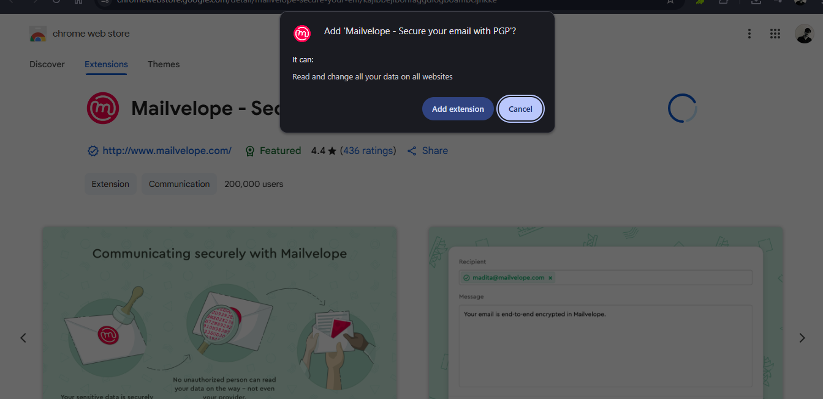

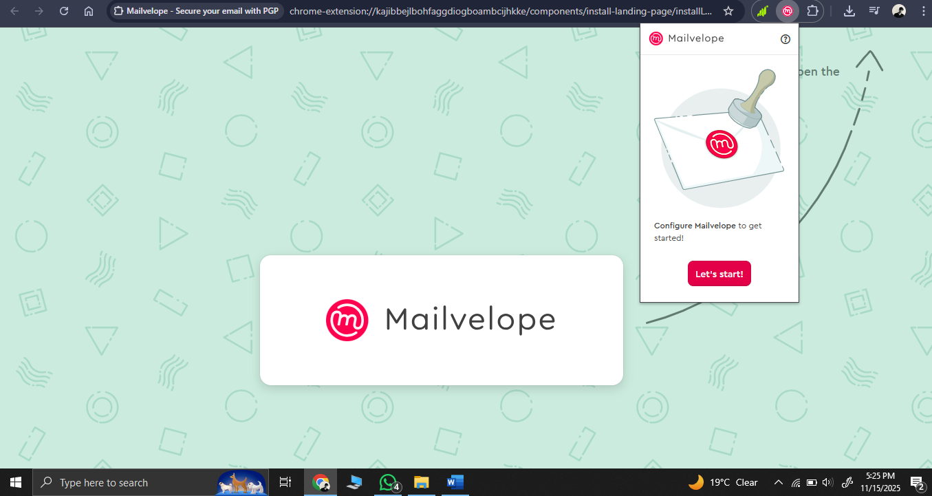
Generating Key Pairs for sender and receiver for secure email transfer

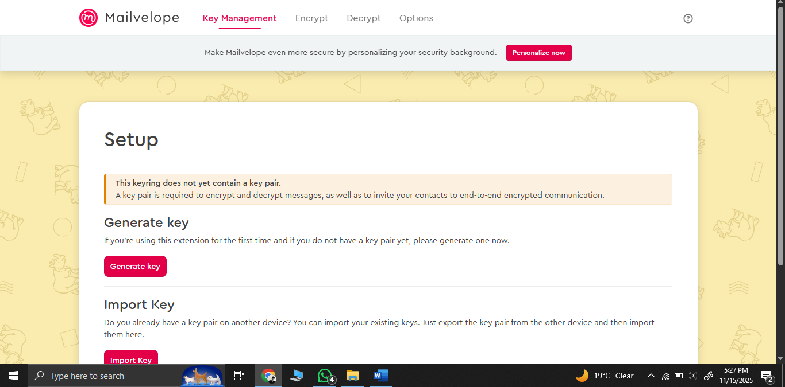

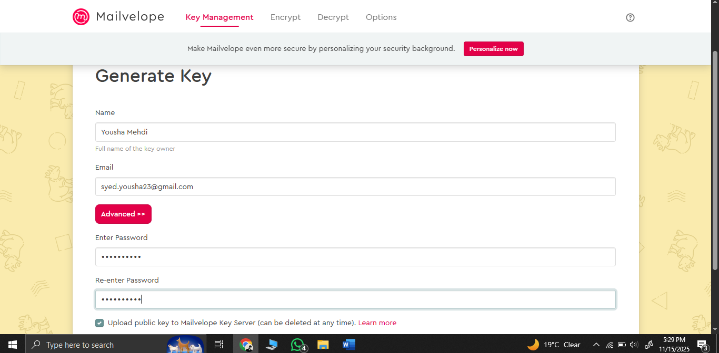
Successful Key Generation for Sender (name: Yousha Mehdi)

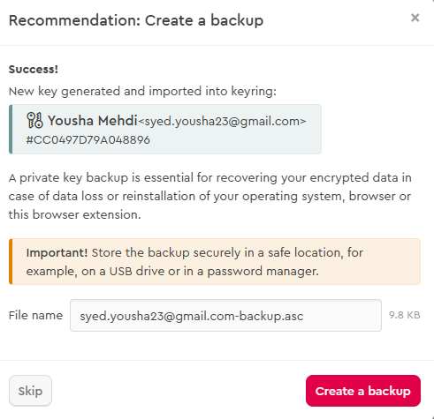

Key generation for receiver (name Yoo)

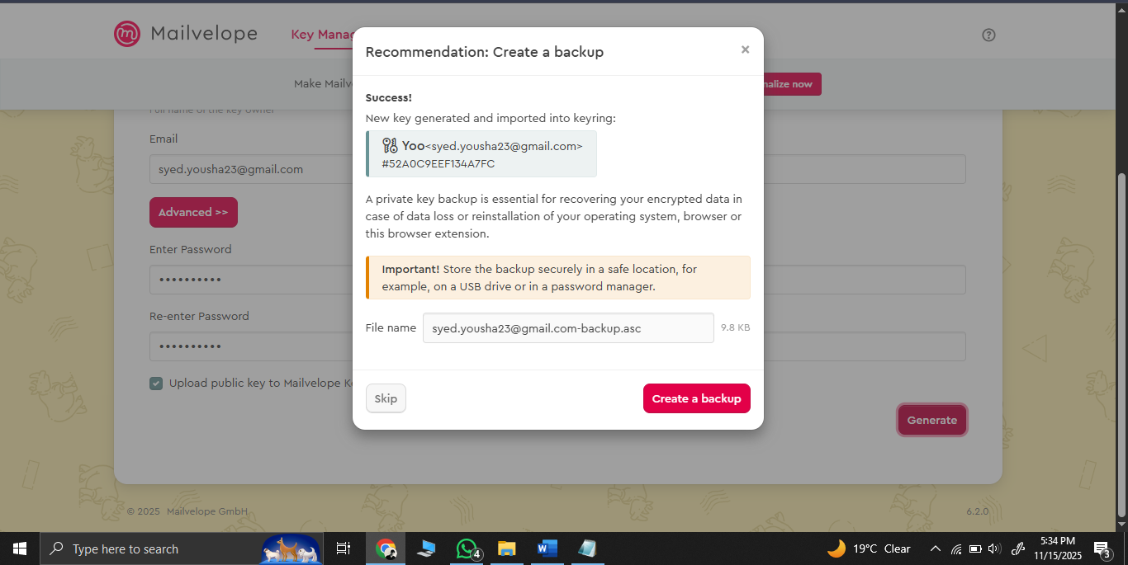

Both keys are generated and are visible in key management section
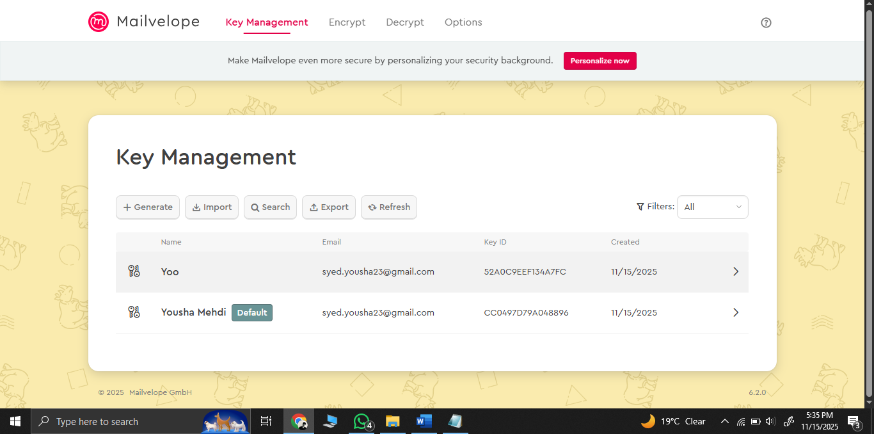

Verification of Email Address (both sender and receiver via gmail)

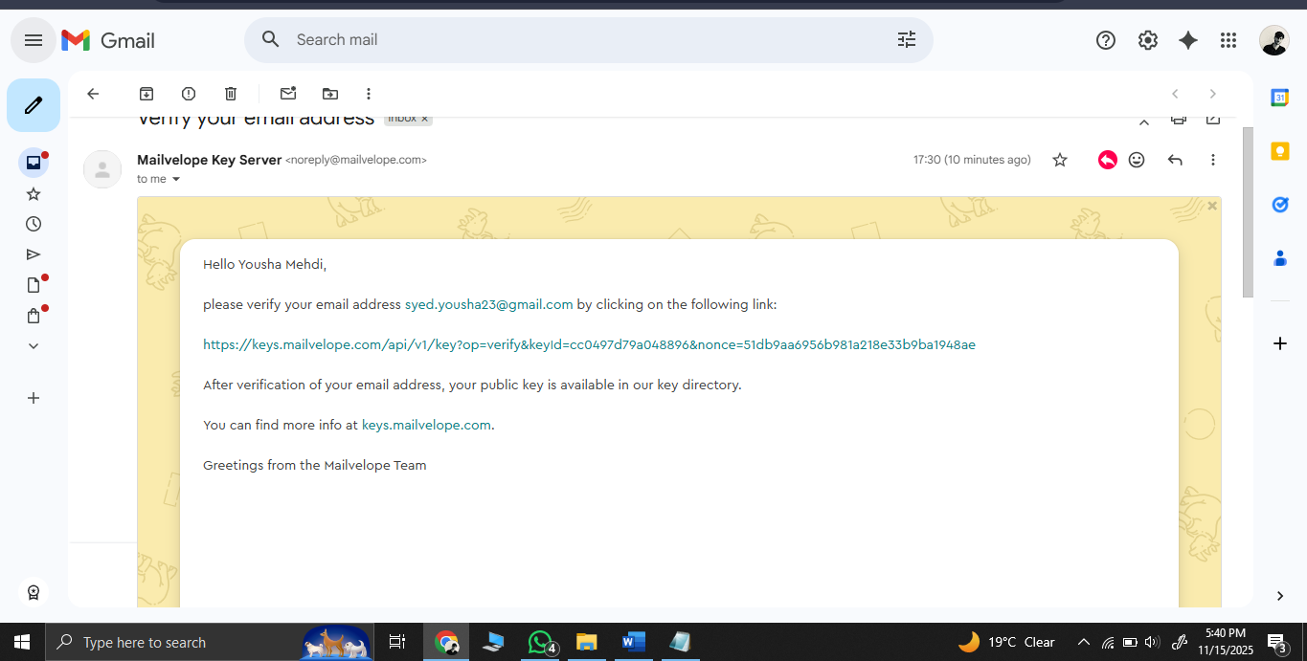

Optional: Enabling Gmail Api for Mailvelope

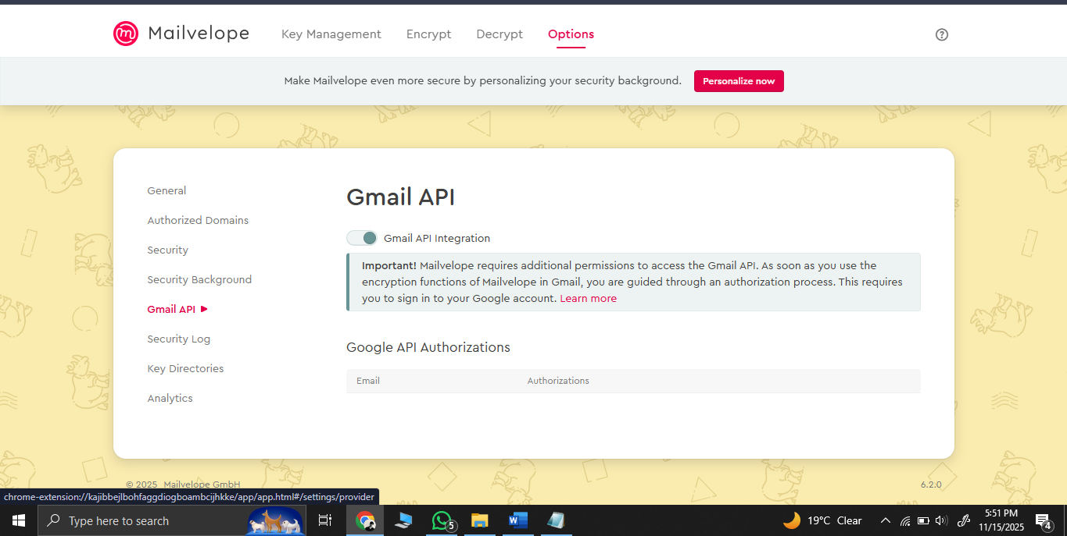

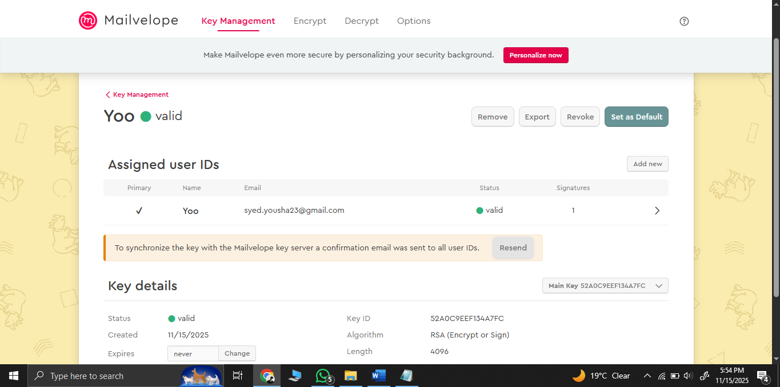

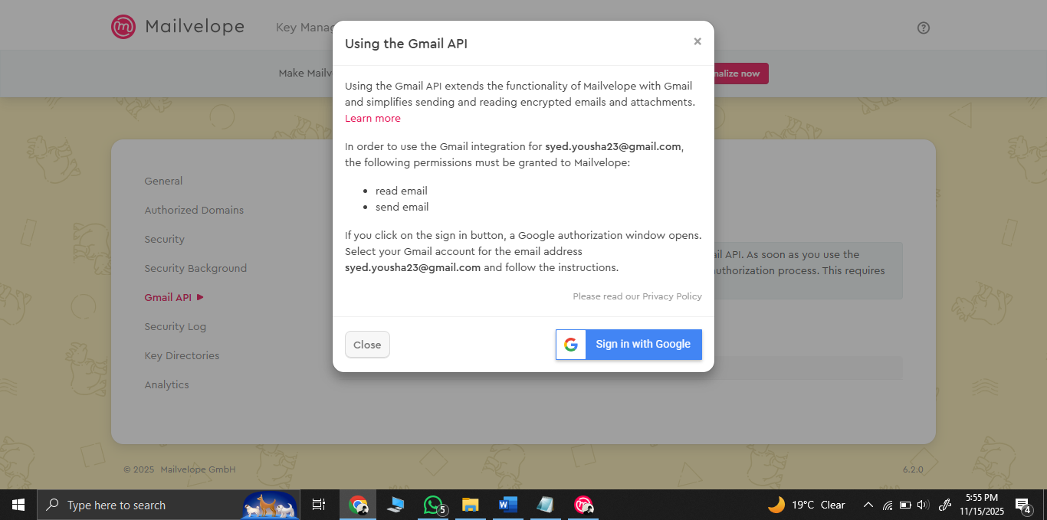

Creating and sending Encrypted Email via Mailvelope from sender (Yousha) to receiver (Yoo)

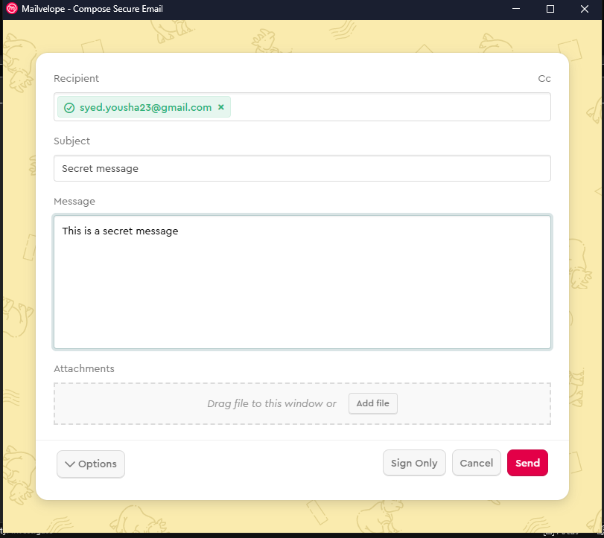

Successfully sent from sender’s side

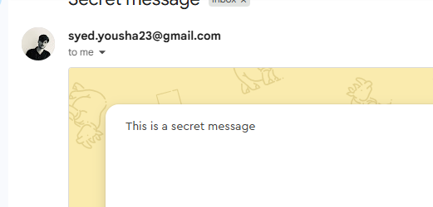

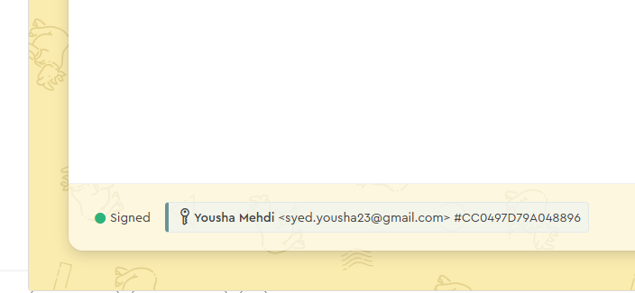
Q1. Conceptual Model Diagram
This flowchart shows end to end flow starting with raw data, blending static and dynamic phases with model testing

Start
Malware Sample Collection
Dynamic Analysis Phase
Feature Extraction
Preprocessing
Features Selection

Machine Learning Classification
Results Test model performance
Stop

Ans 2) Analytical Explanation
Random Forest won because the hybrid features (static like permissions + dynamic like API calls) are complex, high dimensional, and sparse. It uses multiple small decision trees on random feature subsets, catching tricky patterns without assuming features are independent unlike naive bayes which fails when features are linked. Logistic regression is less good because it's linear and weak on sparse data.
The dataset is imbalanced (some families have 1,148 samples while others just one) Simpler models favor big groups. Random Forest fixes this with bagging that is resampling data so trees don’t ignore small families. Naive bayes over weights common features, and logistic regression needs extra tweaks to cope.
Finally, ensemble learners adapt well. Random forest averages many weak trees, reducing errors on noisy, changing malware. It handles evolving threats better than naive bayes and logistic regression both of which needs strict assumptions.

Ans 3 i)
- Static features: Email header (sender, subject), links, attachment type etc
- Dynamic features: Where links go when clicked, scripts that run etc
Ans 3 ii)
Two new risks:
- Privacy leak: scanning personal emails may expose private info
- Too many false alarms: normal emails with links can be blocked

Ans 4 i)

Ans 4 ii)

Ans 5 i)

- Strength: Scalable – used 5 virtual machines to analyze approx 3,339 samples in 8 days
- Limitation: Imbalanced data – big families dominate, small ones get ignored unfortunately

- Improvement: Add fake balanced samples (SMOTE) to train fairly.

Proposed Method = Adversarial training i.e. train model with fake "tricky" malware along with normal data
Ans 5 ii)
Adversarial training makes the model tougher by testing it with fake "attack" samples—like slightly changed malware. This stops small tricks (like altered API calls) from fooling it.
  - Integrity: Keeps detections accurate, so real threats don’t slip through.
  - Trust: You can check how it handles attacks, so users believe it works.
  - Privacy: Train safely on anonymized or devicelocal data—no need to share personal info.
  - Scalability: Once trained, it handles new malware with less retraining, staying fast and light on phones or cloud.
In short, it makes the system stronger and more reliable.

