Information Security Assignment #2

Yousha Mehdi (22k-6007)

The lab environment was set up using Docker. The sqllab_users database was accessed
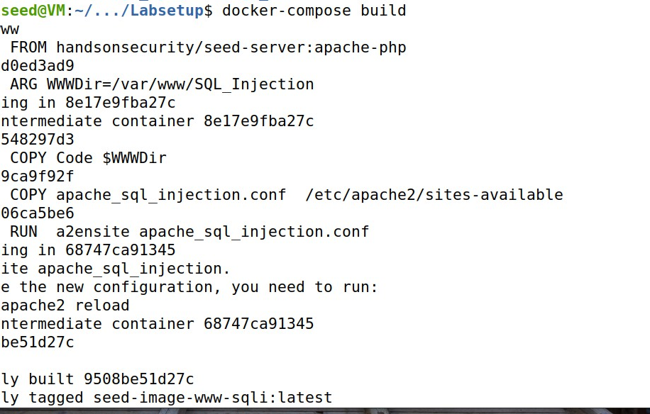
inside the MySQL container. The web application vulnerable to SQL injection was hosted at http://www.seed-server.com.

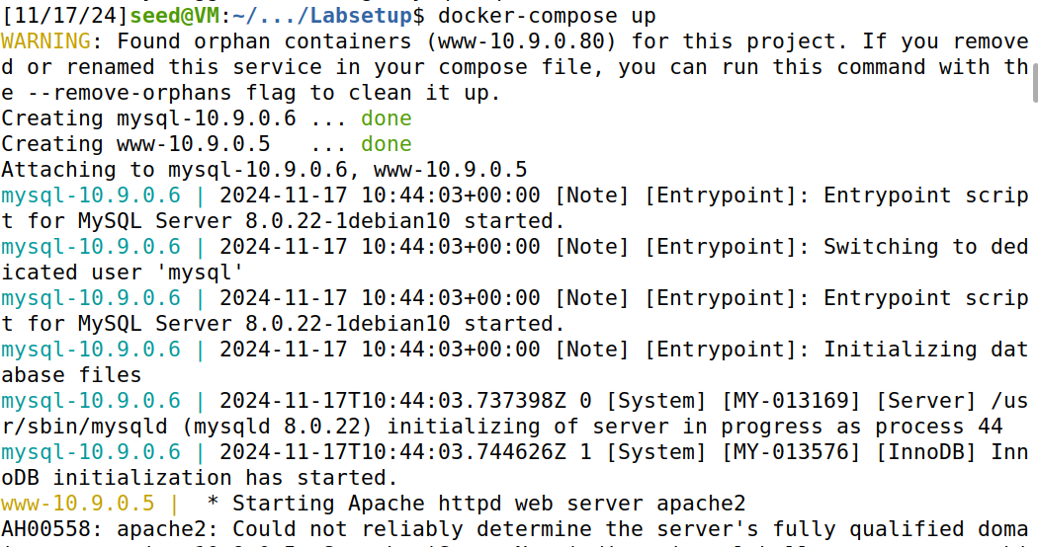

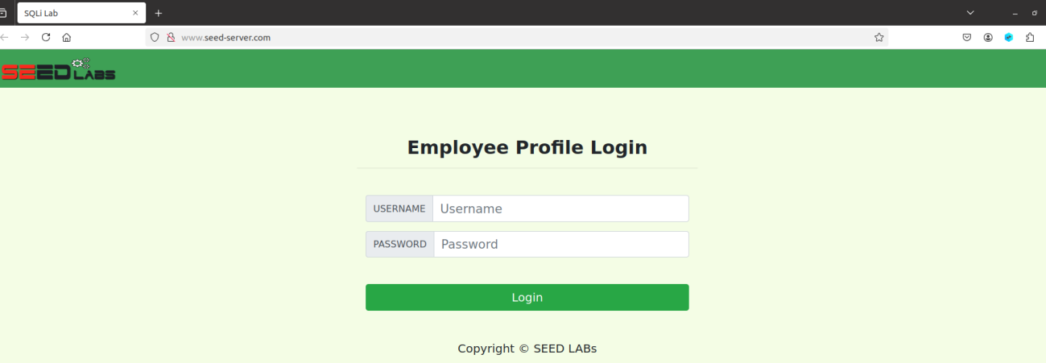
Task 1: Get Familiar with SQL Statements
First build the docker and start it, then execute it.

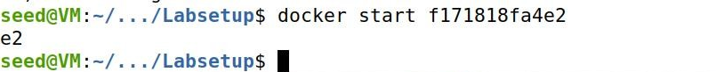

Inside the container login to mysql database. Using the sqllab_users database display all employees data contains in credential table.

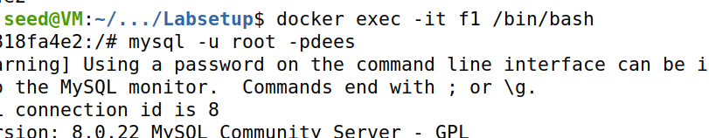
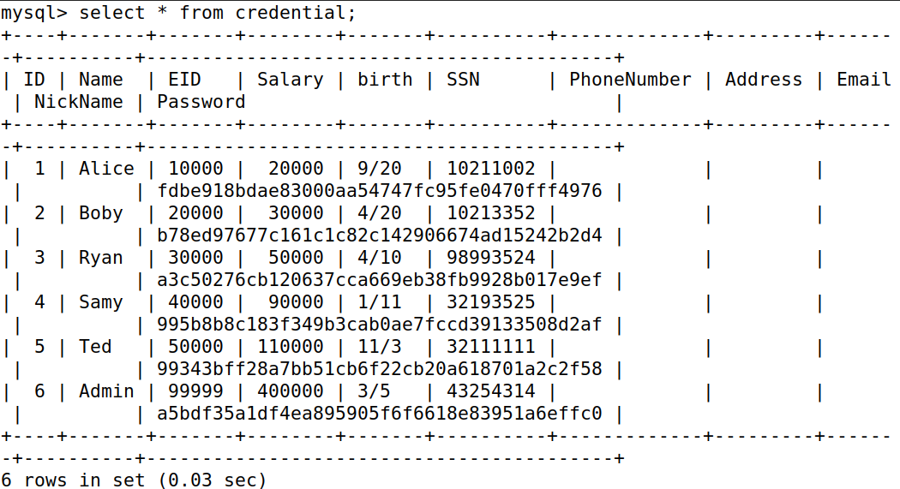

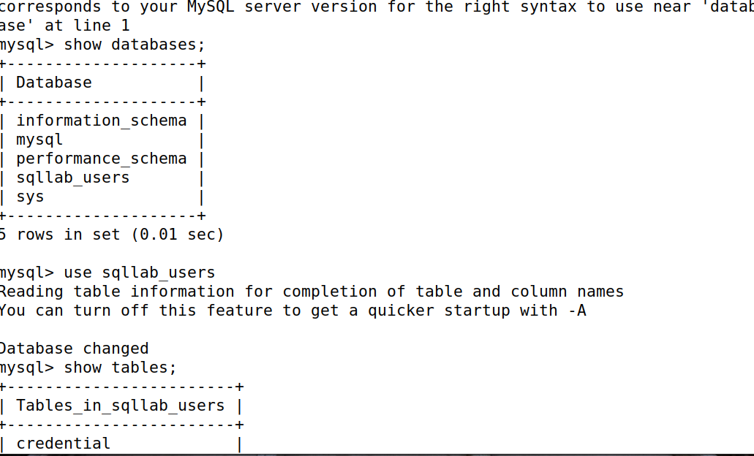

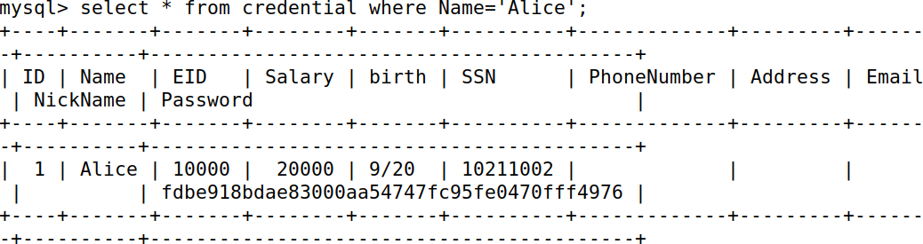
Task 2: SQLInjection Attack on SELECT Statement Task 2.1: SQL Injection Attack from webpage.
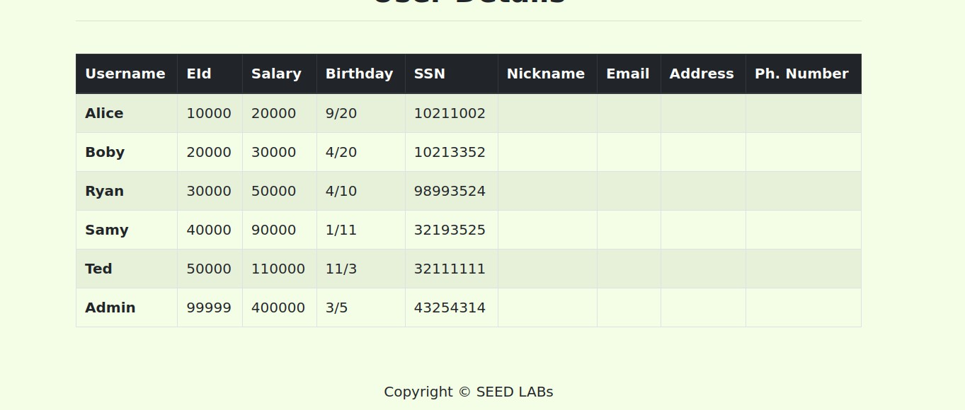
In username option type admin’ # and leaved password blank then click on login, it will login to the administrative. ‘#’ this symbol will comment the rest of the part in URI.
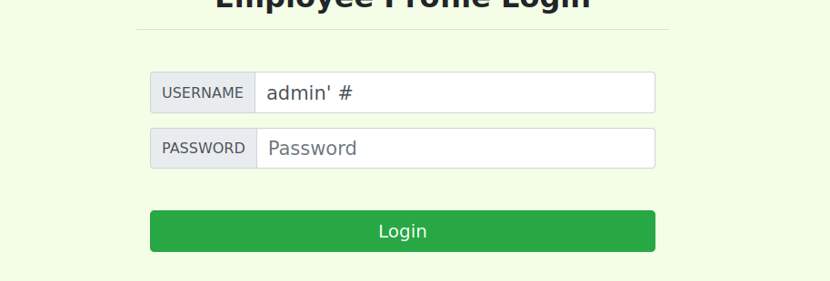

Task 2.2: SQL Injection Attack from command line.

Similarly, in command line injection attack we encode the quotation, white space and
special character and then by using this curl command, getting us bunch of code which we save in temp.html file and then open it.
curl 'http://www.seed-
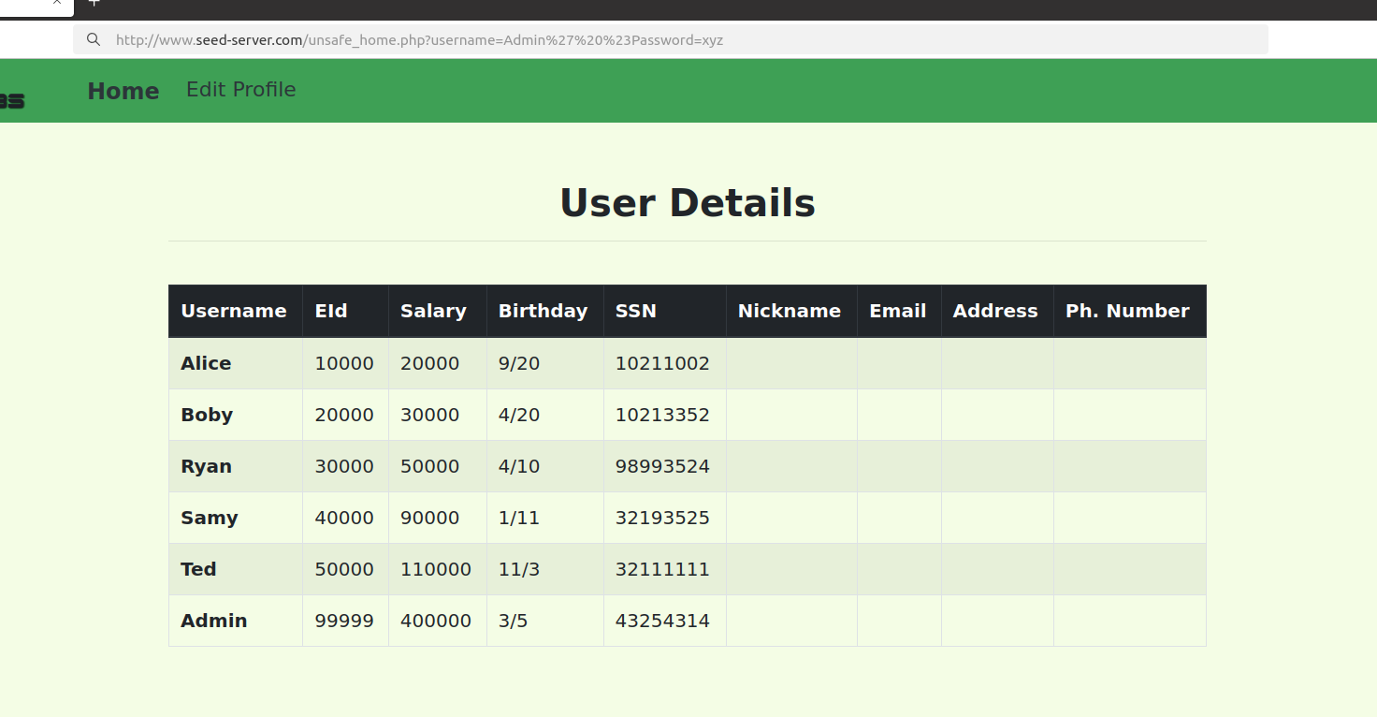
server.com/unsafe_home.php?username=Admin%27%20%23Password=xyz' > temp.html

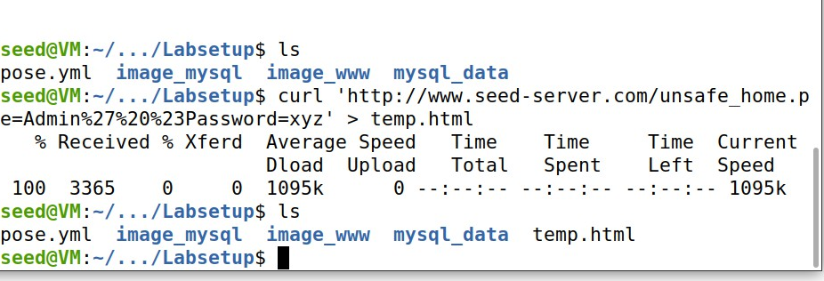

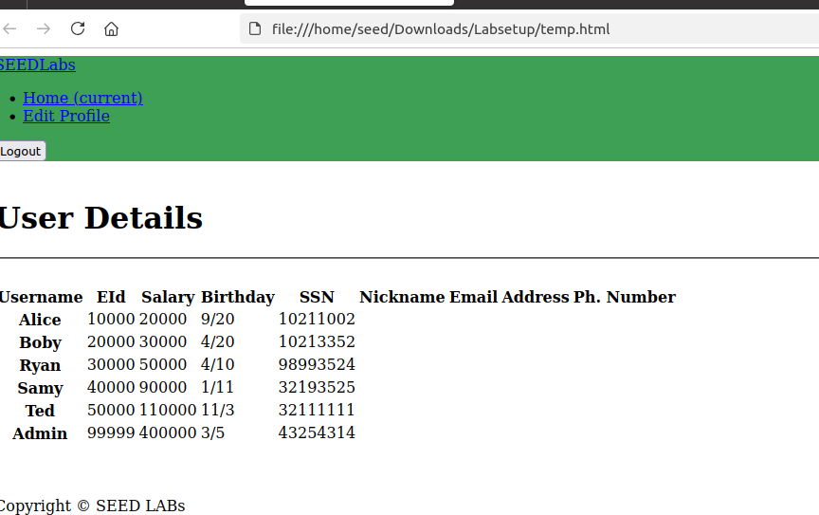

Task 2.3: Append a new SQL statement.
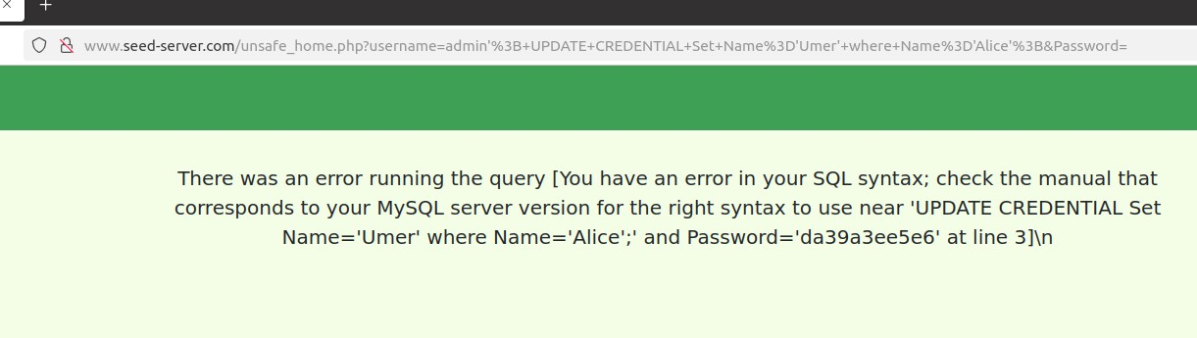
While running two SQL query, it give an SQL Query Error
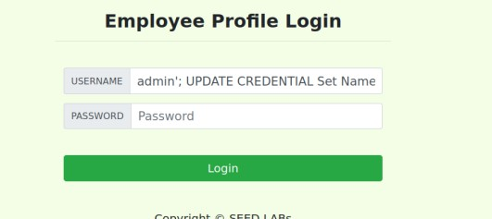

So we conclude that there would be an function used multiquery(). Because in
PHP's mysqli extension, which invokes mysql::query API to handle SQL statements, it

doesn’t support for multiple queries within the same run. Of course, the design of this API attributes to the concern of SQL injection.

Task 3: SQLInjection Attack on UPDATE Statement. Task 3.1: Modify your own salary.
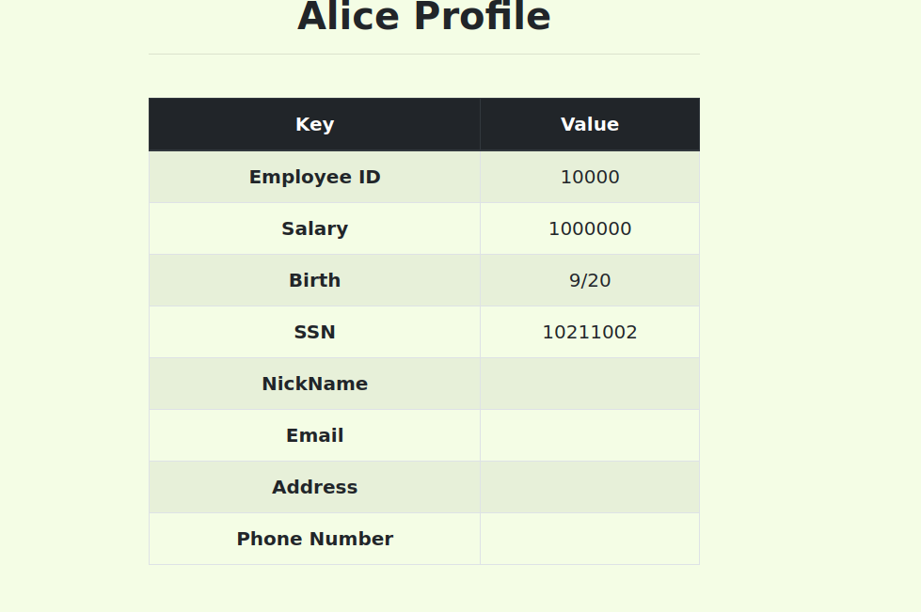
Firstly logon Alice profile, then in name option type ', Salary=’1000000 because its an vulnerability in it which cause to edit salary using SQL injection.

Task 3.2: Modify other people’ salary.
Similarly, as in above task we logon boby profile then update salary to $1.

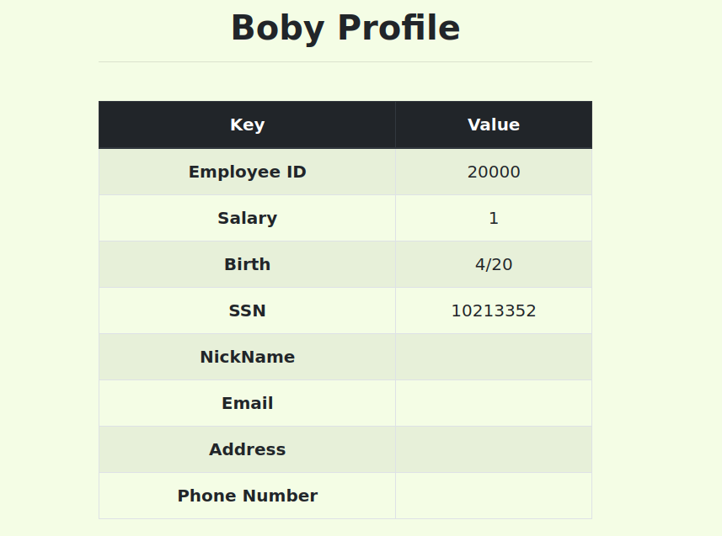

Task 3.3: Modify other people’ password.
we want to change boby password by damdam by using sha1sum we first encode the plaintext into sha1.
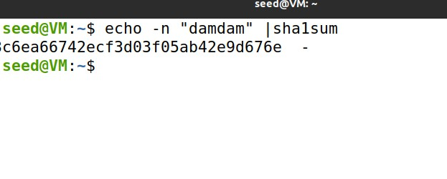
First logon with Alice profile then in nickname section type hacker',

password='5G7be72213c6ea66742ecf3d03f05ab42eGd676e' where name='Boby' #
Save it, and log out. Use Boby new password to sign in where username=Boby and password=damdam.

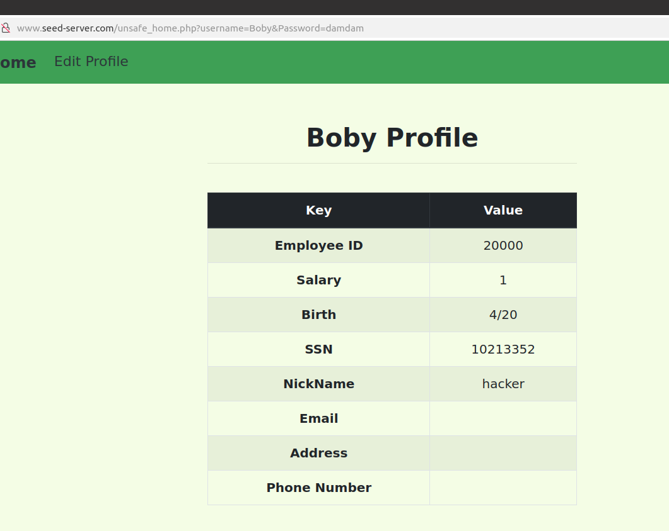

Task 4: Countermeasure — Prepared Statement.
First, we execute the www docker and change directory to unsafe.php file. Then modified the vulnerable code with provided code in manual. Save it and reload the page, do same process to login the Alice profile by SQL injection then it will not give the details of Alice Profile.

