**VALLIAMMAL COLLEGE FOR WOMEN**

DEPARTMENT OF COMPUTER SCIENCE

TEAM ID: SWTID1741250353149964

TEAM SIZE: 5

TEAM LEADER: SYED ALI AASIN J

TEAM MEMBER1: SUNDARAKAMATCHI I

TEAM MEMBER2: SWETHA R

TEAM MEMBER3: SWETHA S

TEAM MEMBER4: SWETHA S

GITHUB LINK(INCLUDES CODING AND DOCUMENTATION):

DRIVE LINK(INCLUDE DEMO VIDEO):

**CookBook**

**Introduction:**

CookBook is a revolutionary web application designed to change the way you discover, organize, and create recipes. It caters to both novice and professional chefs, offering a user-friendly interface, robust features, and a vast collection of inspiring recipes.

**Description:**

Welcome to the forefront of culinary exploration with CookBook!

Our cutting-edge web application is meticulously crafted to transcend the boundaries of culinary experiences, catering to the tastes of both passionate cooking enthusiasts, and seasoned professional chefs. With an emphasis on an intuitive user interface and a robust feature set, CookBook is poised to revolutionize the entire recipe discovery, organization, and creation process.

From those taking their first steps in the kitchen to seasoned professionals, CookBook embraces a diverse audience, nurturing a dynamic community united by a shared passion for the art of cooking. Our vision is to reshape how users interact with recipes, presenting a platform that not only sparks inspiration but also fosters collaboration and sharing within the vibrant culinary community.

Embark on this gastronomic journey with us, where innovation seamlessly intertwines with tradition. Every click within CookBook propels you closer to a realm of delicious possibilities. Join us and experience the evolution of recipe management, where each feature is meticulously crafted to offer a glimpse into the future of culinary exploration. Elevate your culinary endeavours with CookBook, where every recipe becomes an adventure waiting to be discovered and savoured.

**Technical** **Architecture:**

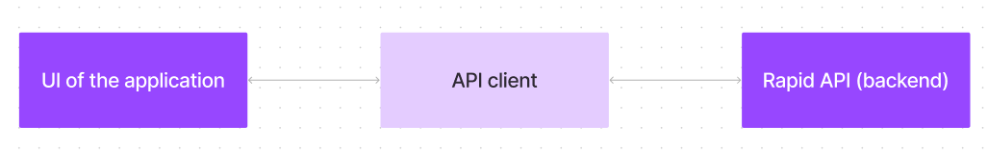

The user experience starts with the CookBooks web application's UI, likely built with a framework like React or Vue.js for a smooth, single-page experience. This UI interacts with an API client specifically designed for CookBooks. This client handles communication with the backend, but with a twist: it leverages Rapid API, a platform providing access to various external APIs. This suggests CookBooks might integrate external data feeds or functionalities through Rapid API, enriching the user experience without building everything from scratch.

**Project** **Goals** **and** **Objectives:**

The primary goal of CookBook is to provide a user-friendly platform that caters to individuals passionate about cooking, baking, and exploring new culinary horizons. Our objectives include:

• **User-Friendly** **Experience:** Create an interface that is easy to navigate, ensuring users can effortlessly discover, save, and share their favourite recipes.

• **Comprehensive** **Recipe** **Management:** Offer robust features for organizing and managing recipes, including advanced search options.

• **Technology** **Stack:** Leverage modern web development technologies, including React.js, to ensure an efficient, and enjoyable user experience.

**Features** **of** **CookBooks:**

✓ **Recipes** **from** **the** **MealsDB** **API**: Access a vast library of international recipes spanning diverse cuisines and dietary needs.

✓ **Visual** **recipe** **browsing:** Explore recipe categories and discover new dishes through curated image galleries.

✓ **Intuitive** **and** **user-friendly** **design:** Navigate the app effortlessly with a clean, modern interface and clear navigation.

✓ **Search** **feature:** various dishes can be accessed easily through the search feature.

**PRE-REQUISITES**:

Here are the key prerequisites for developing a frontend application using

React.js:

✓ **Node.js** **and** **npm**:

Node.js is a powerful JavaScript runtime environment that allows you to run JavaScript code on the local environment. It provides a scalable and efficient platform for building network applications.

Install Node.js and npm on your development machine, as they are required to run JavaScript on the server-side.

• Download: https://nodejs.org/en/download/

✓ **React.js**:

React.js is a popular JavaScript library for building user interfaces. It enables developers to create interactive and reusable UI components, making it easier to build dynamic and responsive web applications.

Install React.js, a JavaScript library for building user interfaces.

• Create a new React app:

npx create-react-app my-react-app Replace my-react-app with your preferred project name.

• Navigate to the project directory:

cd my-react-app

• Running the React App:

With the React app created, you can now start the development server and see your React application in action.

• Start the development server:

npm start

This command launches the development server, and you can access your React app at http://localhost:3000 in your web browser.

✓ **HTML,** **CSS,** **and** **JavaScript**: Basic knowledge of HTML for creating the structure of your app, CSS for styling, and JavaScript for client-side interactivity is essential.

✓ **Development** **Environment**: Choose a code editor or Integrated Development

Environment (IDE) that suits your preferences, such as Visual Studio Code.

• Visual Studio Code: Download from https://code.visualstudio.com/download

To clone and run the Application project from Google drive:

Follow below steps:

**Install** **Dependencies:**

• Navigate into the cloned repository directory and install libraries:

cd recipe-app-react

npm install

✓ **Start** **the** **Development** **Server**:

• To start the development server, execute the following command:

npm start

**Access** **the** **App:**

• Open your web browser and navigate to http://localhost:3000.

• You should see the recipe app's homepage, indicating that the installation and setup were successful.

You have successfully installed and set up the application on your local machine. You can now proceed with further customization, development, and testing as needed.

**Project** **structure:**

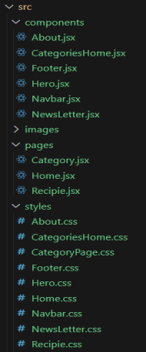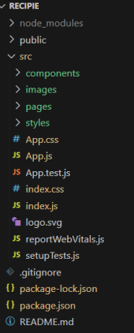

In this project, we’ve split the files into 3 major folders, *Components,* *Pages* *and* *Styles.* In the

pages folder, we store the files that acts as pages at different url’s in the application. The components folder stores all the files, that returns the small components in the application. All the styling css files will be stored in the styles folder.

**Project** **Flow:**

**Milestone** **1:** **Project** **setup** **and** **configuration.**

• **Installation** **of** **required** **tools**:

To build CookBook, we'll need a developer's toolkit. We'll use React.js for the interactive interface, React Router Dom for seamless navigation, and Axios to fetch news data. For visual design, we'll choose either Bootstrap or Tailwind CSS for pre-built styles and icons.

Open the project folder to install necessary tools, In this project, we use:

* React Js
* React Router Dom
* React Icons
* Bootstramp/tailwind
* css
* Axios

• For further reference, use the following resources

o https://react.dev/learn/installation

**Milestone** **2:** **Project** **Development**

❖ Setup the Routing paths

Setup the clear routing paths to access various files in the application.

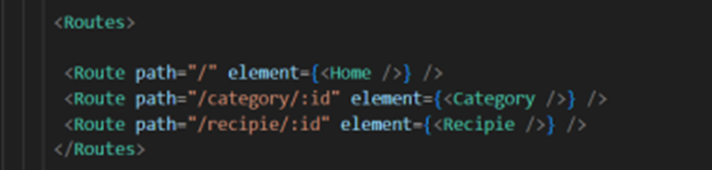

❖ Develop the Navbar and Hero components

❖ Code the popular categories components and fetch the categories from ***themealsdb*** Api.

❖ Also, add the trending dishes in the home page.

❖ Now, develop the category page to display various dishes under the category.

❖ Finally, code the recipe page, where the ingredients, instructions and a demo video will be integrated to make cooking much easier.

**Important** **Code** **snips:**

➢ **Fetching** **all** **the** **available** **categories**

Here, with the API request to Rapid API, we fetch all the available categories.

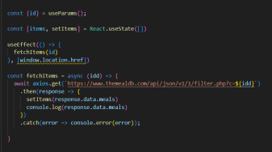

This code snippet demonstrates how to fetch data from an API and manage it within a React component. It leverages two key functionalities: state management and side effects.

**Processing** **API** **Response:**

The .then method is chained to the axios.get call to handle a successful response from the API. Inside the .then block, the code retrieves the categories data from the response and updates the React component's state using the setCategories function. This function, associated with the useState hook, allows for modification of the categories state variable. By calling setCategories(response.data.categories), the component's state is updated with the fetched list of meal categories.

➢ **Fetching** **the** **food** **items** **under** **a** **particular** **category**

Now, with the API request, we fetch all the available food items under the certain category.

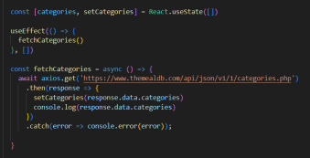

This React code snippet manages data fetching from an API.

● The fetchCategories function is an asynchronous function responsible for handling the API interaction. This particular endpoint presumably returns a JSON response containing a list of meal categories.

● Inside the .then block, the code retrieves the categories data from the response and updates the React component's state using the setCategories function.

● An optional error handling mechanism is incorporated using the .catch block. This block is designed to manage any errors that might arise during the API request.

➢ **Fetching** **Recipe** **details**

With the recipe id, we fetch the details of a certain recipe.

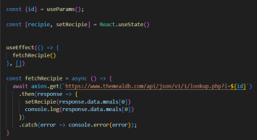

This React code manages fetching recipe data from an API and storing it within a state variable.

● The fetchRecipie function is an asynchronous function responsible for handling the API interaction.

● The code snippet employs the .then method, which is chained to the axios.get call, to handle a successful response from the API. Inside the .then block, the code retrieves the first recipe from the data.meals array in the response and updates the React component's state using the setRecipie function.

● An optional error handling mechanism is incorporated using the .catch block. This block is designed to manage any errors that might arise during the API request.

**User** **Interface** **snips:**

➢ **Hero** **components**

The hero components of the application provide a brief description about our application and a button to view more recipes.

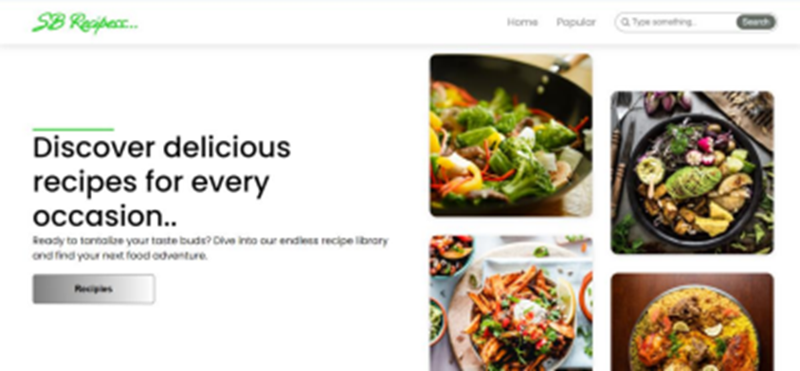

➢ **Popular** **categories**

This component contains all the popular categories of recipes..

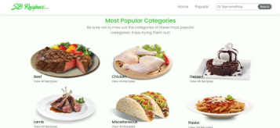

➢ **Trending** **Dishes**

This component contains some of the trending dishes in this application.

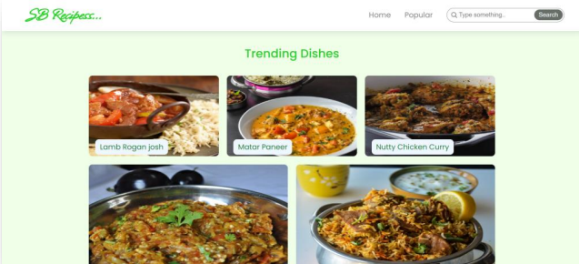

* **News** **Letter**

The news letter component provides an email input to subscribe for the recipe newsletters.

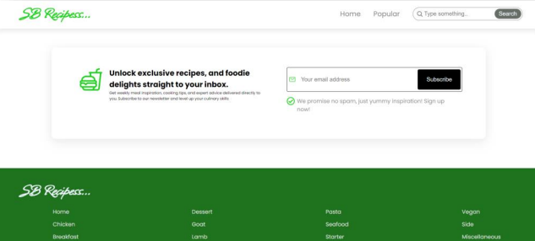

➢ **Category** **dishes** **page**

The category page contains the list of dishes under a certain category.

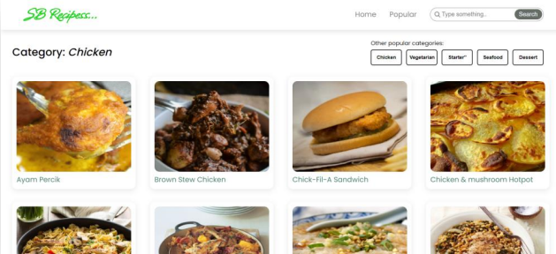

Project demo link: <https://drive.google.com/file/d/1khMJkccySgKyqRaEZgCpgDACHi572Llj/view?usp=sharing>