Feasibility Study

Happy Home

Team 13 Legs Production

Abdullah Amjad AE1980

Study Assignment

FF Ticorporate Demo Lab 1

10/09/2024

Business Information Technology

Contents

1 What is Feasibilty Study 2

2 Executive Summary 2

3 Technological Considerations 2

2 Existing Marketplace 2

2 Executive Summary 2

References 3

Appendices 4

Appendix 1. Title of the Appendix 4

Appendix 2. Title of the Appendix 5

Figures

Figure 1. Title of the figure, no reference 2

Tables

Table 1. Title of the table, no reference 7

Table 2. Title of the table, no reference 11

# What is feasibility study

A feasibility study aims to assist decision-makers in assessing the likelihood of success for a proposed project or investment. In this document we are going to assess the possibility in finishing the project with the end goal of releasing a working game into a Steam by 14th of December.

# Executive Summary

The feasibility study for Happy Home assesses the project's ability to meet its goal of delivering a fully playable horror game by December 14th. The game will be developed on the PC platform using Unity, leveraging the team's experience with this engine. The key objectives are to create an engaging narrative-driven horror game that combines visual novel elements with exploration mechanics. The project is primarily student-driven, with all major roles filled by team members.

The study covers technological considerations, including the use of GitHub for version control, Trello for task management, and various tools for graphics and audio production. The game's primary marketplace is Steam, with the possibility of additional platforms such as Epic Games and itch.io for broader distribution and beta testing. Competitor analysis and targeted marketing strategies will help position Happy Home effectively in the market.

The schedule anticipates a completed demo by late September, followed by testing and polish in time for a November release. While the project is funded by the school and not expected to generate revenue, it offers significant learning experiences and portfolio development for the team.(by ChatGPT)

# Technological Considerations

The platform we selected is PC since we have all have laptops and worked on PC games before and our game engine is Unity by default since we are all fairly acquainted with it, it fits our scope and everyone has some experience with one or the other part of it. Our main method of communication is Discord with addition to Microsoft Teams, For the project we are using Github for version control, Trello for keeping track of our tasks and Entity Relation Diagram(ERD) for keeping track of project on a broader spectrum. For Programing we eill be using Visual Studio. For Graphics and 2D art we are using ProCreate and Photoshop as we are going for a specific vibe our team is determined to make everything ourselves but if that is not the case then Assets store is also in consideration. Audio team is using SoundTrap to produce the background music as well as sound effects that we are going to use in the game. Design for the game is being documented in the relative Game design documents, project planing and our discord server. This will help us set a straight path of development.

# Existing Marketplace

The game will be released on Steam and the initial demo will be released for free for people to experience a masterpiece from 13 Legs Productions. We are considering distributing it from other platforms as well like Epic Games , GOG and itch.io. Itch.io is an excellent platform for beta testing due to its community focused environment, which encourages detailed feedback and bug reports. The feedback from itch.io will help us fine-tune the game and ensure a smooth and polished experience upon release.

Our game is unique but taking into consideration of area time and size of the project we can assume that other ticorporate teams are our competitors not direct competitors by analyzing their strengths weaknesses and player reviews we can understand our market expectations

1. **Marketing strategy**

Our marketing strategy for Happy Home focuses on building a strong community presence both local and online. Since we all are a game production student and are in a lot of communities we can promote our game locally for online we have many options for the moment we will start sharing to development process on Instagram to get the people interested this will include sharing gameplay clips, concept art, screen shots and overall relevant information to peak people’s interest.

Since the success of the game fully depends on marketing strategy we will be going through these steps to ensure that we have a good strategy.

* 1. **Market research**

We will identify our target audience, including demographics, preferences, and behaviors. We will also analyze competitors to understand their strengths and weaknesses.

* 1. **Pre-launch Teasers**

We will create teaser trailers, screenshots, and social media posts to generate interest and anticipation before the game's release. We are going to assess and analyze which platforms to utilize, for example YouTube, Twitter, Instagram, and Facebook to reach potential players.

* 1. **Social media marketing**

We are going to establish and maintain active social media profiles dedicated to your game. This will mean that we will post regularly with engaging content, such as gameplay snippets, concept art, and behind-the-scenes insights. To engage audience, we will use appropriate hashtags and encourage use-generated content.

1. **Required staffing**

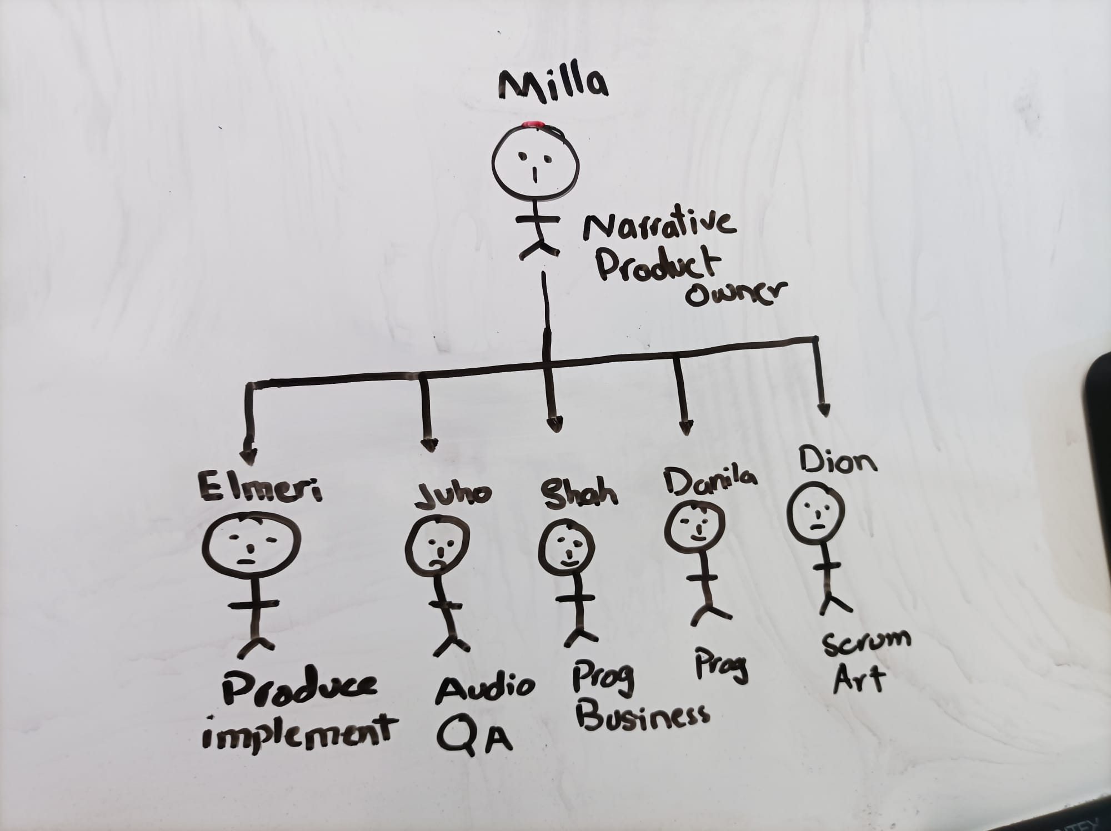

The staff we have for this project is: Product owner, Scrum Master, Business lead, Quality assurance lead, implementation lead, Narrative lead, Background/UI Artist, Programming Lead, Programing support, Graphic Designer, Sound/Music lead, Producer (timetables, publishing). At the moment we do not need any more staff members.

1. **Schedule and timeline**

According to calendar plan we will be completing the game in the 3rd week of November which will give us time to test and polish the final product. we are and will be working 5-6 hours daily some us work overtime and will be working on weekends as well when the workload increases it is typically 5 days a week depending on the their schedule. We do not have any strict limit it is agreed that rest days can be taken if you work late or do extra work on weekends. On Mondays we have whole team meeting in which we set goals and recognize what needs to be done setting priority and time and on Fridays we again have a meeting to see what we have done and what needs more time.

1. **Project Financials**

This refers to the financial aspects and considerations associated with a specific project. These financials are a crucial component of project planning and management, as they provide insights into the financial feasibility, costs, revenue projections, and overall financial health of the project. We do not have revenue, costs or anything revolving around financial aspects, so i am going to talk about the health of the people and the project.

If we were to have a budget we would have to take into account the salaries, materials, equipment, software and any other resources needed for the completion of the project, but all of these are provided by the school. Our salary is getting a free product out to put in our portfolios and to get a valuable learning experience of a simulated work environment.

Sadly we will not be producing any revenue. But we could say that we are “funded” by the school and it is investing in our futures.

1. **Finding and recommendations**

**Project Overview:**  
*Happy Home* is a narrative-driven horror game that combines visual novel elements with exploration mechanics. The game preogresses through the cutscenes, text base choices, other game mechanics and exploration.

**Technological Considerations:**  
The development is centered on the PC platform using the Unity engine, which aligns with the team's familiarity and the scope of the project. Key tools include GitHub for version control, Trello for task management, Discord and Microsoft Teams for communication, ProCreate and Photoshop for graphics, and SoundTrap for audio production. Game design and planning are documented in detail to guide development.

**Marketplace and Competitors:**  
The primary marketplace for *Happy Home* will be Steam, with the initial demo released as per Jamk requirments it will be free and to attract players and gather feedback. Additional platforms like Epic Games, GOG, and itch.io are also considered for broader distribution and beta testing if we decide to continue building the game. Competitor analysis focuses on similar horror games and narrative-driven titles to understand player expectations and identify market gaps.

**Marketing Strategy:**  
Our marketing is based on engaging with both local and online gaming communities since we are all in game development and in communities, utilizing social media, especially Instagram, to create visually appealing content such as concept art, gameplay clips, and behind-the-scenes updates. Most of the marketing will be done by ourselves talking about the game with people.

**Required Staffing:**  
The project requires roles including Game Designer, Programmer, Art Lead, Scrum master, Narrative designer, Implementor, Producer and Sound Designer. All key roles are filled by the team since we are multi talented people.

**Schedule and Timeline:**  
According to current schedule the demo should be complete by the 3rd week of september which gives us enough time to test and release the game. The development schedule involves a blend of focused work phases ("crunch time") to meet critical milestones, followed by more relaxed periods to ensure quality and team well-being. Weekly meetings are held to set goals and review progress.

**Project Financials:**  
There are no specific revenue projections or financial costs for the project, as it is funded by the school. The focus is on providing learning experiences and valuable portfolio material for the team that is why our team will be focusing on building our portfolio.

1. **Recommendations:**
2. **Continue Market Research:** Stay informed about current market trends and competitors to adapt the game's features and marketing tactics.
3. **Leverage Social Media:** Maintain an active presence on Instagram and consider expanding to other platforms to reach a broader audience.
4. **Stick to the Schedule:** Adhere to the development timeline to avoid delays and ensure timely completion.
5. **Maximize Team Resources:** Utilize the strengths of the existing team and the freelance artist to ensure efficient development.
6. **Health and Well-being:** Ensure team members maintain a healthy work-life balance, especially during intense work phases, to prevent burnout.
7. **Documentation:** Keep comprehensive documentation of project progress, key decisions, and outcomes for future reference and learning.
8. **Continuous Evaluation:** Regularly review project milestones and adjust strategies based on evolving project needs and market dynamics.