Nodejs Application

# Link of hosted web application

<http://localhost:3000/employee>

Introduction

The project is built in NodeJS using mongo database. The project is about the real-life problem

Entering the employee info and saving it in database and also it stores the item info and show

The order details that have been placed. The project is in NodeJS with complete MVC.

This project was made to solve the real-life problems like a company wants all the record of there

Employees and in this project that problem is solved by giving the information of the employee and

Saving it in Mongo database. Also like sometimes we order something and want to see what we order

So this project also stores the detail of the item.

System Overview

# Frontend:

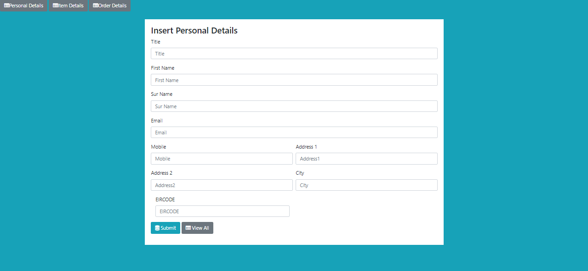

This is the employee form where employee enters all the details and then press submit and the record is saved in the database and by clicking on the view all button you can see all the employees details.

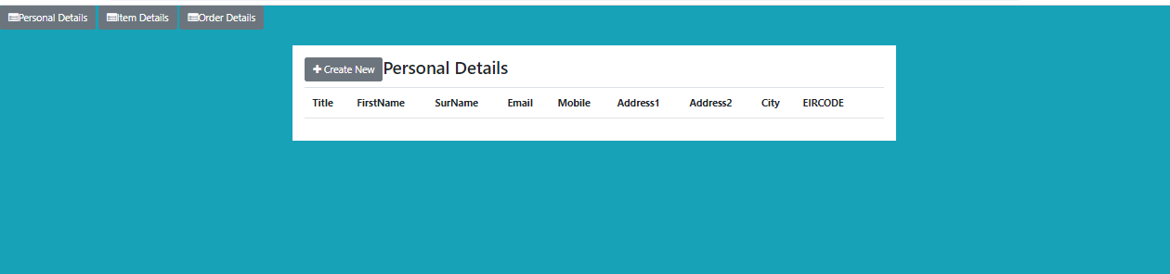

Here you can see all of your employees after they are stored in the database and the button on the above create new will take you the insert record form.

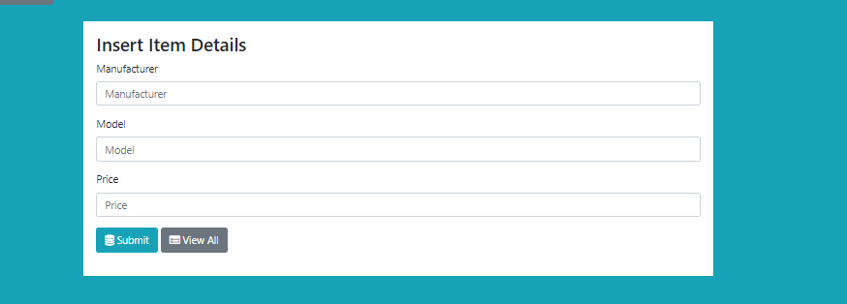

Here you can enter the item details and submit it in database and you can view them.

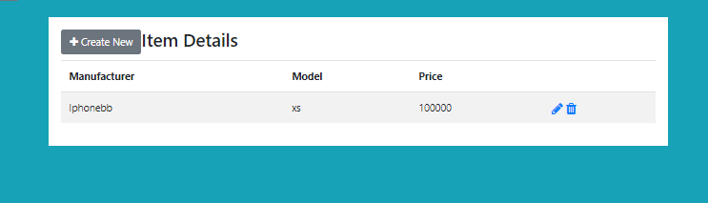

After clicking on view all on the previous screen you are redirected to this page where you can see the item that you have entered and here you can delete or update the item.

After clicking on the pen icon you can update the record below screen shows the updation.

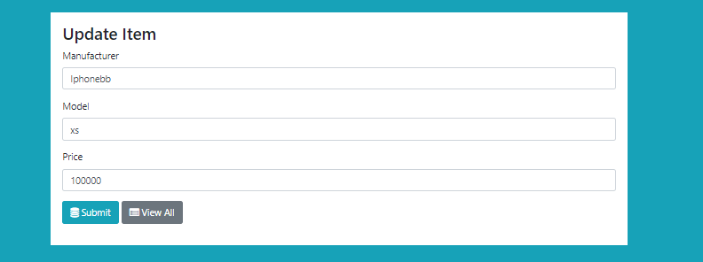

Here you can update your item detail and after updating it will take you the item details page with the updating value.

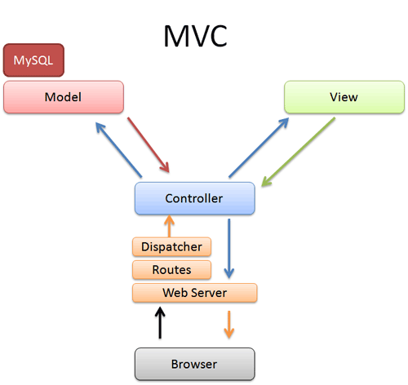

The main thing that links all the things in the project is MVC . The Diagram above shows how MVC interacts with each other and with the browser.

# Database Connection:

The below code is for the connection with the database as I have used Mongo Database so you can see the code of how your application connects with the database.

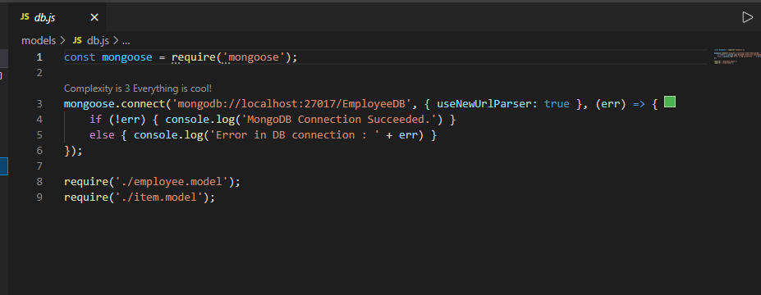

# Models:

This is the model file of employee in this file you define the types of input that will be taken from the form on the website like Title accepts the input of String type.

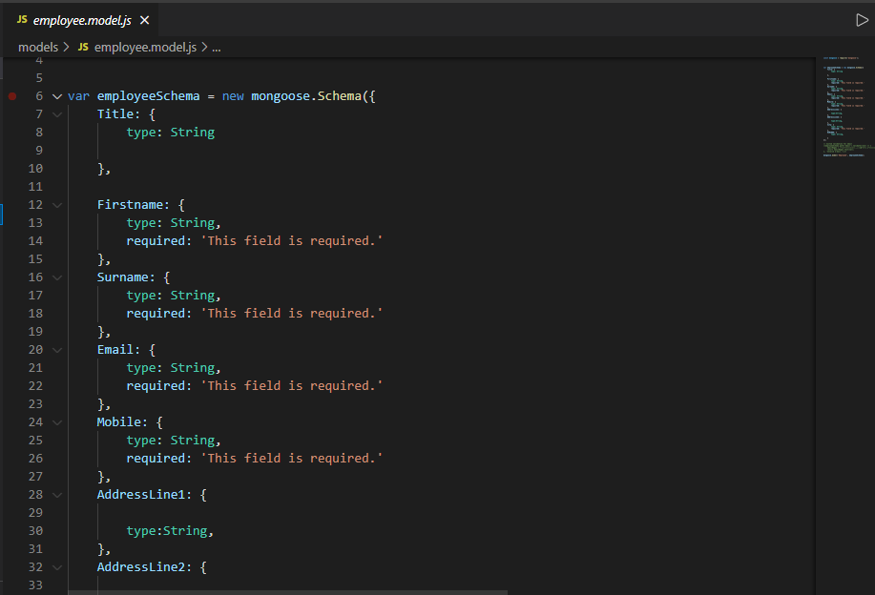

# Controllers/Crud :

In Controllers you define the functions that you are using in your project like below in pic you can see the insert function here you also defines the URL of where your page should go after inserting the record like I have given path (**res.render(“employee/addOrEdit”** )

I have Applied **Crud** Operation in this project

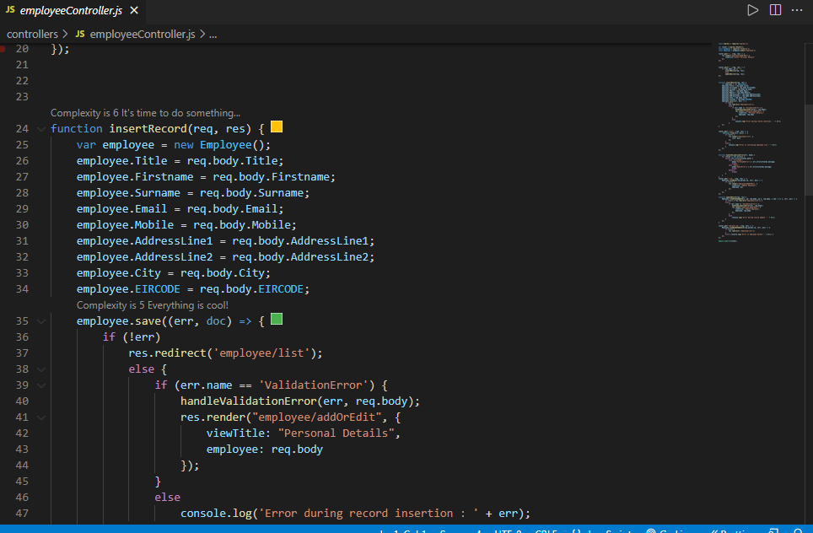

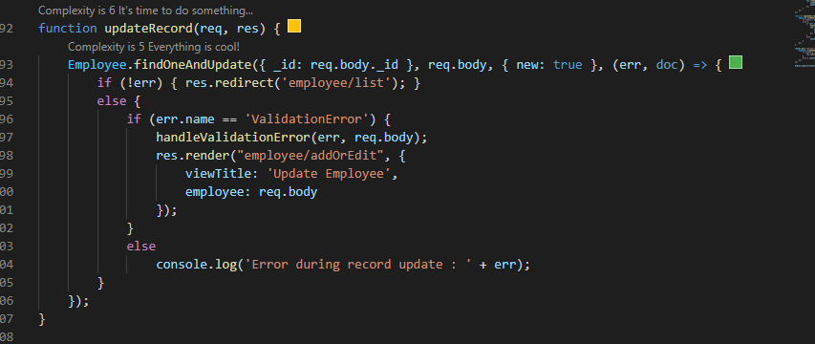

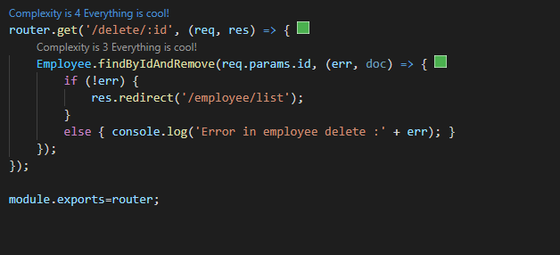

# Views:

In views you provide all of your web content/User Interface like how your application will be on web.

You provide all the html CSS and forms etc. in views section the extension of the file used in views is .hbs

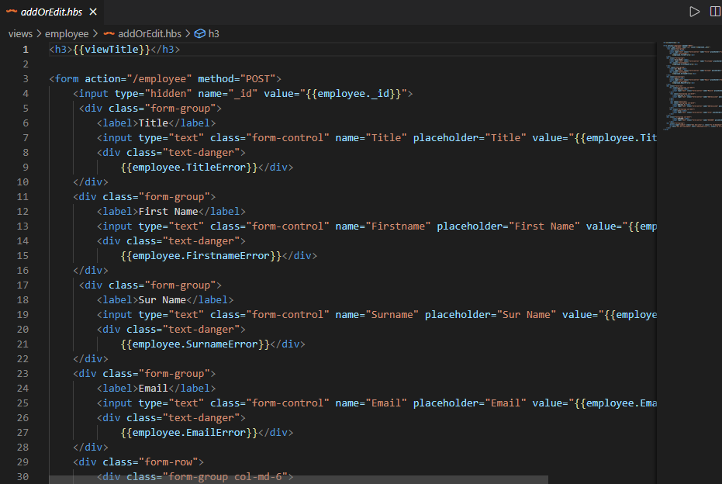

# Database:

Database used in this project is MongoDB. MongoDB is a source-available cross-platform document-oriented database program. Classified as a NoSQL database program, MongoDB uses JSON-like documents with optional schemas

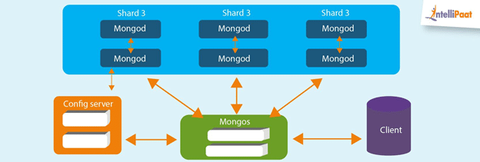

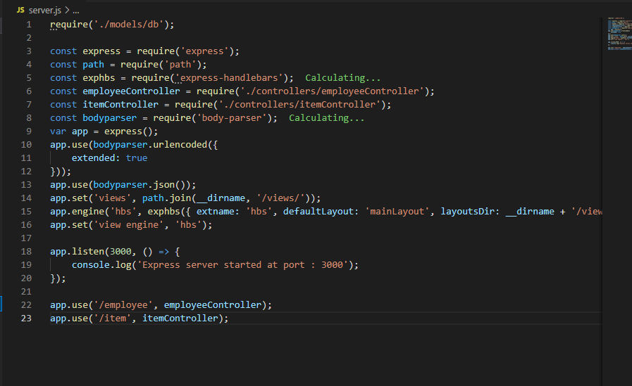

The image below is the file server.js it is the main file of your app where you define all your model, controller, views. Your application server port on which your application will work on the browser.

You have to run this file in the terminal by writing node server.js

As the file name is server.js

Key Design Decisions

# Database Design:



Like I have shown you earlier in the image below last two lines are where the data is imported from the models and used to be stored in the database.

Name of the database is EmployeeDB that is written in the URL of the connection of mongoose.

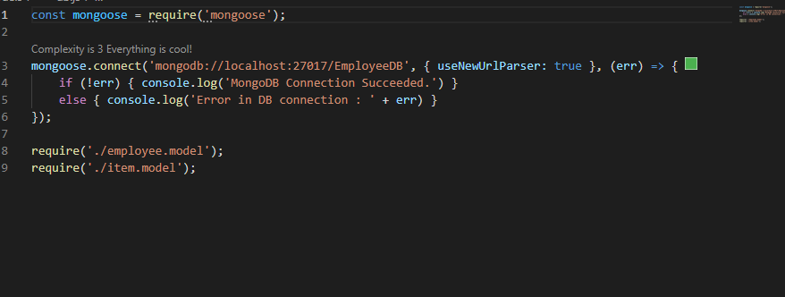

The below is the interface of the mongo dB

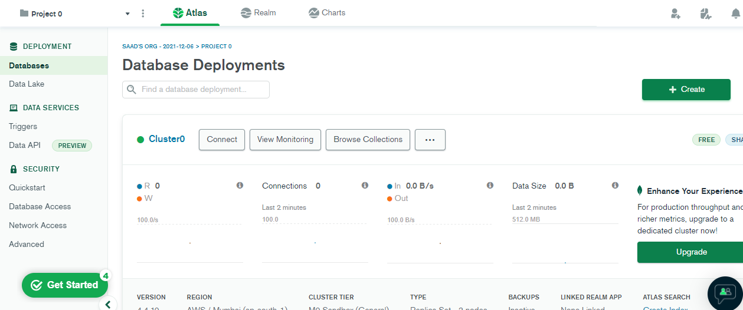

# Security and Scalability:

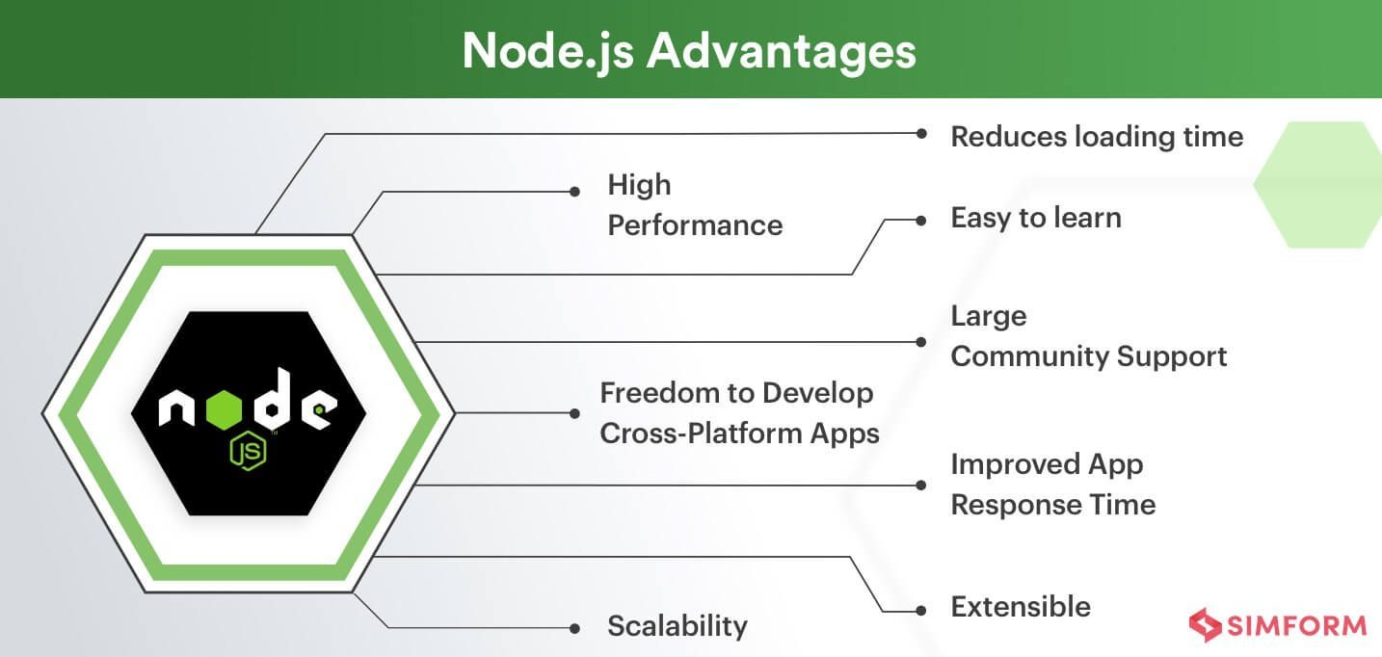

Above are the features of the Node JS and how it is so efficient.

Also, the project that I have built is Single Page Application (SPA).

It is secure that there are ports assign for your server that is different and it provides security for that.

Conclusion and Reflection

As this application is useful for entries the record and all the item details with the proper database connection it performs all the operations that a user can perform.

It includes

1. Insertion
2. Updation
3. Deletion
4. Reading

By creating this project, I have explored the MVC and Node JS and learn how the effectiveness can be bring in an application and how to build a single page application and it will help me a lot in future

And by this project I have perform CRUD operations and I know well know about these operations.