# Department of Computing

**Abdulrab 369946 BESE12-A**

# MATH 333: Numerical Analysis

# Class: BESE-12

# Lab 3: Bisection Method Using Function

# Date: February 9, 2022

# Lab Engineer: Syed Muhammad Ali Musa

# Lab 3: Bisection Method Using Function

**Introduction**

MATLAB, which stands for MATrix LABoratory, is a state-of-the-art mathematical software package, which is used extensively in both academia and industry.

**Objectives**

The purpose of this lab is to get familiar with Bisection Method

**Tools/Software Requirement**

Matlab R2016a

**Description**

Function files, on the other hand, play the role of user defined commands that often have input and output. You can create your own commands for specific problems this way, which will have the same status as other MATLAB commands.

create m file and named it as log3.m. The contents of file should be:

function [a] = log3(x)

%[a] = log3(x) - Calculates the base 3 logarithm of x.

a = log(abs(x))./log(3);

% End of function

Go to console window and run log3(5)

Every MATLAB function begins with a header, which consists of the following :

* The word function.
* The output(s) in brackets, (the variable a in the above example)
* The equal sign.
* The name of the function, which must match the function filename (log3 in

the above example)

* The input(s) (the variable x in the above example).

Any statement that appears after a “%” sign on a line is ignored by MATLAB

and plays the role of comments.

function [output] = xsq(input)

output = input.ˆ2;

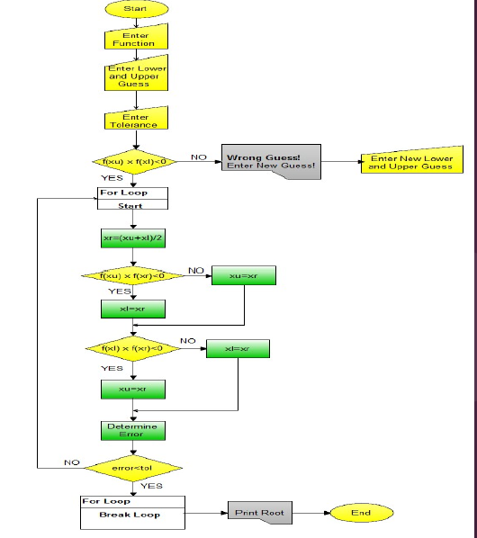

**Take Input**

a=input('Enter function’);

f=inline(a);

xl=input('Enter lower guess:') ;

xu=input('Enter upper guess:');

tol=input('Enter tolerance(recommended 0.001):');

**Checking First Condition**

if f(xu)*f(xl)<0

else

fprintf('Wrong Guess!Enter new guess\n');

xl=input('Enter lower guess:\n') ;

xu=input('Enter upper guess:\n');

end

for i=2:1000

%write missing part of code by following and understanding the flow chart

% xnew(1)=0;

xnew(i)=xr;

if abs(xnew(i))<tol,break,end

end

str = ['The required root of the equation is: ', num2str(xr), '']

**Lab Task**

The bisection method in mathematics is a root-finding method that repeatedly bisects an interval and then selects a subinterval in which a root must lie for further processing. It is a very simple and robust method, but it is also relatively slow.

* Implement the bisection method using functions.

a=input('Enter function ');

f=inline(a);

xl=input('Enter lower guess:') ;

xu=input('Enter upper guess:');

tol=input('Enter tolerance(recommended 0.001):');

%Checking First Condition

if f(xu)*f(xl)<0

else

fprintf('Wrong Guess!Enter new guess\n');

xl=input('Enter lower guess:\n') ;

xu=input('Enter upper guess:\n');

end

for i=2:1000

%write missing part of code by following and understanding the flow chart

xr=(xl+xu)/2;

if f(xu)*f(xr)<0

xl=xr;

else

xu=xr;

end

if f(xl)*f(xr)<0

xu=xr;

else

xl=xr;

end

% xnew(1)=0;

xnew(i)=xr;

if abs(xnew(i))<tol,break,end

end

str = ['The required root of the equation is: ', num2str(xr), '']

**Deliverables**

Submit single word file with matlab code and screen shot of Output.